CORE CYBERSECURITY CONCEPTS
CodeKrafters Club – First Year Cybersecurity Task 2
Name | M Avinaash
TryHackMe Profile | https://tryhackme.com/p/avinaashvista

Introduction
For this task, I chose five basic cybersecurity concepts that I felt were useful to understand as a beginner: Confidentiality, Integrity, Availability, Authentication and Authorization. I have explained each one in simple terms and used a practical situation to show where it matters.

1. Confidentiality
Confidentiality means keeping information private and making sure only people who are allowed to see it can access it.
Real-world scenario: For example, when I log in to a college portal, my marks and personal details should not be visible to another student. The system should protect this information from unauthorized users.
What I understood: What I understood: The main idea is privacy. Information should be available only to the right people.
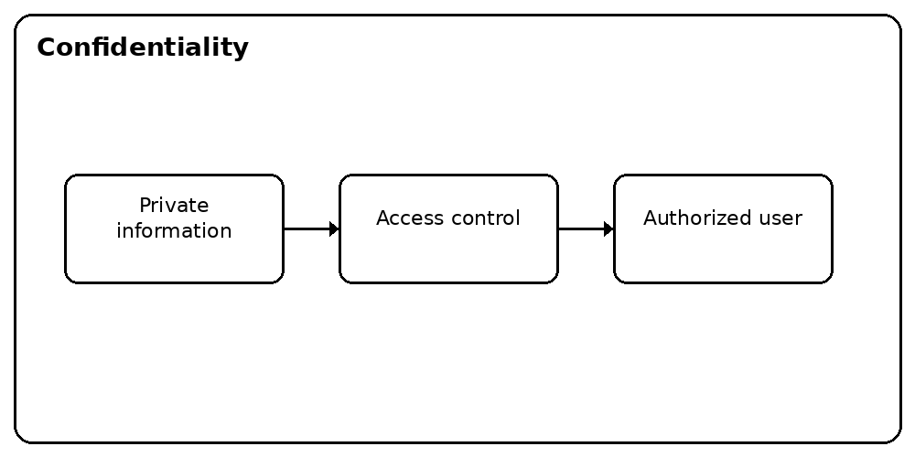
Original illustration – Confidentiality

2. Integrity
Integrity means making sure information stays accurate and is not changed without permission.
Real-world scenario: Imagine a college database containing a student's internal marks. If someone changes the marks without permission, the data is no longer trustworthy. Security controls should help prevent or detect such changes.
What I understood: What I understood: Integrity is about being able to trust that data is still correct.
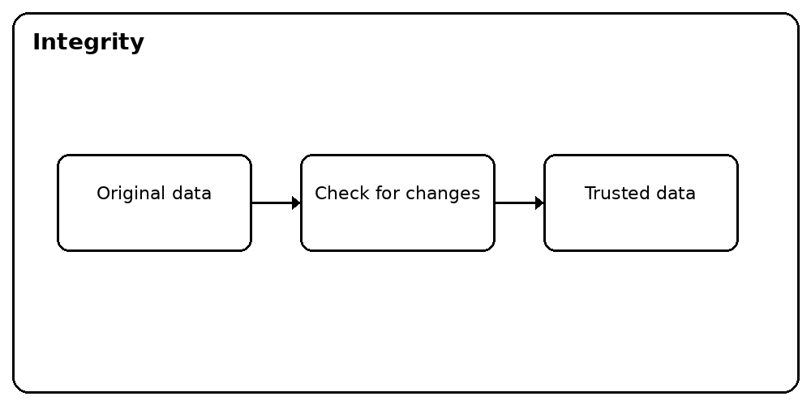
Original illustration – Integrity

3. Availability
Availability means that a system or service should be accessible when an authorized user needs it.
Real-world scenario: Suppose students have to submit an assignment through an online portal before a deadline. If the server keeps going down, students may not be able to submit their work. Keeping systems running and having recovery methods helps maintain availability.
What I understood: What I understood: Security is also about keeping services usable when legitimate users need them.
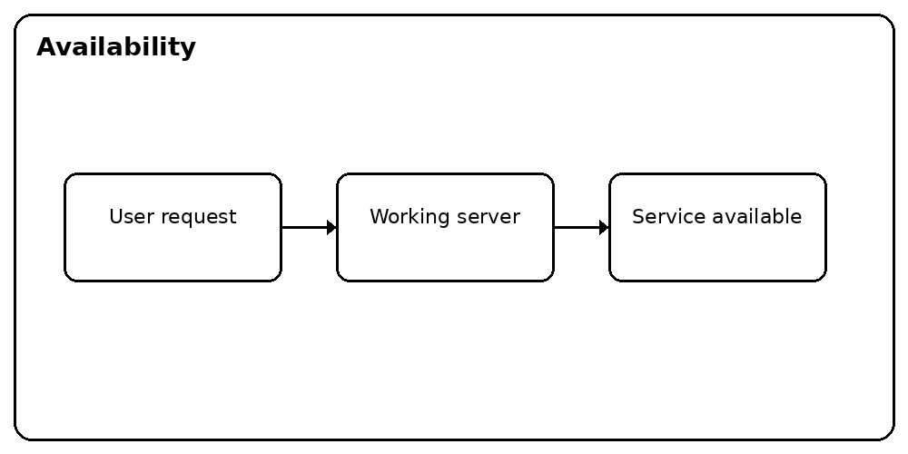
Original illustration – Availability

4. Authentication
Authentication is the process of checking whether someone really is the person they claim to be.
Real-world scenario: When I sign in to an account using a username and password, the service checks those details before giving me access. Other methods, such as a one-time code or fingerprint, can also verify identity.
What I understood: What I understood: Authentication answers, 'Who are you?' It verifies the user's identity.
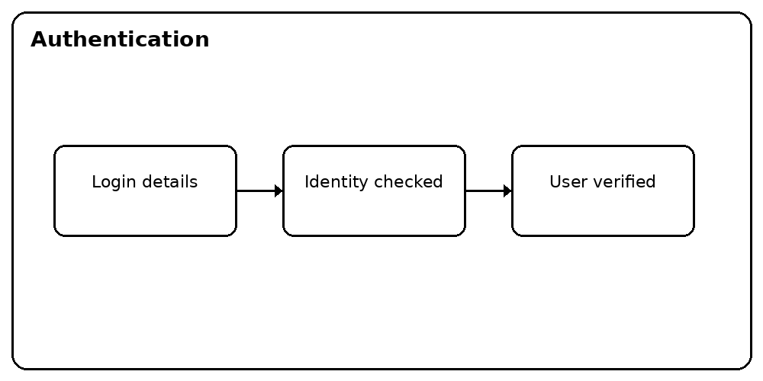
Original illustration – Authentication

5. Authorization
Authorization is about deciding what an already authenticated user is allowed to access or do.
Real-world scenario: A student and a college administrator may both successfully log in to the same college system. The student might only be allowed to view their own marks, while an administrator may have permission to update marks.
What I understood: What I understood: Authorization answers, 'What are you allowed to do?' Authentication identifies the user, while authorization controls permissions.
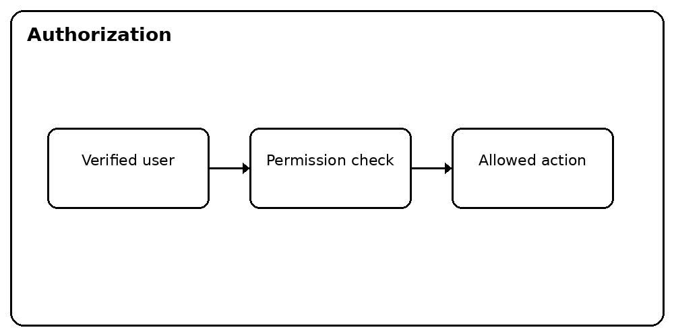
Original illustration – Authorization

Conclusion
This task helped me understand that cybersecurity is not only about tools or attacks. Protecting information, keeping data correct, keeping services available, verifying users and controlling permissions are all basic parts of a secure system. These concepts also helped me see why networking and cybersecurity are closely connected.

