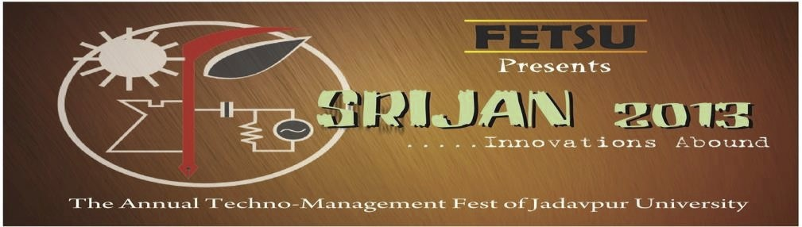

Electronica 2.0



“The ignorant man marvels at the exceptional; the wise man marvels at the common; the greatest wonder of all is the regularity of nature” - G.D. Boardman

So you think that learning electronics have made you a wise man???? Think again.

Come and test your knowledge of electronics at the biggest tech fest of Kolkata, SRIJAN 2013.

WELCOME FRIENDS TO ELECTRONICA 2.0

General Rules:



The maximum number of participants in a team is 3.

Each member must produce a valid ID card of his/her respective institution. However students from different institutions can form a team.

Event Specific Rules:

1>Anyone found using an electronic device(mobiles etc) will be disqualified. 2> Only the materials provided should be used for solving any problem.   
3> Participants found taking external help will be disqualified.   
4> The participants have to complete their tasks within the specified time.

5> The decision of the judges will be final and binding.

Event Details:

The event will take place in two Rounds :

1> Round 1 is the elimination round. It will comprise of a written exam testing the basic concepts of electronics comprising of MCQs and long problems.

2> Round 2 is the real deal. Each team will have to solve a problem regarding circuit designing using basic knowledge of analog, digital and power electronics etc. Contestants would be provided with scratch sheets and Pens.

For more information’s contact:

Arijit Karmakar Tathagata Maitra

9831509845 7890412634