Machine Learning-Assisted Discovery and Application-Specific Screening of Metal Hydride Materials for Hydrogen Storage
A B. Tech Project Report Submitted
in Partial Fulfillment of the Requirements
for the Degree of
Bachelor of Technology
by
Avinash
(230151005)
under the guidance of
Dr. Saket Verma

to the
SCHOOL OF ENERGY SCIENCE AND ENGINEERING
INDIAN INSTITUTE OF TECHNOLOGY GUWAHATI
GUWAHATI - 781039, ASSAM

CERTIFICATE
This is to certify that the work contained in this thesis entitled “Machine Learning-Assisted Discovery and Application-Specific Screening of Metal Hydride Materials for Hydrogen Storage” is a bona fide work of Avinash (230151005), carried out in the School of Energy Science and Engineering, Indian Institute of Technology Guwahati under my supervision and that it has not been submitted elsewhere for a degree.

Supervisor: Dr. Saket Verma
Assistant Professor,
School of Energy Science and Engineering,
Indian Institute of Technology Guwahati, Assam.
Date
Guwahati.
Acknowledgements
I thank my supervisor, Dr. Saket Verma, Assistant Professor, School of Energy Science and Engineering, and my teaching assistant, Dr. Joy Nondy, for their guidance throughout this project.
The Purdue Hydrogen Systems Laboratory made the Metal Hydride Toolbox publicly available, and Sandia National Laboratories released the ML-HydPARK dataset. This work would not have been possible without these open data sources.
Avinash
November 2026
Abstract
Metal hydrides store hydrogen at low pressure and close to room temperature, but choosing an alloy for an application requires its desorption enthalpy (ΔH) and entropy (ΔS), because together they fix the temperature and pressure at which hydrogen is released. This project builds an audited, composition-level dataset from two public sources, the Purdue Metal Hydride Toolbox (337 materials) and ML-HydPARK v0.0.5 (772 records), and uses it for three tasks: predicting ΔH from composition, converting thermodynamic data into operating windows, and screening materials against application requirements.
The audit found opposite sign conventions, entropies back-calculated from a single pressure–temperature point, capacities of unstated definition, and a large overlap between the sources: 248 of 288 parseable Purdue compositions also appear in HydPARK, so one dataset cannot validate the other. A random forest using 38 composition descriptors predicts ΔH with a mean absolute error (MAE) of 5.26 ± 0.14 kJ mol⁻¹ H₂ under nested grouped cross-validation (R² = 0.72), compared with 8.88 kJ mol⁻¹ for a family-median rule. The error rises from 2.6 to 16.9 kJ mol⁻¹ as the distance to the nearest training composition grows, and the model fails when a whole alloy family is held out. Predictions are therefore reported with an 80% interval and an applicability-domain flag. Van't Hoff analysis of the experimental ΔH and ΔS shows, for example, that LaNi₅ reaches 1 bar at 11.6 °C and needs 15.9 MJ of heat per kg of H₂ released, whereas MgH₂ needs 302 °C and 38.8 MJ kg⁻¹.
A rule-based screening (hard constraints, weighted criteria, Pareto fronts and evidence classes) ranks the experimental materials for mobile and stationary requirements and is implemented in an interactive Streamlit application. The rankings are material-level screening results, and the compositions generated with the model are candidates for measurement, not discoveries. No laboratory work was carried out; a synthesis and characterisation plan is proposed as future work.
Keywords: metal hydrides; hydrogen storage; machine learning; random forest; Van't Hoff; applicability domain; materials screening
Contents
List of Figures vii
List of Tables viii
List of Abbreviations and Symbols ix
1 Introduction 1
1.1 Background 1
1.2 Why composition and thermodynamics matter 1
1.3 Problem statement 2
1.4 Objectives 2
1.5 Scope and limitations 2
1.6 Organisation of the report 3
2 Literature Review and Theoretical Background 4
2.1 Hydrogen absorption in metals 4
2.2 Pressure–composition isotherms and the Van't Hoff relation 4
2.3 Engineering properties of hydride storage 5
2.4 Families of metal hydrides 6
2.5 Composition–property relationships 6
2.6 Machine learning for materials properties 7
2.7 Research gap 7
2.8 Summary 8
3 Datasets and Methodology 9
3.1 Data sources 9
3.2 Data audit 10
3.3 Construction of the modelling dataset 11
3.4 Composition descriptors 11
3.5 Validation design 12
4 Machine Learning Model Development 13
4.1 Target and models 13
4.2 Cross-validated performance 13
4.3 How precise is the model? 14
4.4 Performance by family and within families 15
4.5 Extrapolation to unseen families 15
4.6 Applicability domain and prediction intervals 16
4.7 What the model uses 17
4.8 Sensitivity to data quality, and the capacity model 18
4.9 Final model and deployment 18
5 Thermodynamic Analysis 19
5.1 Method and a worked example 19
5.2 Representative materials 19
5.3 Whole-database view 20
5.4 Hysteresis and plateau slope 21
5.5 Consistency with the digitised isotherms 21
5.6 Estimates for new compositions 22
5.7 Kinetics 23
6 Application-Specific Screening and Software Platform 24
6.1 Screening principles 24
6.2 Mobile and stationary screening of the experimental materials 24
6.3 Software platform 26
7 Results and Discussion 28
7.1 Data and model 28
7.2 Thermodynamic findings 28
7.3 Mobile and stationary rankings 28
7.4 Requirement-driven scenarios 29
7.5 ML-generated candidates 31
7.6 Critical discussion of limitations 31
8 Conclusion and Future Work 32
8.1 Conclusions 32
8.2 Engineering insights 32
8.3 Proposed experimental programme 33
8.4 Further development 33
References 34
Appendix A Composition Descriptors 36
Appendix B Additional Machine-Learning Results 37
Appendix C Data-Quality Flags 38
Appendix D ML-Generated Candidates of the Demonstration Scenarios 40
Appendix E Scenario Rankings 42
Appendix F Proposed Characterisation Matrix 43
List of Figures
1.1 Project workflow 2
2.1 Schematic pressure–composition isotherms with the α, α + β and β regions, and the Van't Hoff plot built from the plateau pressures 5
3.1 Distribution of material classes in the Purdue toolbox and ML-HydPARK v0.0.5 9
3.2 Data-preparation workflow from the two raw sources to the composition-level ΔH dataset 11
4.1 Mean absolute error and R² of the models and baselines under nested grouped cross-validation 14
4.2 Random forest on the grouped hold-out set: predicted against reported ΔH, residuals against prediction and residual distribution 14
4.3 Leave-one-family-out MAE of the random forest and of the mean of the other families 16
4.4 Out-of-fold MAE against the L1 distance to the nearest training composition outside the same CV group 17
4.5 Permutation importance of the 15 most important descriptors 18
5.1 Van't Hoff lines of the representative materials over all single-plateau AB₅, AB₂, AB and SS Purdue materials 20
5.2 Reaction heat against the temperature for 1 bar desorption pressure for all Purdue plateaus 21
5.3 Digitised pressure–composition isotherms of five representative hydrides 22
5.4 Estimated (not validated) ΔH and T(1 bar) along four substitution series 23
6.1 Hard-constraint screening of the 337 Purdue materials for mobile and stationary use 25
6.2 Architecture and data flow of the METAL HYDRIDE AI platform 26
6.3 Screening workflow of the Application Requirement Designer 27
7.1 Material-level capacity against reaction heat in the two scenarios: materials failing a hard constraint, ranked materials, the top five and the Pareto front among ranked materials 30
C.1 Missing-data map of the Purdue and HydPARK records 39
List of Tables
2.1 Main hydride families in the Purdue Metal Hydride Toolbox 6
3.1 The two datasets as received 9
3.2 Conventions adopted for all derived data 10
3.3 Composition descriptors used by the ΔH model 12
4.1 Hyperparameter grids searched in the inner cross-validation loop, and the setting selected most often 13
4.2 ΔH prediction under nested grouped 5-fold cross-validation, 3 repeats 13
4.3 Out-of-fold error by family 15
4.4 Leave-one-family-out test: MAE on the held-out family 16
4.5 Calibration of the out-of-fold error against the distance to the nearest training composition 16
5.1 Van't Hoff results for representative materials 19
5.2 Operating criteria met by the 318 single-plateau Purdue materials with typical ΔS 20
6.1 Hard constraints of the mobile and stationary screens 24
6.2 Criterion weights of the mobile and stationary screens 25
7.1 Top five materials of the generic mobile and stationary screens 29
7.2 Requirements of the two demonstration scenarios 29
7.3 Top five materials of the two scenarios 30
7.4 Main limitations of the work and the measurement or data that would address each 31
A.1 Descriptors of the ΔH model 36
B.1 Within-family nested grouped cross-validation 37
B.2 Sensitivity of the ΔH error to the data subset 37
C.1 Data-quality flags in the cleaned datasets 38
D.1 Generation summary, scenario 1 40
D.2 Top candidates, scenario 1 (mobile); ΔH in kJ mol⁻¹ 40
D.3 Generation summary, scenario 2 40
D.4 Top candidates, scenario 2 (industrial); ΔH in kJ mol⁻¹ 40
E.1 Ranking, scenario 1 42
E.2 Ranking, scenario 2 42
F.1 Proposed synthesis and characterisation techniques 43
List of Abbreviations and Symbols
Abbreviation | Meaning
AB, AB₂, AB₅ | intermetallic families by A:B stoichiometry (A = hydride-forming element)
BCC | body-centred cubic
CV | cross-validation
DOE | U.S. Department of Energy
GB | gradient boosting
LHV | lower heating value of hydrogen (119.96 MJ kg⁻¹)
MAE | mean absolute error
MIC | multicomponent intermetallic (HydPARK class)
ML | machine learning
Mm | mischmetal (mixture of rare-earth metals)
NN | nearest neighbour
PCI / PCT | pressure–composition isotherm / pressure–composition–temperature
PEMFC | proton-exchange-membrane fuel cell
RF | random forest
RMSE | root-mean-square error
SS | solid solution (mainly BCC, V-based)
wt% | weight per cent of hydrogen in the hydride

Symbol | Meaning | Unit
ΔH | enthalpy of hydride decomposition (positive desorption value) | kJ mol⁻¹ H₂
ΔS | entropy of hydride decomposition (positive desorption value) | J mol⁻¹ H₂ K⁻¹
P_{eq}, P_{abs}, P_{des} | equilibrium, absorption and desorption plateau pressure | bar
P₀ | reference pressure, 1 atm = 1.01325 bar | bar
R | gas constant, 8.314462618 | J mol⁻¹ K⁻¹
T | absolute temperature | K
T(1 bar) | temperature at which P_{des} = 1 bar | °C
Q | reaction heat per kg of H₂ (= ΔH / M_{H}2~~) | MJ kg⁻¹ H₂
x_{i} | atomic fraction of element i | –
δ | atomic size mismatch | –
d_{NN} | L1 distance to the nearest training composition | –
R² | coefficient of determination | –

Chapter 1
Introduction

1.1 Background
Hydrogen can carry energy from electrolysers and renewable generation to fuel cells, engines and chemical plants, but it is hard to store. Its lower heating value is high per unit mass (119.96 MJ kg⁻¹), whereas its density at ambient conditions is very low. Practical storage therefore has to raise the density, either by compressing the gas to several hundred bar, by liquefying it near 20 K, or by binding it to a solid [1, 2]. Compression and liquefaction are mature, but they cost energy and need heavy pressure vessels or cryogenic insulation, which limits where a store can be placed.
Metal hydrides take the third route. Many metals and intermetallic compounds absorb hydrogen reversibly: hydrogen molecules dissociate at the surface, and the atoms occupy interstitial sites of the metal lattice. The resulting hydride can hold more hydrogen per unit volume than liquid hydrogen. It releases the hydrogen again at a defined equilibrium pressure when heat is supplied [3, 4]. The storage pressure is moderate, often a few bar, and hydrogen is released only as fast as heat reaches the bed, which makes the store inherently safer. Their main drawback is mass: interstitial hydrides of transition-metal alloys hold about 1–2 wt% hydrogen, far below the U.S. Department of Energy (DOE) 2025 target for an onboard vehicle system of 5.5 wt% (1.8 kWh kg⁻¹) [5]. Light hydrides such as MgH₂ hold more but must be heated to around 300 °C. Metal hydrides therefore suit uses where volume, pressure or safety matter more than mass, such as stationary buffers, forklifts and systems that can use waste heat [6].

1.2 Why composition and thermodynamics matter
Whether a hydride suits an application is decided mainly by two numbers: the enthalpy ΔH and the entropy ΔS of the decomposition reaction. Through the Van't Hoff relation (Chapter 2) they set the plateau pressure at each temperature, the temperature needed to deliver hydrogen at a given pressure, and the heat that must be supplied on desorption and removed on absorption. ΔS varies relatively little between hydrides, so ΔH effectively decides the operating temperature. For the Purdue materials analysed in this work the median ΔS is 110.6 J mol⁻¹ K⁻¹ (interquartile range 102.8–118.9). A change of 5 kJ mol⁻¹ in ΔH changes the plateau pressure at 25 °C by a factor of about 7.5 (exp[5000/(8.314 × 298)]).
ΔH depends strongly on composition. Substituting Al or Sn for part of the Ni in LaNi₅, or Mn for Fe in TiFe, shifts the plateau by orders of magnitude, and the large AB₂ Laves-phase family is tuned almost entirely through Ti/Zr and Cr/Mn/V/Fe ratios [3]. The number of possible compositions is very large, and measuring each one requires synthesis, activation and pressure–composition isotherms at several temperatures. A model that estimates ΔH from composition, with an honest estimate of its error, could narrow the search to the compositions worth measuring.
Two public datasets make such a model possible: the Metal Hydride Toolbox of the Purdue Hydrogen Systems Laboratory [7, 8] and ML-HydPARK, a machine-learning version of the hydride database collected at Sandia National Laboratories [9, 10]. Both compile literature values, so their quality, units and overlap have to be established before a model is trained.

1.3 Problem statement
The task is to go from an alloy composition to a defensible statement about whether that alloy suits a given storage application. This requires (i) a clean, documented dataset in which measured, derived and missing values are distinguished; (ii) a ΔH predictor whose accuracy is measured honestly and whose range of validity is known; (iii) a transparent conversion from thermodynamic data to operating windows and heat demand; and (iv) a screening method that states which requirements a material meets, which it fails, and which cannot be assessed with the available data. Fig. 1.1 shows how these parts connect in this project.
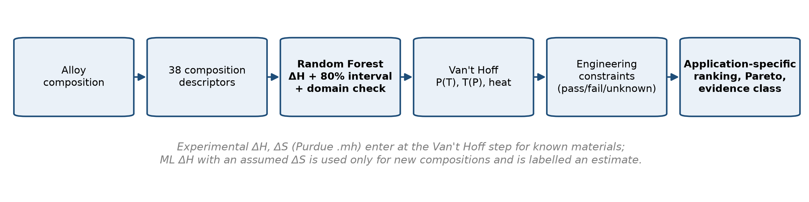
Figure 1.1: Project workflow. The ML model predicts ΔH only; experimental ΔH and ΔS are used whenever they exist.

1.4 Objectives
The objectives of the project were to:
- audit the Purdue Metal Hydride Toolbox and ML-HydPARK, document their conventions and quality problems, and build a composition-level ΔH dataset without converting missing values into measured ones;
- develop a composition-based model for ΔH, validate it with grouped and nested cross-validation against simple baselines, and quantify its uncertainty and applicability domain;
- compute Van't Hoff operating windows, reaction heats and related quantities for the experimental materials, and check them against the digitised isotherms;
- screen the experimental materials against mobile and stationary requirements with explicit constraints, weights and sensitivity analysis;
- implement the model and the screening in an interactive software platform; and
- propose, but not perform, a synthesis and characterisation programme that would test the results.

1.5 Scope and limitations
This is a computational project. All property values come from the two public datasets. No alloy was synthesised and no measurement was made, so the experimental plan in Chapter 8 is a proposal only. The ML model predicts ΔH alone; wherever an operating window is estimated from a predicted ΔH, the entropy is an assumed family median. All capacities are material-level values reported in the literature, with definitions that are not uniform. They are not system capacities, and no volumetric capacity is estimated where a density is not stated. Cost and kinetics enter the screening only as qualitative classes.

1.6 Organisation of the report
Chapter 2 reviews the physics of hydrogen absorption, the main hydride families and the use of machine learning for materials properties. The datasets, their audit, the modelling dataset, the composition descriptors and the validation design are described in Chapter 3, and the ΔH model and its applicability domain in Chapter 4. Chapter 5 applies the Van't Hoff relation to the experimental data, and Chapter 6 covers the application-specific screening and the software built around it. The main results are discussed in Chapter 7; Chapter 8 gives the conclusions and the proposed future work. The appendices list the descriptors, additional results and the proposed characterisation matrix.

Chapter 2
Literature Review and Theoretical Background

2.1 Hydrogen absorption in metals
A metal M reacts with gaseous hydrogen in several steps: physisorption of H₂ on the surface, dissociation into atoms, and diffusion of the atoms into interstitial (tetrahedral or octahedral) sites of the lattice [2, 11]. At low concentration the hydrogen forms a solid solution, the α phase, in which the lattice expands only slightly. Above a critical concentration the hydrogen–hydrogen interaction, mediated by the lattice expansion, makes it favourable to nucleate a hydride phase, β, with a much higher hydrogen content. While α and β coexist, the system has two components (metal and hydrogen) and three phases (α, β and gas). By the Gibbs phase rule it has one degree of freedom, so at a fixed temperature the equilibrium pressure is fixed. This is the plateau of the pressure–composition isotherm (PCI, also called PCT). Once the metal has been converted to β, the pressure rises steeply again [3].
For desorption, written per mole of H₂,
(2/x) MH_{x} ⇌ (2/x) M + H₂, (2.1)
the reaction absorbs heat (it is endothermic), and the reverse reaction, absorption, releases the same amount of heat apart from hysteresis effects. Real materials deviate from the ideal picture in three ways that matter for engineering. Plateaus are sloped, because composition gradients and lattice strain spread the transition over a range of pressures. They show hysteresis: absorption takes place at a higher pressure than desorption at the same temperature, which costs compressor work or a larger temperature swing in each cycle. And some materials show several plateaus, each a different reaction step with its own ΔH and ΔS, as in the complex hydride NaAlH₄ [12].

2.2 Pressure–composition isotherms and the Van't Hoff relation
At equilibrium on the plateau, the Gibbs energy of the desorption reaction is zero, ΔG = ΔH − TΔS + RT ln(P_{eq}/P₀) = 0, with ΔH and ΔS taken as positive desorption values. Rearranging gives the Van't Hoff relation,
ln(P_{eq} / P₀) = − ΔH / (R T) + ΔS / R, (2.2)
where P₀ is the reference pressure of ΔS. A plot of ln P_{eq} against 1/T is a straight line with slope −ΔH/R and intercept ΔS/R (Fig. 2.1). Measuring isotherms at several temperatures therefore gives both quantities [11]. Solving Eq. (2.2) for temperature gives the temperature at which the hydride delivers a pressure P,
T(P) = ΔH / (ΔS − R ln(P / P₀)), (2.3)
and the heat needed per kilogram of hydrogen released is
Q = ΔH / M_{H}2~~, (2.4)
with M_{H}2~ = 2.01588 g mol^−1^. ΔS is dominated by the loss of the entropy of gaseous H2~ (its standard molar entropy is about 130.7 J mol⁻¹ K⁻¹), which is why it varies relatively little between hydrides [2]. As a consequence, the operating temperature at a given pressure is roughly proportional to ΔH, and so is the heat demand. A hydride that releases hydrogen near room temperature cannot also be very stable.
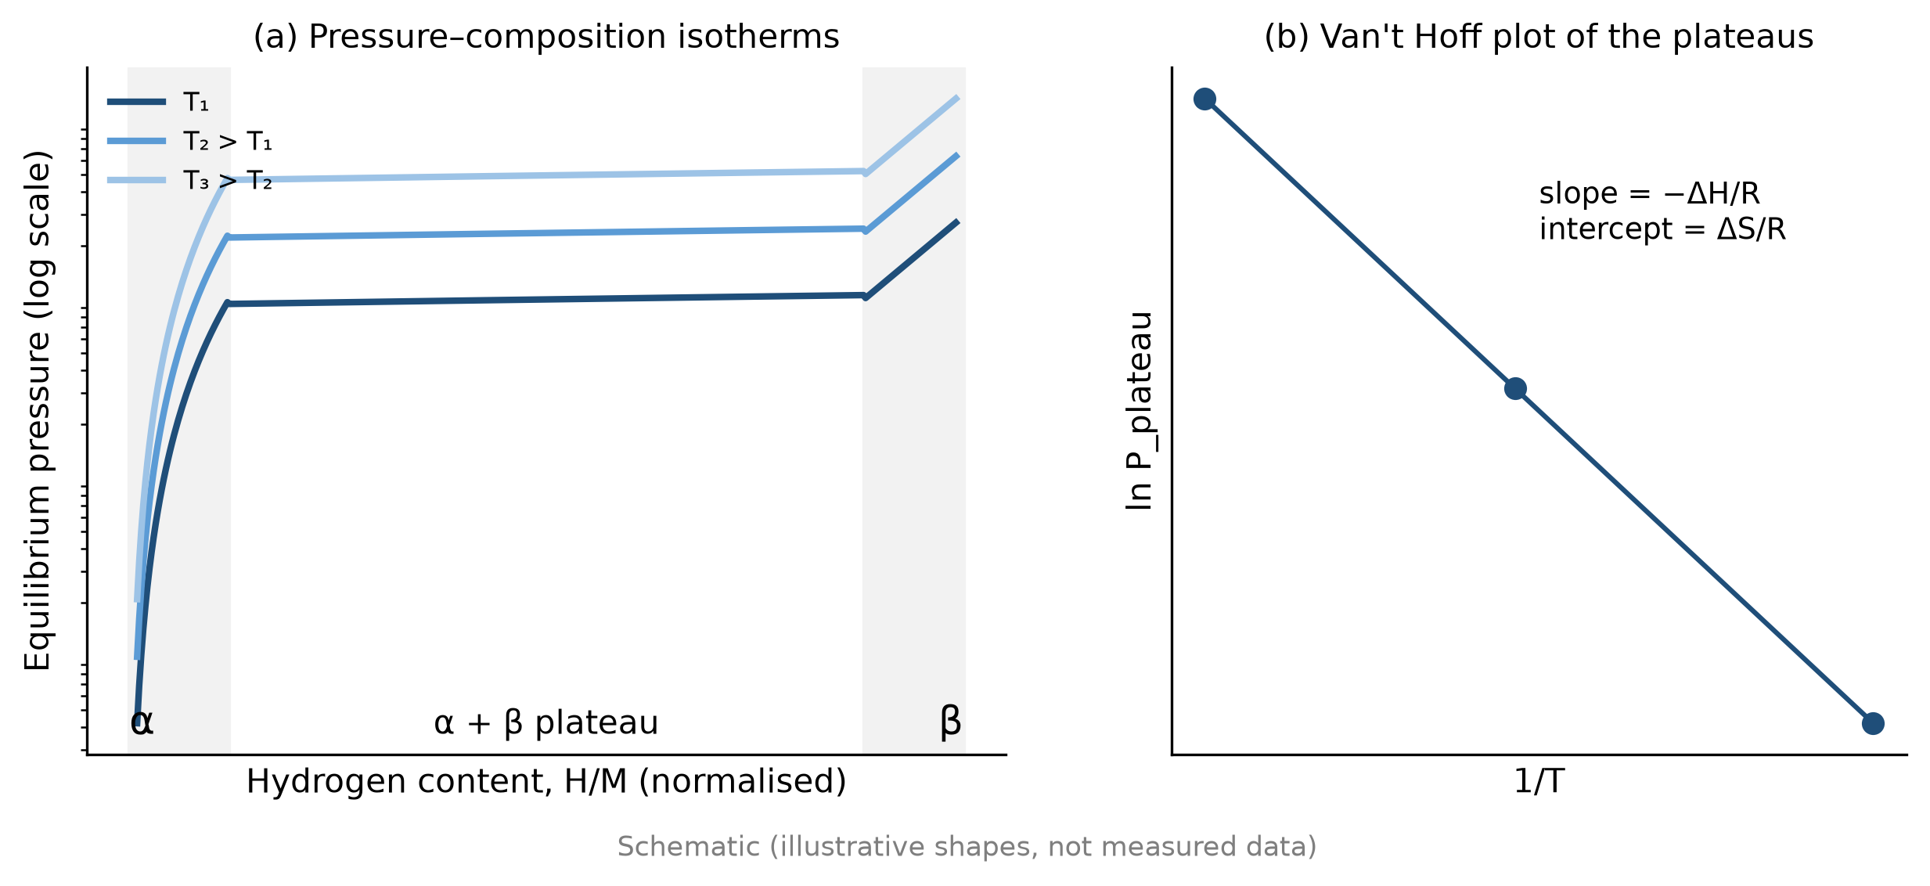
Figure 2.1: Schematic pressure–composition isotherms with the α, α + β and β regions (a), and the Van't Hoff plot built from the plateau pressures (b). Illustrative shapes, not measured data.
The relation assumes that ΔH and ΔS do not depend on temperature and that the plateau is flat. Both assumptions are approximations. The first is usually adequate over the few tens of kelvin covered by a set of isotherms; the second is not, for strongly sloped plateaus, and an operating window computed from the plateau midpoint is then optimistic at low state of charge.

2.3 Engineering properties of hydride storage
Thermodynamics fixes the operating point, but several other properties decide whether a store works [4, 11]. Capacity is quoted as wt% or as H/M (per metal atom or per formula unit) and is defined in different ways: total uptake, reversible capacity between two pressures, or the capacity of the first plateau only. It refers to the material, not to a system with its vessel, heat exchanger and bed porosity, whose capacity is substantially lower; the DOE targets are system targets [5]. Volumetric capacity needs the density of the hydride or of the powder bed, which is often not reported.
Desorption needs the heat Q (Eq. (2.4)), and absorption releases about the same amount, which must be removed during refuelling. Because powder beds conduct heat poorly, heat transfer often limits the flow rate more than the intrinsic kinetics do. Rates depend on surface condition, particle size, catalysts and the driving force P/P_{eq}, and many alloys, notably TiFe, need an activation treatment before the first absorption [13]. Mg-based hydrides are slow without nanostructuring or catalysts [14]. Hysteresis raises the charging pressure, plateau slope lowers the pressure available near the end of discharge, and capacity loss over many cycles limits the life of the store. Rare earths, Co, V and minor metals raise the cost.

2.4 Families of metal hydrides
Hydride-forming alloys are usually grouped by structure and stoichiometry. A is an element that forms a stable binary hydride (rare earths, Ti, Zr, Mg, Ca); B is a non-hydride-forming element (Ni, Fe, Mn, Cr, Co, Al) that weakens the binding and adjusts the plateau [3]. Table 2.1 summarises the main families as they appear in the Purdue data used in this work.
Table 2.1: Main hydride families in the Purdue Metal Hydride Toolbox (single-plateau materials; medians computed in this work from the experimental ΔH, ΔS and reported capacities)
Family | Examples | n | Median ΔH (kJ mol⁻¹) | Median ΔS (J mol⁻¹ K⁻¹) | Median wt% (max) | Median T(1 bar) (°C)
AB₅ | LaNi₅, MmNi_{4.5}Al_{0.5}, CaNi₅ | 146 | 33.0 | 111.2 | 1.2 (1.9) | 24.1
AB₂ (Laves) | TiCr_{2−x}Mn_{x}, ZrMn₂, Ti–Zr–Mn–V | 104 | 29.0 | 109.7 | 1.7 (2.9) | −3.8
AB | TiFe, TiFe_{1−x}Mn_{x} | 29 | 34.7 | 108.8 | 1.5 (2.2) | 32.0
SS (BCC) | V–Ti–Fe, V–Ti–Cr | 24 | 30.8 | 96.7 | 0.7 (3.7) | 49.1
Mg-based | MgH₂, Mg₂Ni | 4 | 72.4 | 133.6 | 5.6 (7.6) | 265.5

AB~5~ compounds. The discovery that LaNi₅ absorbs large amounts of hydrogen reversibly at room temperature [15] made AB₅ alloys the reference hydride. They activate easily, have flat plateaus and small hysteresis, and their plateau can be tuned by substituting Al, Sn, Mn or Co for Ni, or mischmetal (Mm) for La. Their capacity is low, about 1.2–1.5 wt%, and La and Co are costly.
AB~2~ Laves phases. Ti- and Zr-based AB₂ alloys with hexagonal C14 or cubic C15 structures form the largest family in both datasets. They are lighter than AB₅ alloys, so their capacity is higher (up to about 2 wt% at the material level), and their plateau can be moved over several orders of magnitude by changing the Ti/Zr and Cr/Mn/V/Fe ratios. Many have sloped plateaus and noticeable hysteresis.
AB compounds. TiFe forms a hydride at near-ambient conditions from cheap and abundant elements [13]. It shows two plateaus and is difficult to activate; Mn and other substitutions ease activation and adjust the plateau.
BCC solid solutions. V-based alloys can absorb close to 4 wt%, but only part of it is reversible at ambient conditions, because the first, very stable hydride does not decompose [4].
Mg-based and complex hydrides. MgH₂ contains 7.6 wt% hydrogen, but its high ΔH requires about 300 °C for a desorption pressure of 1 bar, and its kinetics are slow without ball milling and catalysts [14]. Complex hydrides such as NaAlH₄ became reversible after Ti doping [16]. They decompose in two steps with different thermodynamics [12]. These families are poorly represented in the datasets used here.

2.5 Composition–property relationships
Empirical rules link composition to hydride stability. Lundin, Lynch and Magee correlated ΔH with the size of the interstitial holes in intermetallic compounds: larger holes give more stable hydrides [17]. In high-entropy and multicomponent alloys the atomic size mismatch δ is used as a descriptor of lattice strain and phase stability [18]. Such rules explain trends within a family, but they are too coarse for quantitative design, which motivates data-driven models.

2.6 Machine learning for materials properties
Machine-learning models for inorganic materials usually represent a composition by statistics of elemental properties, such as fraction-weighted means, spreads, minima and maxima of atomic mass, radius, electronegativity, melting point and valence-electron count, together with a few alloy descriptors [19]. Libraries such as pymatgen supply the elemental data and composition parsing [20]. Tree ensembles suit such small, non-linear tabular problems well. A random forest averages many decision trees, each grown on a bootstrap sample and with a random subset of features at each split, which reduces variance without much tuning [21]. Standard implementations are available in scikit-learn [22].
For metal hydrides, Witman et al. cleaned the Sandia HydPARK database into ML-HydPARK and trained gradient-boosted trees on composition descriptors. Feature importance showed a strong dependence of the equilibrium pressure on a volume-based descriptor, which they linked to a log-linear relation between ln P_{eq} and the volume per atom [9]. This agrees with the hole-size correlation of Lundin et al. [17].
How far such models can be trusted depends mostly on how they are validated. Literature compilations contain the same or nearly the same composition several times, and when near-duplicates fall into both the training and the test folds, the test error is optimistic; grouping near-identical compositions before splitting avoids this. Choosing hyperparameters by their cross-validated error and then reporting that same error also biases the estimate downwards. Nested cross-validation, which tunes the hyperparameters only inside each outer training fold, removes most of this bias [23].
Random cross-validation measures interpolation among materials like those in the training data, whereas discovery needs extrapolation. Meredig et al. showed that leaving out whole clusters of materials gives much larger errors than random cross-validation [24]. A prediction is therefore only as reliable as the training data near the query. A practical measure of this applicability domain is the distance from the query composition to the nearest training composition, with an error estimate calibrated against that distance.

2.7 Research gap
Published ML studies on hydrides concentrate on predictive accuracy. For work with public data, three gaps remain. First, the main public datasets are rarely audited before use. Their overlap, sign conventions and derived columns can make validation misleading, for instance when an entropy computed from the same (T, P) point as the target is used as an input. Second, predictions are seldom accompanied by a calibrated, distance-dependent uncertainty and an explicit applicability domain. Third, the path from a predicted or measured ΔH to an application decision, through operating windows, heat demand and explicit engineering constraints, is usually left implicit. This work addresses all three and makes the workflow available as a software tool.

2.8 Summary
Metal hydrides store hydrogen at moderate pressure, with the plateau pressure fixed by ΔH and ΔS through the Van't Hoff relation. Because ΔS is nearly constant, ΔH controls both the operating temperature and the heat demand, and it depends strongly on composition. AB₅, AB₂ and AB intermetallics operate near ambient conditions with about 1–2 wt%, while Mg-based and complex hydrides store more but need higher temperatures. Composition-based machine learning can estimate ΔH, provided leakage, model-selection bias and extrapolation are handled and the uncertainty is reported. The following chapters build such a workflow on audited public data.

Chapter 3
Datasets and Methodology

3.1 Data sources
Two public datasets were used. Both are compilations of literature values; neither contains new measurements. Table 3.1 compares them.
Table 3.1: The two datasets as received (verified counts from the Phase 1 audit)
Property | Purdue Metal Hydride Toolbox | ML-HydPARK v0.0.5
Origin | Purdue Hydrogen Systems Laboratory, MATLAB toolbox [7, 8] | Sandia HydPARK database, cleaned for ML [9, 10]
Records | 337 material files (.mh) | 772 rows, in 4 appended blocks (397 / 25 / 15 / 335)
Families | AB₅ 146, AB₂ 106, AB 29, SS 24, AB₃ 14, A₂B₇ 8, Misc 5, Mg 4, Complex 1 | AB₂ (incl. C14/C15) 454, AB₅ 106, SS 60, MIC 52, AB 33, Mg 32, A₂B 10, unlabelled 25
ΔH, ΔS | desorption plateau(s), all 337; absorption for 83 | one value per row
Sign and unit | negative formation values, J mol⁻¹ H₂ | positive values, kJ mol⁻¹ H₂
Capacity | wt% stated for 223, H/M stated for 114 | wt% for 741 rows
Other | 68 digitised PCI files; kinetics 31 abs / 26 des; density 37, Cp 28, k_{eff} 14 | one (T, P) point for 412 rows; reference DOI for 373

The Purdue toolbox stores each material as a text file with desorption (and sometimes absorption) ΔH and ΔS for each plateau, capacity, plateau slope, hysteresis, optional heat-transfer and kinetic parameters, and a reference. The toolbox's MATLAB classes were read to fix the conventions: the Van't Hoff function evaluates P = 101 325 · exp((ΔH_{f} − TΔS_{f})/(RT)) Pa with negative formation values, so the reference pressure is 1 atm. The "H/M" entry is hydrogen per formula unit, not per metal atom. ML-HydPARK reports ΔH and ΔS as positive magnitudes, together with derived columns (P_{eq} and ln P_{eq} at 25 °C, H/M). Fig. 3.1 shows the class distributions.
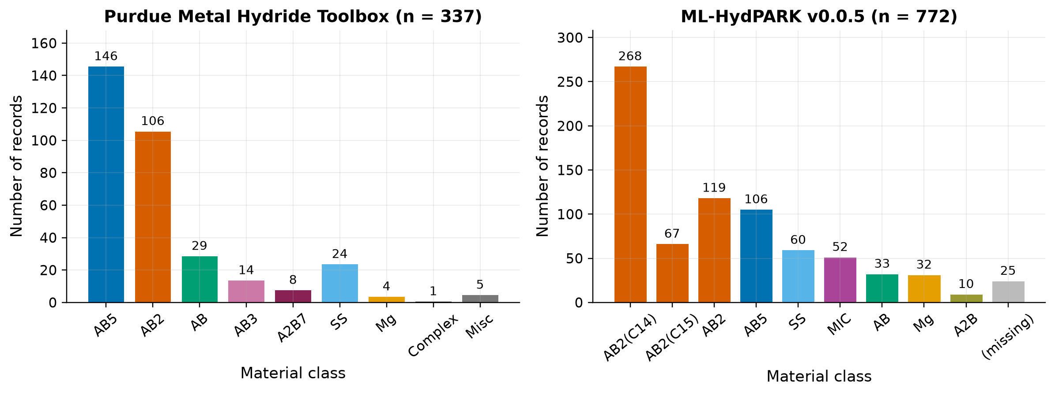
Figure 3.1: Distribution of material classes in the Purdue toolbox (left) and ML-HydPARK v0.0.5 (right).

3.2 Data audit
No model was trained before the audit was complete. Every record was kept and flagged rather than deleted, and the raw files were never modified. The findings that changed the analysis were the following.
Opposite sign conventions. Purdue stores negative formation values in J mol⁻¹ H₂; HydPARK stores positive decomposition values in kJ mol⁻¹ H₂. Both reproduce the Van't Hoff relation once the convention is known. All derived data in this work use positive desorption values, ΔH in kJ mol⁻¹ H₂ and ΔS in J mol⁻¹ H₂ K⁻¹ (Table 3.2).
Table 3.2: Conventions adopted for all derived data
Quantity | Convention in this work | Conversion from the sources
ΔH | positive, desorption, kJ mol⁻¹ H₂ | Purdue: −ΔH_{f}/1000; HydPARK: unchanged
ΔS | positive, desorption, J mol⁻¹ H₂ K⁻¹, referred to P₀ = 1 atm | Purdue: −ΔS_{f}; HydPARK: unchanged
Pressure | bar (1 atm = 1.01325 bar) | –
R | 8.314462618 J mol⁻¹ K⁻¹ | –
Missing value | NaN, never a default | toolbox type defaults are not used

Back-calculated entropy in HydPARK. For 395 of the 412 rows that have a (T, P) point, ΔS = R ln P + ΔH/T holds to better than 0.01 J mol⁻¹ K⁻¹. These entropies are functions of ΔH and a single pressure–temperature point, so they are not independent measurements. Using ΔS, P_{eq}(25 °C) or ln P_{eq}(25 °C) as inputs for predicting ΔH would leak the target into the features, so they were excluded.
Undefined capacities. Only 8 Purdue files describe their capacity as reversible, and 17 describe it as assumed, approximate, theoretical or unconfirmed. Capacity is therefore treated as a reported, material-level value of uncertain definition.
Default substitution. When a property is missing, the toolbox substitutes a family-type default (for example for hysteresis, density or kinetics). These defaults were excluded, so missing properties stay missing: density is available for 37 materials, heat capacity for 28, effective thermal conductivity for 14, and kinetic parameters for 31 (absorption) and 26 (desorption).
Digitised and shifted isotherms. All 68 PCI files were digitised from published figures, and 14 were shifted along the composition axis by the curators. They are useful for consistency checks but are not raw measurements.
References and compositions. 102 Purdue files cite an unverified placeholder reference to the Sandia database; 49 use pseudo-elements (mischmetal Mm, lanthanum-rich mischmetal Lm, ferrovanadium Vf) whose exact composition is not defined; 12 have more than one plateau.
Overlap between the datasets. Of 288 Purdue compositions that could be parsed into real elements, 248 also occur in HydPARK, usually with the same value from the same original source (median ΔH difference 0.0 kJ mol⁻¹). For pairs whose Purdue entry cites an independent reference, the mean absolute ΔH difference is 2.2 kJ mol⁻¹. Two consequences follow. A model trained on one dataset cannot be validated on the other, because the test would measure memorisation of shared records, and about 2 kJ mol⁻¹ is a floor on the error that any model can be expected to reach with these data.
A missing-data map of both datasets is given in Appendix C (Fig. C.1). The sparse properties (absorption data, hysteresis, density, kinetics and isotherms) limit what the screening in Chapter 6 can assess.

3.3 Construction of the modelling dataset
The ΔH modelling set is a composition-level union of the two sources built by explicit rules (Fig. 3.2). Each composition was parsed with pymatgen [20] and reduced to normalised atomic fractions, which give a composition key; one row was kept per key. The Purdue single-plateau value was used where available, otherwise the median of the HydPARK values. Entries with pseudo-elements, multi-plateau entries, suspected HydPARK entry errors and entries that the Purdue curators had excluded were left out of the union but kept in the cleaned files. The source of each value, the spread between sources and the quality flags were stored with each row. The result has 725 compositions, 276 with Purdue values and 449 with HydPARK values. AB₂ dominates (401 compositions), followed by AB₅ (116), SS (59), AB (40), Mg (35) and MIC (33).
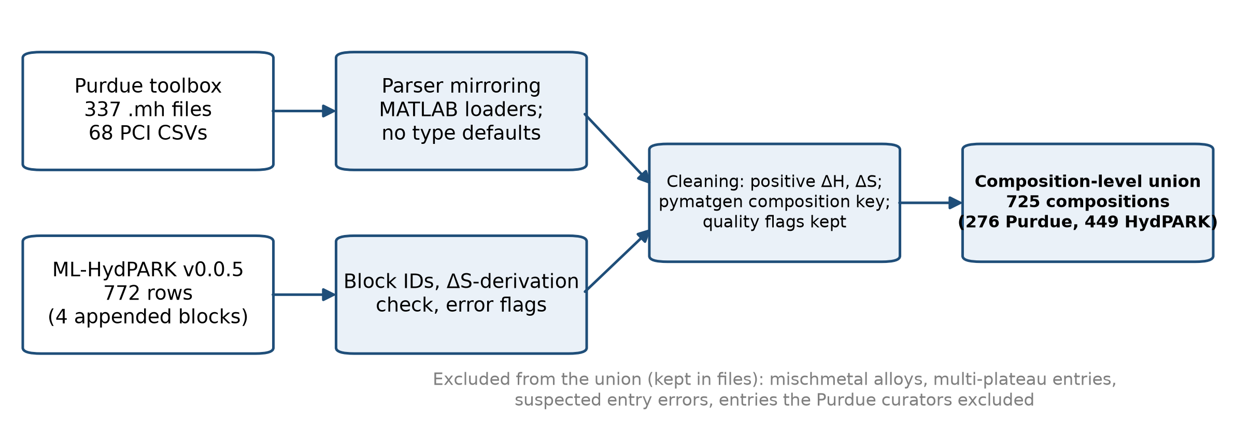
Figure 3.2: Data-preparation workflow from the two raw sources to the composition-level ΔH dataset.

3.4 Composition descriptors
The inputs are computed from composition alone, and the build script checks that no thermodynamic, pressure, temperature or capacity value enters the feature table. Elemental properties were read from pymatgen's periodic table: atomic mass, Pauling electronegativity X, empirical atomic radius, melting point T_{m}, molar volume and valence-electron count (group number for groups 1–12, group − 10 for groups 13–18, and 3 for lanthanides and actinides). All 52 elements in the data have values for these six properties, so no elemental value had to be filled in by hand. Metallic and calculated radii, which are missing for some elements, were not used.
For each property the fraction-weighted mean and standard deviation and the minimum and maximum over the elements present were computed. Four alloy descriptors were added: the number of elements; the ideal configurational entropy, in units of R,
S_{conf} / R = − Σ_{i} x_{i} ln x_{i} ; (3.1)
the atomic size mismatch [18],
δ = [ Σ_{i} x_{i} (1 − r_{i} / r̄)² ]^{1/2}, with r̄ = Σ_{i} x_{i} r_{i} ; (3.2)
and the fraction of hydride-forming atoms (groups 1–5, lanthanides, actinides and Pd). Atomic fractions of the 12 elements that occur in at least 5% of the compositions (Zr, Ti, Mn, Fe, Ni, Cr, V, La, Co, Al, Mg, Cu) complete the set. Features were taken in order of interpretability, and a feature was dropped if its absolute Pearson correlation with one already kept exceeded 0.95. This removed the radius standard deviation (r = 0.999 with δ) and the maximum molar volume (r = 0.964 with the maximum radius), leaving 38 descriptors (Table 3.3; full list in Appendix A). A family one-hot encoding was prepared as an optional extra set.
Table 3.3: Composition descriptors used by the ΔH model
Group | Descriptors | Number
Elemental statistics | mean, std, min, max of mass, X, radius, T_{m}, molar volume, valence electrons (radius std and volume max removed) | 22
Alloy descriptors | number of elements, S_{conf}/R, δ, fraction of hydride formers | 4
Element fractions | x_{Zr}, x_{Ti}, x_{Mn}, x_{Fe}, x_{Ni}, x_{Cr}, x_{V}, x_{La}, x_{Co}, x_{Al}, x_{Mg}, x_{Cu} | 12
Total |  | 38

No single descriptor correlates strongly with ΔH (largest absolute Spearman coefficient 0.54, for the mean molar volume), which is consistent with the absence of leakage. The sign of that correlation is positive, as expected from the hole-size rule [17].

3.5 Validation design
Compositions with the same elements and an L1 distance between their fraction vectors of at most 0.02 were joined into groups, giving 659 groups from 725 compositions, and every split keeps a group on one side. The generalisation error was estimated with nested grouped cross-validation: an outer five-fold GroupKFold, shuffled and repeated three times, and inside each outer training part an inner four-fold GroupKFold grid search that chose the hyperparameters. The outer test folds were never used for any choice, which avoids the selection bias discussed in Section 2.6 [23]. Two baselines were fitted on each training fold: the global mean and the median ΔH of the material's family.
A single grouped 80/20 split (seed 42) was kept for parity plots and permutation importance. Leave-one-family-out tests measured extrapolation [24], and the models were also refitted on data subsets. With y_{i} the reported and ŷ_{i} the predicted ΔH of n test compositions, the metrics are
MAE = (1/n) Σ_{i} | y_{i} − ŷ_{i} |, RMSE = [ (1/n) Σ_{i} (y_{i} − ŷ_{i})² ]^{1/2}, R² = 1 − Σ_{i} (y_{i} − ŷ_{i})² / Σ_{i} (y_{i} − ȳ)². (3.3)
Results are reported as the mean ± standard deviation over the three repeats.

Chapter 4
Machine Learning Model Development

4.1 Target and models
The target is the enthalpy of hydride decomposition, ΔH, for the 725 compositions of the union (kJ mol⁻¹ H₂, positive). The model predicts ΔH only. It does not predict ΔS, capacity, kinetics or cycle life. Three model types were compared with the two baselines of Section 3.5: ridge regression on standardised features, a random forest (RF) [21] and gradient boosting (GB), all from scikit-learn [22]. Each model was trained with the 38 composition descriptors alone and with the family one-hot columns added. The hyperparameter grids (Table 4.1) were kept small, because with 725 compositions a large search would mainly fit noise in the inner folds.
Table 4.1: Hyperparameter grids searched in the inner cross-validation loop, and the setting selected most often
Model | Grid | Most frequently selected
Ridge | α ∈ {0.1, 1, 10, 100, 300, 1000} | α = 100
Random forest (300 trees) | max_features ∈ {0.33, 0.66}; min_samples_leaf ∈ {1, 3} | 0.33; 1
Gradient boosting | learning_rate ∈ {0.05, 0.1}; max_depth ∈ {2, 3} | 0.1; 3

4.2 Cross-validated performance
Table 4.2 and Fig. 4.1 give the nested grouped cross-validation results. Both tree ensembles beat the baselines by a wide margin. The random forest reaches an MAE of 5.26 ± 0.14 kJ mol⁻¹, 41% lower than the family-median rule (8.88) and 57% lower than the global mean (12.26). Gradient boosting has the same MAE within one standard deviation (5.30) and a slightly better RMSE and R². Ridge regression is clearly worse (MAE 7.09), so the relation between composition and ΔH is non-linear. Adding the family label changes nothing beyond one standard deviation: the composition descriptors already encode the family.
Table 4.2: ΔH prediction under nested grouped 5-fold cross-validation, 3 repeats (725 compositions; mean ± sd over repeats)
Model | Features | MAE (kJ mol⁻¹) | RMSE (kJ mol⁻¹) | R²
Random forest | composition | 5.26 ± 0.14 | 10.32 ± 0.78 | 0.715 ± 0.04
Random forest | composition + family | 5.26 ± 0.11 | 10.5 ± 0.75 | 0.71 ± 0.04
Gradient boosting | composition | 5.30 ± 0.13 | 9.77 ± 0.69 | 0.744 ± 0.04
Gradient boosting | composition + family | 5.32 ± 0.13 | 9.80 ± 0.71 | 0.74 ± 0.04
Ridge | composition | 7.09 ± 0.03 | 12.3 ± 0.25 | 0.60 ± 0.02
Family-median baseline | – | 8.88 ± 0.11 | 16.3 ± 0.37 | 0.29 ± 0.03
Mean baseline | – | 12.26 ± 0.02 | 19.4 ± 0.02 | 0.00

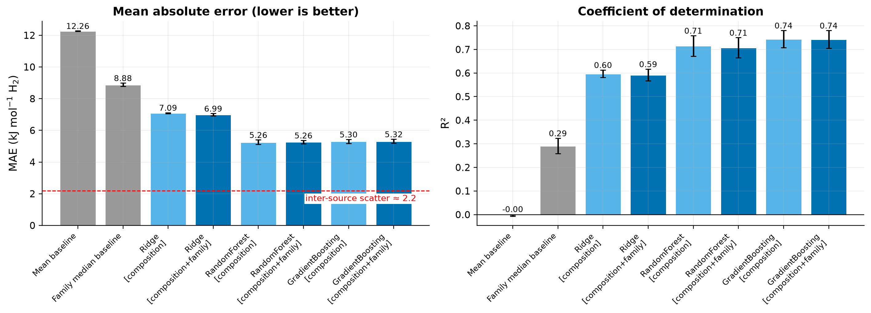
Figure 4.1: Mean absolute error (left) and R² (right) of the models and baselines under nested grouped cross-validation. Error bars: standard deviation over three repeats. The dashed line marks the inter-source scatter of about 2.2 kJ mol⁻¹.
The random forest with composition descriptors was chosen as the final model. The difference between RF and GB is within the fold-to-fold noise, and GB was not better on MAE, the primary metric. The selected RF uses 300 trees, max_features = 0.33, min_samples_leaf = 1 and random_state = 0.
With ordinary, ungrouped five-fold cross-validation the RF error would have been 5.12 kJ mol⁻¹ instead of 5.26, about 3% optimistic. The effect is small because only about 9% of the compositions have near-duplicates, but the grouped value is the one reported.
On the single grouped 20% hold-out set (145 compositions) the RF gives MAE 5.55 kJ mol⁻¹, RMSE 11.9 and R² 0.73, which agrees with the cross-validation estimate. The RMSE is about twice the MAE because a few very stable hydrides (ΔH > 60 kJ mol⁻¹) have large errors, as the parity and residual plots in Fig. 4.2 show.
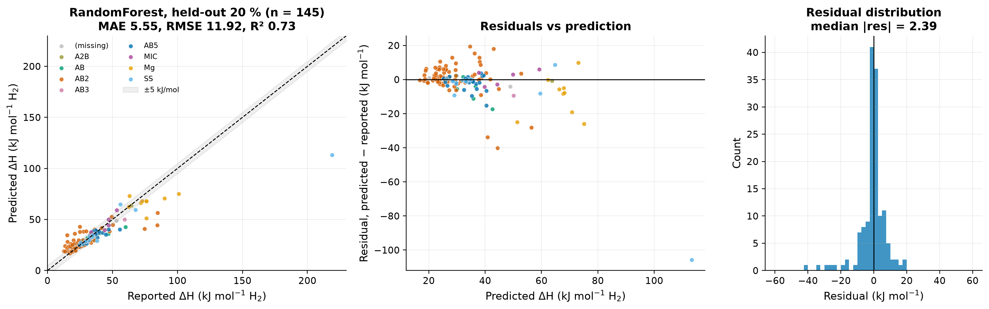
Figure 4.2: Random forest on the grouped hold-out set: predicted against reported ΔH (left), residuals against prediction (centre) and residual distribution (right). Most points lie within ±5 kJ mol⁻¹; the largest errors belong to sparse, very stable hydrides.

4.3 How precise is the model?
Two references put the error in context. The first is the measurement scatter. Where the same composition is reported independently by two sources, the values differ by about 2.2 kJ mol⁻¹ on average (Section 3.2). Of the 261 union compositions that were reported more than once, 149 carry identical values copied from the same source, and the other 112 differ by a median of 1.6 kJ mol⁻¹. No model can be expected to go much below about 2 kJ mol⁻¹ with these data, so the RF error is roughly 2.4 times the measurement scatter. The second is the effect on the operating point. From Eq. (2.2), an error of 5 kJ mol⁻¹ in ΔH changes the plateau pressure at 25 °C by a factor of about 7.5. The model can therefore separate a 25 kJ mol⁻¹ alloy, which delivers several bar at room temperature, from a 40 kJ mol⁻¹ alloy, which needs about 100 °C. It is not precise enough to set a plateau pressure for design.

4.4 Performance by family and within families
Table 4.3 breaks the out-of-fold error down by family. The model works best, in absolute and relative terms, for the two large intermetallic families. For AB₅ the MAE is 3.09 kJ mol⁻¹ against 5.15 for the family median, and for AB₂ it is 4.17 against 7.12. The model therefore captures substitution effects within a family, such as Al or Sn on the Ni site in LaNi₅ or the Ti/Zr and Cr/Mn/Fe ratios in Laves phases. Separate models trained and tested within AB₅ and AB₂ only give similar errors (3.25 and 4.23 kJ mol⁻¹; Appendix B). The errors for AB, MIC, Mg and SS are larger, and their R² values are 0.4–0.67.
Table 4.3: Out-of-fold error by family (random forest, whole-dataset model)
Family | n | Family-median MAE (kJ mol⁻¹) | RF MAE (kJ mol⁻¹) | RF R²
AB₂ | 401 | 7.12 | 4.17 | 0.64
AB₅ | 116 | 5.15 | 3.09 | 0.57
SS | 59 | 12.4 | 6.86 | 0.67
AB | 40 | 16.1 | 8.35 | 0.51
Mg | 35 | 10.5 | 8.41 | 0.40
MIC | 33 | 13.2 | 8.88 | 0.40

4.5 Extrapolation to unseen families
In the leave-one-family-out test, all compositions of one family were removed from training and used as the test set (Table 4.4, Fig. 4.3). The model does not generalise to an unseen family. For AB, AB₅ and SS it is worse than simply predicting the mean of the other families. For SS, for example, the RF MAE is 20.98 kJ mol⁻¹ against 12.33 for the mean. Where it does beat that baseline, as for Mg (14.51 against 36.01), the error is still several times larger than within-family cross-validation. Predictions are therefore meaningful only for compositions similar to the training families. For this reason Mg-based and complex hydrides are not screened with ML anywhere in this work.
Table 4.4: Leave-one-family-out test: MAE on the held-out family (kJ mol⁻¹)
Held-out family | n | Mean of other families | Random forest
AB₅ | 116 | 5.10 | 5.86
AB₂ | 401 | 17.50 | 13.84
AB | 40 | 16.21 | 16.52
SS | 59 | 12.33 | 20.98
Mg | 35 | 36.01 | 14.51
MIC | 33 | 14.30 | 11.09

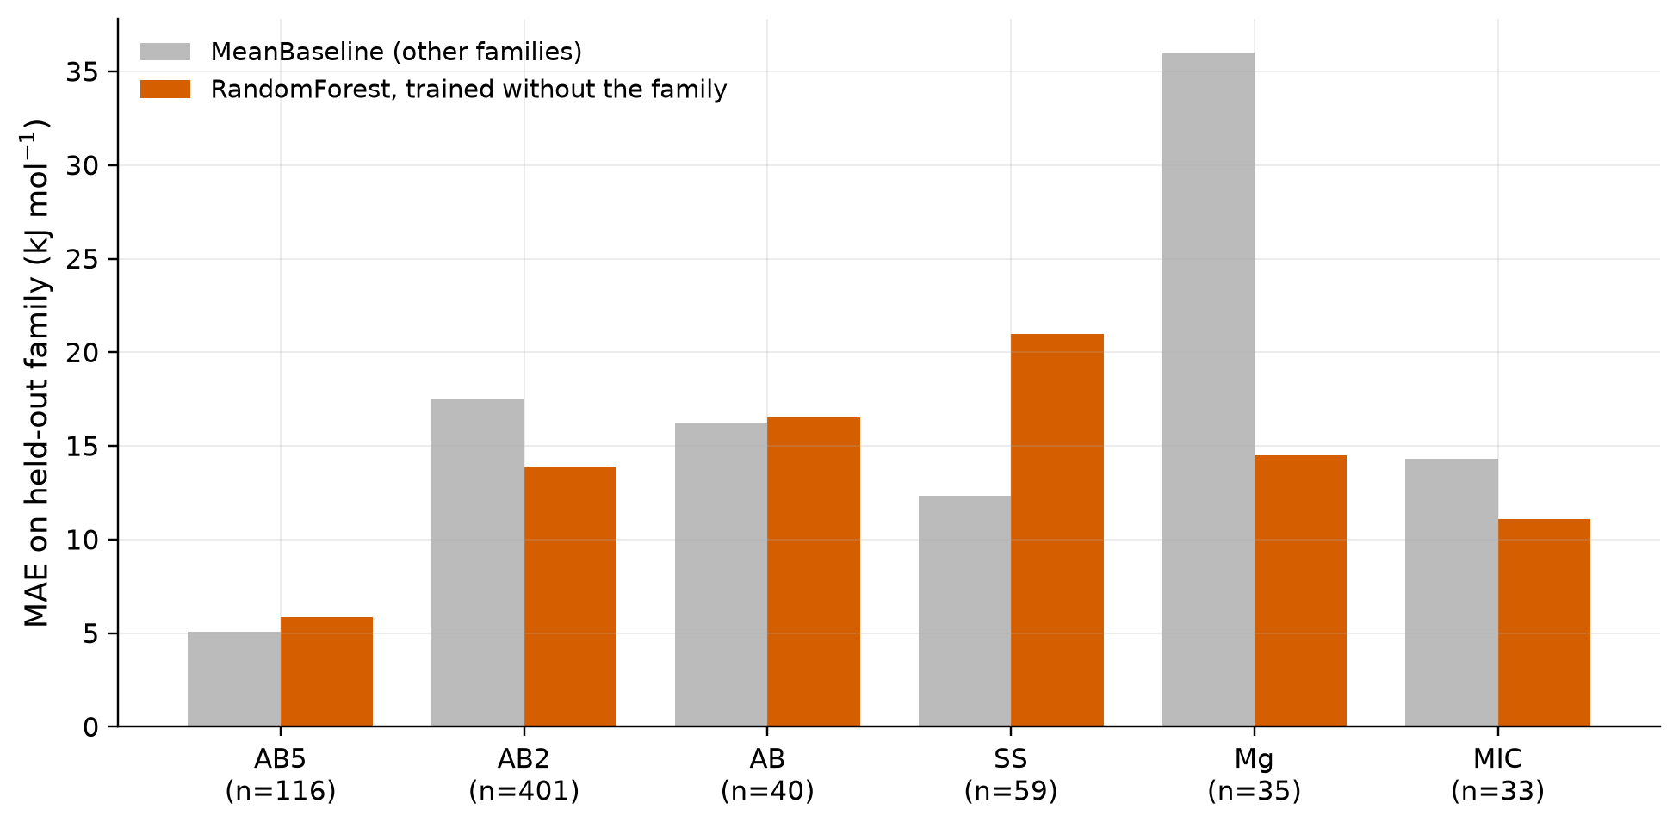
Figure 4.3: Leave-one-family-out MAE of the random forest (orange) and of the mean of the other families (grey).

4.6 Applicability domain and prediction intervals
Because the error depends so strongly on the distance to the training data, every prediction carries a distance and an interval. The distance d_{NN} is the L1 distance between the atomic-fraction vector of the query and that of the nearest training composition. For calibration, each out-of-fold prediction was paired with its distance to the nearest training composition outside its own cross-validation group, and the residuals were binned by that distance (Table 4.5, Fig. 4.4). The MAE rises steadily, from 2.62 kJ mol⁻¹ for d_{NN} ≤ 0.05 to 16.9 kJ mol⁻¹ for d_{NN} > 0.5.
Table 4.5: Calibration of the out-of-fold error against the distance to the nearest training composition (random forest)
d_{NN} (L1) | n | MAE (kJ mol⁻¹) | Median abs. error | 10% residual quantile | 90% residual quantile
≤ 0.05 | 219 | 2.62 | 1.53 | −2.95 | 4.34
0.05–0.10 | 220 | 4.22 | 2.80 | −5.76 | 6.36
0.10–0.15 | 94 | 4.63 | 3.41 | −7.04 | 7.23
0.15–0.20 | 86 | 6.14 | 4.44 | −7.81 | 10.7
0.20–0.30 | 27 | 6.88 | 5.41 | −13.8 | 5.67
0.30–0.50 | 57 | 12.9 | 5.82 | −32.2 | 8.28
> 0.50 | 22 | 16.9 | 9.16 | −22.3 | 23.7

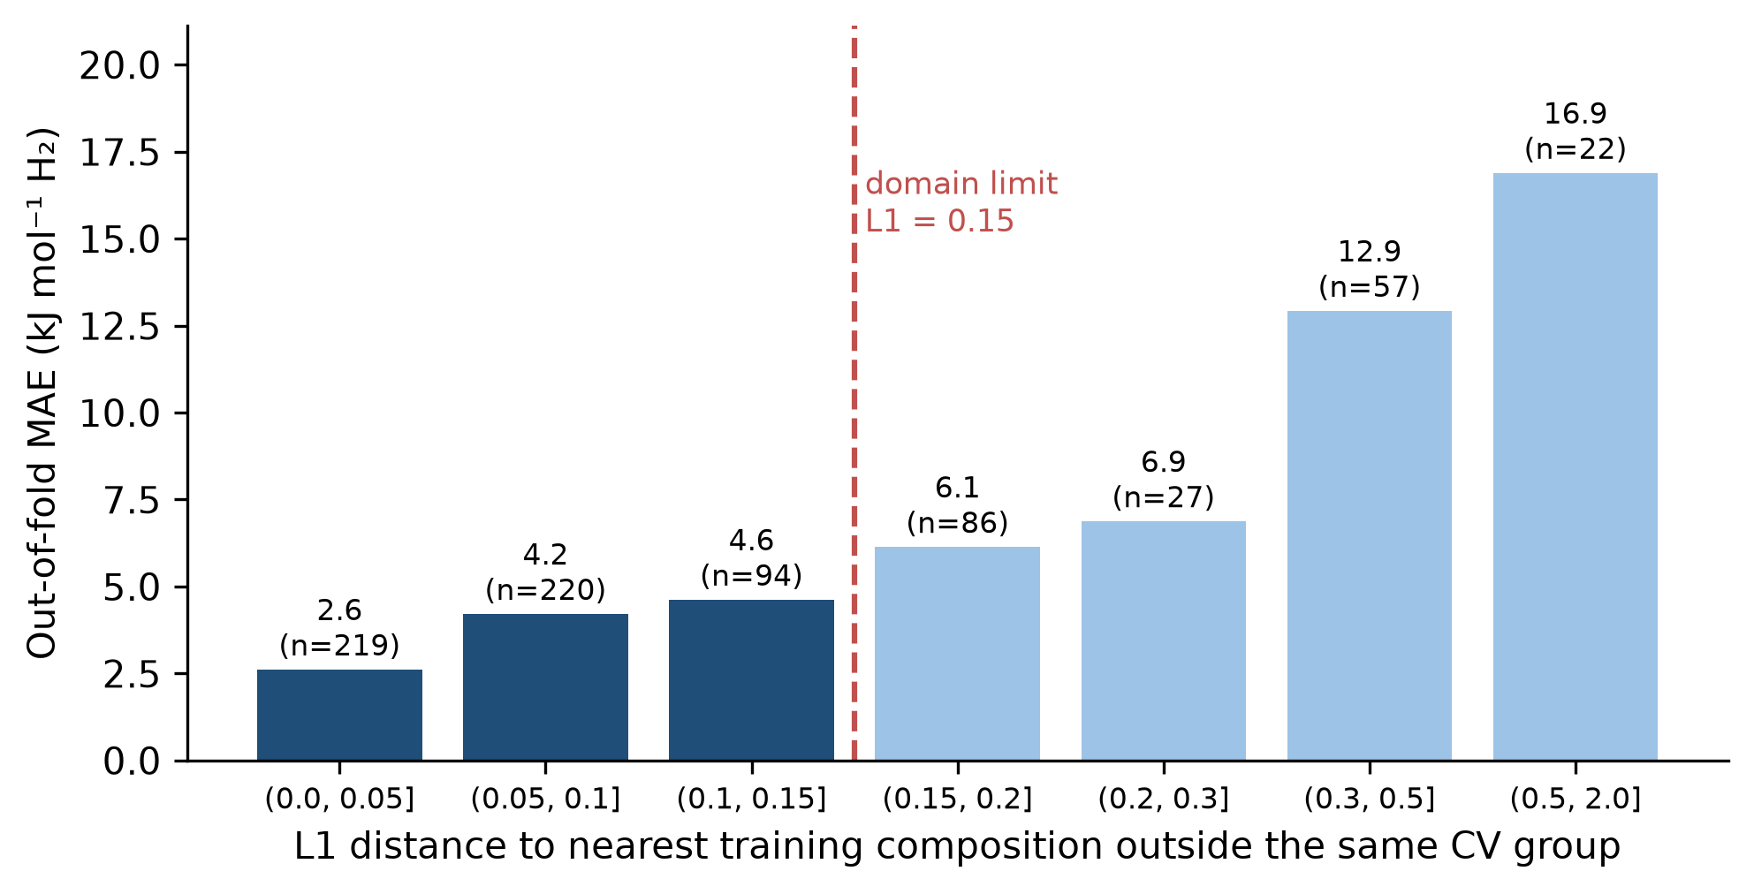
Figure 4.4: Out-of-fold MAE against the L1 distance to the nearest training composition outside the same CV group (data from Table 4.5). Compositions beyond d_{NN} = 0.15 are flagged as outside the applicability domain.
Two rules follow from the calibration. First, the 80% prediction interval of a new composition is the predicted value plus the 10% and 90% residual quantiles of its distance bin. Second, compositions with d_{NN} > 0.15 are flagged as outside the applicability domain: beyond that point the MAE exceeds 6 kJ mol⁻¹ and grows quickly. As a check, for the 22 compositions of four substitution series (Chapter 5) that also have experimental values, the mean absolute difference between the out-of-fold prediction and the experiment is 1.91 kJ mol⁻¹, and 91% of the experimental values fall inside the nominal 80% interval. The intervals are empirical and conditional on the training data. They describe typical errors in each distance bin and are not guarantees for an individual composition.

4.7 What the model uses
Permutation importance on the hold-out set (Fig. 4.5) measures how much the hold-out MAE increases when one descriptor is shuffled. The three most important descriptors are the mean molar volume (3.57 kJ mol⁻¹ increase), the fraction of hydride-forming atoms (2.10) and the spread of the valence-electron count (1.31). The first is a proxy for interstitial-site size, the hole-size effect of Lundin et al. [17], and agrees with the volume-based descriptor reported by Witman et al. [9]. The second encodes the A:B stoichiometry, and the third is an electronic descriptor. Because many descriptors are correlated, importance is shared between them, so the ranking describes the model rather than causation.
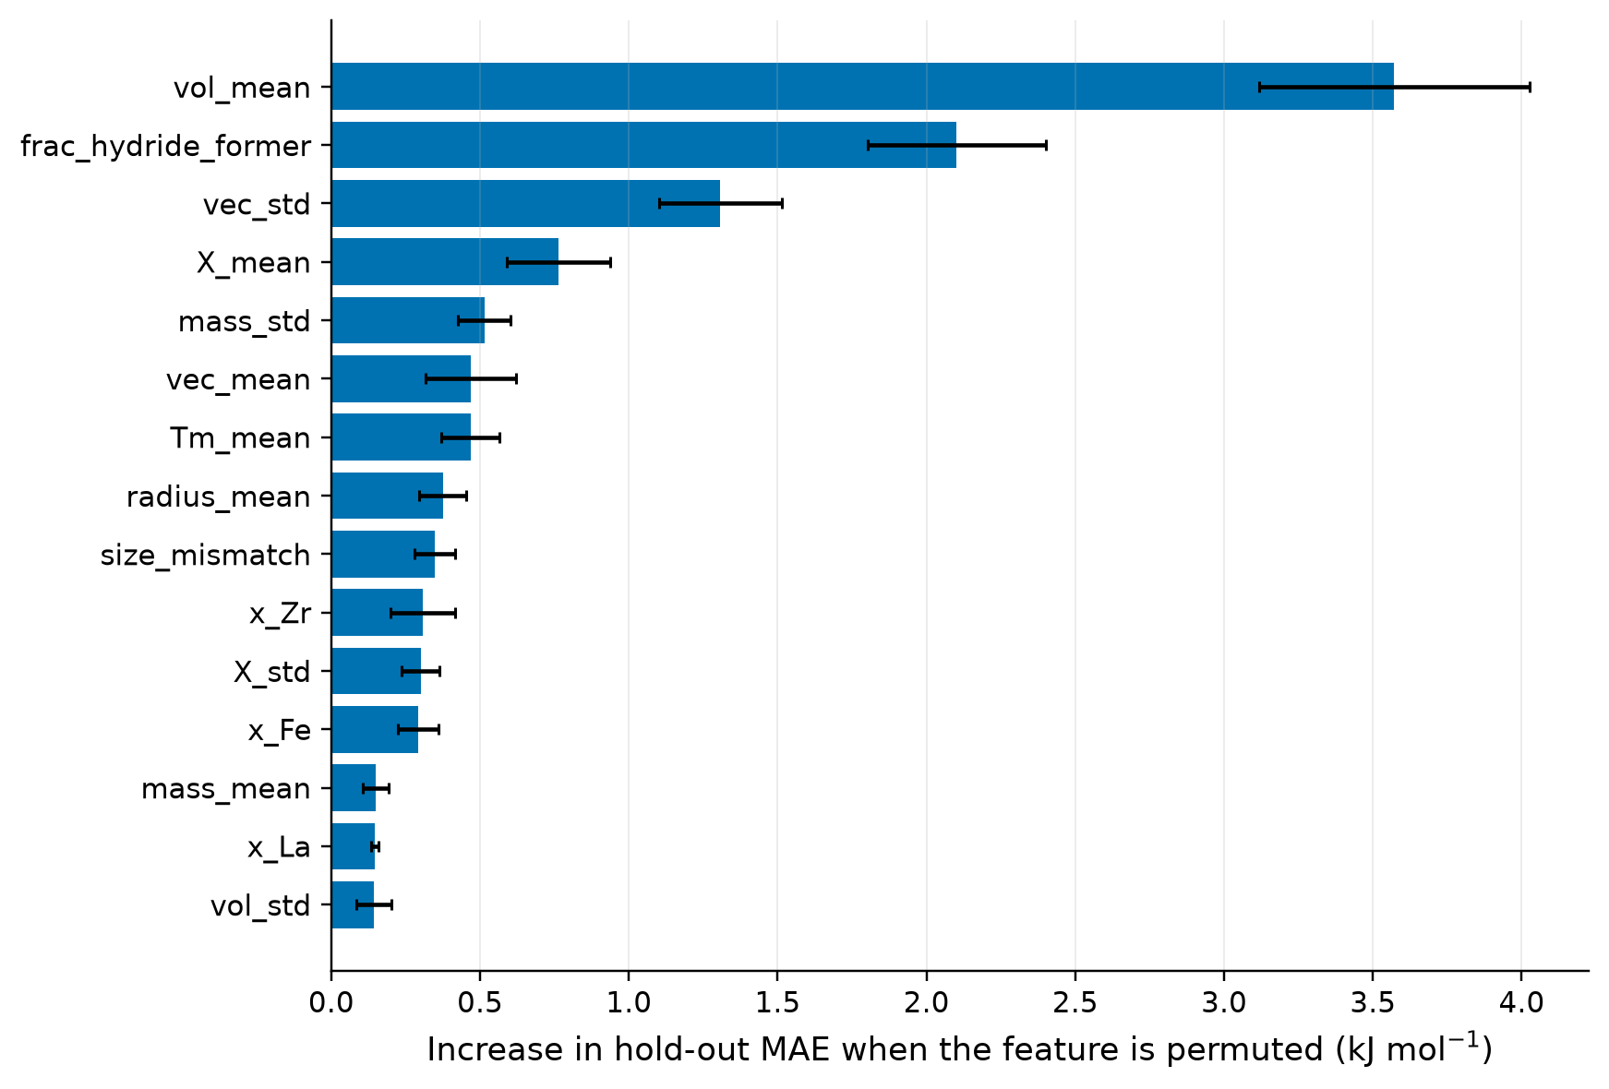
Figure 4.5: Permutation importance of the 15 most important descriptors (increase in hold-out MAE when the descriptor is permuted; error bars: sd over repeats).

4.8 Sensitivity to data quality, and the capacity model
Refitting on data subsets shows that part of the error comes from the data. On a high-confidence subset of 456 compositions (referenced, typical ΔS, metals only) the RF MAE falls to 3.51 kJ mol⁻¹. Excluding very stable hydrides (ΔH > 60 kJ mol⁻¹) gives 4.08 (Appendix B).
A secondary model for gravimetric capacity was also tested on the 181 Purdue records with a stated wt%. Its best MAE, 0.247 wt%, is only slightly better than a physics baseline (0.286 wt%) that fixes H per metal atom at the family median and converts it with the alloy's mean atomic mass. With narrow capacity ranges and non-uniform definitions, this model mostly rediscovers that heavier alloys hold a smaller weight fraction. It is reported but not used; wherever capacity appears later, it is the value reported in the literature.

4.9 Final model and deployment
The final model is the random forest refitted on all 725 compositions with the same grid, saved together with its feature list. For the software platform (Chapter 6) it was packaged unchanged, with the training compositions, the calibration table and the entropy assumption, into a single bundle. A manifest records the SHA-256 hashes of the model files and the package versions. The model was not retrained or modified after validation.

Chapter 5
Thermodynamic Analysis

5.1 Method and a worked example
All operating windows in Sections 5.2–5.5 use the experimental ΔH and ΔS from the Purdue files. Predicted values appear only in Section 5.6, where they are labelled as estimates. The calculations use Eq. (2.2) with P₀ = 1 atm, the convention of both datasets, and R = 8.314462618 J mol⁻¹ K⁻¹. Pressures are converted to bar, the temperature at a pressure follows from Eq. (2.3), and the heat from Eq. (2.4), expressed also as a fraction of the lower heating value of hydrogen (119.96 MJ kg⁻¹).
For LaNi₅ (ΔH = 32.15 kJ mol⁻¹, ΔS = 112.8 J mol⁻¹ K⁻¹) at 298.15 K,
ln(P_{eq} / atm) = − 32 151 / (8.314 × 298.15) + 112.8 / 8.314 = 0.597, (5.1)
so P_{eq} = 1.817 atm = 1.84 bar. The pressure reaches 1 bar at 11.6 °C, and desorption needs 32.15 / 2.01588 = 15.95 MJ per kg of H₂, which is 13.3% of the LHV. The same amount of heat is released on absorption and has to be removed during refuelling.

5.2 Representative materials
Table 5.1 and Fig. 5.1 show the results for fourteen representative materials and reaction steps.
Table 5.1: Van't Hoff results for representative materials (experimental Purdue ΔH and ΔS, desorption)
Material | ΔH (kJ mol⁻¹) | ΔS (J mol⁻¹ K⁻¹) | P(25 °C) (bar) | T(1 bar) (°C) | T(10 bar) (°C) | Q (MJ kg⁻¹ H₂) | Q / LHV (%)
LaNi₅ | 32.2 | 113 | 1.84 | 11.6 | 69.7 | 15.9 | 13.3
MmNi_{4.5}Al_{0.5} | 30.5 | 107 | 1.83 | 11.1 | 72.8 | 15.1 | 12.6
CaNi₅ | 29.7 | 92.9 | 0.449 | 46.3 | 129 | 14.7 | 12.3
TiFe | 28.1 | 106 | 4.16 | −8.3 | 50.0 | 13.9 | 11.6
TiFe_{0.9}Mn_{0.1} | 27.6 | 100 | 2.58 | 1.6 | 66.2 | 13.7 | 11.4
TiCrMn (Ti_{1.01}Cr_{1.06}Mn) | 21.8 | 112 | 107.5 | −78.5 | −38.4 | 10.8 | 9.0
Hydralloy C2 (Ti–Mn–V–Fe AB₂) | 30.0 | 121 | 11.8 | −25.4 | 21.1 | 14.9 | 12.4
TiMn_{1.5} | 28.7 | 114 | 8.56 | −21.6 | 29.1 | 14.2 | 11.9
ZrMn₂ | 53.2 | 121 | 0.00101 | 166 | 249 | 26.4 | 22.0
V_{0.855}Ti_{0.095}Fe_{0.05} (BCC) | 43.2 | 140 | 0.562 | 35.2 | 84.0 | 21.4 | 17.9
Mg₂Ni | 64.5 | 122 | 1.2 × 10⁻⁵ | 255 | 353 | 32.0 | 26.7
MgH₂ | 78.3 | 136 | 2.5 × 10⁻⁷ | 302 | 396 | 38.8 | 32.4
NaAlH₄, Na₃AlH₆ → NaH step | 47.0 | 126 | 0.0225 | 99.5 | 166 | 23.3 | 19.4
NaAlH₄, NaAlH₄ → Na₃AlH₆ step | 37.0 | 122 | 0.787 | 29.9 | 86.2 | 18.4 | 15.3

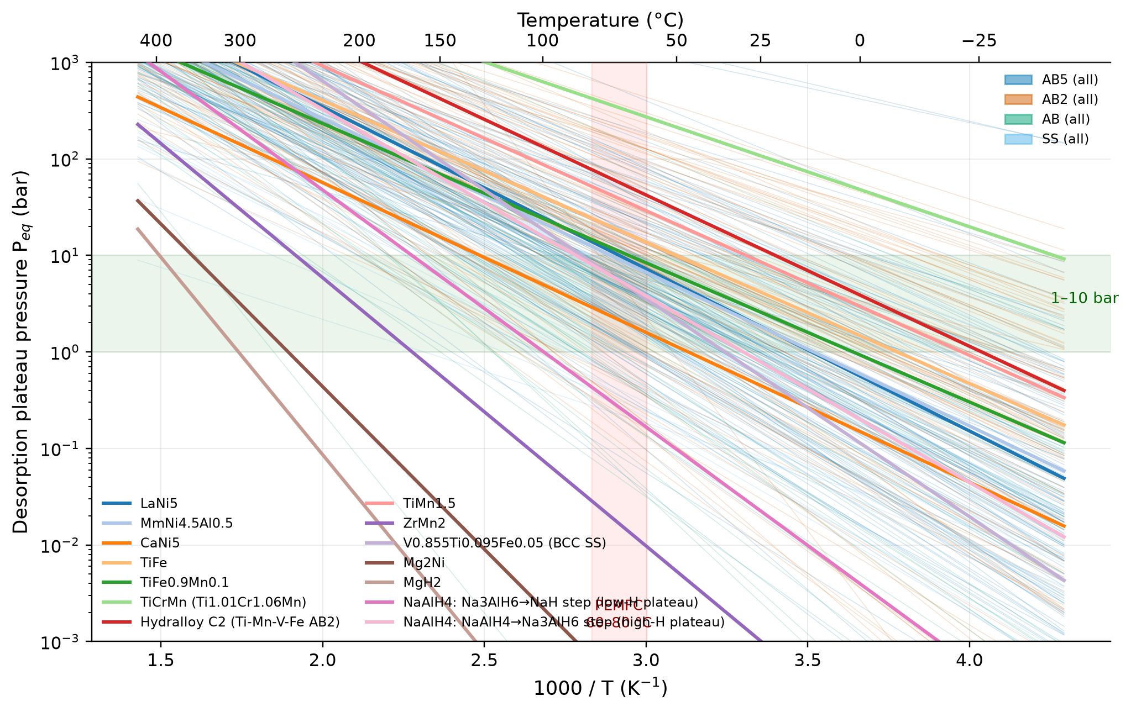
Figure 5.1: Van't Hoff lines of the representative materials (bold) over all single-plateau AB₅, AB₂, AB and SS Purdue materials (faint, coloured by family). The green band marks 1–10 bar and the red band PEM fuel-cell waste-heat temperatures.
The materials fall into four groups. LaNi₅, MmNi_{4.5}Al_{0.5}, TiFe and TiFe_{0.9}Mn_{0.1} deliver 1–10 bar between about −10 and 75 °C and need 14–16 MJ kg⁻¹ H₂ (11–13% of the LHV), which PEM fuel-cell waste heat can supply. TiCrMn and Hydralloy C2 are high-pressure alloys (about 12–108 bar at 25 °C); they suit low-temperature operation or compressor stages and need a pressure-rated vessel. ZrMn₂ and the V-based BCC alloy need 35–170 °C. Mg₂Ni and MgH₂ need 255–300 °C and 32–39 MJ kg⁻¹ H₂, which is 27–32% of the energy content of the stored hydrogen. NaAlH₄ is discussed in Section 5.5.

5.3 Whole-database view
Table 5.2 applies the same calculation to the 318 single-plateau Purdue materials with a typical ΔS. Most of them operate close to ambient conditions: 85% reach 1 bar at or below 80 °C, and 83% stay at or below 10 bar at 25 °C. Only 7 (2%) need more than 150 °C.
Table 5.2: Operating criteria met by the 318 single-plateau Purdue materials with typical ΔS
Criterion | Materials | Share
T(1 bar) ≤ 25 °C (desorption at ambient temperature) | 168 | 53%
T(1 bar) ≤ 80 °C (PEMFC waste heat suffices) | 271 | 85%
P(25 °C) ≤ 10 bar | 263 | 83%
P(50 °C) ≤ 30 bar | 270 | 85%
1 ≤ P(25 °C) ≤ 10 bar | 113 | 36%
T(1 bar) > 150 °C | 7 | 2%

Because T(1 bar) ≈ ΔH/ΔS and ΔS varies little, heat demand and operating temperature are tied together (Fig. 5.2). Among materials that release hydrogen at 1 bar with heat at 80 °C or below, the median reaction heat is 15.1 MJ kg⁻¹ H₂ (12.6% of the LHV), and 95% have ΔH ≤ 41.9 kJ mol⁻¹ and Q ≤ 20.8 MJ kg⁻¹. Materials that need more than 80 °C have a median of 22.4 MJ kg⁻¹ (18.7%). The few exceptions, with ΔH up to 50 kJ mol⁻¹, combine high ΔH with an unusually high ΔS. Low-temperature operation and low heat demand therefore come together, but so do low stability and, for these intermetallics, low capacity.
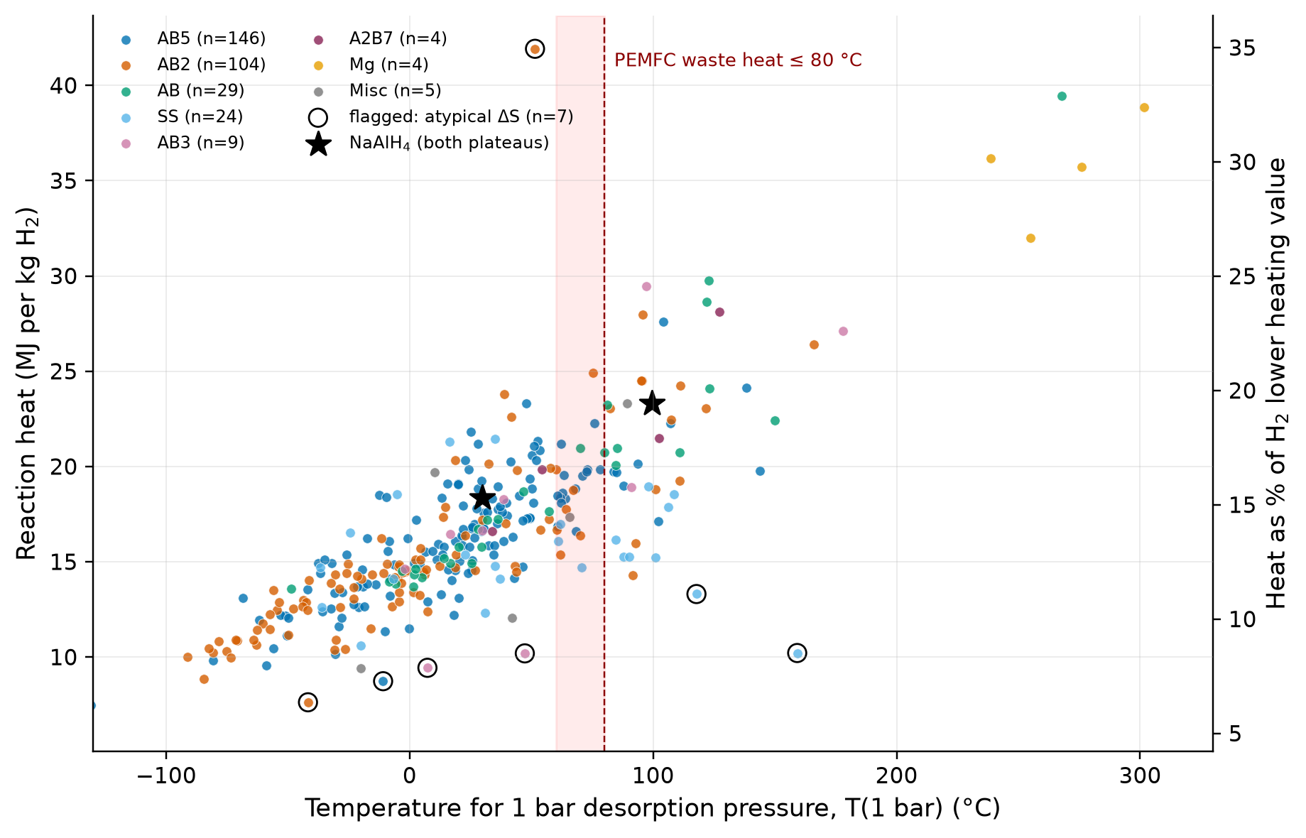
Figure 5.2: Reaction heat against the temperature for 1 bar desorption pressure for all Purdue plateaus. Circles mark atypical ΔS; stars mark the two NaAlH₄ plateaus.

5.4 Hysteresis and plateau slope
Absorption data are stated for 82 materials, and 41 more state a constant hysteresis. In all of them P_{abs} ≥ P_{des}, so no inconsistent record was found. The median ratio P_{abs}/P_{des} at 25 °C is 1.73 for materials with absorption ΔH and ΔS, and 1.34 for those with a stated constant. For TiFe the charging pressure is about 1.9 times the desorption pressure, which raises compressor work. The largest ratio, 40.7 for MgH₂, is an extrapolation of lines measured near 300 °C, not a statement about MgH₂ at room temperature. Where both absorption and desorption lines are given, they cross at a median of 499 K (interquartile range 429–597 K); above this temperature the hysteresis vanishes.
Plateau slopes are stated in 103 files. With the toolbox's model, ln P(x) = ln P_{mid} + slope · (298/T) · (x − 0.5), the pressure at 10% of the capacity is a median of 1.75 times lower than at 90% (interquartile range 1.33–2.76, maximum 24.5). A sloped AB₂ alloy thus delivers its last hydrogen at a pressure several times lower than its first.

5.5 Consistency with the digitised isotherms
The 68 PCI files contain 311 curves (126 absorption, 185 desorption; 5306 points). Fig. 5.3 shows five representative materials. LaNi₅ shows a flat plateau and small hysteresis; its desorption plateau rises by a factor of 3.2 between 273 and 298 K in the digitised curves, against 3.3 from the tabulated ΔH and ΔS. The Ti–Zr–Mn–V–Fe AB₂ alloy has the highest capacity of the intermetallics shown (about 1.9 wt%), a strongly sloped plateau and clear hysteresis. MgNi_{0.02} reaches about 7 wt%, but only at 547–653 K.
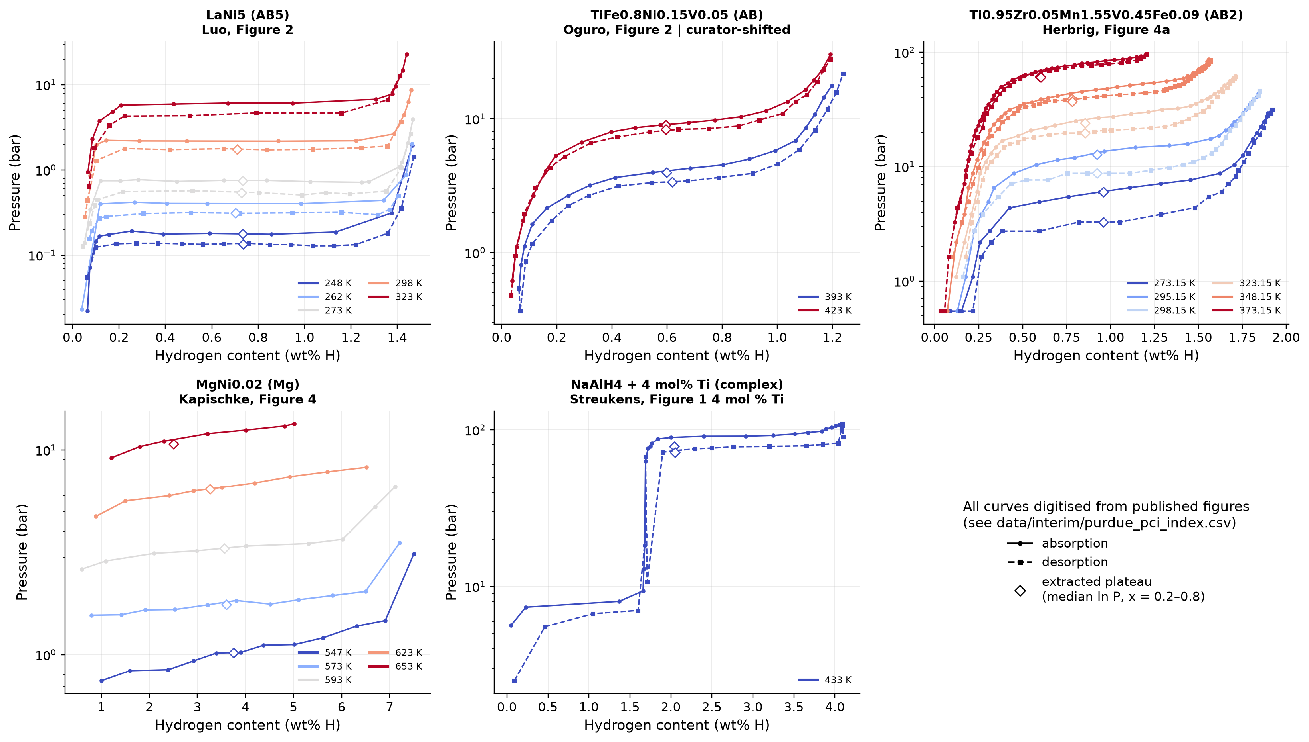
Figure 5.3: Digitised pressure–composition isotherms of five representative hydrides (data from the Purdue PCI files; diamonds mark the extracted plateau pressures).
The Ti-doped NaAlH₄ isotherm at 433 K shows two plateaus in one curve. It is a direct check of which tabulated step belongs to which plateau. The low-hydrogen plateau (6.1 bar in the curve) matches the 47 kJ mol⁻¹ step, Na₃AlH₆ → NaH, which predicts 8.27 bar (ratio 0.74). The high-hydrogen plateau (77.8 bar) matches the 37 kJ mol⁻¹ step, NaAlH₄ → Na₃AlH₆, which predicts 82.2 bar (ratio 0.95). The reverse assignment would be wrong by a factor of about ten. The practical result is that only the first step releases hydrogen near 30 °C; using all of the reported 3.9 wt% requires about 100 °C.
Plateau pressures were extracted from 228 curves as the median pressure between 20% and 80% of the maximum hydrogen content, and Van't Hoff lines were fitted for each material and mode with at least three temperatures. For the 34 single-plateau fits with a tabulated value, the median absolute difference from the .mh ΔH is 1.76 kJ mol⁻¹, and 53% agree within 2 kJ mol⁻¹. This is a consistency check, not an independent validation: for 32 of the desorption fits, the toolbox authors had derived the tabulated value from these same curves. The largest differences, up to 14 kJ mol⁻¹, occur for strongly sloped AB₂ and AB plateaus, where the fixed 20–80% window and the toolbox's sloped-plateau fit pick different pressures.

5.6 Estimates for new compositions
For compositions without experimental data, an operating window can only be estimated. ΔH is the model prediction with its calibrated 80% interval, and ΔS is assumed to be the median experimental value of the family. Fig. 5.4 shows such estimates for four substitution series: LaNi_{5−x}Al_{x}, LaNi_{5−x}Sn_{x}, TiFe_{1−x}Mn_{x} and TiCr_{2−x}Mn_{x}. For compositions already in the data, the out-of-fold prediction is shown, so the model never saw that composition.
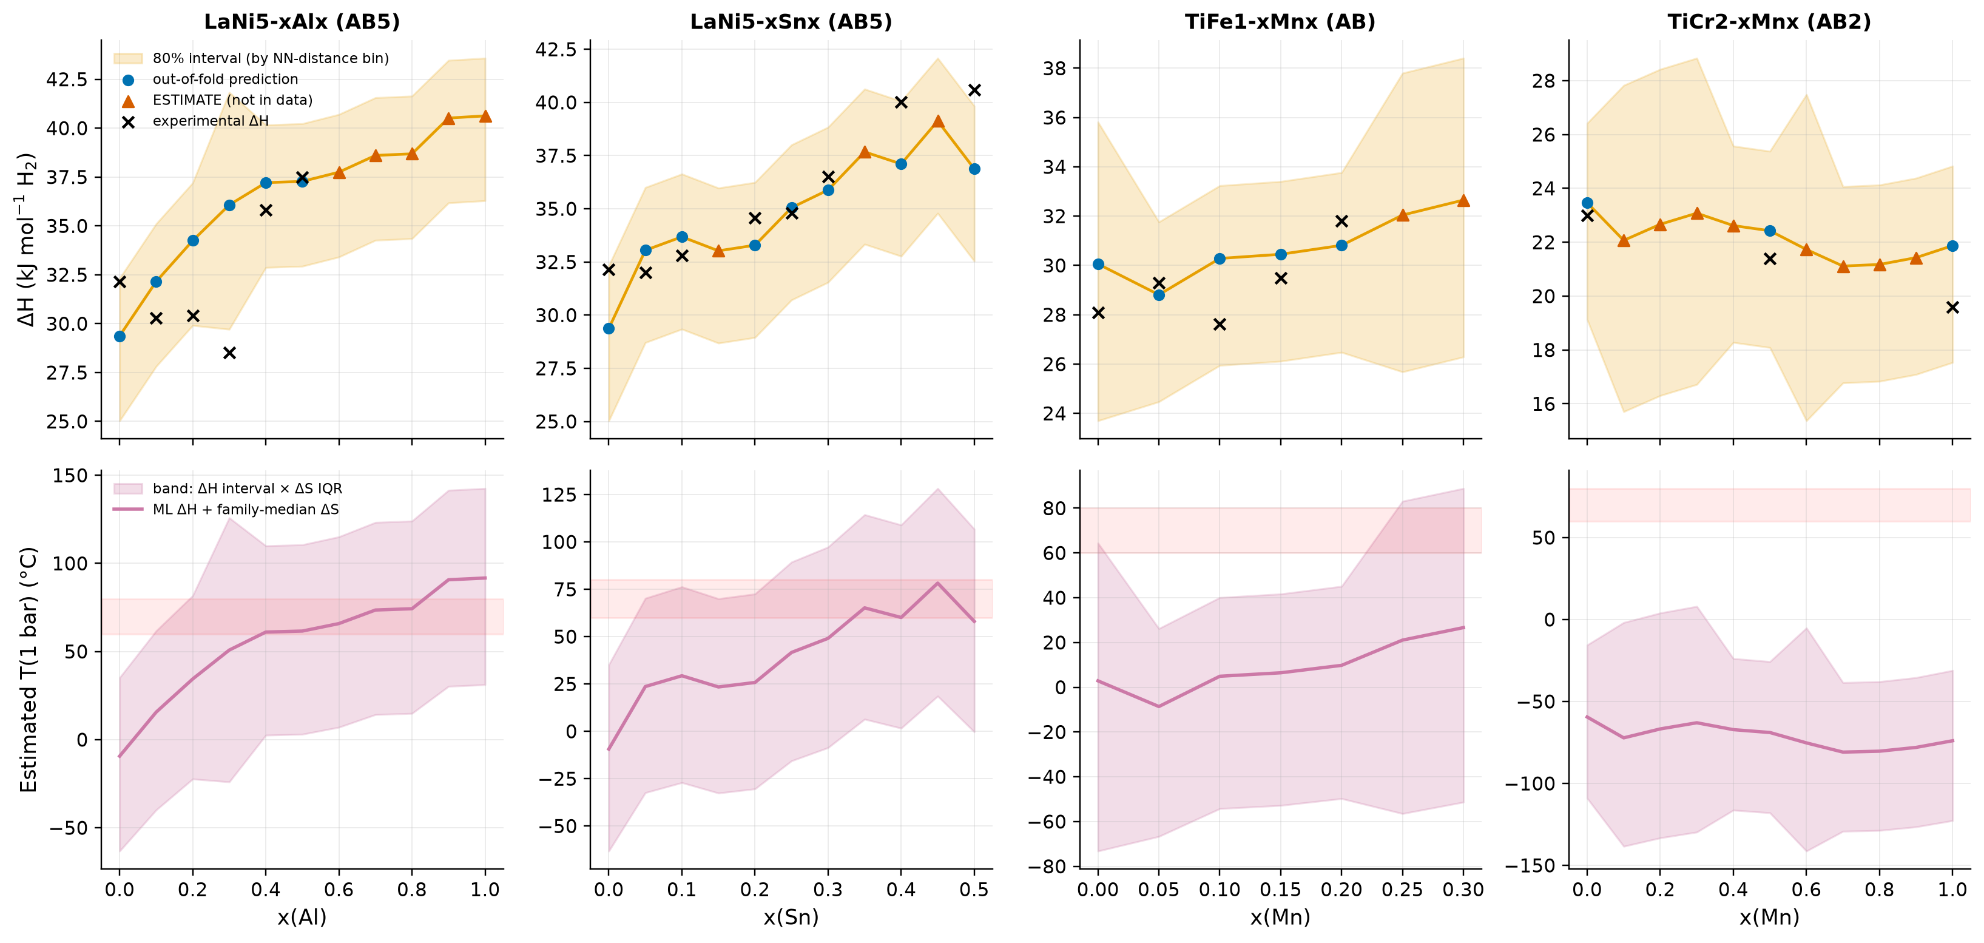
Figure 5.4: Estimated (not validated) ΔH and T(1 bar) along four substitution series. Top: predicted ΔH with the 80% interval (band) and experimental values (crosses). Bottom: the implied temperature for 1 bar, using the assumed family-median ΔS; the band combines the ΔH interval with the interquartile range of ΔS.
The model reproduces the known trends. Al and Sn substitution in LaNi₅ stabilise the hydride, and Mn in TiCr₂ lowers ΔH slightly. All 18 new compositions lie inside the applicability domain (largest d_{NN} 0.09), because the series were chosen close to existing data. The resulting bands of T(1 bar) are about 105 K wide; about 65 K comes from the ΔH interval and about 35 K from the assumed ΔS. For LaNi_{4.2}Al_{0.8}, for example, the prediction is ΔH = 38.7 kJ mol⁻¹ (80% interval 34.3–41.6), and the estimated T(1 bar) is 74 °C, with a band of 15–124 °C. An ML estimate can therefore rank candidates, for example "more stable than LaNi₅", but fixing an operating window needs a PCT measurement, which gives ΔH and ΔS directly.

5.7 Kinetics
The Purdue files contain 31 absorption and 26 desorption kinetic records. For the 47 records that use the same rate law, the median absorption activation energies are 31 kJ mol⁻¹ for AB₅ and 24 kJ mol⁻¹ for AB₂, against 92 kJ mol⁻¹ for Ti-doped NaAlH₄ and 132 kJ mol⁻¹ for MgH₂. This ordering agrees with Mg-based and complex hydrides being kinetically limited [12, 14]. However, the modelled time to 90% conversion at 25 °C spans seven orders of magnitude within the comparable group. The fitted pre-factors depend on the test reactor, particle size, activation and heat-transfer conditions of each study. The kinetic data are therefore used only as a qualitative, family-level class in the screening, never to rank individual materials.

Chapter 6
Application-Specific Screening and Software Platform

6.1 Screening principles
The screening turns the thermodynamic results of Chapter 5 into a ranked list of materials for a stated requirement. Four principles were applied throughout.
1. Experimental data first. Screening uses the 337 Purdue materials with their experimental ΔH and ΔS. ML predictions are evaluated separately and never mixed into the ranking of experimental materials.
2. Material level only. Capacity is the reported, material-level value, whose definition varies. A real store adds a vessel, a heat exchanger and bed porosity, so its system capacity is considerably lower. The DOE system target of 5.5 wt% [5] is shown only for orientation.
3. Missing is not failing. A constraint is evaluated as pass, fail, unknown (the material value is missing) or not specified (no requirement given). A material is rejected only on an evaluated failure; missing evidence is reported and never counts against it.
4. Transparent and tested choices. Constraints, criteria and weights are listed in the output, and the rankings are tested for sensitivity to the weights and thresholds.

6.2 Mobile and stationary screening of the experimental materials
The first screen compares two generic applications. A data-quality gate removes records with an atypical ΔS (outside 70–170 J mol⁻¹ K⁻¹) or an assumed or unconfirmed capacity. Hard constraints then encode the engineering limits of each application (Table 6.1). For multi-plateau materials, the most stable plateau is used for T(1 bar), because the full capacity is needed, and the highest-pressure plateau for the pressure limits.
Table 6.1: Hard constraints of the mobile and stationary screens
Application | Constraint | Engineering reason
both | 70 ≤ ΔS ≤ 170 J mol⁻¹ K⁻¹; capacity not assumed or unconfirmed | data-quality gate
mobile | T(1 bar, full capacity) ≤ 80 °C | desorption with PEM fuel-cell waste heat (stack at 60–80 °C)
mobile | P(50 °C) ≤ 50 bar | moderate tank pressure on a hot day
mobile | charging pressure at 25 °C ≤ 100 bar | refuelling without very high compression
stationary | T(1 bar, full capacity) ≤ 150 °C | low-grade industrial, electrolyser or boiler heat
stationary | P(25 °C) ≤ 10 bar | low-pressure storage at room temperature
stationary | P(50 °C) ≤ 30 bar | warm-day pressure limit
stationary | charging pressure at 25 °C ≤ 30 bar | direct filling from a PEM electrolyser (30 bar delivery assumed)

Materials that pass are scored on criteria normalised to 0–1 among the passing materials: reported capacity, reaction heat, a family-level kinetics class (AB₅, AB₂, AB, AB₃ = 1; complex = 0.25; Mg = 0; families without data = 0.5 and flagged), hysteresis (missing = 0.5, neutral), pressure fit (1 for 1–10 bar at 25 °C, falling to 0 one decade outside), pressure safety (stationary only) and a qualitative cost class. The cost class is an element indicator, not a price model: common metals score 1; rare earths, mischmetal, Co, V and minor metals 0.5; precious metals 0. The weights reflect the applications (Table 6.2). Mobile use emphasises capacity and heat, and stationary use emphasises cost, low pressure and cycling loss.
Table 6.2: Criterion weights of the mobile and stationary screens (each column sums to 1)
Criterion | Mobile | Stationary
capacity | 0.35 | 0.10
reaction heat | 0.20 | 0.10
kinetics class | 0.15 | 0.10
hysteresis | 0.10 | 0.15
pressure fit | 0.10 | 0.10
cost class | 0.10 | 0.25
pressure safety | – | 0.20

Of the 337 materials, 319 pass the data-quality gate; 232 pass all mobile constraints and 252 all stationary constraints (Fig. 6.1). The mobile screen rejects 56 materials whose T(1 bar) is too high and 35 whose pressure at 50 °C is too high. The stationary screen rejects mainly materials with too high a pressure: 57 at 25 °C and 51 at 50 °C. No Mg-based material passes either screen, because all need well over 150 °C.
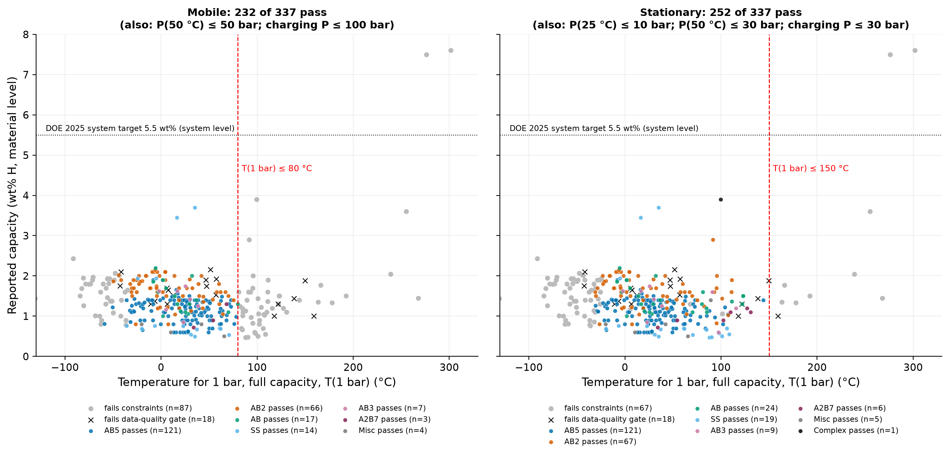
Figure 6.1: Hard-constraint screening of the 337 Purdue materials for mobile (left) and stationary (right) use. Reported material-level capacity against T(1 bar); the grey line marks the DOE 2025 system target, shown for orientation only.
The weights are a judgement, so their influence was tested with 2000 weight vectors drawn from a Dirichlet distribution centred on the base weights (concentration 20), 2000 from a uniform Dirichlet (any weights), one-at-a-time changes (each weight set to zero or doubled) and varied thresholds. The composition of the top group proved robust: Ti-based AB₂ and AB alloys for mobile use, and TiFe-type and Ti–Zr–Mn alloys for stationary use. The leading mobile material stays in the top ten in 88% of the perturbed draws and 72% of the uniform draws. The order within the top group is not robust. The largest one-at-a-time effects are removing the capacity weight for mobile use (Kendall τ = 0.71 against the base ranking) and doubling the pressure-safety weight or removing the cost weight for stationary use (τ = 0.65 each). The rankings should therefore be read as tiers, not as a single winner. The results are presented in Chapter 7.

6.3 Software platform
The model, the thermodynamic functions and the screening were combined into an interactive application, METAL HYDRIDE AI, written in Python with Streamlit. The application computes nothing of its own: every prediction is made live by the saved random forest, and every thermodynamic number comes from the Van't Hoff functions of Chapter 5. Fig. 6.2 shows the architecture: page renderers call engine modules that contain no user-interface code, and the engines read the model bundle and the project data in read-only mode. The application has eight pages: an overview, the Property Predictor, the Candidate Discovery Lab, the Application Requirement Designer, a material comparison, a thermodynamic explorer, a model-performance page that reproduces the validation results of Chapter 4, and a dataset and evidence explorer that shows the overlap, quality flags and missing data of Chapter 3.
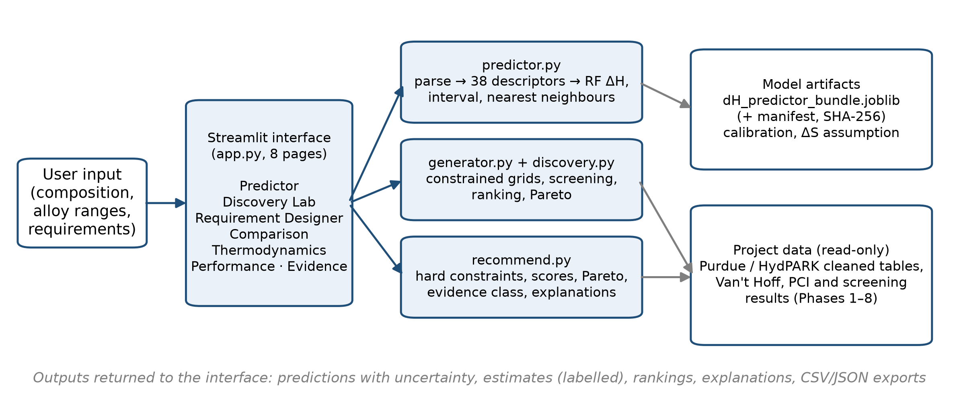
Figure 6.2: Architecture and data flow of the METAL HYDRIDE AI platform.
Property Predictor. A composition typed by the user is converted to the 38 descriptors and passed to the model. The page shows the predicted ΔH with the 80% interval of its distance bin, the distance to the nearest training composition with a domain flag, and the five nearest experimental compositions with their measured ΔH. It warns when the input contains an element absent from the training data, and its Van't Hoff estimate states that ΔS is an assumed family median.
Candidate Discovery Lab. The user chooses an alloy system and composition ranges, either from site templates or as free atomic fractions. Templates are available for TiFe_{1−x}Mn_{x}, Ti–Zr–Mn–Cr and Ti–Cr–Mn Laves phases, La–Ni–Al, La–Ni–Sn and La–Ce–Ni–Al AB₅ alloys, and V–Ti–Cr solid solutions. The generator builds a reproducible grid and removes duplicates. Each candidate is predicted and then rejected with an explicit reason if it contains elements the model has not seen, if it lies outside the applicability domain, or if even the most favourable end of its temperature band misses the target window. The remaining candidates are ranked and their Pareto front is marked. Every output is labelled as a proposed candidate: ΔH is predicted, ΔS is assumed, and capacity is not predicted.
Application Requirement Designer. The user describes an application in seven steps: application type, operating environment, hydrogen requirements, optional engineering constraints, weights, review and results (Fig. 6.3). Five application presets (stationary, mobile, fuel-cell waste-heat integration, industrial buffering and renewable-energy storage) supply default weights. The derived operating conditions follow from the inputs. The highest bed temperature available for delivery is the heat-source temperature if there is a heat source, and otherwise the coldest ambient temperature. The charging temperature is the cooling-water or hottest ambient temperature. The constraints are then evaluated for each experimental material: delivery of the required pressure at the available temperature, maximum pressure on the hottest day, charging pressure (including stated hysteresis), minimum capacity, mass and volume limits, heating power and thermal energy. Cycle life is always "unknown", because no cycle-life data exist.
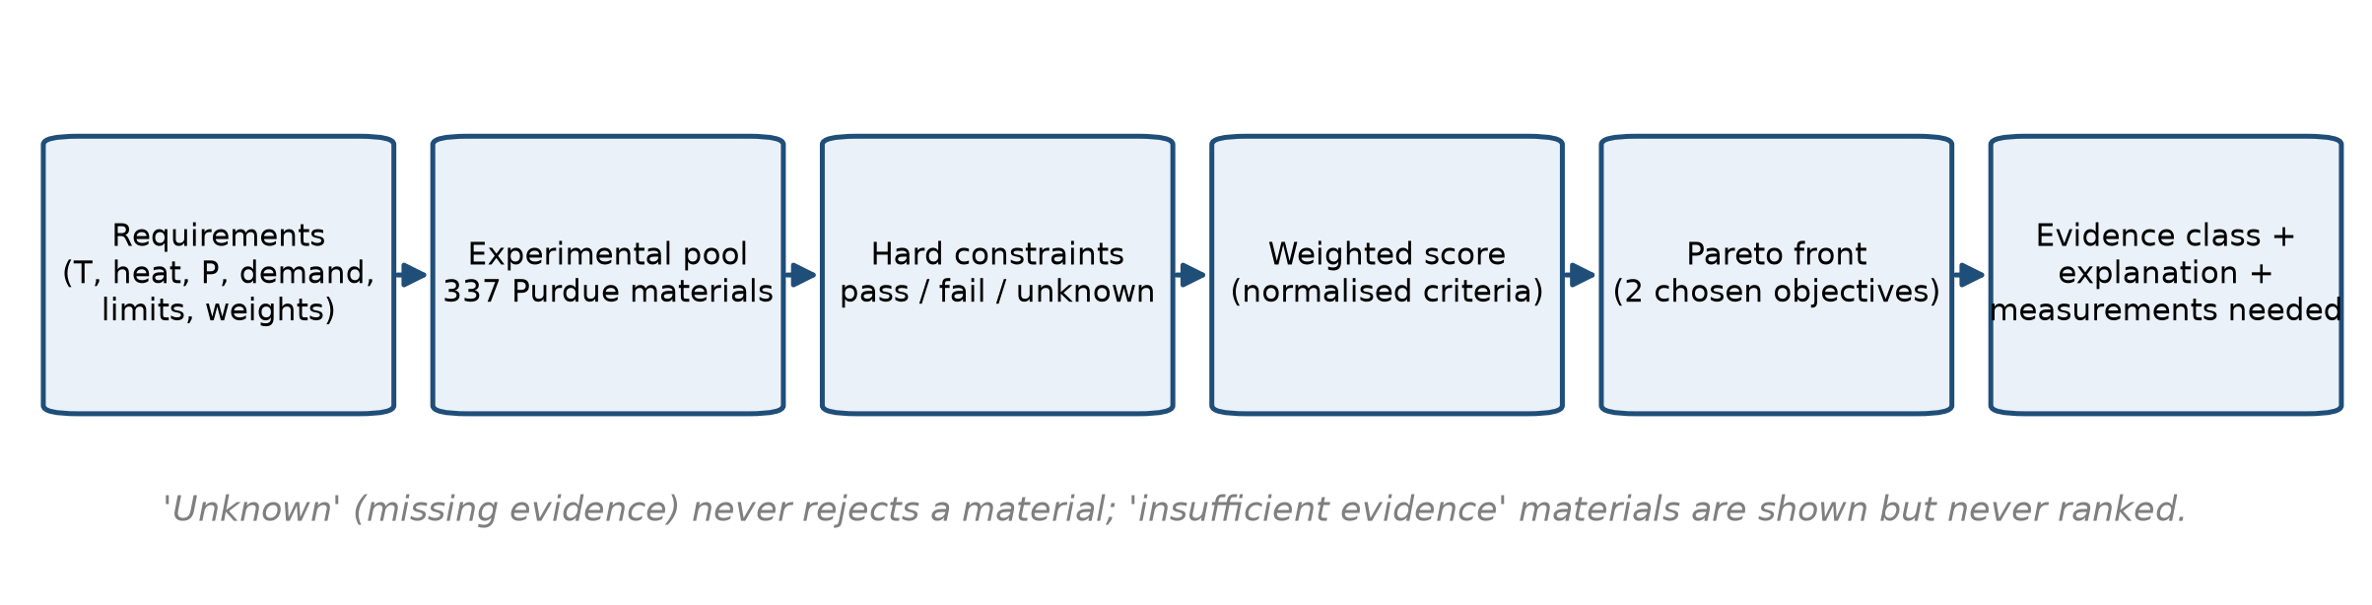
Figure 6.3: Screening workflow of the Application Requirement Designer.
Each material receives an evidence class. Insufficient evidence means that the material fails the data-quality gate; such materials are shown but never ranked. Provisional means that the material passes the gate but carries a caveat: its own PCI curves disagree with the tabulated ΔH by more than 5 kJ mol⁻¹, its reference is an unverified Sandia placeholder, its data are identical to another file, it contains a pseudo-element, or its capacity is approximated, theoretical or first-plateau only. Data-supported means experimental ΔH and ΔS with a literature capacity and none of these caveats. The evidence class enters the score with a weight of 0.1. The Pareto front is computed among the ranked materials on two objectives chosen by the user, by default capacity (maximised) and reaction heat (minimised). For the top material the page states which requirements are met, which could not be evaluated, its main advantages and limitations, and the measurements still needed before use.
Testing and reproducibility. The engines contain no Streamlit code and are covered by 77 automated tests, from parsing and consistency with the training pipeline to constraints, scoring, Pareto fronts, evidence classes, export and a headless run of every page. A review of the demonstration output during this work showed that unranked insufficient-evidence materials could dominate the Pareto front and leave the front among ranked materials empty. The front is now computed among ranked materials only, and a test guards this.

Chapter 7
Results and Discussion

7.1 Data and model
The audit changed the analysis before any model was trained. The HydPARK file contains 772 records, not the roughly 420 previously assumed; the two sources use opposite sign conventions; and the HydPARK entropies are back-calculated. Most Purdue compositions are already in HydPARK, so training on one dataset and testing on the other would have measured memorisation, and using HydPARK's ΔS or P_{eq}(25 °C) as inputs would have leaked the target. Either mistake would have made the model look far better than it is.
On the audited composition-level dataset, the random forest predicts ΔH with an MAE of 5.26 kJ mol⁻¹ under nested grouped cross-validation, 41% below the family-median rule, and the hold-out split confirms this (5.55 kJ mol⁻¹). This accuracy is about 2.4 times the inter-source scatter of the data. It is enough to sort compositions into stability classes but not to set a plateau pressure. The error depends strongly on the distance to the training data: within d_{NN} ≤ 0.05 the MAE is 2.6 kJ mol⁻¹, close to the measurement floor, while beyond 0.5 it is 16.9 kJ mol⁻¹. When a whole family is withheld, the model fails, and for three of six families it is worse than a constant. The model is therefore an interpolation tool for AB₅, AB₂ and related intermetallics, not a way to discover new families, and the platform enforces this with its applicability-domain flag.

7.2 Thermodynamic findings
The Van't Hoff analysis puts numbers on the main trade-off in hydride storage. Because ΔS lies in a narrow range, ΔH sets both the operating temperature and the reaction heat. The materials that release hydrogen at 1 bar with heat at 80 °C or below need a median of 15.1 MJ kg⁻¹ H₂, but they are the transition-metal intermetallics with about 1–2 wt% (Table 2.1). MgH₂ holds 7.6 wt% but needs 302 °C for 1 bar and almost a third of the LHV as heat. No material in the data combines high capacity with near-ambient operation.

7.3 Mobile and stationary rankings
Table 7.1 lists the five highest-ranked materials of the generic mobile and stationary screens of Section 6.2. In the mobile screen, Ti-based AB₂ Laves alloys and a Ti–V–Zr–Mn–Fe–Ni alloy lead, with 1.9–2.2 wt% at the material level, release at 1 bar below 0 °C and need 12.4–13.8 MJ kg⁻¹ H₂. The two highest-ranked AB₂ alloys run at about 19–22 bar at 25 °C, so they need a vessel rated accordingly. The stationary screen favours low-pressure alloys made of common metals: TiFe_{0.9}Al_{0.1}, Ti_{0.9}Zr_{0.1}Mn_{1.4}, TiFe_{0.8}Mn_{0.2} and, further down, CaNi₅ (rank 6). LaNi₅, the textbook reference, passes both screens but ranks only 58th of 232 for mobile use and 66th of 252 for stationary use, because of its modest capacity (1.49 wt%) and the rare-earth cost class. Some of the high-ranked entries carry caveats: the mobile rank-3 alloy has PCI curves that give a ΔH about 11 kJ mol⁻¹ lower than its tabulated value, and the rank-5 alloy cites an unverified reference. These flags are carried in the outputs, and any of these materials would need its own measurement before use.
Table 7.1: Top five materials of the generic mobile and stationary screens (experimental data; reported capacities are material-level values)
Screen | Rank | Material | Family | wt% | T(1 bar) (°C) | P(25 °C) (bar) | Q (MJ kg⁻¹) | Score
Mobile | 1 | Ti_{1.3}Cr_{1.2}Mn_{0.8} | AB₂ | 1.90 | −41.8 | 18.6 | 12.4 | 0.74
Mobile | 2 | Ti_{1.2}CrMn | AB₂ | 2.02 | −44.1 | 22.3 | 12.7 | 0.73
Mobile | 3 | Ti_{0.56}V_{0.3}Zr_{0.1}Mn_{0.94}Fe_{0.06}Ni_{0.04} † | AB | 2.20 | −5.7 | 3.63 | 13.8 | 0.72
Mobile | 4 | Ti_{0.9}Zr_{0.2}Mn_{1.4}Cr_{0.4}Vf_{0.2} ‡ | AB₂ | 2.10 | −7.3 | 3.48 | 12.6 | 0.72
Mobile | 5 | Ti_{0.8}Zr_{0.2}Mn_{1.5}Cr_{0.5} § | AB₂ | 2.00 | −23.1 | 8.44 | 13.6 | 0.71
Stationary | 1 | TiFe_{0.9}Al_{0.1} | AB | 1.30 | 16.8 | 1.41 | 14.9 | 0.73
Stationary | 2 | Ti_{0.9}Zr_{0.1}Mn_{1.4} | AB₂ | 1.91 | 29.7 | 0.80 | 17.2 | 0.72
Stationary | 3 | Ti_{0.5}Zr_{0.5}Mn_{1.2}Fe_{0.3} § | AB₂ | 1.90 | 111 | 0.01 | 24.2 | 0.70
Stationary | 4 | TiFe_{0.8}Mn_{0.2} | AB | 1.30 | 29.4 | 0.83 | 15.8 | 0.70
Stationary | 5 | TiMn_{1.4} † | AB₂ | 1.75 | −4.9 | 3.58 | 14.1 | 0.70

† own PCI curves give a ΔH more than 5 kJ mol⁻¹ different from the tabulated value; ‡ contains ferrovanadium (Vf), whose exact composition is not defined; § unverified Sandia reference.
Two conclusions hold regardless of the exact order. First, no interstitial hydride comes close to the 5.5 wt% system target. With material-level capacities of about 2 wt%, metal hydrides suit uses where volume, pressure and safety matter more than mass. Second, the families that win are different for the two applications, and the reasons are physical: capacity and low heat for mobile use, low pressure and cheap elements for stationary use.

7.4 Requirement-driven scenarios
To show how the Application Requirement Designer responds to a concrete brief, two illustrative scenarios were run with the real engines (Table 7.2). They are examples, not real design briefs.
Table 7.2: Requirements of the two demonstration scenarios (illustrative inputs)
Requirement | Scenario 1: mobile (PEMFC vehicle) | Scenario 2: industrial buffer
Ambient temperature | −10 to 40 °C | 5 to 40 °C
Heat source | PEMFC waste heat, 70 °C, 5 kW | industrial waste heat, 120 °C, 50 kW
Cooling for charging | – | cooling water, 20 °C
Hydrogen stored / flow | 1 kg / 0.5 kg h⁻¹ | 50 kg / 5 kg h⁻¹
Delivery pressure | 3 bar | 5 bar
Maximum / charging pressure | 50 / 100 bar | 30 / 30 bar
Other limits | material mass ≤ 80 kg; capacity ≥ 1.5 wt% | –
Main weights | capacity 0.30, heat 0.20, kinetics 0.15 | kinetics 0.20, pressure fit 0.20, hysteresis 0.15, cost 0.15

In the mobile scenario, 278 of the 337 materials fail at least one hard constraint. The most common failures are the minimum capacity (221 materials), the mass limit (144) and delivery of 3 bar at 70 °C (112). Of the 59 remaining materials, 4 have insufficient evidence and are listed but not ranked, which leaves 55 ranked. In the industrial scenario, 222 materials fail, mostly because their pressure in a 120 °C bed would exceed 30 bar (164 materials); 115 remain, 6 of them with insufficient evidence, so 109 are ranked. Table 7.3 and Fig. 7.1 show the results.
Table 7.3: Top five materials of the two scenarios (all evidence class "data-supported"; temperatures are those needed to deliver the required pressure)
Scenario | Rank | Material | Family | T needed (°C) | wt% | Q (MJ kg⁻¹) | Score
Mobile | 1 | Ti_{0.9}Zr_{0.2}Mn_{1.4}Cr_{0.4}V_{0.2} | AB₂ | 33.1 | 2.10 | 13.2 | 0.64
Mobile | 2 | Ti_{0.9}Zr_{0.2}Mn_{1.8}V_{0.2} | AB₂ | 23.9 | 2.10 | 12.9 | 0.63
Mobile | 3 | V_{0.855}Ti_{0.095}Fe_{0.05} | SS | 56.7 | 3.70 | 21.4 | 0.62
Mobile | 4 | V_{0.8455}Ti_{0.1045}Fe_{0.05} | SS | 35.5 | 3.44 | 21.3 | 0.62
Mobile | 5 | TiCrMn_{0.85}Fe_{0.3}V_{0.15} | AB₂ | −2.3 | 1.60 | 10.4 | 0.61
Industrial | 1 | Ti_{0.9}Zr_{0.1}Mn_{1.4} | AB₂ | 69.8 | 1.91 | 17.2 | 0.87
Industrial | 2 | Zr_{0.7}Ti_{0.3}CrFe | AB₂ | 74.3 | 1.70 | 14.6 | 0.86
Industrial | 3 | TiFe_{0.9}Al_{0.1} | AB | 59.6 | 1.30 | 14.9 | 0.85
Industrial | 4 | TiFe_{0.8}Mn_{0.2} | AB | 73.5 | 1.30 | 15.8 | 0.85
Industrial | 5 | TiFe_{0.9}Ni_{0.1} | AB | 78.3 | 1.40 | 17.2 | 0.84

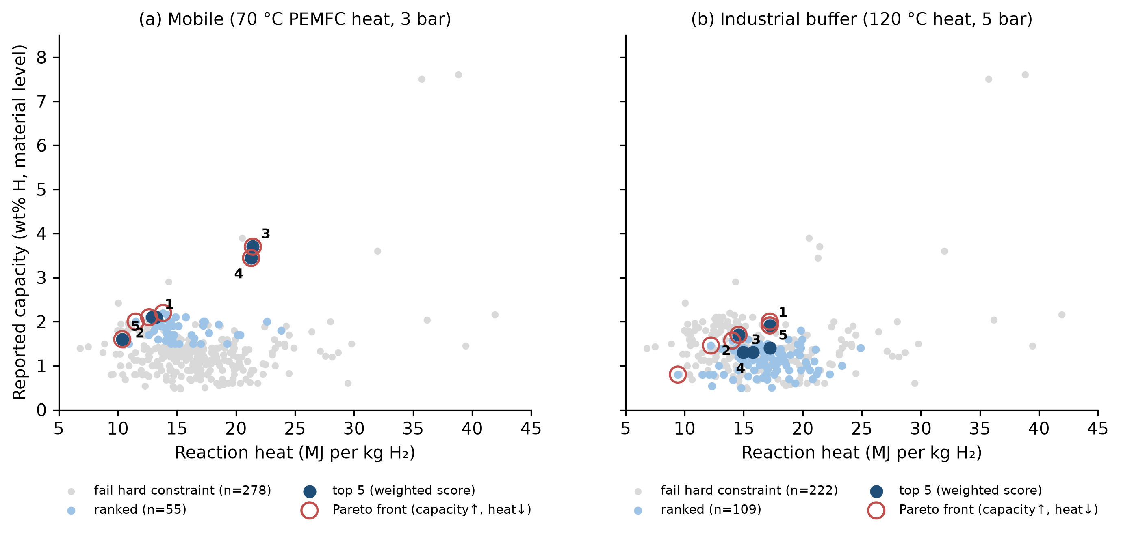
Figure 7.1: Material-level capacity against reaction heat in the two scenarios: materials failing a hard constraint (grey), ranked materials (light blue), the top five (dark blue, numbered) and the Pareto front among ranked materials (red circles).
The two top-five lists have no material in common. The mobile brief rewards capacity at a temperature that 70 °C waste heat can reach. It selects Ti–Zr–Mn AB₂ alloys at about 2.1 wt% and two V-based BCC alloys whose higher capacity (3.4–3.7 wt%) comes with higher heat (21 MJ kg⁻¹); these two lie on the Pareto front. The mobile top material needs about 48 kg of alloy for 1 kg of hydrogen and 1.8 kW of heat at 0.5 kg h⁻¹, within the 5 kW available. The industrial brief accepts more stable hydrides because 120 °C heat is available. Its top five (Ti–Zr–Mn, Zr–Ti–Cr–Fe and TiFe-type alloys) need 60–78 °C to deliver 5 bar, a margin of more than 40 K on the heat source, but storing 50 kg of hydrogen in the top material takes about 2.6 t of alloy: acceptable for a stationary buffer, prohibitive for a vehicle. The industrial ranking is also more robust. When each of the seven weights is removed or doubled in turn (14 cases), the industrial leader stays first in 9 cases and the mobile leader in only 4.

7.5 ML-generated candidates
Each scenario also ran the Discovery Lab on two alloy systems near the training data, separately from the experimental ranking (Appendix D). For the mobile case, 189 Ti–Zr–Mn–Cr compositions were generated; 49 were rejected, mainly for lying outside the applicability domain, and 140 remained inside the domain and the temperature window. The top-scored candidate, Ti_{0.75}Zr_{0.25}Mn_{1.5}Cr_{0.5}, has a predicted ΔH of 28.4 kJ mol⁻¹ (80% interval 24.1–31.4) at d_{NN} = 0.03, close to its nearest known composition (27.5 kJ mol⁻¹). For the industrial case, 143 La–Ce–Ni–Al compositions were generated and 133 retained. The top candidate, La_{0.95}Ce_{0.05}Ni_{4.5}Al_{0.5}, has a predicted ΔH of 36.1 kJ mol⁻¹ (31.8–39.0); with the assumed AB₅ ΔS it would deliver 5 bar at about 95 °C, with a band of 27–154 °C.
These compositions are candidates for measurement, not discoveries. The domain limit keeps them close to known alloys, so their predicted ΔH differs little from that of their neighbours; the entropy behind each temperature is assumed, and no capacity is predicted. They suggest which nearby compositions to synthesise first, each with a stated interval that a PCT measurement can confirm or refute (Section 8.3).

7.6 Critical discussion of limitations
Table 7.4 collects the main limitations, what each implies for the results, and what would be needed to remove it.
Table 7.4: Main limitations of the work and the measurement or data that would address each
Limitation | Consequence for the results | What would address it
No external validation set; the two sources share most values | the CV error is the only estimate of generalisation | an independent set of newly measured compositions
Composition-only descriptors (no structure, C14/C15, microstructure) | ΔH differences between polymorphs and processing routes are invisible | XRD phase data, structure-based descriptors
Model fails on unseen families | no ML screening of Mg-based, complex or new families | data for those families; physics-informed models
ΔS is not predicted, only assumed | T(1 bar) bands of about 105 K for new compositions | PCT isotherms at ≥ 4 temperatures
Capacities of unstated definition, material level only | capacity rankings are indicative; no system capacity | reversible capacity between the application's pressures; system design
Density stated for 37 materials only | volumetric capacity mostly not assessable | density and bed packing measurements
Kinetics and cost only as qualitative classes | no rate or price optimisation | standardised kinetic tests; cost data
No cycle-life data | durability is not screened | cycling tests (≥ 100 cycles)
Digitised, partly shifted isotherms | the PCI check is a consistency check only | original measured isotherms
No laboratory work in this project | all rankings remain screening results | the programme proposed in Section 8.3

The prediction intervals are empirical: they summarise the out-of-fold errors of similar compositions and assume that new compositions behave like the training data at the same distance, so they can order experiments but do not guarantee individual results. Every ranking in this chapter is a rule-based screening of literature data under stated assumptions. A different but defensible choice of weights or thresholds reorders the top group, although it rarely replaces it.

Chapter 8
Conclusion and Future Work

8.1 Conclusions
This project built a documented path from public metal hydride data to application-specific screening. The main conclusions are as follows.
1. The public datasets need an audit before use. ML-HydPARK v0.0.5 has 772 records in four blocks, back-calculated entropies and derived pressure columns. The Purdue toolbox uses the opposite sign convention, substitutes type defaults for missing properties, and has largely undefined capacities. 248 of 288 parseable Purdue compositions also occur in HydPARK, so the two cannot validate each other. A composition-level union of 725 compositions, with provenance and flags kept, is the appropriate modelling set.
2. Composition predicts ΔH usefully, but only near known alloys. A random forest with 38 composition descriptors reaches an MAE of 5.26 ± 0.14 kJ mol⁻¹ (R² 0.72) under nested grouped cross-validation, against 8.88 for a family-median rule and a data scatter of about 2.2 kJ mol⁻¹. The error grows from 2.6 to 16.9 kJ mol⁻¹ with distance from the training data, and the model fails on held-out families. Predictions are therefore reported with a calibrated 80% interval and an applicability domain of d_{NN} ≤ 0.15.
3. Thermodynamics ties operating temperature, heat demand and capacity together. Because ΔS varies little, 85% of the single-plateau Purdue materials reach 1 bar at or below 80 °C and need about 15 MJ kg⁻¹ H₂ (13% of the LHV), but these are the intermetallics with about 1–2 wt%. Mg-based hydrides store more but need about 255–300 °C and 32–39 MJ kg⁻¹.
4. The best material depends on the application. Ti-based AB₂ and AB alloys lead the mobile screens, and TiFe-type, Ti–Zr–Mn and CaNi₅ alloys lead the stationary screens. In two requirement-driven scenarios the top five materials have no member in common. The membership of the top group is robust to the weights, but its order is not.
5. The workflow can be used as a tool. The METAL HYDRIDE AI platform makes the predictor, the candidate generator and the requirement-driven screening available interactively. It keeps experimental results, ML estimates and missing data visibly separate.
All rankings in this report are screening results based on literature data, and the ML-generated compositions are candidates. None of them has been synthesised or measured in this work.

8.2 Engineering insights
A material's suitability is decided first by its plateau at the available temperatures, and only then by its capacity. A fuel-cell vehicle can use only materials that deliver the required pressure with heat at about 70 °C, which excludes Mg-based hydrides at the outset. Heat management scales directly with ΔH: every kilogram of hydrogen absorbed releases about 14–16 MJ in a typical near-ambient intermetallic, which must be removed during refuelling. Hysteresis and plateau slope also cost something: for TiFe the charging pressure is about twice the desorption pressure, and sloped AB₂ plateaus deliver their last hydrogen at several times lower pressure than their first. Finally, mass is decisive: storing 50 kg of hydrogen in a 1.9 wt% alloy requires about 2.6 t of material before any vessel or heat exchanger is added. This is acceptable for a stationary buffer and prohibitive for most vehicles.

8.3 Proposed experimental programme
No laboratory work was done in this project. The following programme is a proposal for future work that would test its results (Appendix F gives the full characterisation matrix). Nine alloys are proposed from the screening. LaNi₅ and TiFe serve as benchmarks; Ti_{1.2}CrMn, Ti_{0.9}Zr_{0.2}Mn_{1.4}Cr_{0.4}V_{0.2} and Ti_{0.56}V_{0.3}Zr_{0.1}Mn_{0.94}Fe_{0.06}Ni_{0.04} come from the mobile tier (the last because its data conflict); and TiFe_{0.9}Al_{0.1}, Ti_{0.9}Zr_{0.1}Mn_{1.4}, TiFe_{0.85}Mn_{0.15} and CaNi₅ from the stationary tier. Two compositions absent from the data are proposed as blind tests of the model: LaNi_{4.2}Al_{0.8} (predicted ΔH 38.7 kJ mol⁻¹, 80% interval 34.3–41.6) and TiFe_{0.75}Mn_{0.25} (32.0 kJ mol⁻¹, 25.7–37.8).
The alloys would be prepared by arc melting under argon with repeated remelting, followed by a homogenisation anneal. Their composition would be checked by ICP-OES, and their phases and lattice parameters by XRD with Rietveld refinement and SEM/EDS. After activation, Sieverts-type PCT isotherms for absorption and desorption at four or more temperatures would give ΔH and ΔS with uncertainties [11]. The model would pass the blind test if the measured ΔH falls within the stated interval. Kinetic uptake curves, cycling tests of at least 100 cycles, DSC as an independent enthalpy check, and measurements of bed density and thermal conductivity would add the properties that the present screening can assess only qualitatively or not at all.

8.4 Further development
On the modelling side, the most useful additions would be structural information (C14 or C15, lattice parameters), a model for ΔS or for the full Van't Hoff line, and an active-learning loop in which new measurements are added and the applicability domain grows where the experiments are made. On the screening side, the next steps are a system-level model with vessel, heat exchanger and bed porosity, so that system capacity and refuelling time can be estimated, and quantitative cost and kinetic data where they become available. The platform's modular engines would allow each of these to be added without changing the user interface.

References
[1] Schlapbach L, Züttel A. Hydrogen-storage materials for mobile applications. Nature. 2001;414(6861):353–8. doi:10.1038/35104634
[2] Züttel A. Materials for hydrogen storage. Mater Today. 2003;6(9):24–33.
[3] Sandrock G. A panoramic overview of hydrogen storage alloys from a gas reaction point of view. J Alloys Compd. 1999;293–295:877–88. doi:10.1016/S0925-8388(99)00384-9
[4] Sakintuna B, Lamari-Darkrim F, Hirscher M. Metal hydride materials for solid hydrogen storage: a review. Int J Hydrogen Energy. 2007;32:1121–40. doi:10.1016/j.ijhydene.2006.11.022
[5] U.S. Department of Energy, Office of Energy Efficiency and Renewable Energy. DOE technical targets for onboard hydrogen storage for light-duty vehicles [Internet]. Washington (DC): U.S. DOE; 2017 [cited 2026 Nov 4]. Available from: https://www.energy.gov/eere/fuelcells/doe-technical-targets-onboard-hydrogen-storage-light-duty-vehicles
[6] Hirscher M, Yartys VA, Baricco M, Bellosta von Colbe J, Blanchard D, Bowman RC Jr, et al. Materials for hydrogen-based energy storage – past, recent progress and future outlook. J Alloys Compd. 2020;827:153548. doi:10.1016/j.jallcom.2019.153548
[7] Voskuilen TG, Waters EL, Pourpoint TL. A comprehensive approach for alloy selection in metal hydride thermal systems. Int J Hydrogen Energy. 2014;39:13240–54. doi:10.1016/j.ijhydene.2014.06.119
[8] Purdue Hydrogen Systems Laboratory. Metal Hydride Toolbox [software and database, MATLAB]. GitHub [cited 2026 Nov 4]. Available from: https://github.com/PurdueH2Lab/MetalHydrideToolbox
[9] Witman M, Ling S, Grant DM, Walker GS, Agarwal S, Stavila V, et al. Extracting an empirical intermetallic hydride design principle from limited data via interpretable machine learning. J Phys Chem Lett. 2020;11(1):40–7. doi:10.1021/acs.jpclett.9b02971
[10] Sandia National Laboratories. ML-HydPARK: machine-learning-ready hydride property database, version 0.0.5 [dataset]. Zenodo; 2024 Feb 19 [cited 2026 Nov 4]. Available from: https://zenodo.org/records/10680097
[11] Broom DP. Hydrogen storage materials: the characterisation of their storage properties. London: Springer; 2011. (Green Energy and Technology). doi:10.1007/978-0-85729-221-6
[12] Bogdanović B, Brand R, Marjanović A, et al. Metal-doped sodium aluminium hydrides as potential new hydrogen storage materials. J Alloys Compd. 2000;302:36–58.
[13] Reilly JJ, Wiswall RH. Formation and properties of iron titanium hydride. Inorg Chem. 1974;13(1):218–22. doi:10.1021/ic50131a042
[14] Huot J, Liang G, Boily S, Van Neste A, Schulz R. Structural study and hydrogen sorption kinetics of ball-milled magnesium hydride. J Alloys Compd. 1999;293–295:495–500.
[15] van Vucht JHN, et al. Reversible room-temperature absorption of large quantities of hydrogen by intermetallic compounds. Philips Res Rep. 1970;25:133–40.
[16] Bogdanović B, Schwickardi M. Ti-doped alkali metal aluminium hydrides as potential novel reversible hydrogen storage materials. J Alloys Compd. 1997;253–254:1–9.
[17] Lundin CE, Lynch FE, Magee CB. A correlation between the interstitial hole sizes in intermetallic compounds and the thermodynamic properties of the hydrides formed from those compounds. J Less-Common Met. 1977;56(1):19–37.
[18] Zhang Y, Zhou YJ, Lin JP, Chen GL, Liaw PK. Solid-solution phase formation rules for multi-component alloys. Adv Eng Mater. 2008;10(6):534–8. doi:10.1002/adem.200700240
[19] Ward L, Agrawal A, Choudhary A, Wolverton C. A general-purpose machine learning framework for predicting properties of inorganic materials. npj Comput Mater. 2016;2:16028. doi:10.1038/npjcompumats.2016.28
[20] Ong SP, Richards WD, Jain A, Hautier G, Kocher M, Cholia S, et al. Python Materials Genomics (pymatgen): a robust, open-source python library for materials analysis. Comput Mater Sci. 2013;68:314–9. doi:10.1016/j.commatsci.2012.10.028
[21] Breiman L. Random forests. Mach Learn. 2001;45(1):5–32. doi:10.1023/A:1010933404324
[22] Pedregosa F, Varoquaux G, Gramfort A, Michel V, Thirion B, Grisel O, et al. Scikit-learn: machine learning in Python. J Mach Learn Res. 2011;12:2825–30.
[23] Varma S, Simon R. Bias in error estimation when using cross-validation for model selection. BMC Bioinformatics. 2006;7:91. doi:10.1186/1471-2105-7-91
[24] Meredig B, Antono E, Church C, Hutchinson M, Ling J, Paradiso S, et al. Can machine learning identify the next high-temperature superconductor? Examining extrapolation performance for materials discovery. Mol Syst Des Eng. 2018;3(5):819–25. doi:10.1039/C8ME00012C

Appendix A
Composition Descriptors
The 38 descriptors used by the ΔH model, in the order of the model input (source: results/tables/feature_list.csv). Elemental values are from pymatgen; fractions are atomic fractions.
Table A.1: Descriptors of the ΔH model
Descriptor | Group | Definition
mass_mean | elemental statistic | fraction-weighted mean of g/mol
mass_std | elemental statistic | fraction-weighted std of g/mol
mass_min | elemental statistic | minimum over elements of g/mol
mass_max | elemental statistic | maximum over elements of g/mol
X_mean | elemental statistic | fraction-weighted mean of Pauling electronegativity
X_std | elemental statistic | fraction-weighted std of Pauling electronegativity
X_min | elemental statistic | minimum over elements of Pauling electronegativity
X_max | elemental statistic | maximum over elements of Pauling electronegativity
radius_mean | elemental statistic | fraction-weighted mean of empirical atomic radius, Å
radius_min | elemental statistic | minimum over elements of empirical atomic radius, Å
radius_max | elemental statistic | maximum over elements of empirical atomic radius, Å
Tm_mean | elemental statistic | fraction-weighted mean of K
Tm_std | elemental statistic | fraction-weighted std of K
Tm_min | elemental statistic | minimum over elements of K
Tm_max | elemental statistic | maximum over elements of K
vol_mean | elemental statistic | fraction-weighted mean of cm3/mol
vol_std | elemental statistic | fraction-weighted std of cm3/mol
vol_min | elemental statistic | minimum over elements of cm3/mol
vec_mean | elemental statistic | fraction-weighted mean of valence electrons (group convention)
vec_std | elemental statistic | fraction-weighted std of valence electrons (group convention)
vec_min | elemental statistic | minimum over elements of valence electrons (group convention)
vec_max | elemental statistic | maximum over elements of valence electrons (group convention)
n_elements | alloy descriptor | number of elements
config_entropy | alloy descriptor | ideal configurational entropy, -sum x ln x (units of R)
size_mismatch | alloy descriptor | atomic size mismatch delta
frac_hydride_former | alloy descriptor | fraction of atoms from stable-hydride-forming elements
x_Zr | elemental fraction | atomic fraction of Zr
x_Ti | elemental fraction | atomic fraction of Ti
x_Mn | elemental fraction | atomic fraction of Mn
x_Fe | elemental fraction | atomic fraction of Fe
x_Ni | elemental fraction | atomic fraction of Ni
x_Cr | elemental fraction | atomic fraction of Cr
x_V | elemental fraction | atomic fraction of V
x_La | elemental fraction | atomic fraction of La
x_Co | elemental fraction | atomic fraction of Co
x_Al | elemental fraction | atomic fraction of Al
x_Mg | elemental fraction | atomic fraction of Mg
x_Cu | elemental fraction | atomic fraction of Cu

Appendix B
Additional Machine-Learning Results
Models trained and tested within one family (nested grouped CV), and the random forest refitted on data subsets (one repeat). Source: results/metrics/.
Table B.1: Within-family nested grouped cross-validation
family | model | MAE (kJ mol⁻¹) | R² | n
AB5 | FamilyMedianBaseline | 5.18 ± 0.05 | -0.02 | 116
AB5 | MeanBaseline | 5.17 ± 0.05 | -0.02 | 116
AB5 | RandomForest | 3.25 ± 0.02 | 0.51 | 116
AB5 | Ridge | 3.80 ± 0.26 | 0.2 | 116
AB2 | FamilyMedianBaseline | 7.11 ± 0.02 | -0.04 | 401
AB2 | MeanBaseline | 7.38 ± 0.01 | -0.01 | 401
AB2 | RandomForest | 4.23 ± 0.10 | 0.57 | 401
AB2 | Ridge | 4.64 ± 0.08 | 0.61 | 401

Table B.2: Sensitivity of the ΔH error to the data subset
subset | model | MAE (kJ mol⁻¹) | RMSE (kJ mol⁻¹) | R² | n
all (union) | FamilyMedianBaseline | 8.82 | 16.19 | 0.3 | 725
all (union) | MeanBaseline | 12.28 | 19.43 | -0.01 | 725
all (union) | RandomForest | 5.24 | 9.97 | 0.73 | 725
Purdue values only | FamilyMedianBaseline | 6.32 | 9.17 | 0.19 | 276
Purdue values only | MeanBaseline | 7.37 | 10.3 | -0.02 | 276
Purdue values only | RandomForest | 4.94 | 7.68 | 0.43 | 276
HydPARK-only compositions | FamilyMedianBaseline | 9.97 | 18.93 | 0.34 | 449
HydPARK-only compositions | MeanBaseline | 15.38 | 23.28 | -0.0 | 449
HydPARK-only compositions | RandomForest | 5.83 | 13.2 | 0.68 | 449
high-confidence (referenced, typical dS, metals only) | FamilyMedianBaseline | 6.42 | 9.15 | 0.22 | 456
high-confidence (referenced, typical dS, metals only) | MeanBaseline | 7.51 | 10.38 | -0.0 | 456
high-confidence (referenced, typical dS, metals only) | RandomForest | 3.51 | 5.33 | 0.74 | 456
dH <= 60 kJ/mol (exclude very stable) | FamilyMedianBaseline | 6.74 | 9.19 | 0.16 | 667
dH <= 60 kJ/mol (exclude very stable) | MeanBaseline | 7.9 | 10.03 | -0.01 | 667
dH <= 60 kJ/mol (exclude very stable) | RandomForest | 4.08 | 5.84 | 0.66 | 667

Appendix C
Data-Quality Flags
Flags set during the audit (Phase 1–2). Flagged records are kept; the flags decide exclusion from the ΔH union, the screening data-quality gate and the evidence class. Source: data/processed/*_cleaned.csv.
Table C.1: Data-quality flags in the cleaned datasets
Dataset | Flag | Records flagged | Records
Purdue | unverified ref sandia | 102 | 337
Purdue | pseudo element | 49 | 337
Purdue | trade name file | 2 | 337
Purdue | composition approximate | 3 | 337
Purdue | contains H in formula | 1 | 337
Purdue | ambiguous formula | 51 | 337
Purdue | multi plateau | 12 | 337
Purdue | des thermo from isotherm fit | 67 | 337
Purdue | has pci digitized | 68 | 337
Purdue | capacity from HM | 114 | 337
Purdue | capacity uncertain | 17 | 337
Purdue | dS atypical | 7 | 337
Purdue | todo in file | 76 | 337
Purdue | unparseable composition | 49 | 337
HydPARK | dS derived from TP | 395 | 772
HydPARK | dS TP inconsistent | 8 | 772
HydPARK | lnP25 mismatch | 25 | 772
HydPARK | missing reference | 399 | 772
HydPARK | missing class | 25 | 772
HydPARK | missing wt | 31 | 772
HydPARK | zero capacity | 1 | 772
HydPARK | T zero suspect | 16 | 772
HydPARK | dS atypical | 40 | 772
HydPARK | dS negative | 1 | 772
HydPARK | dH very stable | 9 | 772
HydPARK | duplicate formula | 52 | 772
HydPARK | suspected entry error | 4 | 772
HydPARK | chemical duplicate | 127 | 772
HydPARK | excluded by purdue curators | 15 | 772

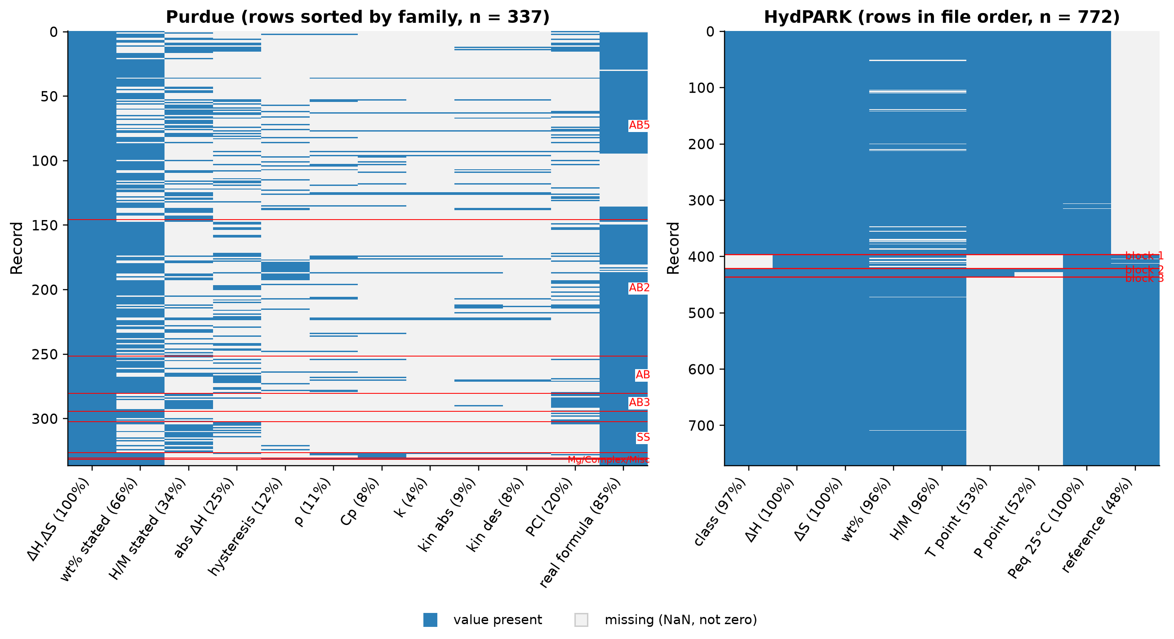
Figure C.1: Missing-data map of the Purdue (left, sorted by family) and HydPARK (right, file order) records. Percentages give the fraction of records in which the property is present; missing values are shown as missing, not as zero.

Appendix D
ML-Generated Candidates of the Demonstration Scenarios
Candidates generated by the Discovery Lab (source: reports/platform_demo_scenarios.md). Proposed compositions, not validated: ΔH is the ML prediction with its 80% interval, ΔS is the assumed family median, capacity is not predicted. Temperatures are those needed for the scenario's delivery pressure.
Table D.1: Generation summary, scenario 1 (mobile)
alloy system | generated | in domain and in window | rejected | main rejection reason
Ti-Cr-Mn (AB2 Laves) | 25 | 24 | 1 | even the pessimistic T(3 bar) -23 °C < -20 °C (plateau too high: needs cooling or a high-pressure vessel)
Ti-Zr-Mn-Cr (AB2 Laves) | 189 | 140 | 49 | outside applicability domain (NN L1 0.166 > 0.15)

Table D.2: Top candidates, scenario 1 (mobile); ΔH in kJ mol⁻¹
Candidate | ΔH pred. | 80% low | 80% high | d_{NN} | T est. (°C) | Nearest known | Its ΔH (exp.)
Ti1Cr2 | 23.2 | 18.8 | 26.1 | 0.02 | -43.1 | Cr0.667Ti0.333 | 23
Ti1Cr1.95Mn0.05 | 22.8 | 18.4 | 25.8 | 0.03 | -46.8 | Al0.013Cr0.653Ti0.333 | 22.8
Ti1Cr1.75Mn0.25 | 22.9 | 18.6 | 25.9 | 0.05 | -45.7 | Cr0.572Mn0.071Ti0.357 | 28
Ti1Cr1.55Mn0.45 | 22.5 | 18.2 | 25.5 | 0.03 | -49.5 | Cr0.5Mn0.167Ti0.333 | 21.4
Ti0.75Zr0.25Mn1.5Cr0.5 | 28.4 | 24.1 | 31.4 | 0.03 | 9.43 | Cr0.167Mn0.5Ti0.267Zr0.067 | 27.5
Ti0.75Zr0.25Mn1.2Cr0.8 | 28.3 | 24 | 31.3 | 0.03 | 8.34 | Cr0.267Mn0.4Ti0.267Zr0.067 | 28.9
Ti0.8Zr0.2Mn1.25Cr0.75 | 28.2 | 23.9 | 31.2 | 0.03 | 6.98 | Cr0.267Mn0.4Ti0.267Zr0.067 | 28.9
Ti0.8Zr0.2Mn1.45Cr0.55 | 27.6 | 23.3 | 30.6 | 0.03 | 1.3 | Cr0.167Mn0.5Ti0.267Zr0.067 | 27.5

Table D.3: Generation summary, scenario 2 (industrial)
alloy system | generated | in domain and in window | rejected | main rejection reason
La-Ce-Ni-Al (AB5) | 143 | 133 | 10 | outside applicability domain (NN L1 0.150 > 0.15)
Ti-Fe-Mn (AB, TiFe1-xMnx) | 9 | 8 | 1 | outside applicability domain (NN L1 0.189 > 0.15)

Table D.4: Top candidates, scenario 2 (industrial); ΔH in kJ mol⁻¹
Candidate | ΔH pred. | 80% low | 80% high | d_{NN} | T est. (°C) | Nearest known | Its ΔH (exp.)
La0.95Ce0.05Ni4.5Al0.5 | 36.1 | 31.8 | 39 | 0.02 | 95.2 | Al0.083La0.167Ni0.75 | 37.5
La1Ni4.6Al0.4 | 36 | 31.6 | 38.9 | 0.02 | 94 | Al0.067La0.167Ni0.767 | 35.8
La0.95Ce0.05Ni4.6Al0.4 | 35.5 | 31.1 | 38.4 | 0.02 | 88.7 | Al0.067La0.167Ni0.767 | 35.8
La0.95Ce0.05Ni4.55Al0.45 | 36.1 | 31.8 | 39.1 | 0.03 | 95.7 | Al0.083La0.167Ni0.75 | 37.5
Ti1Fe0.8Mn0.2 | 31.4 | 27.1 | 34.3 | 0.05 | 55.4 | Fe0.4Mn0.1Ti0.5 | 31.8
Ti1Fe0.85Mn0.15 | 29.9 | 25.5 | 32.8 | 0.05 | 39.4 | Fe0.425Mn0.075Ti0.5 | 29.5
Ti1Fe0.95Mn0.05 | 29.1 | 24.7 | 32 | 0.05 | 31.1 | Fe0.475Mn0.025Ti0.5 | 29.3
Ti1Fe0.75Mn0.25 | 32 | 25.7 | 37.8 | 0.05 | 62.3 | Fe0.4Mn0.1Ti0.5 | 31.8

Appendix E
Scenario Rankings
Top eight experimental materials of each scenario as produced by the Application Requirement Designer (source: reports/platform_demo_scenarios.md). Capacities are reported, material-level values; mass is the alloy mass for the scenario's hydrogen quantity.
Table E.1: Ranking, scenario 1 (mobile)
Rank | Material | Family | Evidence | Score | T needed (°C) | wt% | Q (MJ kg⁻¹) | Alloy mass (kg)
1 | Ti0.9Zr0.2Mn1.4Cr0.4V0.2 | AB2 | data-supported | 0.64 | 33.1 | 2.1 | 13.2 | 47.6
2 | Ti0.9Zr0.2Mn1.8V0.2 | AB2 | data-supported | 0.63 | 23.9 | 2.1 | 12.9 | 47.6
3 | V0.855Ti0.095Fe0.05 | SS | data-supported | 0.62 | 56.7 | 3.7 | 21.4 | 27
4 | V0.8455Ti0.1045Fe0.05 | SS | data-supported | 0.62 | 35.5 | 3.44 | 21.3 | 29
5 | TiCrMn0.85Fe0.3V0.15 | AB2 | data-supported | 0.61 | -2.3 | 1.6 | 10.4 | 62.5
6 | Ti0.9Zr0.2Mn1.4Cr0.4Vf0.2 | AB2 | provisional | 0.61 | 20.7 | 2.1 | 12.6 | 47.6
7 | Ti0.56V0.3Zr0.1Mn0.94Fe0.06Ni0.04 | AB | provisional | 0.61 | 20 | 2.2 | 13.8 | 45.5
8 | TiFe0.9Mn0.1 | AB | data-supported | 0.6 | 29.1 | 1.9 | 13.7 | 52.6

Table E.2: Ranking, scenario 2 (industrial buffer)
Rank | Material | Family | Evidence | Score | T needed (°C) | wt% | Q (MJ kg⁻¹) | Alloy mass (kg)
1 | Ti0.9Zr0.1Mn1.4 | AB2 | data-supported | 0.87 | 69.8 | 1.91 | 17.2 | 2.61e+03
2 | Zr0.7Ti0.3CrFe | AB2 | data-supported | 0.86 | 74.3 | 1.7 | 14.6 | 2.94e+03
3 | TiFe0.9Al0.1 | AB | data-supported | 0.85 | 59.6 | 1.3 | 14.9 | 3.85e+03
4 | TiFe0.8Mn0.2 | AB | data-supported | 0.85 | 73.5 | 1.3 | 15.8 | 3.85e+03
5 | TiFe0.9Ni0.1 | AB | data-supported | 0.84 | 78.3 | 1.4 | 17.2 | 3.57e+03
6 | CaNi5 | AB5 | data-supported | 0.81 | 100 | 1.15 | 14.7 | 4.35e+03
7 | ZrFe0.6Mn1.4 | AB2 | data-supported | 0.79 | 57 | 0.8 | 12.4 | 6.25e+03
8 | LaNi4.8Sn0.2 | AB5 | data-supported | 0.79 | 91.7 | 1.4 | 17.1 | 3.57e+03

Appendix F
Proposed Characterisation Matrix
Proposed future work only; none of these measurements was made in this project. Source: results/tables/characterisation_matrix.csv.
Table F.1: Proposed synthesis and characterisation techniques
Technique | Families | Property measured | Gap it addresses
Arc melting (Ar, Ti getter, 4–5 remelts with flipping) | AB5, AB2, AB, BCC/SS | synthesis | produce the nominal compositions screened
Homogenisation anneal (sealed quartz under Ar, then quench) | AB5, AB2, AB | synthesis | remove segregation, so measured ΔH belongs to the intended phase
High-energy ball milling (Ar, sealed vials) | Mg-based, NaAlH4 (+Ti catalyst) | synthesis / nanostructuring | kinetic limitation of Mg and complex hydrides (Phase 7)
ICP-OES of dissolved alloy | all, esp. mischmetal alloys | bulk composition | nominal vs actual composition (ML uses nominal); Mm composition is unknown in Purdue
XRD + Rietveld refinement | all | phases, lattice parameters, C14/C15, hydride expansion | C14/C15 is invisible to composition features (Phase 4 limitation)
SEM/EDS (BSE imaging, point and map analysis) | all | microstructure, secondary phases, local composition | explains sloped plateaus / extra plateaus
Activation cycles in the Sieverts rig | AB (TiFe) especially; all | activation behaviour | TiFe activation is not in the data
Sieverts (volumetric) PCT, abs + des, ≥4 temperatures over ≥40 K | all | plateau P(T), capacity, slope, hysteresis | replaces literature/digitised data; gives ΔH, ΔS with uncertainty
Kinetic uptake / release curves at fixed P/Peq | all | rate constants, Ea (several T) | kinetics comparable across materials (Phase 7 found 7 orders of spread)
Cycling (≥100 abs/des cycles) with periodic PCT | selected candidates | capacity retention, plateau shift | cycle life is missing from the screening
DSC (heat-flux, high-pressure cell if needed) | all; Mg, NaAlH4 | reaction enthalpy; Kissinger Ea from heating-rate series | independent ΔH check of the Van't Hoff value
TGA / TPD-MS | Mg-based, NaAlH4 | desorption temperature, gravimetric capacity, impurity release | capacity definition (reversible vs total)
Thermal conductivity: transient plane source on powder beds/compacts | selected candidates | k_eff vs H2 pressure and compaction | only 14 Purdue materials have k_eff; heat removal limits refuelling
Bed density / tapped density | selected candidates | packing density | converts solid-basis volumetric capacity to bed basis (Phase 8)

