Q1.

Code:

|  |
| --- |
| ***package Q_01;  public class Temperature {  private double celsius;   public Temperature() {  this.celsius=0;  }   public Temperature(double celsius) {  this.celsius = celsius;  }   public void setCelsius(double celsius) {  this.celsius = celsius;  }   public void setFahrenheit(double fahrenheit) {  this.celsius = (fahrenheit - 32) * 5 / 9;  }    public double toFahrenheit (){  return(this.celsius * 9 / 5 + 32);  }   public double toCelsius (){  return celsius;  }   }*** |

Q2.

Code:

|  |
| --- |
| ***package Q_02;  import Q_01.Temperature;  import java.util.Scanner;  public class ProgramQ2 {  public static void main(String[] args) {  Scanner scanner = new Scanner(System.in);   Temperature ToCelsius = new Temperature();   System.out.println("enter fahrenheit :");  double fahrenheit = scanner.nextDouble();   ToCelsius.setFahrenheit(fahrenheit);  System.out.println("fahrenheit in celsius : "+ToCelsius.toCelsius());  } }*** |

Output:

Q3.

Code: Circle.java

|  |
| --- |
| ***package Q_03;  public class Circle {  private double radius;   public Circle () {  this.radius = 0;  }   public void setRadius(double radius) {  this.radius = radius;  }   public double computeArea (){  return (Math.PI*radius*radius);  }   public double computeCircumference (){  return (2*Math.PI*radius);  } }*** |

Q3.

Code: ProgramQ3.java

|  |
| --- |
| ***package Q_03;  import java.util.Scanner;  public class ProgramQ3 {  public static void main(String[] args) {   Scanner scanner = new Scanner(System.in);  Circle innerRadius = new Circle();  Circle outerRadius = new Circle();    System.out.println("enter radius Inner Circle Radiud :");  double radius_i = scanner.nextDouble();  innerRadius.setRadius(radius_i);   System.out.println("enter radius Outer Circle Radius :");  double radius_o = scanner.nextDouble();  outerRadius.setRadius(radius_o);   double shaded_area = outerRadius.computeArea() - innerRadius.computeArea();  System.out.println("the shaded area of the circle is " + shaded_area);    } }*** |

Output:

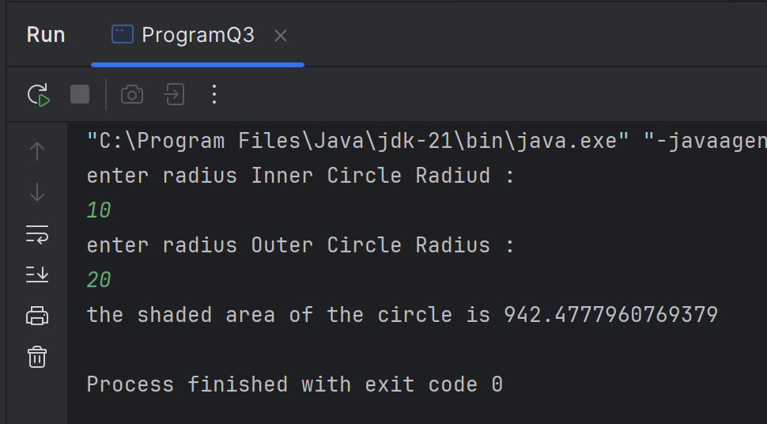

Q4.

Code: Bicycle.java

|  |
| --- |
| ***package Q_04;  class Bicycle {  // Data Member  private Owner owner;   public Bicycle() {  this.owner = new Owner();  }   public Bicycle(String name, String num) {  this.owner = new Owner(name,num);  }   public String getOwnerName() {  return owner.getOwnerName();  }   public void setOwnerName(String name) {  owner.setOwnerName(name);  }   public String getPhoneNo() {  return owner.getPhoneNo();  }   public void setPhoneNo(String num) {  owner.setPhoneNo(num);  }   }*** |

Q4.

Code: Owner.java

|  |
| --- |
| ***package Q_04;  public class Owner {  // Data Member  private String ownerName;  private String phoneNo;   public Owner() {  ownerName = "Unknown";  }   public Owner(String ownerName, String phoneNo) {  this.ownerName = ownerName;  this.phoneNo = phoneNo;  }   public String getOwnerName() {  return ownerName;  }   public void setOwnerName(String ownerName) {  this.ownerName = ownerName;  }   public String getPhoneNo() {  return phoneNo;  }   public void setPhoneNo(String phoneNo) {  this.phoneNo = phoneNo;  } }*** |

Q5.

Code: Course.java

|  |
| --- |
| ***package Q_05;  public class Course {  private String courseName;  private String courseCode;  private Lecturer lecturerIncharge;   public String getCourseName() {  return courseName;  }   public void setCourseName(String courseName) {  this.courseName = courseName;  }   public String getCourseCode() {  return courseCode;  }   public void setCourseCode(String courseCode) {  this.courseCode = courseCode;  }   public Lecturer getLecturerIncharge() {  return lecturerIncharge;  }   public void setLecturerIncharge(Lecturer lecturerIncharge) {  this.lecturerIncharge = lecturerIncharge;  } }*** |

Q5.

Code: Lecturer.java

|  |
| --- |
| ***package Q_05;  public class Lecturer {  private String lecturerName;  private String courseTeaching;   public String getLecturerName() {  return lecturerName;  }   public void setLecturerName(String lecturerName) {  this.lecturerName = lecturerName;  }   public String getCourseTeaching() {  return courseTeaching;  }   public void setCourseTeaching(String courseTeaching) {  this.courseTeaching = courseTeaching;  } }*** |

Q5.

Code: Student.java

|  |
| --- |
| ***package Q_05;  public class Student {  private String studentName;  private String degreeName;  private String courseFollowing;   public String getStudentName() {  return studentName;  }   public void setStudentName(String studentName) {  this.studentName = studentName;  }   public String getDegreeName() {  return degreeName;  }   public void setDegreeName(String degreeName) {  this.degreeName = degreeName;  }   public String getCourseFollowing() {  return courseFollowing;  }   public void setCourseFollowing(String courseFollowing) {  this.courseFollowing = courseFollowing;  } }*** |

Q5.

Code: Main.java

|  |
| --- |
| ***package Q_05;  public class Main {  public static void main(String[] args) {   Lecturer kumar = new Lecturer();  kumar.setCourseTeaching("Object oriented prog");  kumar.setLecturerName("kumar");   Course oop = new Course();  oop.setCourseName("Object oriented prog");  oop.setCourseCode("CTEC 22043");  oop.setLecturerIncharge(kumar);   Student sanga = new Student();  sanga.setCourseFollowing("Object oriented prog");  sanga.setDegreeName("BICT");  sanga.setStudentName("sanga");   System.out.println("\nLecturer Name : "+kumar.getLecturerName());  System.out.println("Teaching course : "+kumar.getCourseTeaching());   System.out.println("\nCourse Name : "+oop.getCourseName());  System.out.println("Course code : "+oop.getCourseCode());   System.out.println("\nStudent Name : "+sanga.getStudentName());  System.out.println("Following Degree : "+sanga.getDegreeName());  System.out.println("Following Course : "+sanga.getCourseFollowing());  } }*** |

Output:

