Q1.

Code:

|  |
| --- |
| ***package Q1;  public class Q1 {  public static void main(String[] args) {   System.out.println();   for (int i =10; i<50; i++){  System.out.print(i+" ");   if ((i-10)%10==9)  System.out.println();  }  } }*** |

Output:

Q2.

Code:

|  |
| --- |
| ***package Q2; import java.util.Scanner; public class Q2 {  public static void main(String[] args) {  Scanner scanner = new Scanner(System.in);  int inputvalue, count ;  while (true){  System.out.println("\n# exit the programme enter negative number #\n\nEnter integer value :");  inputvalue = scanner.nextInt();  count = 0;  int x = inputvalue;   if (x<0)  break;  if (x == 0) {  count = 1;  }  else {  for (; x != 0; count++) {  x /= 10;  }  }  System.out.println("Number of digits : " + count);  }  } }*** |

Output:

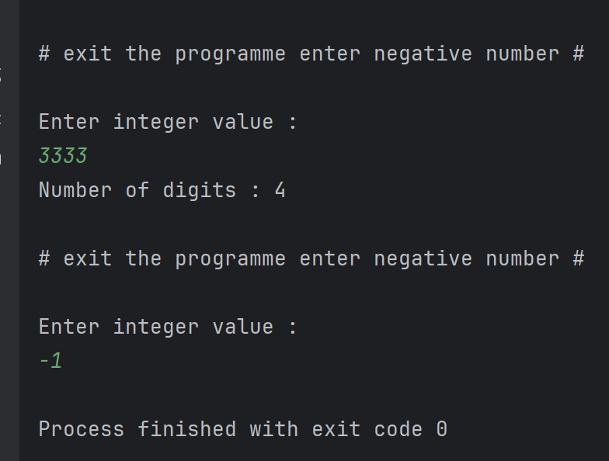

Q3.

Code:

|  |
| --- |
| ***package Q3;  import java.util.Scanner;  public class Q3 {  public static void main(String[] args) {  Scanner scanner = new Scanner(System.in);   System.out.println("\nEnter the integer for show multiplication table :");  int N= scanner.nextInt();   for (int i =1;i<=10; ++i){  int z = i*N;  System.out.println(""+i+"*"+N+"="+z);  }  } }*** |

Output:

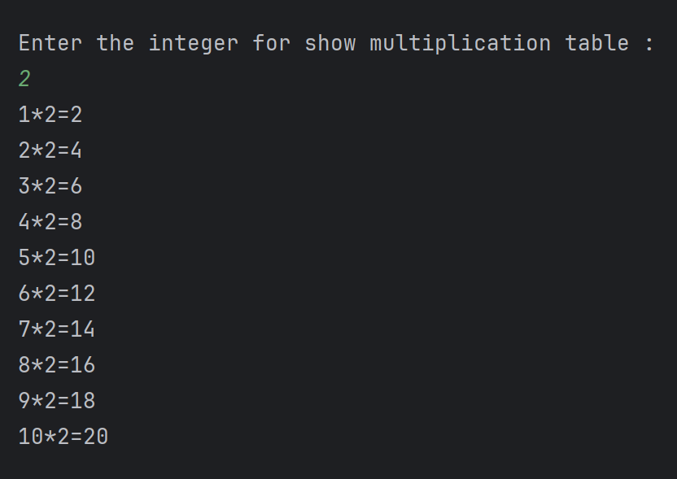

Q4.

Code:

|  |
| --- |
| ***package Q4; import java.util.Scanner;  public class Q4 {  public static void main(String[] args) {  Scanner scanner = new Scanner(System.in);   System.out.println("Enter the row for make pyramid :");  int row = scanner.nextInt();   for (int i=0; i<row; i++){  for (int j=row-i; j>0;j--){  System.out.print(" ");  }  for (int j=0; j<=i; j++){  System.out.print("* ");  }  System.out.println();  }  } }*** |

Output:

Q5.

Code:

|  |
| --- |
| ***package Q5; import java.util.Scanner;  public class Q5 {  public static void main(String[] args) {  Scanner scanner = new Scanner(System.in);   System.out.println("Enter the word or phrase :");  String x= scanner.nextLine();  int length = x.length();   String reverse ="";   for (int i = length-1 ; i>=0; i--){  reverse+= x.charAt(i);  }  if (x.equals(reverse))  System.out.println("given word is palindrome");  else  System.out.println("given not word is palindrome");  } }*** |

Output:

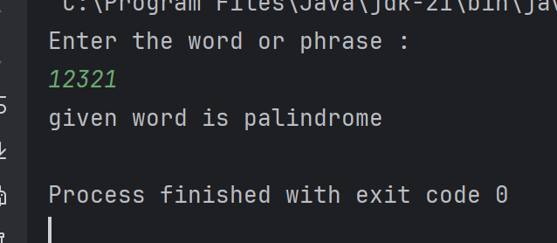

Q6.

Code:

|  |
| --- |
| ***package Q6; import java.util.Random; import java.util.Scanner;  public class Q6 {  public static void main(String[] args) {  Scanner scanner = new Scanner(System.in);  Random num= new Random();  while (true){  int x = num.nextInt(100)+1;  System.out.println("enter the guessed number between 1 to 100 :");  int y = scanner.nextInt();  if (x==y){  System.out.println("guessed correctly");  break;  }  else if (x>y) {  System.out.println(y + " is lower than random number");  }  else{  System.out.println(y + " is higher than random number");  }  }  } }*** |

Output:

Q7.

Code:

|  |
| --- |
| ***package Q7;  import java.util.Scanner;  public class Q7 {  public static void main(String[] args) {  Scanner scanner = new Scanner(System.in);  String sentence="", replacedword="", replacementword="";   System.out.println("Enter the sentence :");  sentence = scanner.nextLine();  System.out.println("Enter the replace word :");  replacedword = scanner.nextLine();  System.out.println("Enter the replacement wrod :");  replacementword = scanner.nextLine();   String[] words = sentence.split(" ");   for (int i=0; i< words.length; i++){  if (words[i].equalsIgnoreCase(replacedword)){  words[i]=replacementword;  }  }  String modifiedword = String.join(" ",words);   System.out.println("Modified Word : "+modifiedword);    } }*** |

Output:

