Q1.

Code: Pet

|  |
| --- |
| ***package Q1;***  ***public class Pet {***  ***private String name;***  ***public Pet(String name) {***  ***this.name=name;***  ***}***  ***public String getName( ) {***  ***return name;***  ***}***  ***public void setName(String petName) {***  ***name = petName;***  ***}***  ***public String speak( ) {***  ***return "I'm your cuddly little pet.";***  ***}***  ***}*** |

Code: Dog

|  |
| --- |
| ***package Q1;***  ***public class Dog extends Pet {***  ***public double weight =0;***  ***public double getWeight() {***  ***return weight;***  ***}***  ***public void setWeight(double weight) {***  ***this.weight = weight;***  ***}***  ***public Dog(String name) {***  ***super(name);***  ***}***  ***public String speak (){***  ***return "";***  ***}***  ***}*** |

Code: Cat

|  |
| --- |
| ***package Q1;***  ***public class Cat extends Pet {***  ***public String coatColor="";***  ***public String getCoatColor() {***  ***return coatColor;***  ***}***  ***public void setCoatColor(String coatColor) {***  ***this.coatColor = coatColor;***  ***}***  ***public Cat(String name) {***  ***super(name);***  ***}***  ***public String speak (){***  ***return "";***  ***}***  ***}*** |

Q2.

Code:

|  |
| --- |
| ***package Q2;***  ***import Q1.Cat;***  ***import Q1.Dog;***  ***import Q1.Pet;***  ***import java.util.Scanner;***  ***public class Q2 {***  ***public static void main(String[] args) {***  ***Scanner scanner = new Scanner(System.in);***  ***String name;***  ***int maxvalue =10, petcount = 0;***  ***Pet[] pets = new Pet[maxvalue];***  ***while (true){***  ***System.out.println("Enter the Pet Name ( STOP to quit):");***  ***name = scanner.nextLine();***  ***if (name.equals("stop"))***  ***break;***  ***System.out.println("Enter Pet type ‘c’ for cat and ‘d’ for dog :");***  ***char type = scanner.nextLine().charAt(0);***  ***if (type=='d'){***  ***pets[petcount] = new Dog(name);***  ***} else if (type=='c') {***  ***pets[petcount] =new Cat(name);***  ***}else***  ***System.out.println("invalid type");***  ***petcount++;***  ***}***  ***for (int i =0; i<petcount; i++){***  ***System.out.println("pet "+i+" : "+pets[i].getName()+" is a "+pets[i].getClass().getSimpleName());***  ***}***  ***}***  ***}*** |

Output:

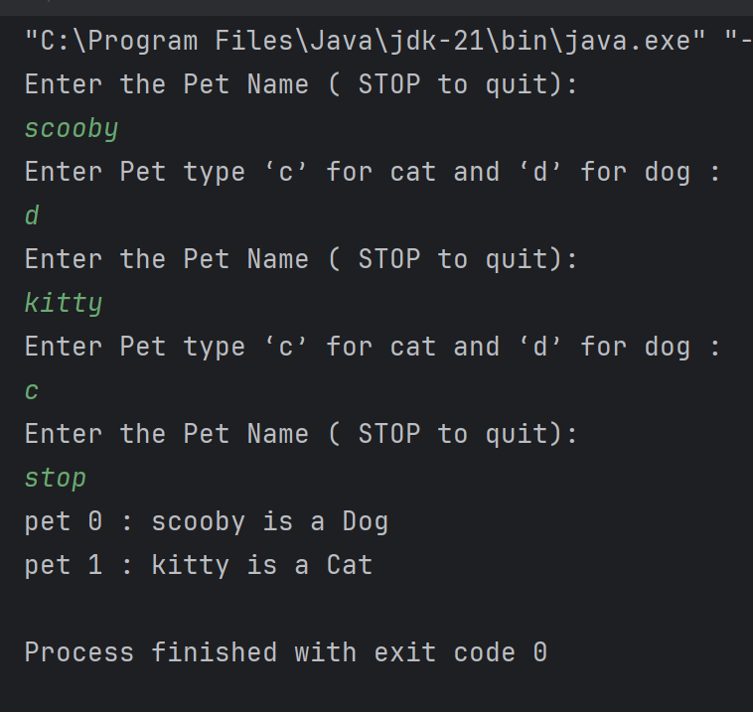

Q3.

Code:

|  |
| --- |
| ***package Q3;***  ***import Q1.Cat;***  ***import Q1.Dog;***  ***import Q1.Pet;***  ***import java.util.Scanner;***  ***public class Q3 {***  ***public static void main(String[] args) {***  ***Scanner scanner = new Scanner(System.in);***  ***String name;***  ***int maxvalue =10, petcount = 0;***  ***Pet[] pets = new Pet[maxvalue];***  ***while (true){***  ***System.out.println("Enter the Pet Name ( STOP to quit):");***  ***name = scanner.nextLine();***  ***if (name.equals("stop"))***  ***break;***  ***System.out.println("Enter Pet type ‘c’ for cat and ‘d’ for dog :");***  ***char type = scanner.nextLine().charAt(0);***  ***if (type=='d'){***  ***pets[petcount] = new Dog(name);***  ***} else if (type=='c') {***  ***pets[petcount] =new Cat(name);***  ***}else***  ***System.out.println("invalid type");***  ***petcount++;***  ***}***  ***System.out.println("\nThe Cats names:\n");***  ***for (int i =0; i<petcount; i++){***  ***if (pets[i] instanceof Cat)***  ***System.out.println("pet "+i+" : "+pets[i].getName());***  ***}***  ***System.out.println("\nThe Dogs names:\n");***  ***for (int i =0; i<petcount; i++){***  ***if (pets[i] instanceof Dog)***  ***System.out.println("pet "+i+" : "+pets[i].getName());***  ***}***  ***}***  ***}*** |

Output:

Q4.

Code:

|  |
| --- |
| ***package Q4;***  ***import Q1.Cat;***  ***import Q1.Dog;***  ***import Q1.Pet;***  ***import java.util.Scanner;***  ***public class Q4 {***  ***public static void main(String[] args) {***  ***Scanner scanner = new Scanner(System.in);***  ***String name;***  ***int maxvalue =10, petcount = 0;***  ***Pet[] pets = new Pet[maxvalue];***  ***while (true){***  ***System.out.println("Enter the Pet Name ( STOP to quit):");***  ***name = scanner.nextLine();***  ***if (name.equals("stop"))***  ***break;***  ***System.out.println("Enter Pet type ‘c’ for cat and ‘d’ for dog :");***  ***char type = scanner.nextLine().charAt(0);***  ***if (type=='d'){***  ***pets[petcount] = new Dog(name);***  ***System.out.println("Enter weight :");***  ***double weight = scanner.nextDouble();***  ***scanner.nextLine();***  ***((Dog) pets[petcount]).setWeight(weight);***  ***}***  ***else if (type=='c') {***  ***pets[petcount] =new Cat(name);***  ***System.out.println("Enter coatcolor :");***  ***String coatColor = scanner.nextLine();***  ***((Cat) pets[petcount]).setCoatColor(coatColor);***  ***}***  ***else***  ***System.out.println("invalid type");***  ***petcount++;***  ***}***  ***System.out.println("\nThe Cats names:\n");***  ***for (int i =0; i<petcount; i++){***  ***if (pets[i] instanceof Cat)***  ***System.out.println("\npet "+i+" : "+pets[i].getName()+" is a "+pets[i].getClass().getSimpleName()+" Coatcolor : "+((Cat) pets[i]).getCoatColor());***  ***else***  ***System.out.println("\npet "+i+" : "+pets[i].getName()+" is a "+pets[i].getClass().getSimpleName()+" Weight : "+((Dog) pets[i]).getWeight());***  ***}***  ***}***  ***}*** |

Output:

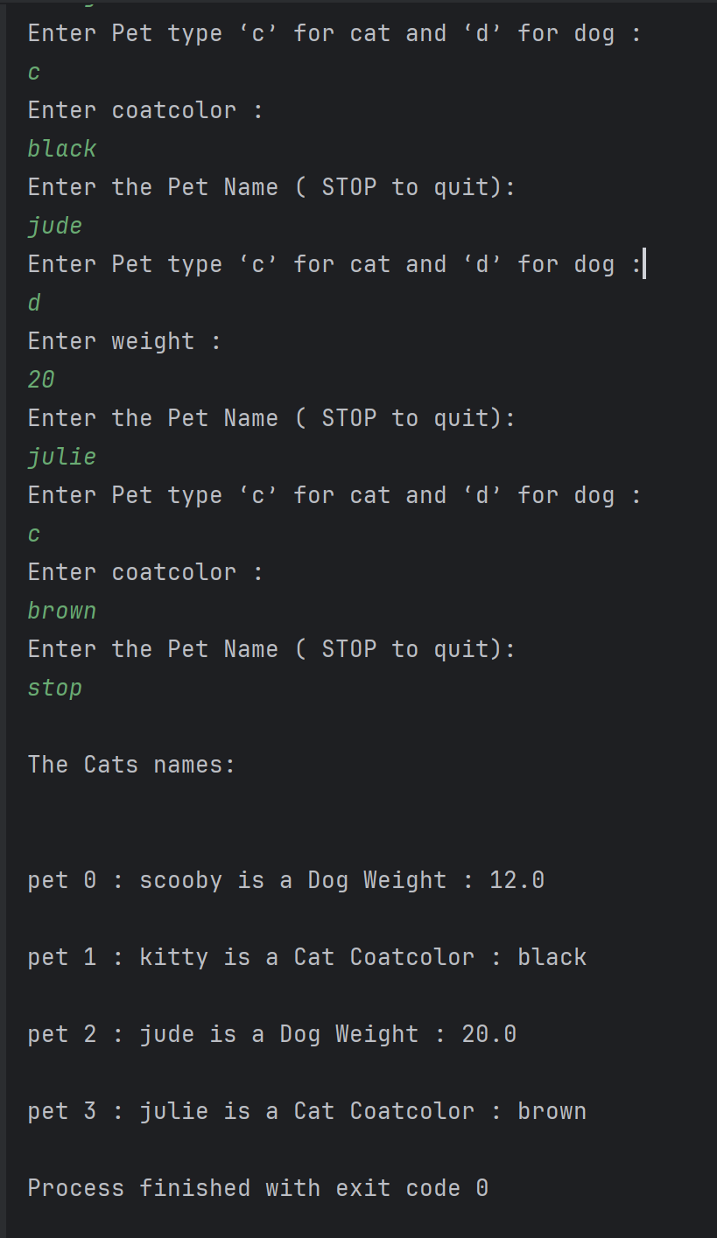

Q5.

Code:

|  |
| --- |
| ***package Q5;***  ***import Q1.Cat;***  ***import Q1.Dog;***  ***import Q1.Pet;***  ***import java.util.Scanner;***  ***public class Q5 {***  ***public static void main(String[] args) {***  ***Scanner scanner = new Scanner(System.in);***  ***String name;***  ***int maxvalue =10, petcount = 0,count=0;***  ***Pet[] pets = new Pet[maxvalue];***  ***Pet[] petdog = new Pet[maxvalue];***  ***while (true){***  ***System.out.println("Enter the Pet Name ( STOP to quit):");***  ***name = scanner.nextLine();***  ***if (name.equals("stop"))***  ***break;***  ***System.out.println("Enter Pet type ‘c’ for cat and ‘d’ for dog :");***  ***char type = scanner.nextLine().charAt(0);***  ***if (type=='d'){***  ***pets[petcount] = new Dog(name);***  ***System.out.println("Enter weight :");***  ***double weight = scanner.nextDouble();***  ***scanner.nextLine();***  ***((Dog) pets[petcount]).setWeight(weight);***  ***petdog[count]=(Dog) pets[petcount];***  ***count++;***  ***}***  ***else if (type=='c') {***  ***pets[petcount] =new Cat(name);***  ***System.out.println("Enter coatcolor :");***  ***String coatColor = scanner.nextLine();***  ***((Cat) pets[petcount]).setCoatColor(coatColor);***  ***}***  ***else***  ***System.out.println("invalid type");***  ***petcount++;***  ***}***  ***//average max min***  ***int total=0,max =0,min =(int) ((Dog) petdog[0]).getWeight();***  ***for (int i=0; i<count; i++){***  ***total+= (int) ((Dog) petdog[i]).getWeight();***  ***if (max<(int) ((Dog) petdog[i]).getWeight()){***  ***max=(int) ((Dog) petdog[i]).getWeight();***  ***}***  ***if (min>(int) ((Dog) petdog[i]).getWeight()){***  ***min=(int) ((Dog) petdog[i]).getWeight();***  ***}***  ***}***  ***System.out.println("the average dogs weight is : "+(total/count)+" Kg");***  ***System.out.println("the max dogs weight is : "+max+" Kg");***  ***System.out.println("the min dogs weight is : "+min+" Kg");***  ***}***  ***}*** |

Output:

Q6.

Code:

|  |
| --- |
| ***package Q6;***  ***import Q1.Cat;***  ***import Q1.Dog;***  ***import Q1.Pet;***  ***import java.util.Scanner;***  ***public class Q6 {***  ***public static void main(String[] args) {***  ***Scanner scanner = new Scanner(System.in);***  ***String name;***  ***int maxvalue =10, dogcount = 0, catcount=0;***  ***Pet[] dog = new Pet[maxvalue];***  ***Pet[] cat = new Pet[maxvalue];***  ***while (true){***  ***printmenu();***  ***int ope =scanner.nextInt();***  ***if (ope==1){***  ***System.out.println("Enter the Cat Name :");***  ***name = scanner.nextLine();***  ***scanner.nextLine();***  ***cat[catcount] = new Cat(name);***  ***System.out.println("Enter coatcolor :");***  ***String coatColor = scanner.nextLine();***  ***((Cat) cat[catcount]).setCoatColor(coatColor);***  ***catcount++;***  ***}***  ***else if (ope==2){***  ***System.out.println("Enter the Dog Name :");***  ***name = scanner.nextLine();***  ***scanner.nextLine();***  ***dog[dogcount] = new Dog(name);***  ***System.out.println("Enter weight :");***  ***double weight = scanner.nextDouble();***  ***scanner.nextLine();***  ***((Dog) dog[dogcount]).setWeight(weight);***  ***dogcount++;***  ***}***  ***else if (ope==3){***  ***System.out.println("Enter the cat name to remove :");***  ***String x= scanner.nextLine();***  ***scanner.nextLine();***  ***for (int i=0; i<catcount; i++){***  ***if (cat[i].getName().equals(x)){***  ***cat[i].setName("NULL");***  ***break;***  ***}***  ***}***  ***}***  ***else if (ope==4){***  ***System.out.println("Enter the dog name to remove :");***  ***String x= scanner.nextLine();***  ***scanner.nextLine();***  ***for (int i=0; i<dogcount; i++){***  ***if (dog[i].getName().equals(x)){***  ***dog[i].setName("NULL");***  ***break;***  ***}***  ***}***  ***}***  ***else if (ope==0){***  ***break;***  ***}***  ***else***  ***System.out.println("invalid operation");***  ***}***  ***}***  ***public static void printmenu (){***  ***System.out.println("1. Add Cat ");***  ***System.out.println("2. Add Dog ");***  ***System.out.println("3. Remove Cat ");***  ***System.out.println("4. Remove Dog ");***  ***System.out.println("0. Quit ");***  ***}***  ***}*** |

Output:

