Q1.

Code:

|  |
| --- |
| ***package Q1;***  ***import javax.swing.*;***  ***public class Q1 {***  ***public static void main(String[] args) {***  ***String intput1 = JOptionPane.showInputDialog("Enter the first integer :");***  ***int num1 = Integer.parseInt(intput1);***  ***String intput2 = JOptionPane.showInputDialog("Enter the second integer :");***  ***int num2 = Integer.parseInt(intput2);***  ***String intput3 = JOptionPane.showInputDialog("Enter the third integer :");***  ***int num3 = Integer.parseInt(intput3);***  ***int sum = num1+num2+num3;***  ***JOptionPane.showMessageDialog(null, "The sum is : "+sum);***  ***}***  ***}*** |

Output:

Q2.

Code:Main

|  |
| --- |
| ***package Q2;***  ***import Q2.MyFrame;***  ***class Main {***  ***public static void main(String[] args) {***  ***MyFrame myFrame = new MyFrame();***  ***myFrame.setVisible(true);***  ***}***  ***}*** |

Code:MyFrame

|  |
| --- |
| ***package Q2;***  ***import javax.swing.*;***  ***import java.awt.*;***  ***public class MyFrame extends JFrame {***  ***public MyFrame() {***  ***setSize(400, 450);***  ***setDefaultCloseOperation(EXIT_ON_CLOSE);***  ***getContentPane().setBackground(Color.BLUE);***  ***}***  ***}*** |

Output:

Q3.

Code:

|  |
| --- |
| ***package Q3;***  ***import javax.swing.*;***  ***import java.awt.event.ActionEvent;***  ***public class MyFrame extends JFrame {***  ***public MyFrame() {***  ***setSize(400, 450);***  ***setDefaultCloseOperation(EXIT_ON_CLOSE);***  ***JButton pushbutton = new JButton("click here");***  ***pushbutton.addActionListener(new AbstractAction() {***  ***@Override***  ***public void actionPerformed(ActionEvent e) {***  ***JOptionPane.showMessageDialog(null,"You clicked!");***  ***}***  ***});***  ***add(pushbutton);***  ***}***  ***}*** |

Output:

Q4.

Code:

|  |
| --- |
| ***package Q4;***  ***import javax.swing.*;***  ***import java.awt.event.ActionEvent;***  ***public class MyFrame extends JFrame {***  ***public MyFrame() {***  ***setSize(400, 450);***  ***setDefaultCloseOperation(EXIT_ON_CLOSE);***  ***JTextField inputtitle = new JTextField();***  ***JButton pushbutton = new JButton("change title");***  ***pushbutton.addActionListener(new AbstractAction() {***  ***@Override***  ***public void actionPerformed(ActionEvent e) {***  ***setTitle(inputtitle.getText());***  ***}***  ***});***  ***add(inputtitle);***  ***add(pushbutton);***  ***setLayout(null);***  ***inputtitle.setBounds(50,50,200,30);***  ***pushbutton.setBounds(100,100,100,30);***  ***}***  ***}*** |

Output:

Q5.

Code:

|  |
| --- |
| ***package Q5;***  ***import javax.swing.*;***  ***import java.awt.*;***  ***import java.awt.event.ActionEvent;***  ***public class MyFrame extends JFrame {***  ***public MyFrame() {***  ***setSize(400, 450);***  ***setDefaultCloseOperation(EXIT_ON_CLOSE);***  ***getContentPane().setBackground(Color.green);***  ***JButton pushbutton = new JButton("OFF");***  ***pushbutton.addActionListener(new AbstractAction() {***  ***@Override***  ***public void actionPerformed(ActionEvent e) {***  ***if (pushbutton.getText().equals("OFF")){***  ***getContentPane().setBackground(Color.red);***  ***pushbutton.setText("ON");***  ***}else {***  ***getContentPane().setBackground(Color.GREEN);***  ***pushbutton.setText("OFF");***  ***}***  ***}***  ***});***  ***add(pushbutton);***  ***setLayout(null);***  ***pushbutton.setBounds(100,100,100,30);***  ***}***  ***}*** |

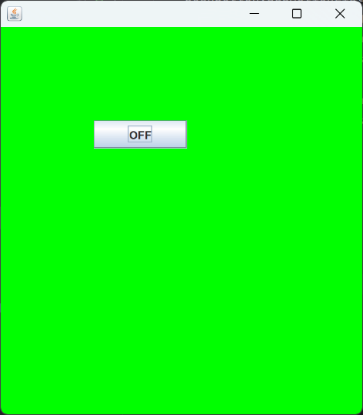Output: