Deployment Guide

WebRTC Virtual Classroom PLatform

Table of Contents

Software Versions 2

Preparing a dev/test VM 3

Assumptions 3

Initial Preparation 3

Installing nodejs and other utilities 3

Checking out code 3

Installing Mongodb & docker 3

Running REDIS 4

Creating docker run envinronment 4

Other Development tools 4

# Software Versions

The following table lists the versions baselined for WebRTC VC.

|  |  |  |
| --- | --- | --- |
| Software | Version | Source |
| OS | Ubuntu 14.04.3 LTS (trusty) |  |
| OS (Azure) | ~~Ubuntu 15.04/vivid~~ | ~~Ubuntu-15-04-Shellinabox~~ |
| git | 2.1.4 (~not critical) |  |
| nodejs | 4.3.0 Argon | [here](https://nodejs.org/download/release/v4.3.0/) |
|  |  |  |

# Field Deployment

The actual field deployment of VC would span across multiple machines, with each node serving a specific purpose as shown below:

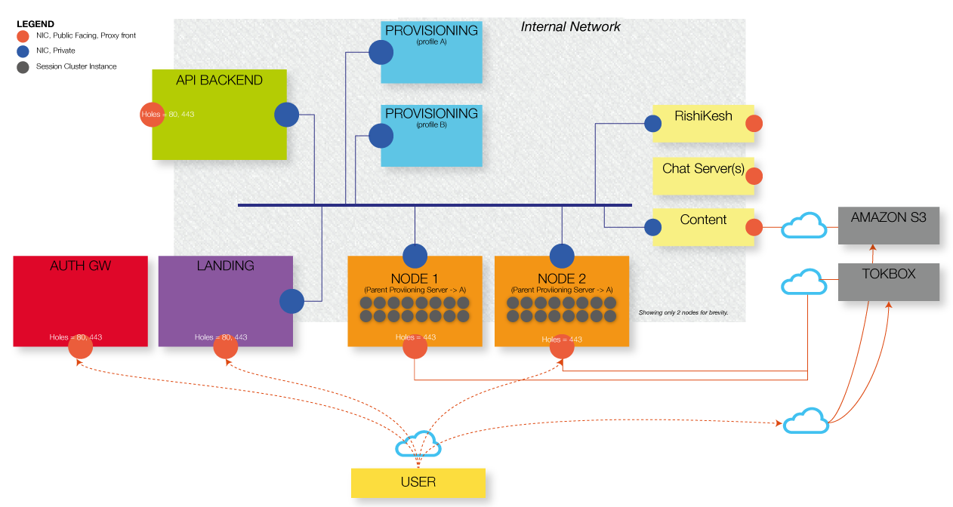The diagram illustrates a full blown deployment scenario which the architecture must enable. A more typical deployment may have lesser nodes.

# Single machine deployment

This deployment should ideally have at least the following on a single machine:

* Auth GW
* Landing
* Api-backend
* Provisioning (1 instance)
* Node (1 instance, containing possibly multiple session clusters)

## Commands

Check out the entire code:

git clone <http://github.com/avinash-bhatia/wvc>

Assuming that the machine is already prepared, first run the proxy:

cd $REPOS/app/proxy

authbind --deep pm2 start --name proxy app.js -- --host <host-name>

Run the main application, which includes auth-gw, landing, api-backend & provisioning:

cd $REPOS/app

pm2 start --name main app.js -- --sess-ip <host-name> --sess-port 443 –ssl

Ensure these are running and free of any startup errors:

pm2 ls

pm2 log –raw | bunyan

Now run a session cluster (by hand for now – it will eventually happen automatically):

cd $REPOS/docker/scripts

./start-session2 ../../session/v2 <session-name>

This should prepare the system to receive any requests to join the above named session.