**GitHub**

Github is a hosting service for git repositories. Git is the tool, while Github is the service to use it.

Git is a revision control system used to track changes in computer files. It’s a tool to manage your code & file history while cordinating work remotely on those file with others.

**Step 1:**

Create a Project.

Start a project and create a repository.

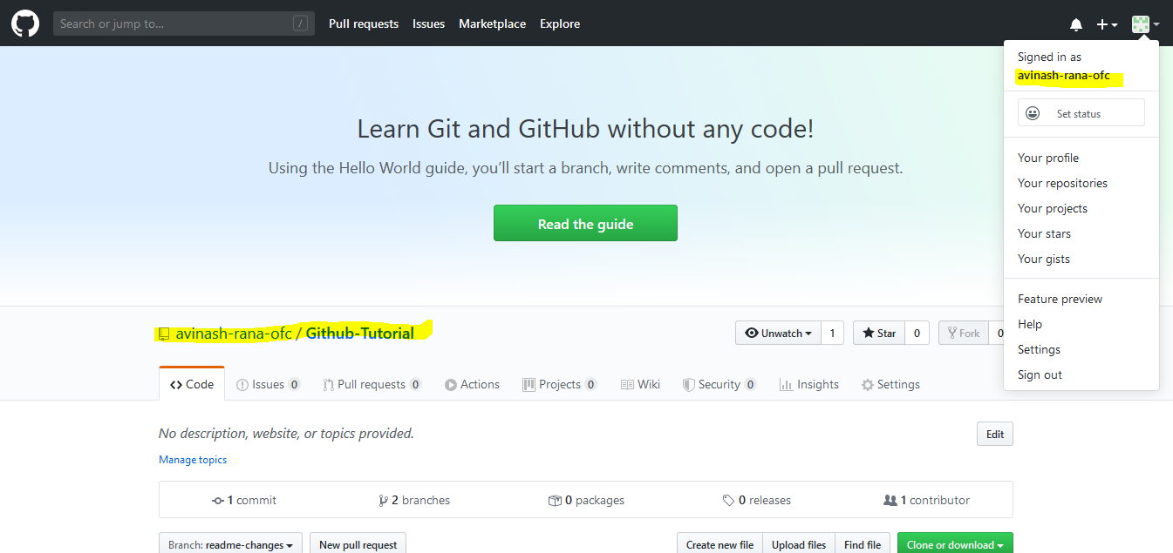

**Step 2:**

Open Eclipse. Go to select perspective and select ***git repository*** 🡪 and select ***Add Git Repository***.

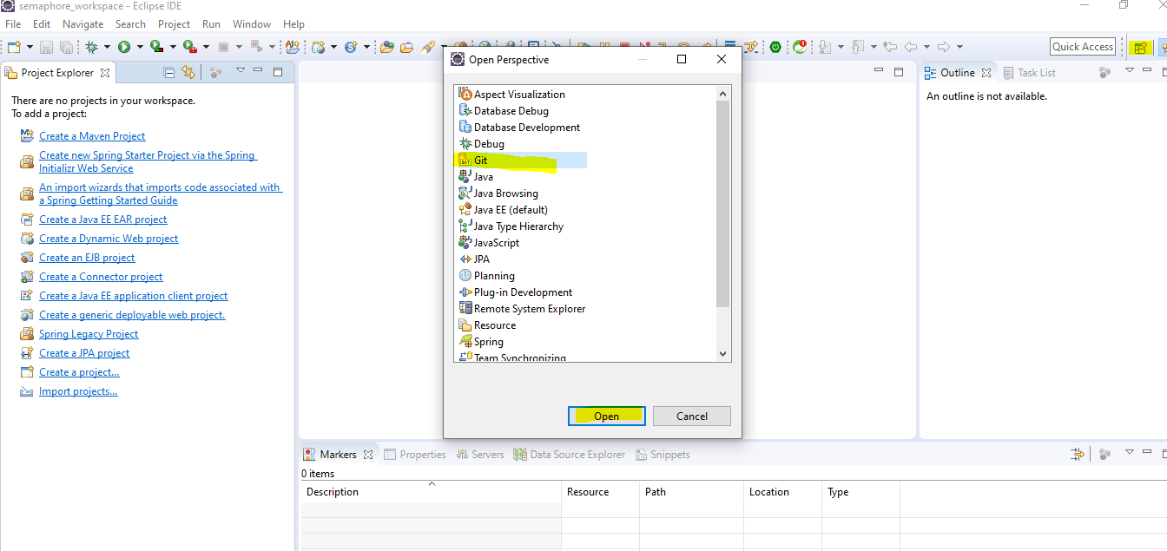

**Step 3:**

Copy the Url of the repository created and followed up by your credentials if required.

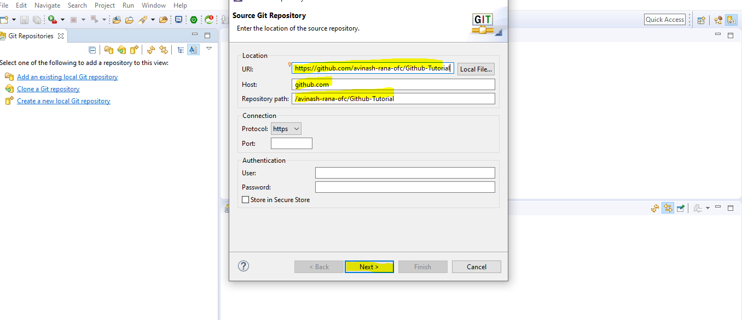

**Step 4:**

Select 🡪 ***next*** and finish.

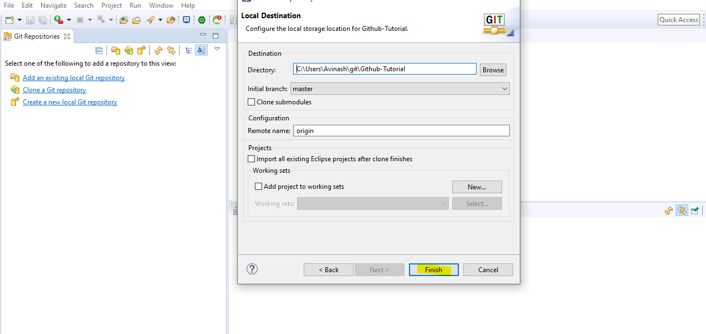

**Step 5:**

Here the github repository is stored.

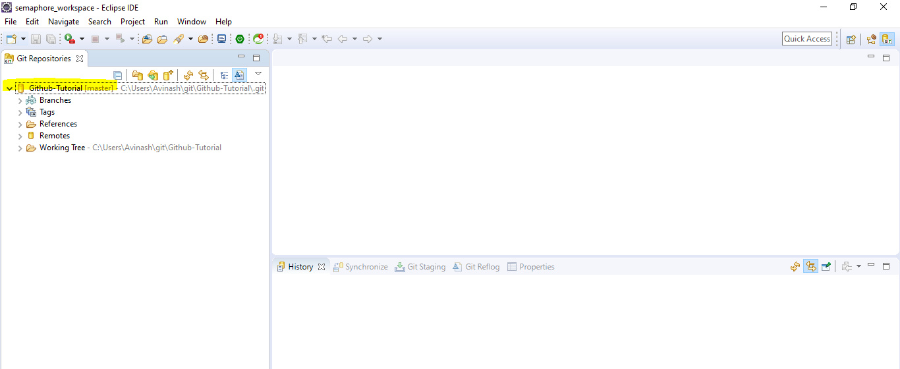

**Step 6:**

Now create a java project or import it.

After that right click on your ***project*** 🡪select ***team***🡪select ***share the project***🡪now select your ***repository*** from the dropdown and click finish.

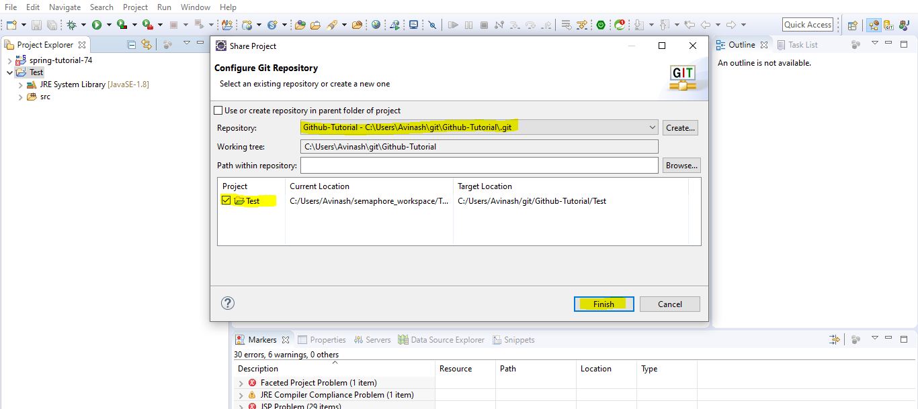

**Step 7:**

Now again rigtht click on ***project***🡪 select ***team***🡪 select ***commit***.

And select the files and move to the ***staged changes*** and give a small ***commit*** ***message*** about the changes and hit ***commit and push*** button.

If asked for credential then please provide your github user id and password.

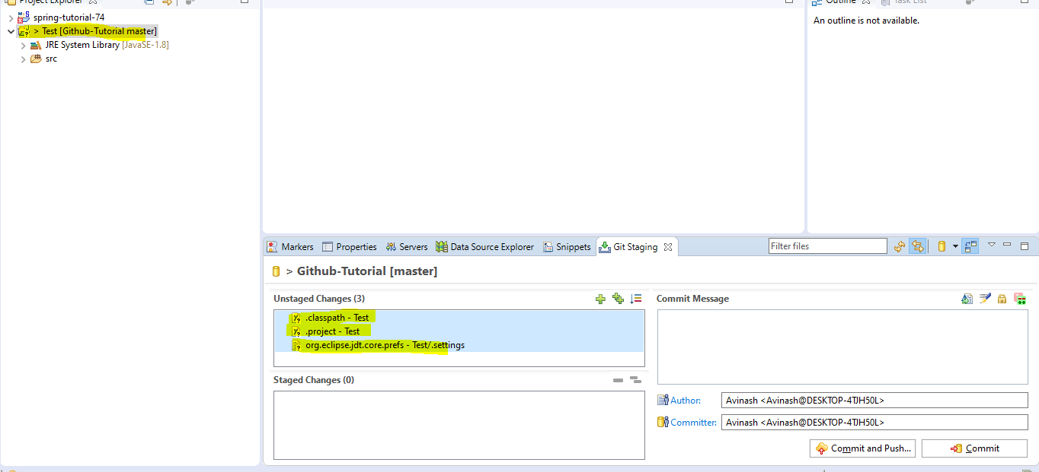

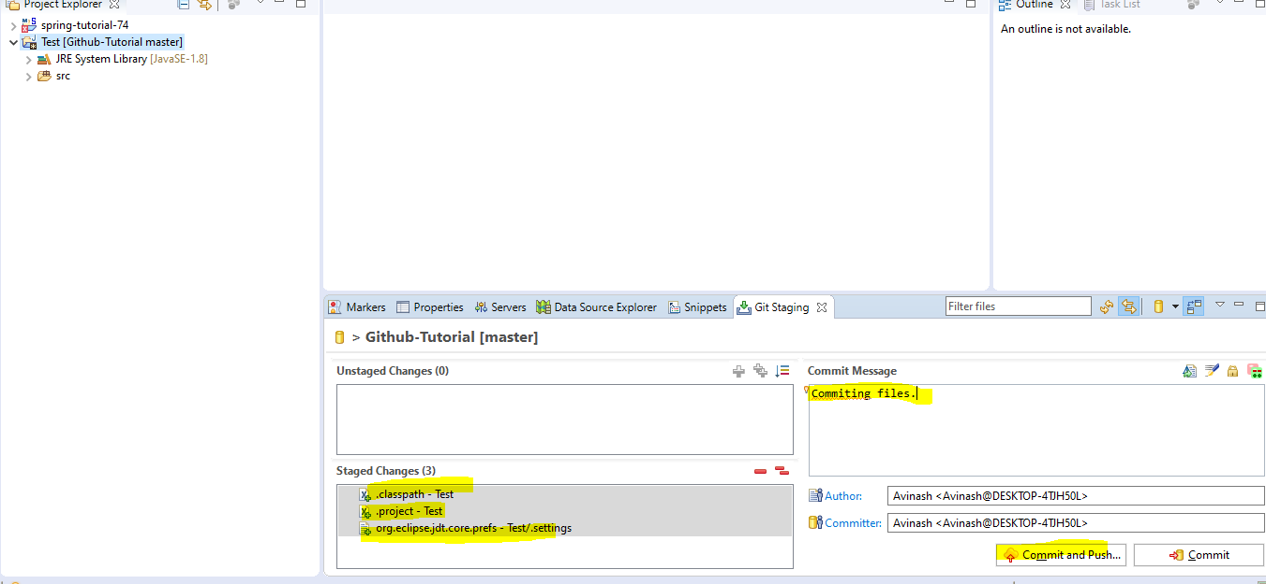

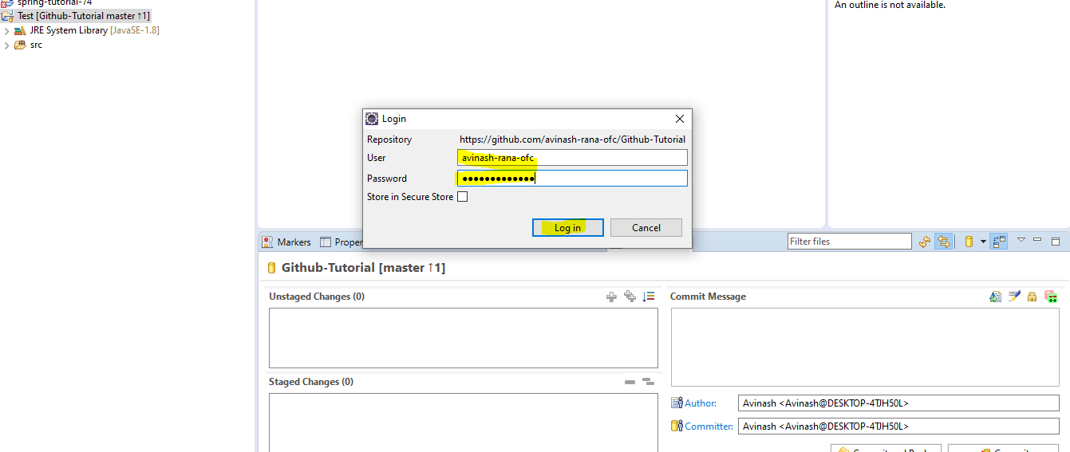

**Step 8:**

All the commited files we can see by refreshing our project in web.

Like below.

