**Rebel Foods Assignment**

-by Avinash Kumar Widhani

***Part One: ​To compare the experience of 2 food apps, one Indian and another its international counterpart.***

Indian App: ​**Swiggy**

International counterpart: ​**GrubHub**

*Five pointers for what I like and dislike the apps*

1. **Restaurant Page:**​In swiggy, when we open the restaurant page, there is a FAB (floatingaction button) at the bottom which helps the user to navigate across the menu. This is the feature which I liked in swiggy because in case of GrubHub, the user has to scroll the list to select the food items and it becomes a daunting task when the menu is too long.Also in swiggy there is button of veg only so that user can filter out only veg item but this feature is not there in GrubHub.

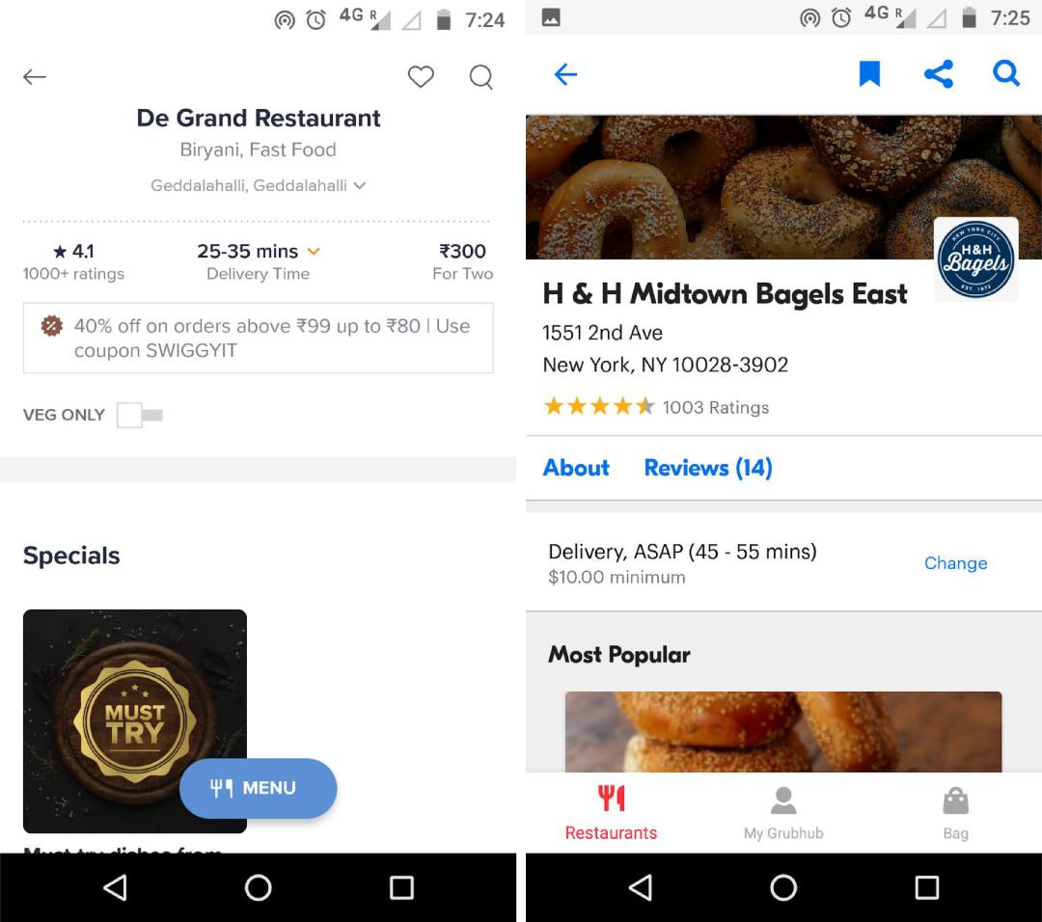

SWIGGY GrubHub

1. **Cart Page:**​One of the most important features that I liked in GrubHub in empty bagbutton. This is the feature that I am waiting for not only in swiggy but in all the food delivery apps in India i.e. an empty cart button. Assume a situation where you are

ordering for 3-4 people. Now if you order roti sabzi then you have to add too many rotis (12-16 for 4 people) but if we change our plan or find another good deal then we have to remove everything by clicking on " - "sign. It means more than 12 click just to remove everything from cart which a waste of user’s valuable time. When we come to GrubHub, there is a button "empty bag" which clears your cart on a single tap.

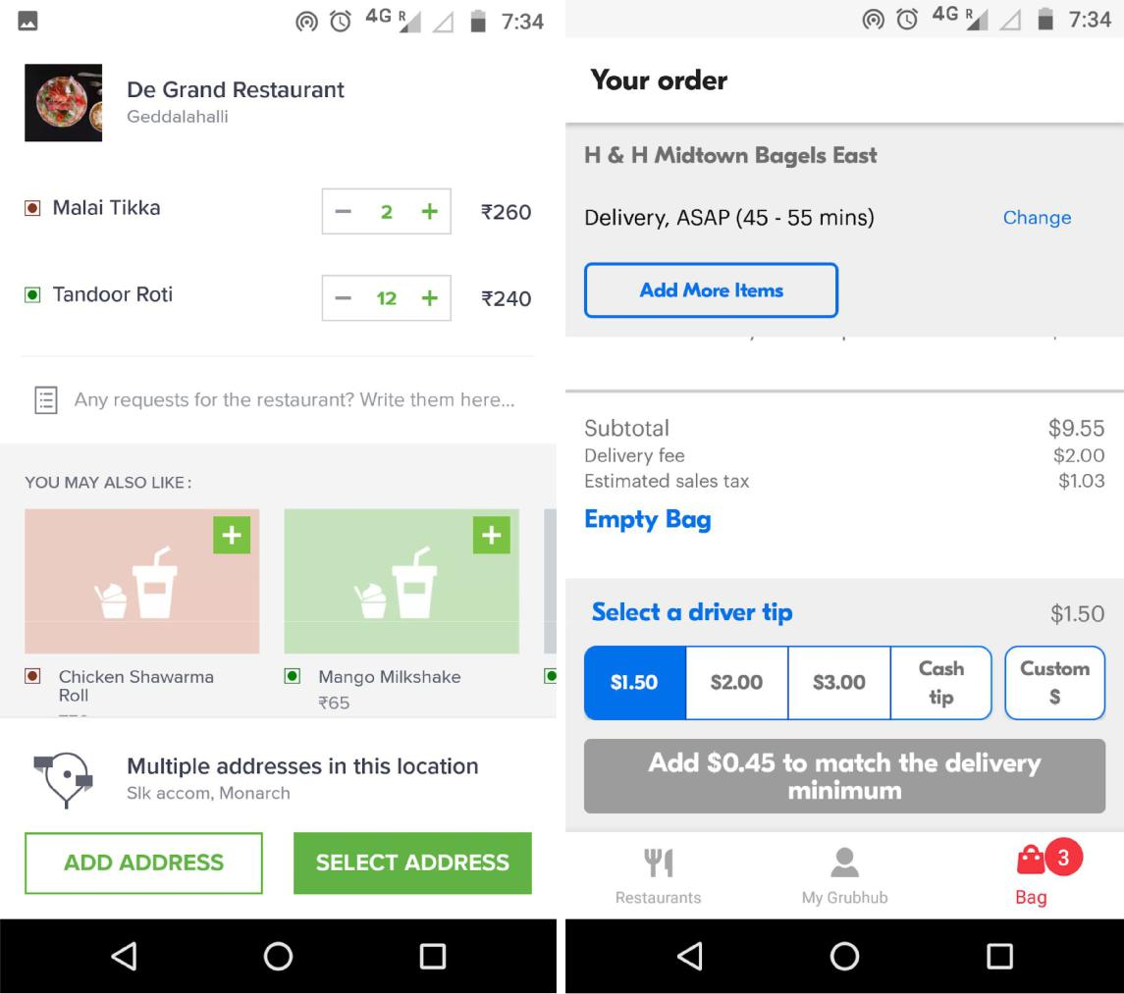

SWIGGY GrubHub

1. **Scheduling:**​When it comes to scheduling an order, I liked the way swiggy provided anoption on the top left corner for scheduling. User doesn't have to think much. It indicates “ASAP” to the delivery location. When we schedule an order using this feature, swiggy filters out the restaurant which can deliver in that specific time range. In case of GrubHub, either you first click on the restaurant and there it will show option for scheduling or you click refine and then apply a filter of scheduling and then it will show which restaurants can deliver within that time range. This is quite confusing as user has to think first that where they should go to schedule an order. Assume a situation where the user goes directly to the restaurant page and try for scheduling and it shows that scheduling is not available. It directly causes users to switch to other food-delivery.

services. It is an industry in which consumers have low switching cost and high bargaining power.

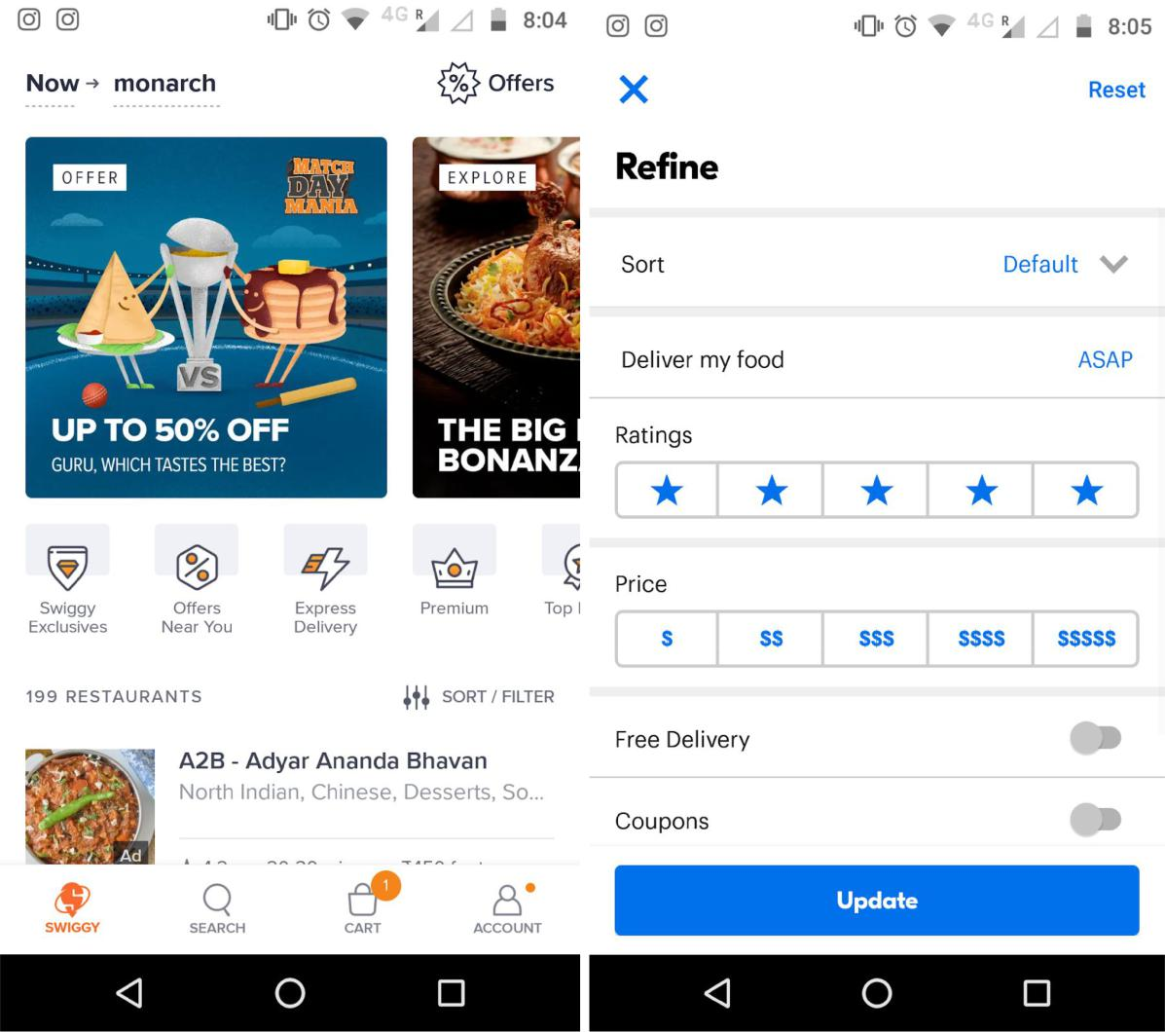

SWIGGY GrubHub

1. **Search:**​When we search any dish on GrubHub, it shows us all the restaurants on whichthe particular item is available. This feature I didn't liked at all. If we compare it with swiggy, with all the restaurant, it shows price, add button and all sorts of relevant information plus there is an option to switch between restaurants and dishes as well. This is how swiggy reduces the effort by user and provide a seamless user experience which I liked very much.

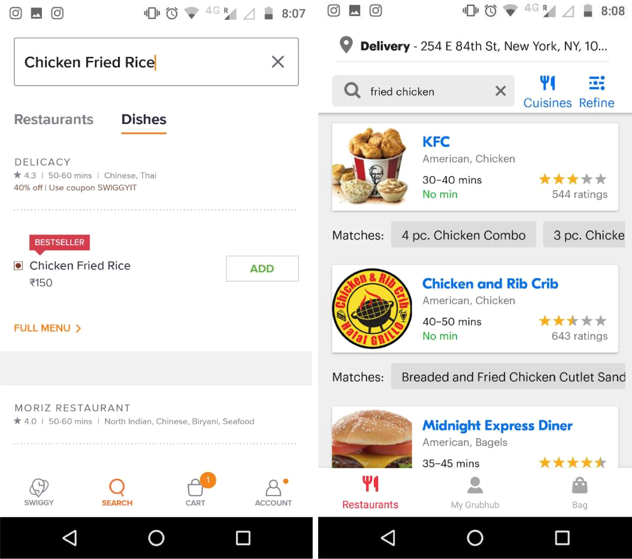

SWIGGY GrubHub

1. **Customization Page:**​I didn’t like the food customization page of swiggy. The reasonbehind is one of the radio buttons is always checked and all checkboxes are unchecked. Take example of Subway- When I click on add, it shows customization screen. Now even if user does not choose any thing, add item to cart button is enabled and if user clicks on that, the item gets added to the cart. In case of GrubHub everything is unchecked whether it is a radio button or a checkbox to ensure that user knows what they are ordering which is very essential. Until user selects their choices, Grubhub doesn't allow them to add item to cart by disabling the add to cart button. I know that swiggy has done this to reduce effort by user but for the user who don’t have much knowledge/experience in online food ordering may end up ordering something which they don't like.

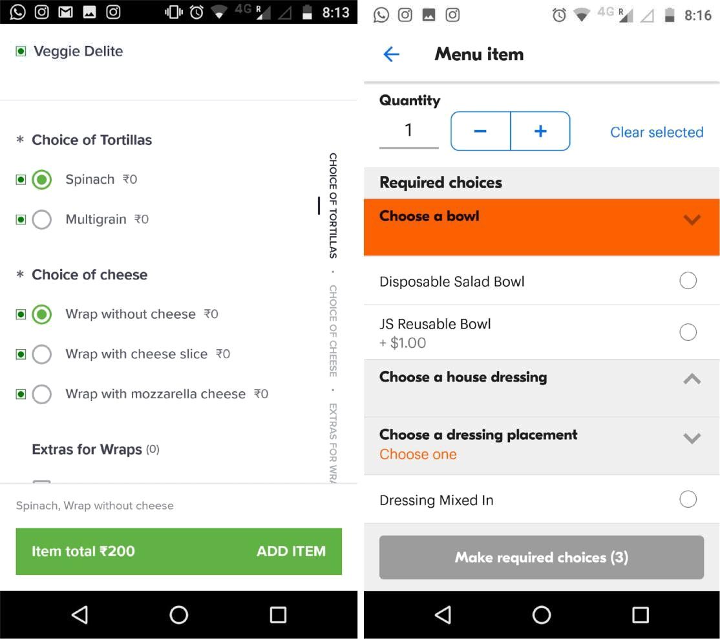

SWIGGY GrubHub

1. **Logout:** In swiggy user will be confused to log out because the logout button is not available in the account section. You have to scroll till the end. but in GrubHub, it is very easy to log out. everything is logical.

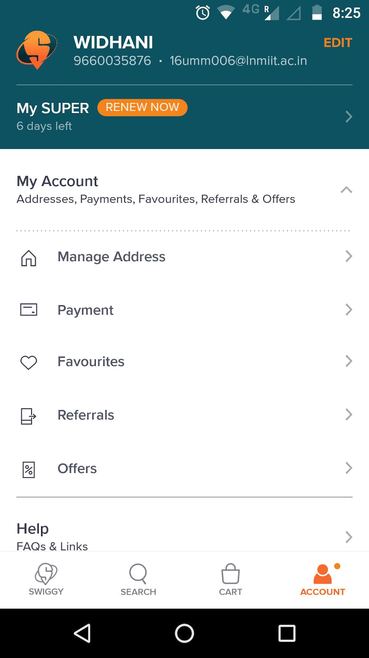

*Insights from the first part to ​****come up****​with new experience/ features which can make a difference in the Indian online food ordering industry.*

1. **Empty Cart Button:** ​An important feature which is required in all Indian food deliveryapp
2. **Scheduling:**​​ Automate the task of ordering food with the purpose of feeding thepopulation who order food everyday and end up with a mediocre option, even after waste a major amount of their time ordering food. I have done a project on similar kind of feature. I have provided the wireframe for the same with some changes in the next part.
3. **Customization Page:**​Just like GrubHub, the app should not allow to add item to cartuntil you customize it or specify your requirement. Here we can also add an option of cooking instruction which will be different from the one in cart section. This cooking instruction will only be for that specific food item and delivery instruction in cart will be for all.
4. **Personalized Homepage:** ​​Personalize restaurant display without specifying category tominimize cognitive load. Among all the restaurants, user clicked through those that met their preferences (types of cuisine). The take away from this observation is that

personalization of home page is key​.Users are less adventurous on food-delivery appsand only order from the type of cuisine they already like. Keep a minimal design by only displaying recommended restaurant based on users’ past order history or we can use the predictive analytics (used by e-commerce website) as well to provide user much more personalized UX.

1. **Different items from different restaurants:** ​Well this feature sounds a bit difficult, thatis why I have kept it in last. This is a feature in which the user can order different items from different restaurant. For example I can order main course from one restaurant and my dessert or beverage from another restaurant and both are brought to me by the same delivery boy together. This feature is much more related to logistics that’s I have kept it in last but maybe in future this feature can come.

*Wire-frames exhibiting some of the features/experience listed above.*

1. **Empty Cart Button:**

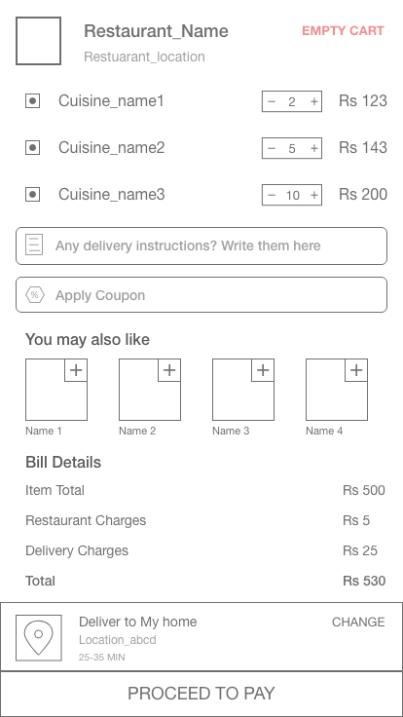

1. **Automated Scheduling:** The first screen (left one) will come during Signup so that the user can enter their preferences and app will show the dishes and restaurants accordingly. This also helps to create a personalized home screen which we discussed above. The second screen would come while placing an order. For example user orders a thali from a restaurant, so they have an option to schedule it for a complete week (the scheduling screen will change according to the which day of week you are scheduling) as the menu of thali changes everyday.

PS: User is also given an option to skip this step if they want to and can browser normally.

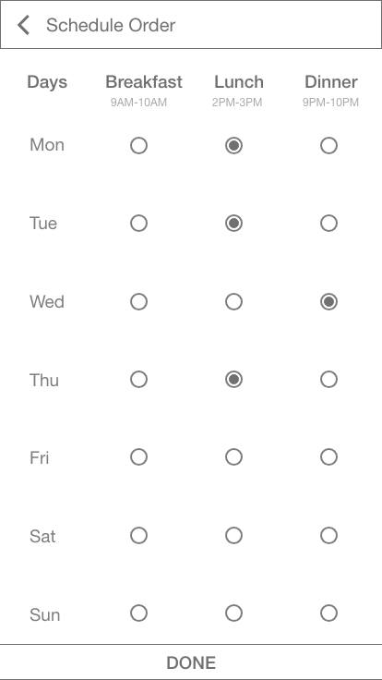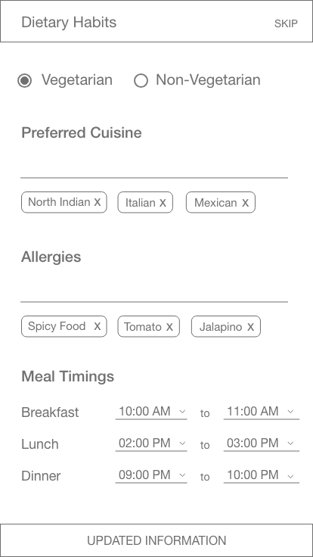

***Part Two: UI for Home Page and Cart:*** *For designing UI, I usually stick to material design but this time I’ve took the liberty to deviate from material design and followed what came naturally to me. Although I have stuck to basic principles of designing.*

1. **Home Screen:** Home Screen consist of similar features which are there in food delivery apps. Here I have used a carousel menu for listing. The main purpose to use carousel menu was to provide some more information to user and enhance the information architecture. A “Sell All” button is also provided at right side of every label which which navigate to a new screen showing the complete listing in that particular label. For example if I click “Sell All” of food categories it will navigate to a screen where it will show all the food categories available.

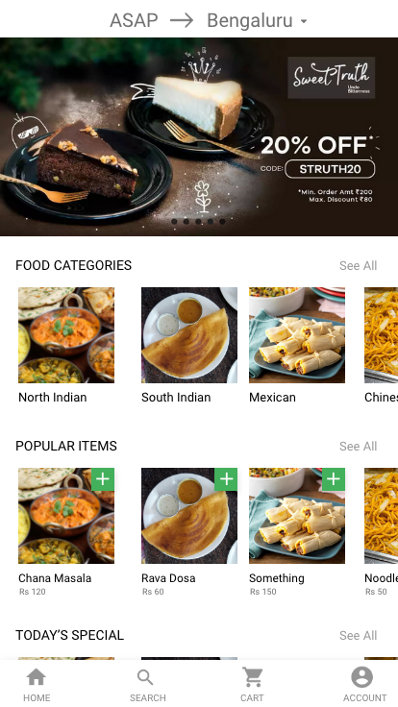

1. Cart Page: I tried to keep cart page as simple as possible. Organised the information in such a way that user is inform continuously about the current state. In the screen provided to me, the information architecture was not proper. First it shows the suggestion and then the price details. From user point of view they are always in a hurry and always look for affordable and discounted food and even before showing the order details we cannot offer them suggestion. A hierarchy needs to be followed that *this is your order->appy code(if any)->suggestions-> bill details.*

