Sentinels website security assessment
  - Web application vulnerability assessment
Avinash Kumar Singh
VIT Bhopal University
Registration number 23BCY10006
7 October 2026

Executive summary
The assessment identified three security issues in the Sentinels test website. The most serious was in the article download feature: changing the filename in a request allowed a file outside the public folder to be downloaded. A controlled request through Burp Suite returned /etc/hostname without an application login.
Two other issues were confirmed. Error pages revealed application code, internal paths and library versions. The application session cookie and the cookie used to access the test environment were also sent over plain HTTP because they lacked the Secure attribute.
ID | Finding | Severity
F01 | Directory traversal in article downloads | High
F02 | Detailed Rails errors disclose internal information | Medium
F03 | Session and access cookies can travel over HTTP | Medium

The download issue should be fixed first because it allows access beyond the intended folder. Detailed error pages should then be disabled for remote visitors, and cookie settings should be corrected. These changes are necessary before using the environment with real accounts or sensitive information.

Scope and method
The target was https://sentinels-interview.dev.hotstar-labs.com. Initial requests returned 403 Access Denied. An authorized signed link provided access through the site’s entry control. Testing then continued without an application login. Reproducing the findings from the tested network requires valid access through that entry control.
Testing used Burp Suite Community Edition v2026.8, browser inspection and scripted HTTP requests. Burp’s proxy captured the download and cookie checks. The detailed error response was also reproduced in Repeater. The findings come from manual checks; no Burp automated scanner results are claimed.
Severity reflects the observed behavior and its likely impact. The report does not assign numeric CVSS scores or claim unverified CVE exploits. No existing records were changed and no account was compromised.

F01 Directory traversal in article downloads
High severity | Confirmed | Affected input: file_name
The download feature accepts a filename from the request and joins it to the public folder. It then sends the resulting file to the visitor. The ../ sequence moves up a directory, allowing the request to reach a file outside that folder. A successful read of /etc/hostname confirmed this behavior.

Reproduction and observed result
After obtaining authorized access to the site, the following request was sent through Burp without an application login. It did not require an article_id:
GET /articles/download_file?file_name=..%2F..%2Fetc%2Fhostname
Host: sentinels-interview.dev.hotstar-labs.com
Evidence | Observed result
Positive test at 14:19:10 IST | HTTP 200; attachment filename="hostname"; 13-byte body
Returned content | 383b64e49b4f followed by a newline
Negative control | A nonexistent file at the same traversal depth returned HTTP 500

The nonexistent-file control returned 500. Together with the exposed code, the successful response confirms a file read outside the public folder. Testing was limited to /etc/hostname; no secrets, credentials or user files were requested.
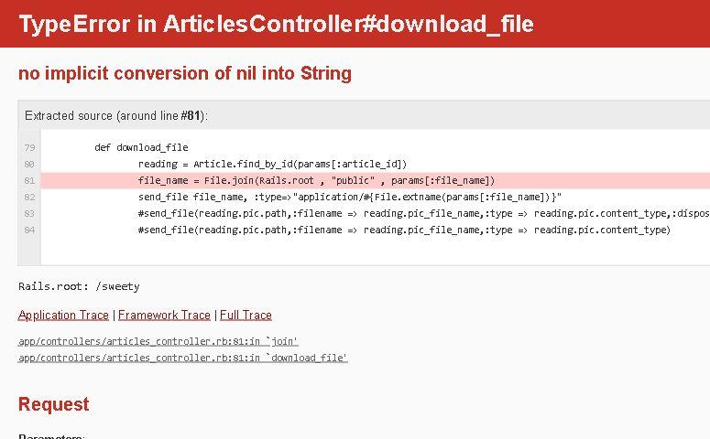
Figure 1. The download error page exposes the filename join and send_file call around line 81 of app/controllers/articles_controller.rb. The successful download result is recorded in the table above.

Impact and fix
Other files readable by the application may also be exposed, although that broader access was not tested. The download should look up an authorized attachment by its record ID. If a path is unavoidable, resolve its full location and verify that it stays inside the allowed folder, including after following symbolic links. Check ownership before sending the file. Retesting should confirm that traversal is blocked and legitimate downloads still work.

F02 Detailed error pages expose application information
Medium severity | Confirmed | Multiple error responses
After passing the site’s entry control, a visitor can trigger detailed Rails error pages without logging in. These pages show code excerpts, stack traces, library versions and the application folder /sweety. A request to an unknown route also revealed the route table, including the article download endpoint.
GET /users/sign_in.json
Result: HTTP 406 with ActionController::UnknownFormat
The regular sign-in page returned 200. Adding .json to the path returned 406 and displayed a detailed exception. The same response was reproduced in Burp Repeater. Omitting required inputs from the download and article-search routes also exposed controller code.
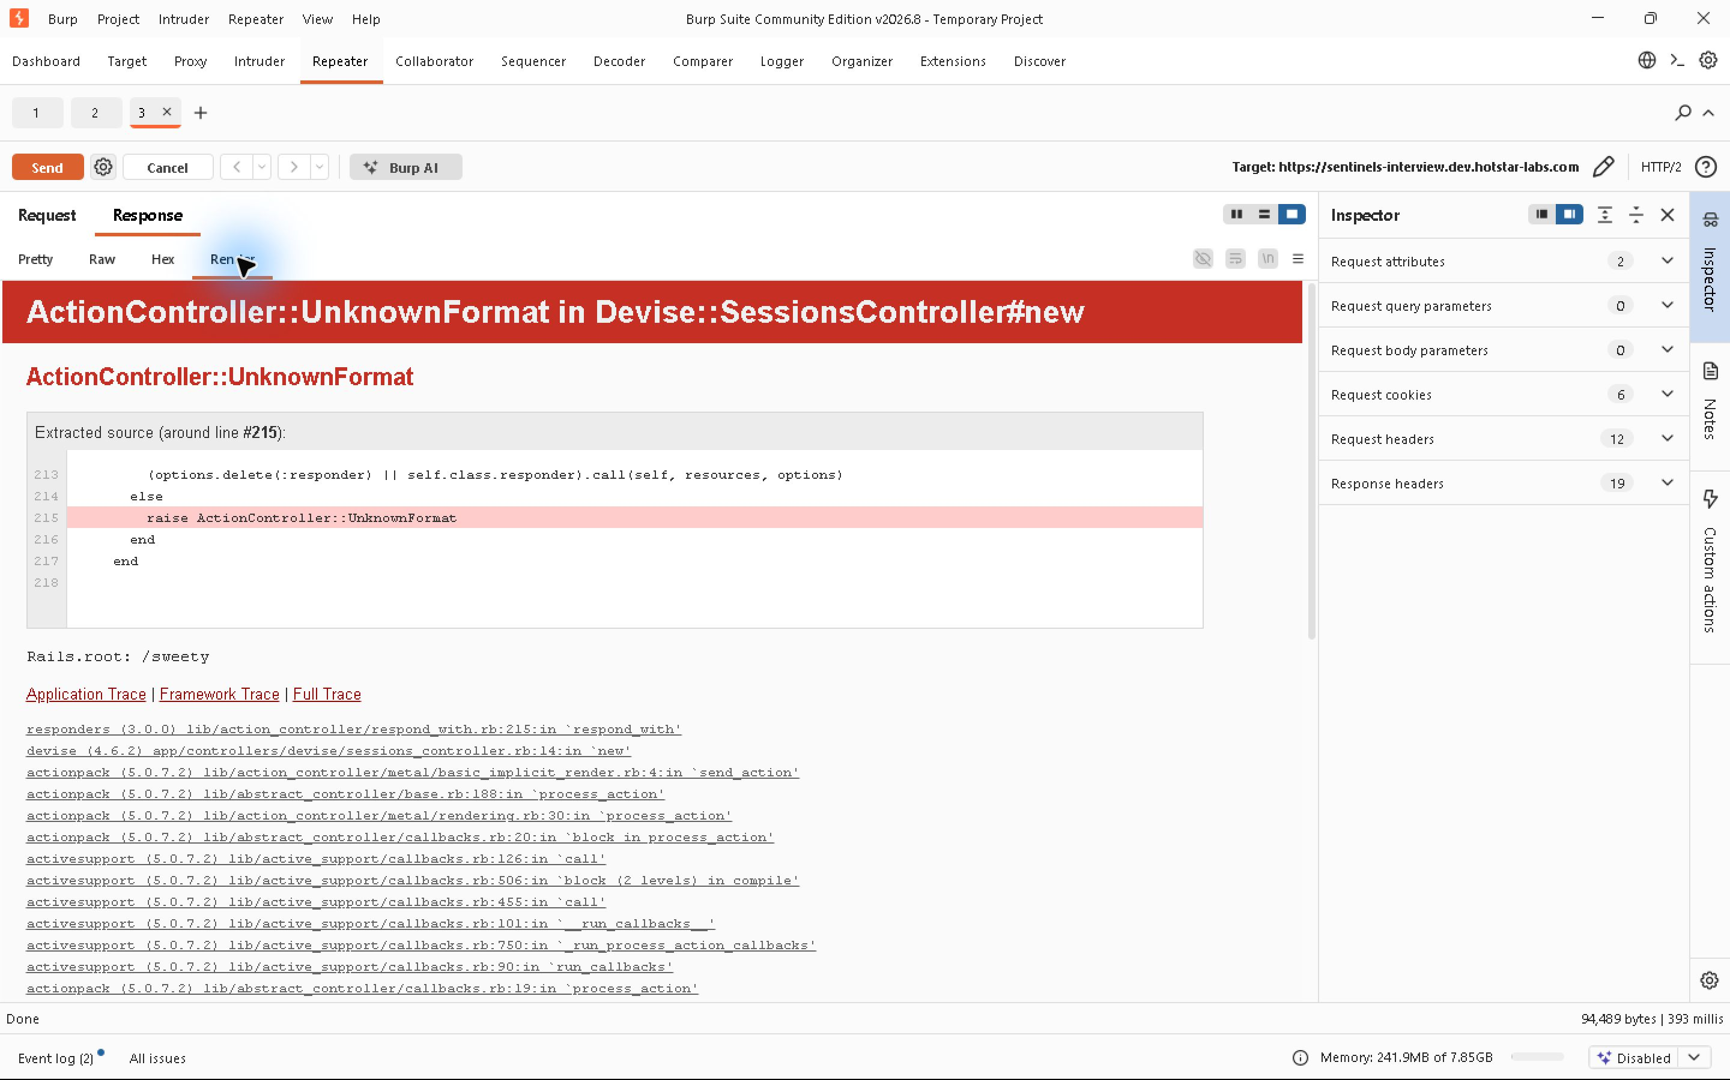
Figure 2. Burp Repeater displays the error response, source excerpt and framework trace. The cookie pane is hidden to keep access tokens out of the screenshot.

Impact and fix
These details make it easier to understand the application and target its weak points. In this assessment, the error output helped identify how the download feature handled filenames. The disclosure alone does not establish command execution or access to a Rails console.
Remote visitors should receive a brief error message, with diagnostic details kept in protected logs. Review the deployed Rails error settings, including config.consider_all_requests_local, and validate required inputs before using them. Repeat the three error cases after the fix. The responses should no longer include source code, internal paths, library versions or routes. [1]

F03 Session and access cookies lack secure transport protection
Medium severity | Confirmed transport exposure | Cookie configuration
The _rails-bootstrap_session cookie was set without the Secure attribute. The userAuth cookie issued by the signed access link also lacked Secure and HttpOnly. During a request through Burp, the test client’s cookie jar attached both cookies to an HTTP request. The server then returned a redirect to HTTPS.

Observed evidence
Set-Cookie: _rails-bootstrap_session=[REDACTED]; path=/; HttpOnly
Set-Cookie: userAuth=[REDACTED]; expires=[date]
Check | Observed result
HTTPS sign-in response | 200; application session cookie did not include Secure
HTTP GET / at 14:05:46 IST | Outgoing cookies included userAuth and _rails-bootstrap_session
HTTP response | 301 redirect to the HTTPS home page
Strict-Transport-Security | Not present in the sampled application responses

To repeat the check, establish authorized access over HTTPS using a fresh cookie jar. Then request the HTTP home page through Burp with the same jar. Inspect the outgoing Cookie header before the 301 redirect. Cookie values have been removed from the report.

Impact and limits
If a client sends these cookies over HTTP, someone able to observe that connection could read them. Redirecting the response to HTTPS does not protect the earlier request. Browser HTTPS-first settings or HSTS may reduce this risk; inherited and preloaded HSTS policies were not checked. This test demonstrated transmission by a cookie jar through Burp, not theft from another browser user.
The Rails cookie belonged to a session that had not logged in. Account takeover or reuse of a logged-in session was not tested. The userAuth cookie still needs protection because it is used to enter the test environment.

Recommended fix and retest
Set Secure on both cookies and retain HttpOnly on the Rails session. Add HttpOnly to userAuth unless the application genuinely needs JavaScript to read it. Choose an explicit SameSite policy that suits the application. Enable HSTS after checking the intended domain scope. Retest that the cookies are excluded from HTTP requests while normal HTTPS access still works. [2]

Testing coverage and recommended actions
Area | Outcome
Entry and signed access | Unsigned requests were denied; authorized signed access worked
Sign-in rejection | A login attempt with invented credentials was rejected
CSRF handling | A sign-in POST without a CSRF token returned 422 and a detailed error
Posts and articles | Listings and the new-article page loaded without login. Their intended access policy was not established, so no access-control flaw is claimed.
File boundary | Read of /etc/hostname confirmed; no sensitive files requested
Authenticated features | Account ownership, role isolation, session logout and reset flows not assessed
Other attack classes | No claim of SQL injection, stored XSS, upload execution or denial of service

Suggested repair order
1. Restrict the download endpoint until filenames are resolved safely. Verify that traversal fails and authorized downloads succeed.
2. Disable detailed errors for remote visitors and handle missing or unsupported inputs. Repeat the error cases described in F02.
3. Correct cookie attributes and HTTPS enforcement. Check cookies issued by both the application and the site’s entry control.
4. Review the deployed libraries. The trace reports Rails components 5.0.7.2, Devise 4.6.2, Rack 2.0.7 and Puma 3.12.1. Confirm the installed versions and plan upgrades to supported releases. A disclosed version alone is not proof that a particular CVE is exploitable. [3]

Assessment limits
The assessment covers the behavior observed during this testing session. It does not establish that all other parts of the application are secure. No application accounts or records were created, changed or deleted. File-read testing was limited to /etc/hostname. Code excerpts came from live error pages; the full repository and deployment configuration were not reviewed. Each finding needs a successful retest before it can be closed.

References
[1] Ruby on Rails configuration guide, consider_all_requests_local:
https://guides.rubyonrails.org/configuring.html#config-consider-all-requests-local
[2] MDN Set-Cookie reference, Secure and HttpOnly attributes:
https://developer.mozilla.org/en-US/docs/Web/HTTP/Reference/Headers/Set-Cookie
[3] Ruby on Rails maintenance policy:
https://guides.rubyonrails.org/maintenance_policy.html

