Mental Health and Well-being Support Agentic AI
Project Report
Author: Avinash M
Roll No: ______________
Department: ______________
College: ______________
University: ______________
Supervisor: ______________
Date of Submission: ______________
(Generated on 18/10/2025)

Table of Contents

1. Abstract
This project aims to create an AI-powered mental health and well-being support system that allows users to interact with an intelligent agent for emotional support and self-care guidance. Built using React for the frontend, Node.js and Express for the backend, MongoDB for database management, and Python integrated with the Gemini API for natural language understanding, the system provides personalized conversations, appointment booking with counselors, and well-being tracking. The goal is to enhance mental health accessibility through intelligent, empathetic AI support.

2. Introduction
The rise of mental health concerns worldwide has highlighted the need for accessible, scalable, and empathetic support systems. Many individuals face barriers to care, including stigma, cost, and availability of professionals.
Agentic AI systems can provide always-available assistance, helping users reflect, self-regulate, and access resources. This project explores such a system, combining an LLM-powered agent with secure backend services and a responsive web interface.
Motivation includes improving access, reducing wait times, and augmenting professional care with supportive, privacy-aware tools.

3. Objectives
- Design an intelligent agent capable of responding empathetically to users
- Integrate a real-time counseling request and booking feature
- Securely manage user and counselor data
- Implement an interactive web interface using React
- Ensure privacy and security in user communications

4. System Architecture / Methodology
Frontend: React.js for UI
Backend: Node.js + Express for API endpoints
Database: MongoDB for storing user, counselor, and session data
AI Agent: Python (Flask) with Gemini API for NLU/NLG
Integration: Communication between backend and AI agent via REST
Flow: [User] → [React Frontend] → [Express Server] → [Python Agent + Gemini API] → [Response]; MongoDB supports persistence.
Figure 1: System Architecture Diagram
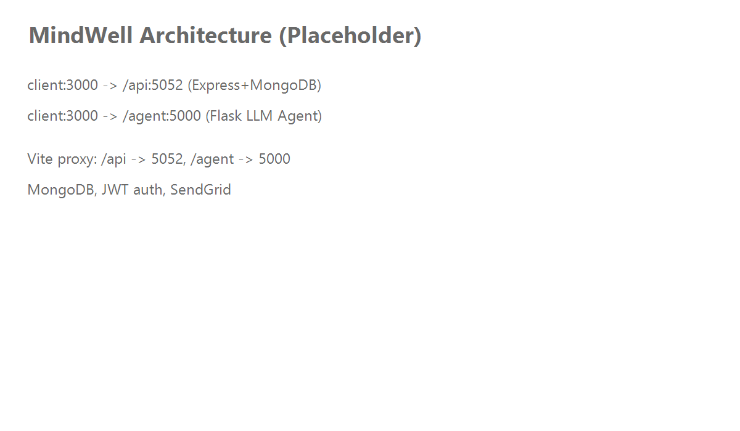

5. Modules / Features
- User Authentication (Login/Signup) with JWT
- AI Chat Support (Gemini API-based agent)
- Counselor Management (stored in MongoDB)
- Counseling Session Booking
- Email Notification System (SendGrid/Nodemailer)
- Admin Dashboard (optional)
Each module integrates with the core API and contributes to the user experience for guidance, triage, and follow-up.

6. Technologies Used
Layer | Technologies
Frontend | React.js, Vite, CSS, JavaScript
Backend | Node.js, Express.js, Mongoose (MongoDB)
Database | MongoDB
AI Integration | Python, Flask, Google Generative AI (Gemini API)
Additional | Nodemailer, Axios, CORS, JWT Authentication, Dotenv

7. Implementation
The frontend collects messages and routes agent queries to the Flask service via the dev proxy at /agent. The Node API manages users, sessions, and auxiliary workflows (e.g., email).
Example Node → Python data flow:
POST client:/agent/chat → Flask:/chat → LLM → JSON response
Example backend API usage:
GET client:/api/health → Express:/api/health → 200 OK
Database schemas (e.g., User, Session) define core entities and are persisted via Mongoose.

8. Results / Output
- Chat interface renders AI responses and supports iterative conversations
- Counselor booking flow returns confirmations
- Agent health and API health endpoints report service status
- MongoDB collections store users, sessions, and resources
(Insert screenshots of chat, booking confirmations, and DB entries here.)

9. Conclusion
The system demonstrates an integrated Agentic AI approach for accessible mental health support, combining an LLM agent with secure backend services and a modern web UI. It offers a foundation for empathetic, available assistance and can augment professional support.

10. Future Scope
- Integrate voice-based emotional analysis
- Add multi-language support
- Use sentiment analysis for more empathetic responses
- Build a mobile app version
- Enhance long-term memory and retrieval

11. References
- Gemini API documentation
- React, Node.js, Express, MongoDB official docs
- Research on AI for mental health and digital therapeutics

