SIMATS ENGINEERING
Department of Information Technology
DSA01 – Object Oriented Programming with C++

ASSIGNMENT 1 – CO2
Design, Implement and Validate the Fare Logic of a City Metro Smart Card System
CO1: Apply object oriented programming principles and C++ constructs such as data types, operators and control structures to design and write structured OOP based programs.
Student Name | K Avinash | Register Number | 192411044
Department / Section | CSE | Academic Year/ Semester | 2024
Faculty Name | Dr.Amirtha | Nature of Assignment | Individual
Duration | 1 Week | Total Marks | 50
Date of Submission | 7-11-26 | Date of Evaluation
GitHub Repository | github.com/avinash19107/DSA01-192411044/tree/main/Assignment/CO2 | Compiler | g++ 13.3.0, -std=c++17 -Wall -Wextra

MARK SHEET (Rubric based Evaluation)
Task | Task Title | Max | Marks Awarded | Remarks
1 | Object Oriented Analysis | 4
2 | Tokens, Keywords, Identifiers and Constants | 3
3 | Data Types and Compatibility | 4
4 | Implicit Conversions | 4
5 | Operators and Precedence | 4
6 | Control Structures | 4
7 | Procedural vs Object Oriented | 4
8 | Input and Output | 4
9 | Implementation and Testing | 4
10 | Expectation vs Execution | 4
11 | Final Recommendation | 4
12A | Re evaluate: Impact Analysis | 2
12B | Re evaluate: Evaluation of Original Design | 2
12C | Re evaluate: Adaptation or Redesign | 2
12D | Re evaluate: Evidence Based Defence | 2
 | TOTAL | 50 |  | Percentage:
OVERALL REMARKS

Avinash k
Student Signature | Faculty Signature | Program Director

Q1 – Call by Value, by Reference and by Pointer
The three parameter-passing methods differ in whether the function receives an independent copy or access to the caller's object. In call by value, the parameter is a local copy, so changing it does not modify the caller's fee. In call by reference, the parameter is an alias for the caller's variable. In call by pointer, the function receives an address and changes the pointed-to object by dereferencing the pointer.
The concession comparison starts each fee at Rs 45,000. A 10% value concession changes only the local copy to Rs 40,500, leaving the stored fee at Rs 45,000. A 15% reference concession changes the caller's fee to Rs 38,250. A 25% pointer concession changes the caller's fee to Rs 33,750.

Prediction and observed output
Before execution, the predicted output for the supplied change/bigger/show program was:
1 12 13\n1 100\n16 13 6
The actual output matched. `a` remains 1 because `a` is passed by value; `b` and `c` become 12 and 13 because they are passed by reference and pointer. `bigger(a, c)` returns a reference to the larger variable; assigning 100 therefore changes `c`. The calls to `show` use default values (5 and 10), then only 10, then no defaults.
A `const` reference is appropriate when a function should read a potentially large object without copying it but must not modify it. For multiple concessions, returning the new fee makes the transformation explicit and composable; in-place reference modification is also reasonable when the operation is intentionally an update to the student's stored fee. The chosen interface should make the side effect clear.
Complexity: each arithmetic concession is O(1). Passing a `long long` by value copies a fixed-size scalar; passing by reference or pointer passes an address-sized handle. Passing a large Student object by value copies the object and its members, while a reference or const reference avoids that object copy.
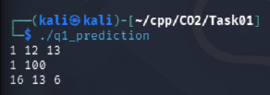
Q1 prediction program output
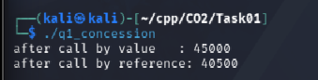
Q1 completed concession function output
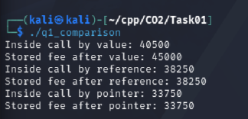
Q1 value, reference and pointer comparison

Q2 – Return by Reference and Its Dangers
The highest-mark function scans the array and returns a reference to the element containing the maximum mark. The reference aliases the original array element, so `highestMark(marks, 5) += 2` changes the stored mark from 92 to 94. Returning a reference is safe here because the referenced array remains alive after the function returns.
A reference to a local automatic variable must not be returned. The local object ceases to exist when the function returns, leaving a dangling reference. The compiler emitted the warning `reference to local variable 'value' returned`. The program was compiled to capture this diagnostic and was not executed.
A non-const reference permits modification of the referred element. A const reference permits read-only access without copying. Returning a copy creates an independent value; modifying that copy does not modify the original array. In the comparison test, the array element became 98 through the non-const reference, while the const-reference and copy calls both read 98.
A vector may reallocate its storage when it grows. Such reallocation invalidates references, pointers and iterators to its elements. The capacity test reserved space for two elements, then adding a third increased capacity to four. The old reference was deliberately not accessed after growth.
Alternative interfaces: returning an index gives the caller a stable logical position only while the container's ordering/content assumptions remain valid; the caller accesses `marks[index]`. Returning a pointer gives direct element access but has similar lifetime and invalidation risks to a reference. Finding the maximum is O(n) time and O(1) auxiliary space for all three approaches.
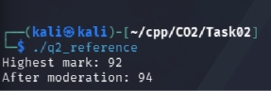
Q2 highest mark returned by reference
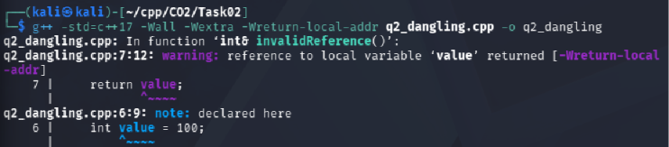
Q2 compiler warning for returning a local reference
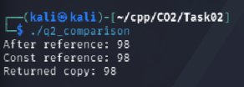
Q2 reference, const reference and copy
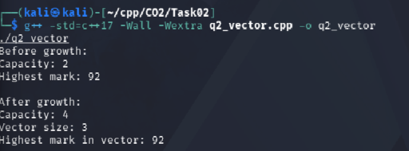
Q2 vector capacity growth

Q3 – Default Arguments and Function Overloading
The original overload set is ambiguous for `charge(2.0)`: both `charge(double)` and the three-parameter overload with default arguments can accept the call. The compiler identified the competing candidates and rejected the call.
The revised design uses three distinct parameter types: `int` for weight in grams, `double` for weight in kilograms with optional express and insurance flags, and `const Parcel&` for a parcel object. The six test calls select the intended overloads: `charge(2000)` selects int; `charge(2.0)` selects double; `charge(2)` selects int; `charge(2.0f)` selects double by conversion; `charge(2.0, true)` selects double; and `charge(p)` selects Parcel.
Overload resolution occurs at compile time. The compiler prefers an exact match over a promotion, and a promotion over a standard conversion when comparing viable candidates. Default arguments supply omitted trailing arguments; therefore, they are specified from right to left. A single Parcel structure could hold optional settings and reduce overload count, while a function template could generalise numeric input types. Overload resolution has no runtime cost; copying a Parcel by value would copy its fields, while the const-reference overload avoids that copy.
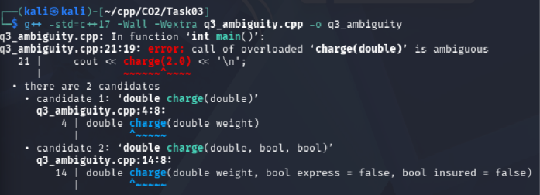
Q3 ambiguous overload compiler error
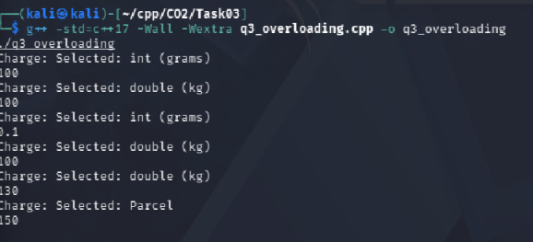
Q3 overload selection results

Q4 – Specifying a Class with an Array Inside It
The SavingsAccount class encapsulates the account number, balance, ten-transaction array and transaction count as private data. Public operations expose controlled deposits, withdrawals and mini-statement output. The constructor and the small insertion function are defined inside the class; deposit, withdraw and miniStatement are defined outside using `SavingsAccount::`.
The transaction array is private to preserve invariants: callers cannot directly overwrite the balance or corrupt the transaction count. When the array is full, the implementation shifts entries one position left and writes the new transaction at the end. The capacity test inserted eleven transactions and retained 200 through 1100, discarding the oldest value 100.
For a fixed array of k entries, shifting costs O(k) per full insertion and O(k) storage. A circular buffer stores a start index and overwrites the oldest slot in O(1) insertion time, with O(k) storage. A deque can also support push_back/pop_front in amortised O(1) time. Increasing the fixed capacity from 10 to 50 changes the array size and loop bounds; a circular-buffer implementation changes its capacity constant but retains the same algorithm.
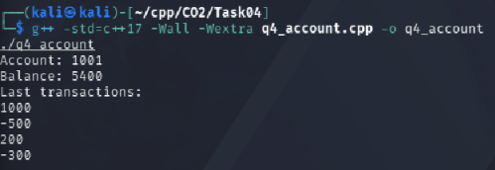
Q4 savings account mini-statement
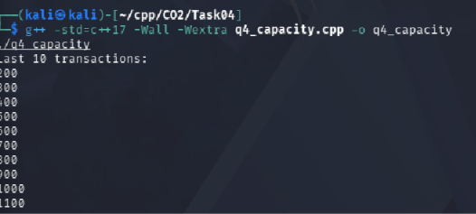
Q4 last ten transactions after eleven insertions

Q5 – Static Members and Arrays of Objects
The Token class has one static data member `next`, shared by every Token object. It is defined outside the class as `int Token::next = 100;`. Each constructor increments the shared counter and stores the resulting identifier in the individual object. Three array elements followed by one extra object produce identifiers 101, 102, 103 and 104; `issued()` returns four.
The BusTicket class uses static `issued` and `CAPACITY` members because seat allocation and capacity belong to the bus-ticket class as a whole. Each object stores its own seat number and passenger name. A static member function has no `this` pointer and cannot directly access non-static instance members because it is not called on one particular object.
The four-object test issues seats 1, 2 and 3, then places Dev on the waiting list; the static count is three. The function-call test shows that static state persists after a function returns: the first call issues seats 1–3; the second issues seats 4–5 and places the third ticket on the waiting list. A separate TicketOffice object would allow independent counters for multiple buses and make the bus context explicit; a global counter would be less encapsulated.
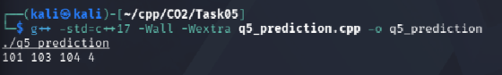
Q5 static token prediction output
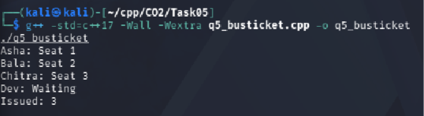
Q5 bus ticket capacity and waiting list
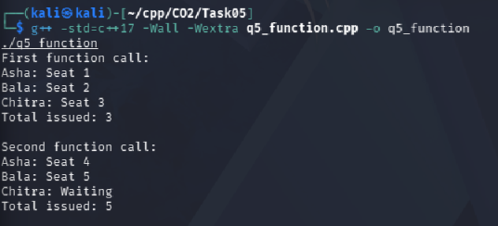
Q5 static counter across function calls

Q6 – Friend Functions and Inline Functions
The Time class keeps hours and minutes private. The friend functions `minutesBetween` and `earlier` are non-member functions granted access to those private members. They are called as ordinary functions with two Time arguments, which is appropriate for symmetric comparisons between two objects. Making the fields public would weaken encapsulation and allow callers to create invalid time values.
The correctness tests produced 205 minutes and false for 09:45 versus 13:10 in the reversed earlier check; 60 minutes and true for 11:30 versus 12:30; and 0 minutes and false for equal times. The functions are small and declared inline, but `inline` is primarily a request/ODR mechanism and does not guarantee that the compiler substitutes the function body at every call.
The benchmark executed 10,000,000 calls. Recorded `-O0` timings were 16 ms for the inline function and 16 ms for the non-inlined function. Recorded `-O2` timings were 0 ms for the inline function and 4 ms for the non-inlined function. The 0 ms display means the measured duration was below the millisecond resolution of the output, not that execution necessarily took no time. Compiler optimisation and measurement noise affect the result. Member functions or getters would preserve encapsulation; getters avoid friend access but add accessor calls that an optimiser may inline. The friend design remains concise for symmetric operations.
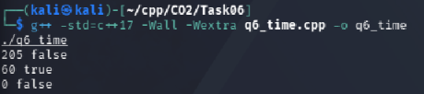
Q6 time comparison and correctness tests
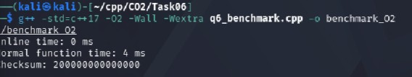
Q6 benchmark compiled with -O2
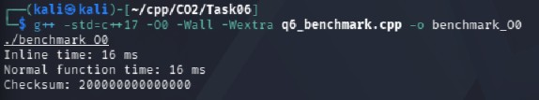
Q6 benchmark compiled with -O0

Q7 – Diagnose, Redesign and Validate
The selected limitation is the fixed transaction history implemented by shifting an array whenever it is full. Each insertion after capacity is reached moves nine stored values for a ten-element history. The design objective is to retain the newest ten values while reducing the insertion work per new value.
The redesign uses a circular buffer with a start index. While the buffer is not full, values are appended at the logical end. Once full, a new value overwrites the oldest slot and advances the start index. This uses the same fixed storage size and preserves the chronological order when read through the logical index.
Prediction: the circular buffer should reduce the insertion work from O(k) element shifts to O(1) index arithmetic and one assignment, while both designs should retain the same last ten values. In the measured test of five million insertions, the shifting array took 24 ms and the circular buffer took 12 ms. Both produced the same final-ten sum, 49999945.
The measured result supports the objective for this workload, with the circular buffer taking half the recorded time in this run. The circular design adds index-management logic and requires careful logical-order access. For very small histories or when simplicity is more important than insertion cost, the shifting array remains understandable and may be adequate. Timings are system- and load-dependent.
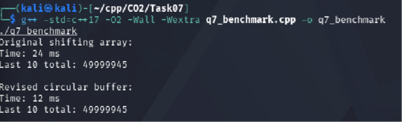
Q7 shifting array versus circular buffer benchmark

