Project4 - Final - Oscar Award Project - Best Actor

1. Demo Site as per the article

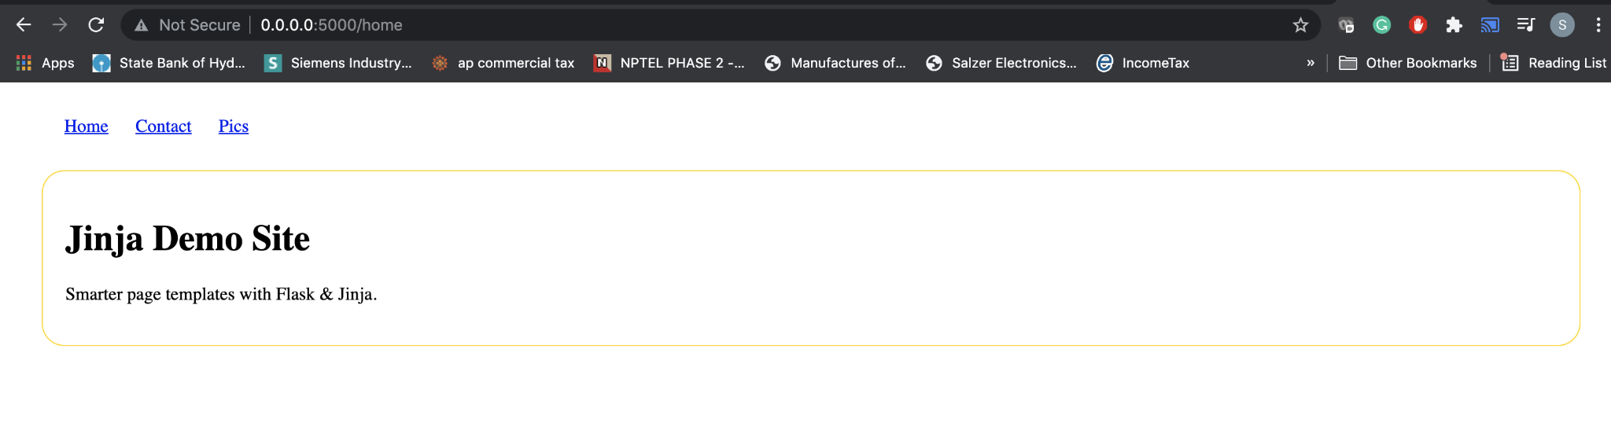

1. Separation of Concerns
2. Used Flask Framework
3. Rendered pages using Jinja
4. Moved all the configuration data into config file.
5. Separated the routes accordingly into separate categories(Ex: add,edit,delete)
6. Used to concept of Demystifying Flask’s Application Factory and started the app using wsgi.py

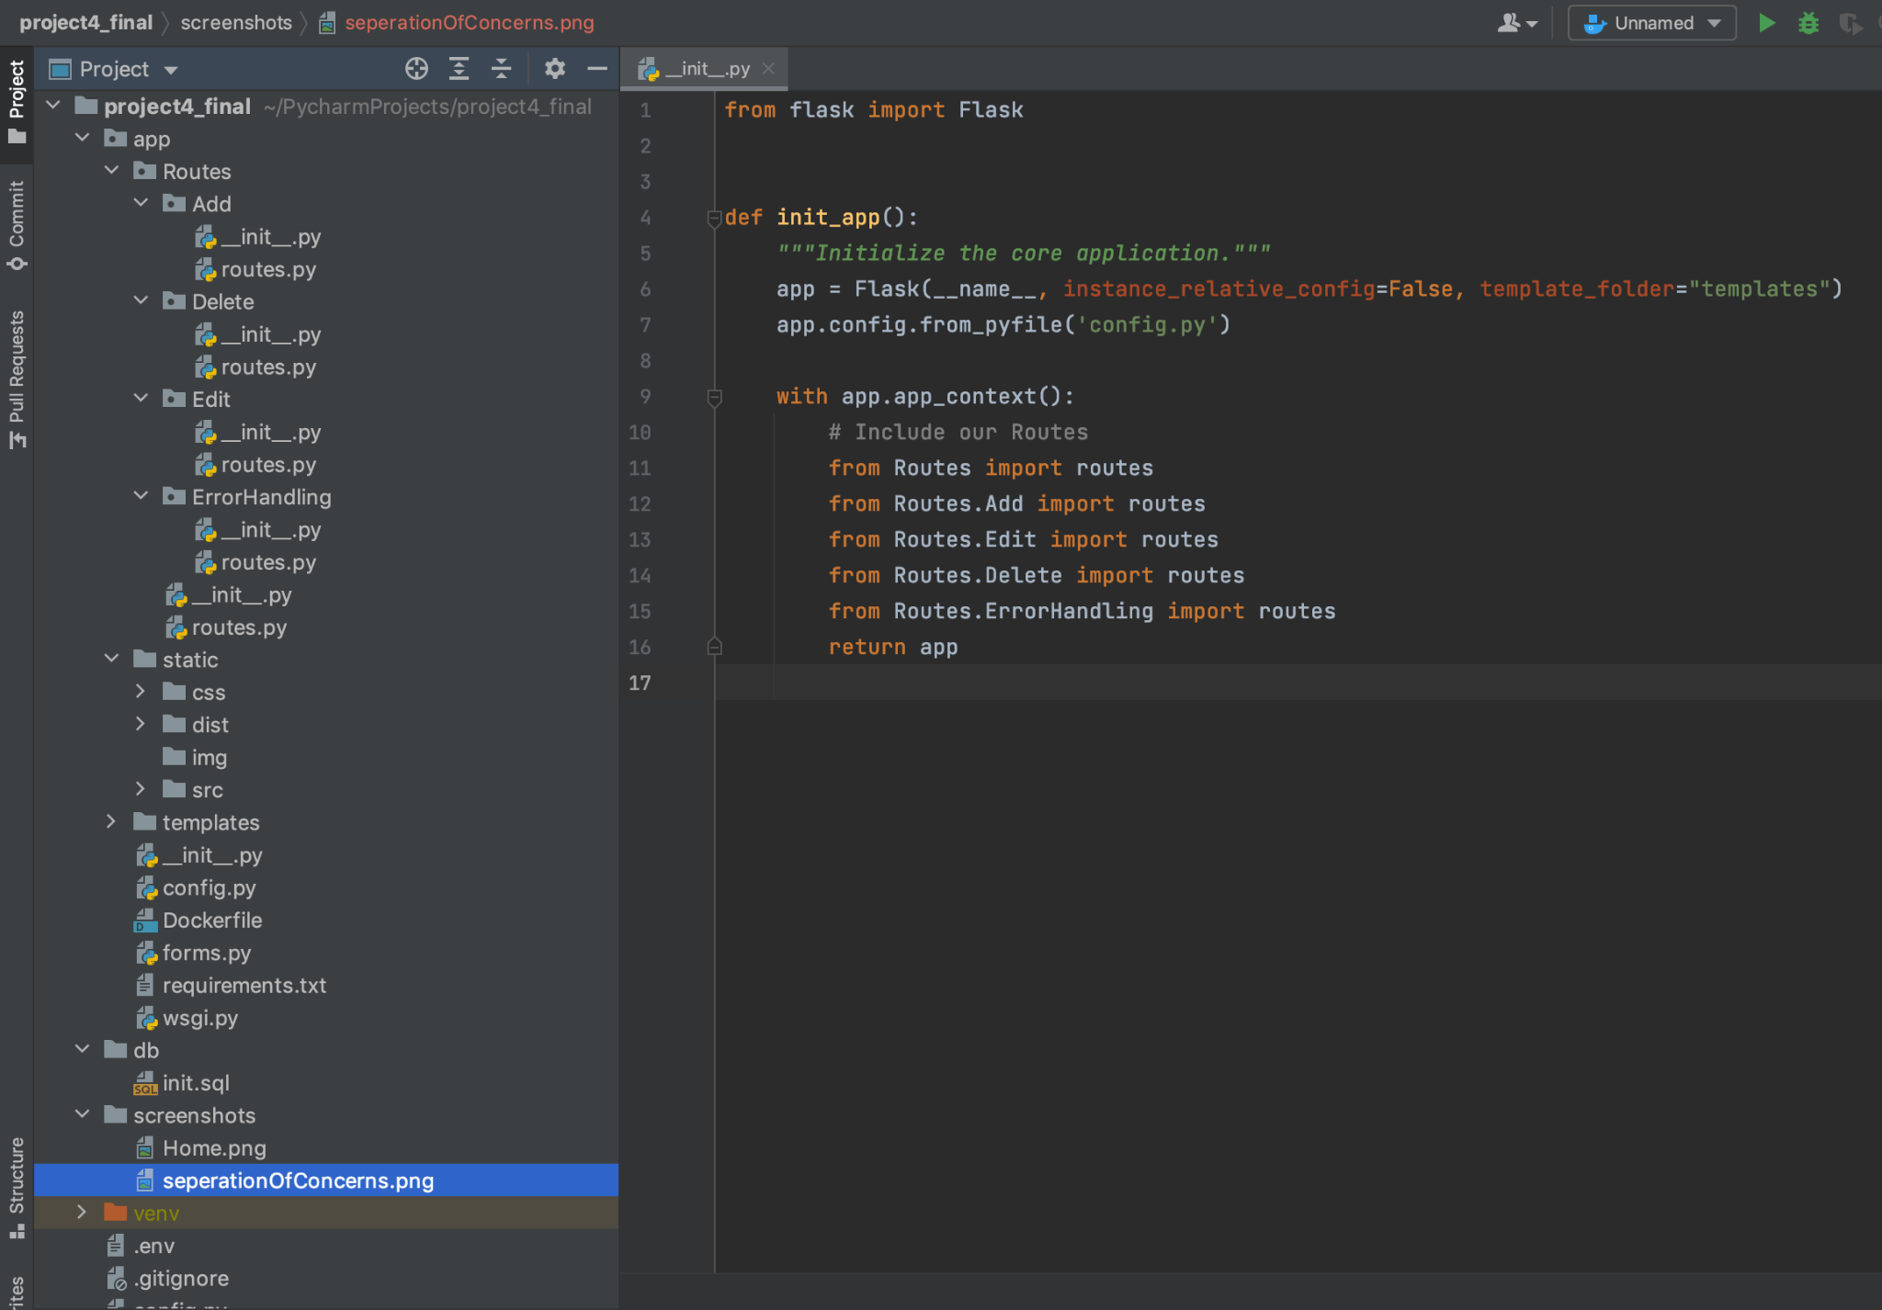

2.

1. Oscar Awards Table:

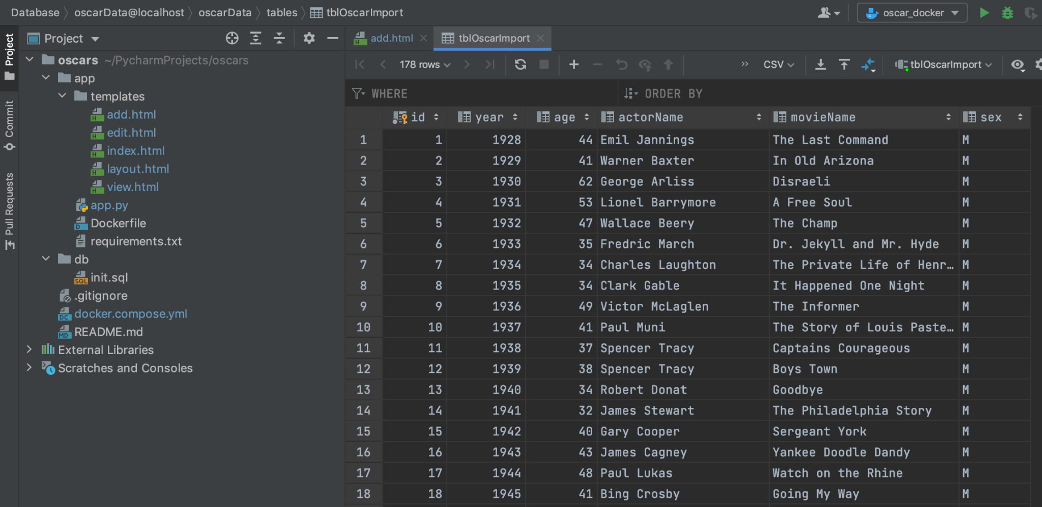

1. Home Page:

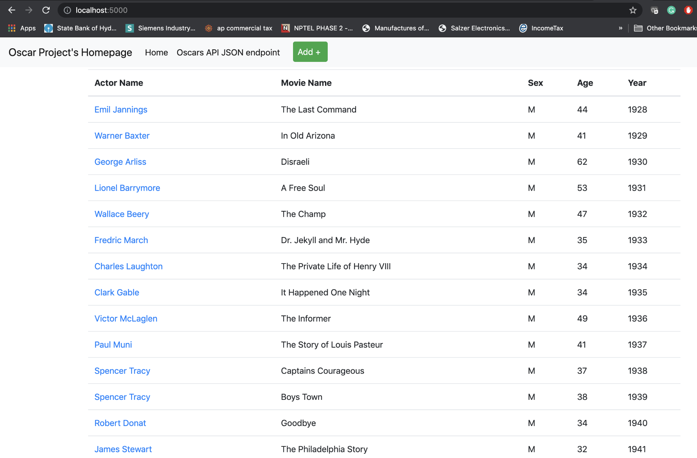

1. View of record:

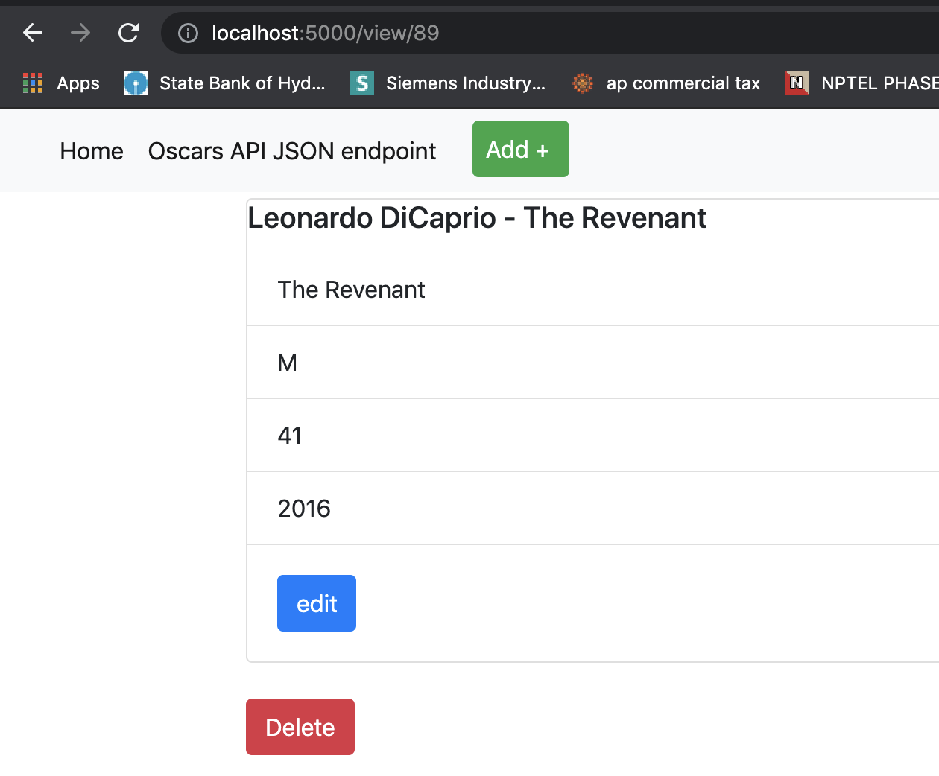

1. Addition of record:

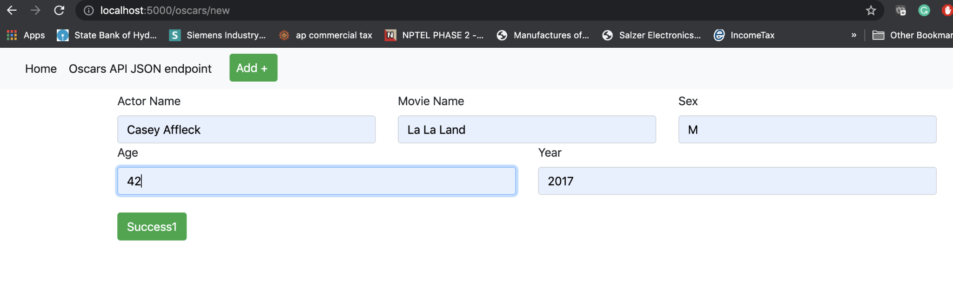

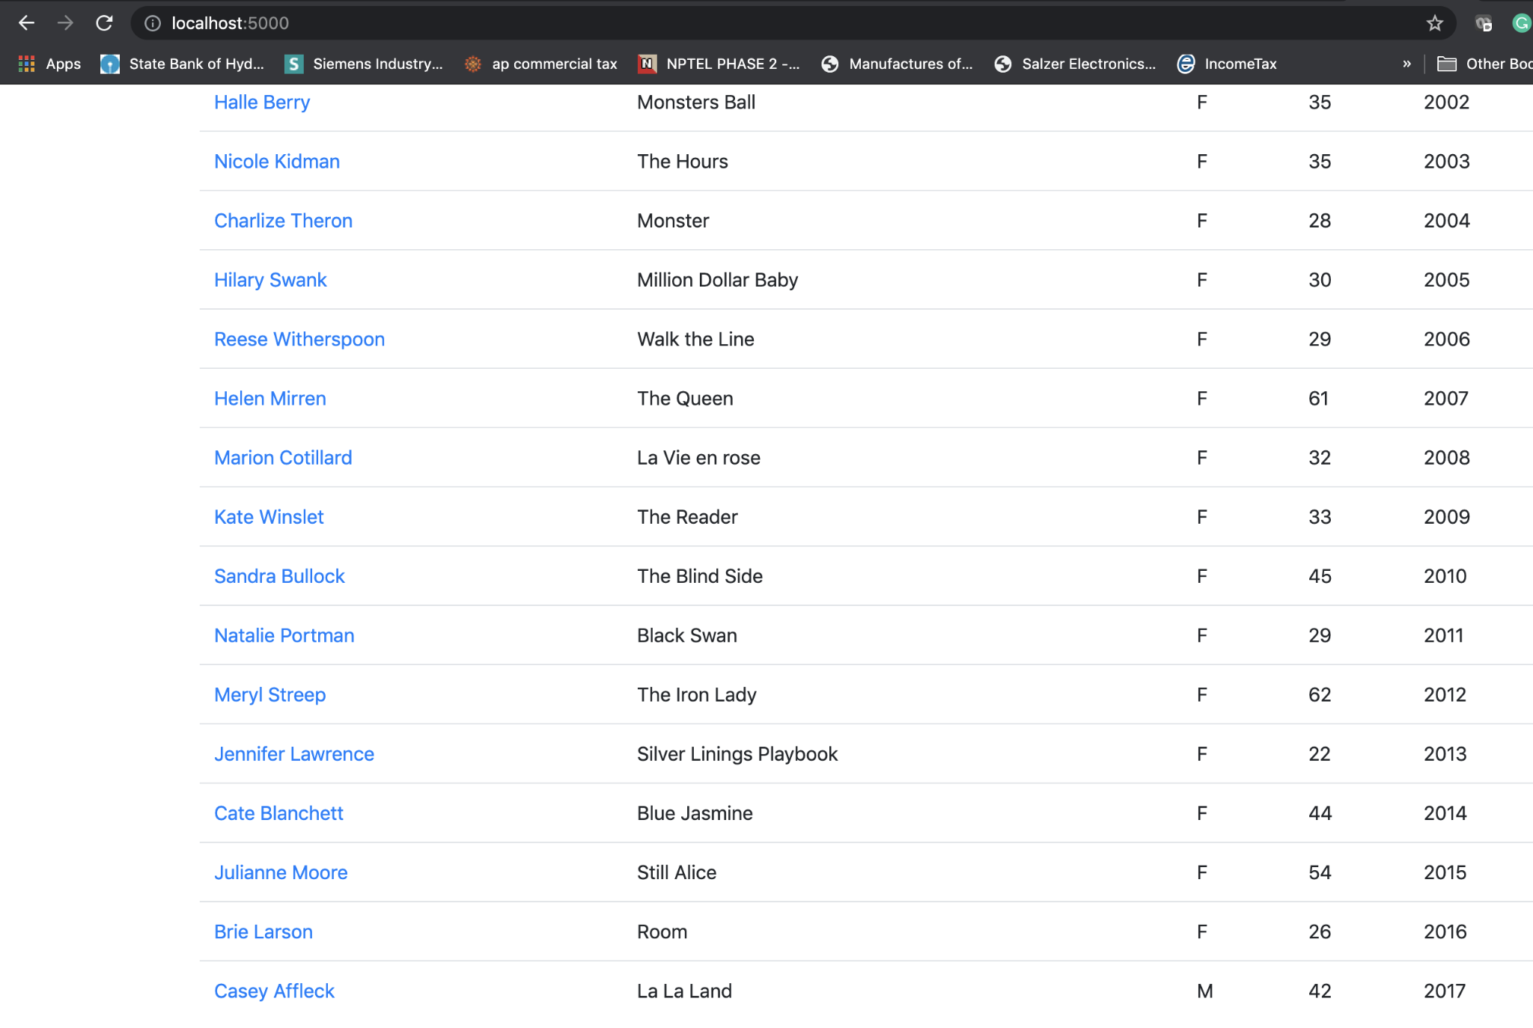

1. Updated record:

Changed Age

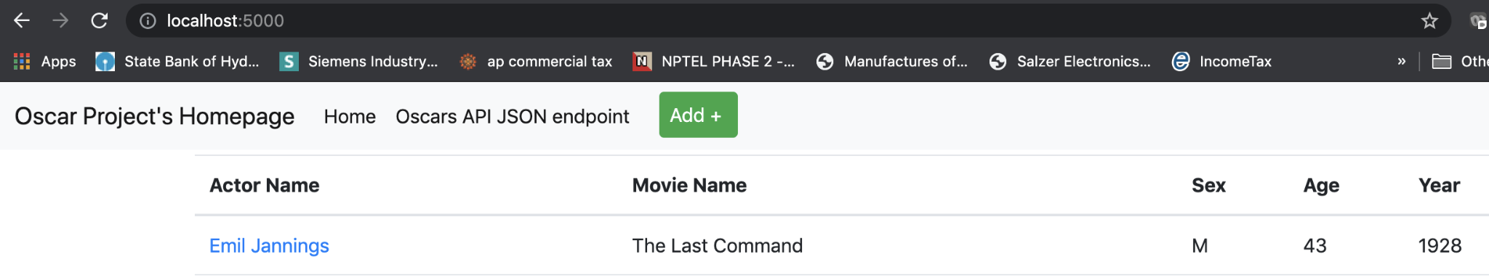

1. Deleted Record

Deleted the record “Emil Jannings - The Last Command”

