**Practical No: 10**

**Aim: Path finding using Ant Colony Optimization with an application.**

Step1: Install the package.

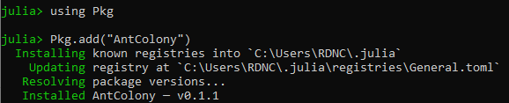

Step2: Create a distance matrix which defines the cost of travelling between nodes. Note that this matrix represents a directed graph and therefore the matrix need not be symmetric.

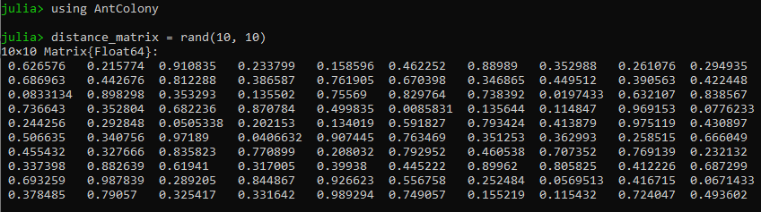

Step3: Find a path which visits all nodes and returns to the start node. Note the function doesn't return the start node twice.

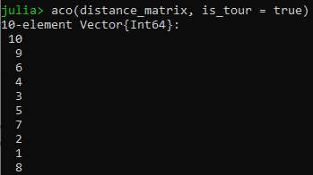

Step 4: Find a path with a specific start and end node

