**Practical No: 01**

**Aim: Implement Contour Plots.**

Step1: Basic Contour Plots.



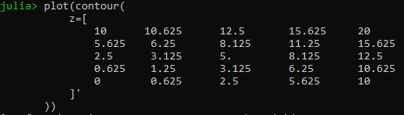

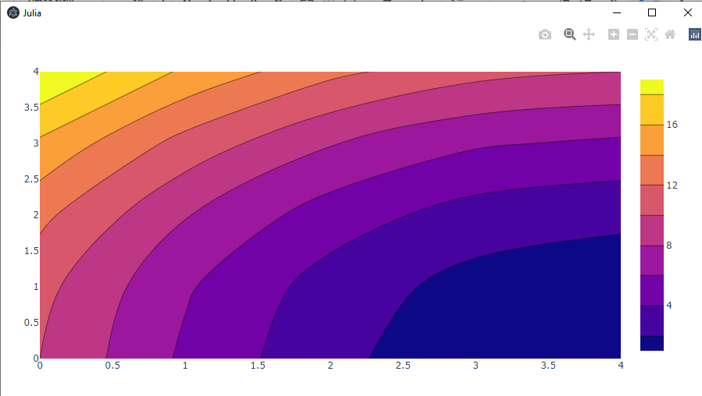

Step2: Setting the X and Y Coordinates in a Contour Plot

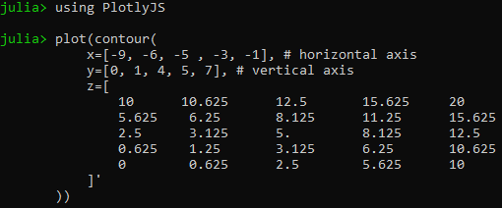

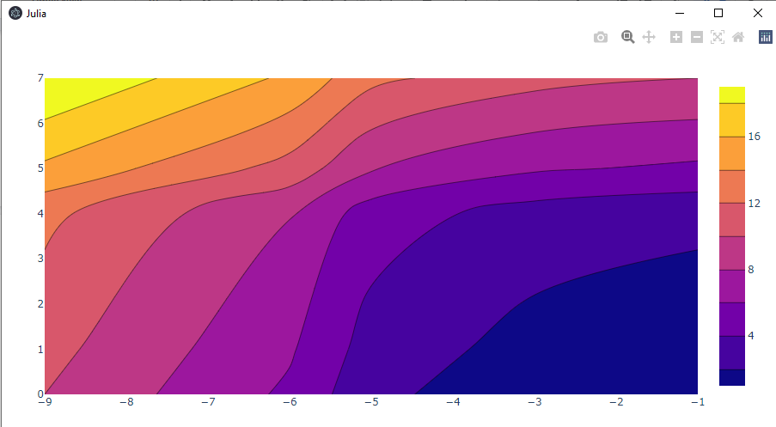

Step 3: Colorscale for Contour Plot

