**Practical No: 02**

**Aim: Implement Fibonacci Search**

**Code:**

**Step 1: Define the Function**

function f(x)

return x * x - x + 1

end

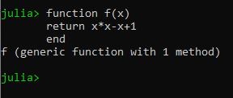

**Step 2: Write a function of Fibonacci Search**

function fibonacci_search(f, a, b, n; ϵ = 0.01)

s = (1 - √5) / (1 + √5)

ρ = 1 / (1.618 * (1 - s^(n + 1)) / (1 - s^n))

d = ρ * b + (1 - ρ) * a

yd = f(d)

for i in 1:n-1

print(a)

print("\n")

print(b)

print("\n")

if i == n - 1

c = ϵ * a + (1 - ϵ) * d

else

c = ρ * a + (1 - ρ) * b

end

yc = f(c)

if yc < yd

b, d, yd = d, c, yc

else

a, b = b, c

end

ρ = 1 / (1.618 * (1 - s^(n - i + 1)) / (1 - s^(n - i)))

end

return a < b ? (a, b) : (b, a)

end

**Step 3: Call Fibonacci Search with the defined function and an interval (a, b) and number of iterations**

In our case a = 2 and b = 4 and number of iterations n = 10

