**Algorithm For Optimizations Practical**

**Aim: Apply Random Forest in Surrogate Model.**

Random forest is a supervised learning algorithm that randomly creates and merges multiple decision trees into one forest.

We are going to use a Random forests surrogate to optimize

*f*(*x*)=*sin*(*x*)+*sin*(10/3∗*x*)

**First of all, import Surrogates and Plots:**

**using Pkg**

**Pkg.add("Surrogates")**

**Pkg.add("SurrogatesRandomForest")**

**Pkg.add("Plots")**

**using Surrogates**

**using SurrogatesRandomForest**

**using Plots**

**default()**

**Output:**

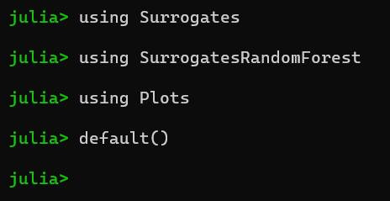

**Sampling:**

We choose to sample f in 4 points between 0 and 1 using the sample function. The sampling points are chosen using a Sobol sequence, this can be done by passing SobolSample() to the sample function.

f(x) = sin(x) + sin(10 / 3 * x)

n_samples = 5

lower_bound = 2.7

upper_bound = 7.5

x = sample(n_samples, lower_bound, upper_bound, SobolSample())

y = f.(x)

**Output:**

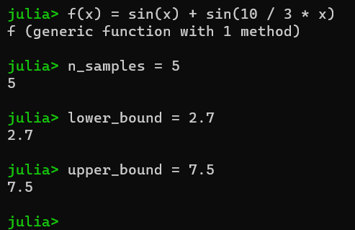

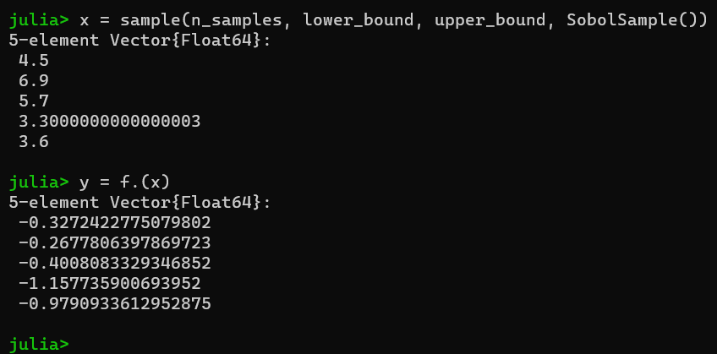

**scatter(x, y, label="Sampled points", xlims=(lower_bound, upper_bound))**

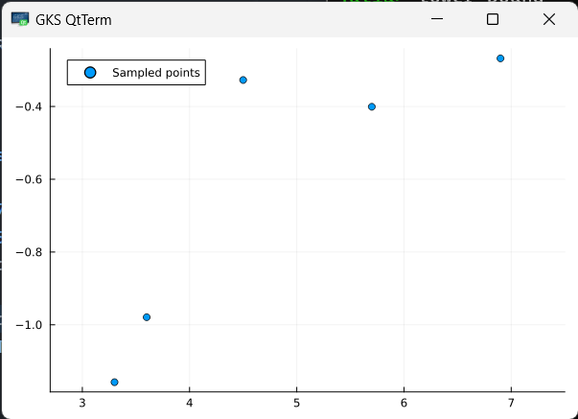

**plot!(f, label="True function", xlims=(lower_bound, upper_bound), legend=:top)**

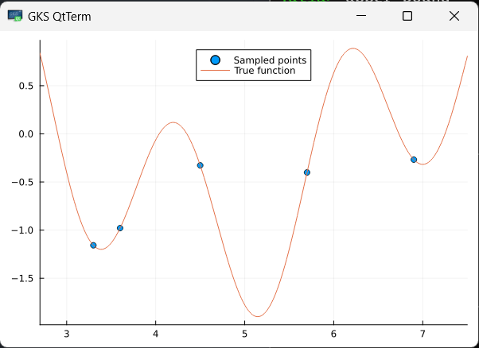

**Building a surrogate:**

With our sampled points we can build the Random forests surrogate using

the RandomForestSurrogate function.

randomforest_surrogate behaves like an ordinary function which we can simply plot.

Additionally, you can specify the number of trees created using the parameter num_round

num_round = 2

randomforest_surrogate = RandomForestSurrogate(x, y, lower_bound, upper_bound, num_round=2)

**Output:**

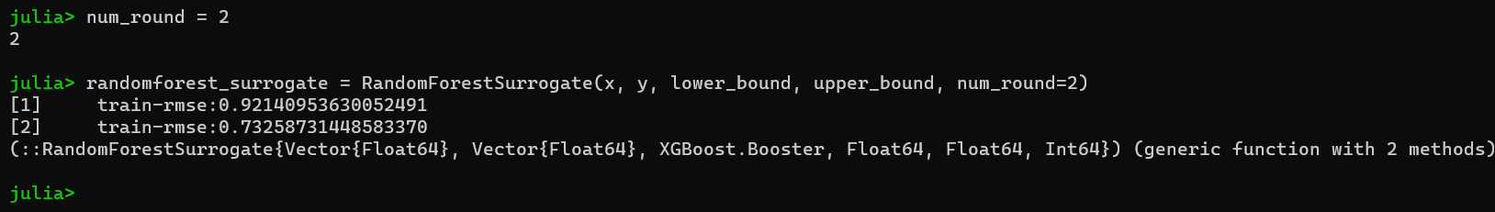

**plot(x, y, seriestype=:scatter, label="Sampled points", xlims=(lower_bound, upper_bound), legend=:top)**

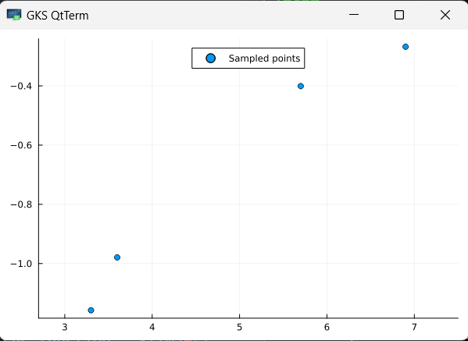

**plot!(f, label="True function", xlims=(lower_bound, upper_bound), legend=:top)**

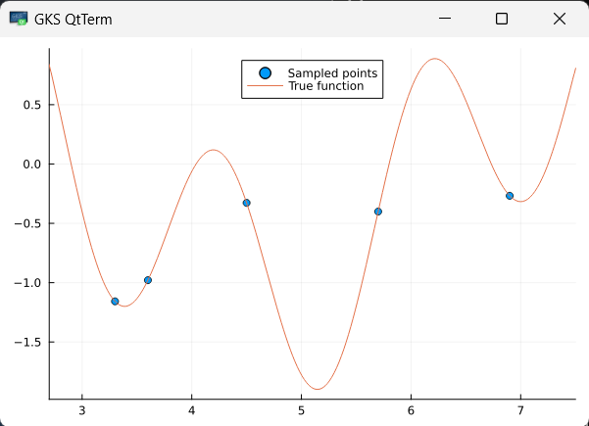

**plot!(randomforest_surrogate, label="Surrogate function", xlims=(lower_bound, upper_bound), legend=:top)**

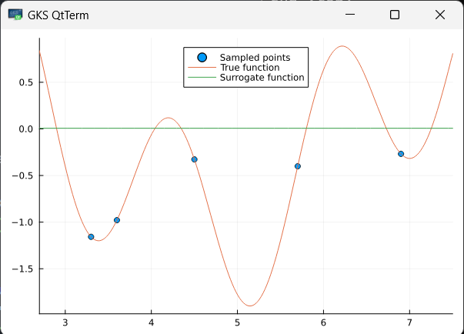

**Optimizing:**

Having built a surrogate, we can now use it to search for minima in our original function f.

To optimize using our surrogate we call surrogate_optimize method. We choose to use Stochastic RBF as optimization technique and again Sobol sampling as sampling technique.

@show surrogate_optimize(f, SRBF(), lower_bound, upper_bound,

randomforest_surrogate, SobolSample())

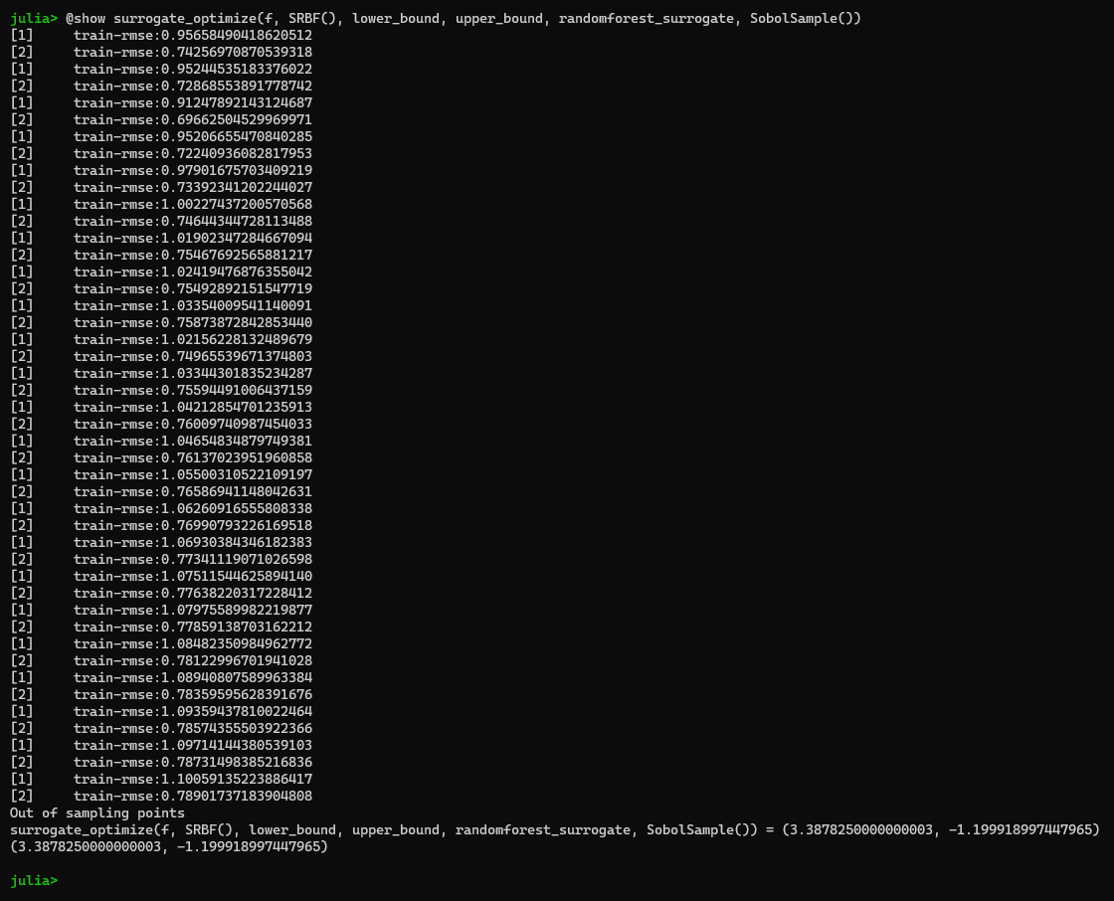

scatter(x, y, label="Sampled points")

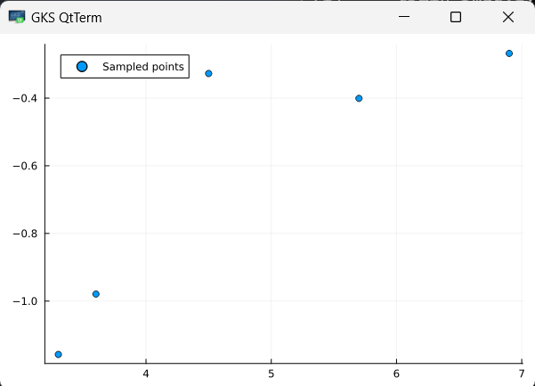

plot!(f, label="True function", xlims=(lower_bound, upper_bound), legend=:top)

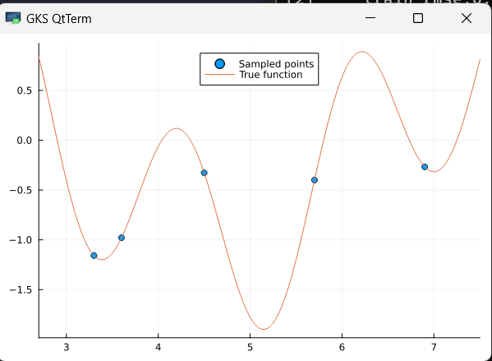

plot!(randomforest_surrogate, label="Surrogate function", xlims=(lower_bound, upper_bound), legend=:top)

