Docker- is a platform to building, running and shipping the applications.
Why sometime application works in our machine not when deployed.
- Missing some files when deploying
- Software version of our local machine is different than the deployment machine. Like node version in local is 8.5 but in deployment server its v12
- Mismatch in system configuration between local and deployment server. Like env variables.
These above issues are solved by docker by packaging the same package/modules and deployed in any server.
Also,
Different docker container can have different node version, for example, so in the same server we can run two different version of node in isolation. So, host machine is free of all these hassles and those containers can be dropped anytime. So, your host machine will be clean as always.

Virtual machines vs Containers
Container – (technically it’s single OS process)
- an isolated environment for running an application.
- Uses the host OS
- Lightweight as they share the host OS resources
- Less hardware resources as it single OS.
- Starts quickly
Virtual machine –
- Isolation environment for running application
- abstraction of a machine (physical hardware). This can be achieved by installing hypervisor software such as VirtualBox or VMware or Hyper-V(windows only). So then we can create any number of vm’s inside those tools.
Problems with VMs
- Each VM needs full blown OS with manually selecting hardware’s such as how many gigs of RAM and how many cores of processor for each vm.
- Slow start
- Resource intensive
Docker Architecture:
Client (docker cli) <-- Server (docker engine)
Windows – can run Linux and windows containers (windows has both Linux and windows kernel)
Linux- can only run Linux containers
Mac – mac has lightweight Linux VM, on top of this, can run Linux containers.
Basically, containers should be talk o there compatible kernels in the host OS. Otherwise it can’t run, because windows containers cannot run on Linux as Linux OS will not have a windows kernel.
Install docker on Windows 10 home
https://docs.docker.com/docker-for-windows/install (follow “WSL 2 backend” backend)
Download and install the docker installer from above link.
https://docs.microsoft.com/en-us/windows/wsl/install-win10#step-4---download-the-linux-kernel-update-package
and do step 4 after installing and we are set with docker on windows

Docker workflow
- Build an app
- Add Docker file
- Create a docker image ( an image can have following as assets)
  - A cutdown OS
  - A runtime environment (example, node.js)
  - Application code/files
  - Third party dependency files
  - Environment variables
- Tell docker to create and run a container (process) based on the image.
- So, application available now. (push image to docker-hub and pull whenever want run the application)
Dockerize simple node application
- Create a folder hello-docker
- Create a application file app.js
console.log(“Hello Docker”)
- Create a Dockerfile
- FROM node:alpine
- COPY . ./app
- WORKDIR /app
- CMD node app.js

4. docker build -t hello-docker .
5. docker images (this will show all the images in local system)
5. docker run hello-docker
6. In console we can the result as “Hello Docker”
Practice Linux command and concepts
docker run -it ubuntu
-it -> run container of ubuntu image in interactive mode, that is it connects our terminal to container OS terminal.
root@22ae7849690f:/#
root -> inside container, we are logged in as root user
22ae7849690f -> ID of container or name of the machine
/ -> path where we are inside container (/ -root directory in Linux based OS)
# -> to say we are root user otherwise it will $

docker ps -> show all running container
docker ps -a -> show all running container with stopped containers too.

Linux commands
whoami -> shows logged in username
echo $0 -> shows path or location of shell program or terminal, which we are executing
Linux commands are case sensitive, ex, echo & Echo are different.
apt -> package manager for ubuntu like npm, pip.
Example apt install nano -> to install the package
apt remove nano -> to uninstall the package
apt update -> this updates the package database with latest available packages.
pwd -> print working directory
cd -> change directory
ls -> list files (in linux everything is files)
cd ~ -> go to home directory
mkdir -> create a directory
mv test.txt hello.txt -> rename test.txt to hello.txt
mv test.rxt /etc/hello.txt -> move
touch file.txt file1.txt -> create single or multiple files
rm file.txt -> delete the file
rm docker/ -> givens error cannot delete the directory
rm -r docker/ -> -r means, delete all the files recursively inside docker directory and delete the docker directory
cat file.txt -> see the content of file.txt
echo hello > hello.txt -> creates file hello.txt and writes and content hello (useful when we want to write a single line)
echo hello >> hello.txt -> appends hello to existing content in hello.txt (again single line)
- -> redirection operator that means echo output is redirected to file called hello.txt
grep -i hello file1.txt file2.txt
- Search the world hello in file1.txt and file2.txt, -i is to tell search should be caseinsentive.
- grep -i -r hello docker/ -> it can also search in directory (-r search recursively in all sub dir or files)
find -> to show all the files and directories in full path
mkdir test;cd test;echo done -> command chaining, if first commads fails , still it keeps on executes
mkdir test && cd test && echo done -> command chaining, here any command fails. It stops execution.
mkdir test || cd test -> command chaining, OR condition. If first one executes, it wont come to second one.
PIPING
ls /bin | less -> first it fetches all the data from /bin and pipe the data to less command
Environment variables
printenv -> print all the env variables

process -> is a instance of running program.
kill processed => kills a process
chmod - > to change the permission on files
chmod u+x deply.sh-> add a file owner (u) a execute permission
u -> user (owner of file)
g - > group(group owns the file)
o - >other
Dockerize a app:
Building an docker image
Dockerfile contains a instruction to build a docker image
FROM -> base image (OS or files, folder)
WORKDIR -> command will execute from this directory
RUN -> to execute OS commands
COPY -& ADD -> to copy and add files and folders.
Baseimage can be either OS, or OS+runtime or OS+other software already installed.
For example.
node-alpine is an base image .i.e OS (linux distro alpine) + node installed on it.

Docker build -t “name of the image” “location/path/directory of Dockerfile”
RUN addgroup app && adduser -S -G app app
(alpine distro) This to create a group called app and then create user called app and add that user to group which we have created ‘app’
USER -> in what account context the code commands should be executed after this line in Dockerfile
CMD -> default command to execute when containers starts( in our example,, npm start)

RUN VS CMD
RUN -> build time instruction, like while building the images. like istalling dependency (npm install ), creating user etc
CMD -> runtime instruction, starting the container, like starting the server, npm start.

Two forms of CMD
Shell form
CMD npm start -< this starts a default shell program on OS and executes it.
Exec form
CMD [“npm”,”start”] -> this wont use the shell program, instead it directly executes. This is better approach as it uses the less resources, so also easy to clean up when stopiing the container.
ENTRYPOINT also has above 2 forms.
CMD vs ENTRYPOINT
CMD commonds can be override while starting the container.
Example,
CMD [“npm”,”start”]
Docker run react-app echo hello
Here , when container starts, echo hello command will run , actual CMD will be ignored
ENTRYPOINT CANNT BE overridden. ( we can override it by using –entry-point)

Image layers:
Each line of instruction in Dockerfile is a layer.
Lets say, if we are going to build the same images again and again. With small modification to Dockerfile. Docker will not rebuild the unchained line (layer), actually it takes it from cache. Only changes instruction layer will be rebuilt from scratch.
If instruction involves copy the directly to inside images, then docker cannot tell whether new file has been added or not. So docker always build that layer and other layer build be rebuilded.

Run same image build commands twice without changing the instruction. Then will see all the layers has been [CACHED] and reused completely.

So. Stable instruction should on top of Dockerfile
And changing instaction should be in bottom

To remove all the stopped containers
Docker container prune

To remove all the dangling containers
Docker image prune (all the containers using this imaegs must pruned before pruing the images)
To remove the actual image
Docker image rm <image name or id>
Taggin:
Docker build -t react-app:3.1.2 .
:3.1.2->is tag for that image
Above is at at while builing the image:
How to tag image for creating it. Or existing one.
Docker image tag <existing image name with tag like reactapp:latest or image id> <new image name with: tag>
SHARE images
Docker hub
Docker login at terminal: provide usename ansd pass
Then,
Docker push youraccountname/react-app:v2

Containers
Dockers ps -> list all the running containers
Docker logs <container-id> => shows logs of containers
PORTS:
Docker run -p 3000:3000
Port map-< host to docker container
Executing commands in running containers:
Docker exec <container-id> <commands to execute>
Docker exec 876869 npm run test

Docker stop <containerid>
Docker start vs docker run:
Docker start will start the stopped container only
Run will start/create the new containers
Docker rm <container-id or name> (this will remove the container and all its in process memory files etc, container has to be stopped mode, then only I can be removed) or else force it like below
Docker rm -f <container-id or name>
Volumes:
If we want to persist the data outside the containers, we can create volumes. Because when we stop the containers, will the data have related to it will destroyed. Also when we mention same volume for other container while starting, new container will read the from same volume. So it like sharing the data between the containers.
Docker volume create app-data
App-data is name of the volume. But how to get the info about the volume.
Docker volume inspect app-data
[
{
"CreatedAt": "2021-04-24T16:47:42Z",
"Driver": "local",
"Labels": {},
"Mountpoint": "/var/lib/docker/volumes/app-data/_data",
"Name": "app-data",
"Options": {},
"Scope": "local"
}
]

docker run -d -p 3000:3000 -v app-data:/app/data react-app react-app
app-data is volume name
/app/data react-app is file path inside the container.
Copy file from container to host machine.
Docker cp <conainer-id>:</app/data/log.txt, which is location inside the contianers> <location of folder in host machine>
From host to containers:
Docker cp <location of file in host machine> <conainer-id>:</app/data/log.txt, which is location inside the contianers>

Live sharing-the-source-code-with-a-container:
We cant build image for each file change we at host machine and then start the containers. So we can live share our code from host machine to running container. Using volume feature but without using named volume.
docker run -d -p 3000:3000 -v $(pwd):/app react-app
here $(pwd) to get absolute path of current directorty or else we can hardcode it too. And /app is where we should live share our changes inside container.
The docker file to containerize the create-react-app.
FROM node:lts-alpine3.13
RUN addgroup app && adduser -S -G app app
USER app
WORKDIR /app
RUN mkdir data
COPY package.json .
RUN npm install
COPY . .
ENV node_env=production
EXPOSE 3000
CMD ["npm","start"]
Docker build -t react-app . (building image)
Docker run react-app (running the container)

Docker Compose
Using compose we can manage multiple containers easily
Sample yaml file
version: "3.8"
services:
web:
build: ./backend
ports:
- 3000:3000
api:
build: ./frontend
ports:
- 3001:3001
environment:
DB_URL: mongodb://db/vidly
db:
image: mongo:4.0-xenial
ports:
- 27017:27017
volumes:
- vidly:/data/db
volumes:
vidly:

how to build all the images at once:
docker-compose build
How to start the all containers
Docker-compose up (if images are not built already, first it will build the images and starts all the containers)
docker-compose up --build --force-recreate
above will build the images if not already built. And if containeis are already exists, above commad will recreate everything from group up.

How to all the containers
Docker-compose down.

Networking
List all the network created for containers to interact in docker-compose:
docker network ls
while we run docker-compose up, this will automatically create a network and add all the containers to that network.so they can interact each other.

By default, each containers are assigned with internal IP address and name .and docker has built in DNS server like below, when particular query comes from another container, the DNS resolver will ask DNS server to resolve the address or name. so that way each containers talks to each other.
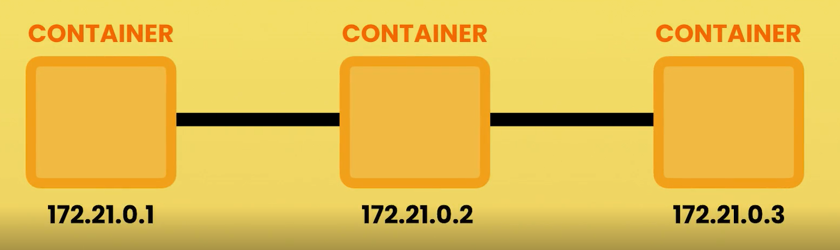
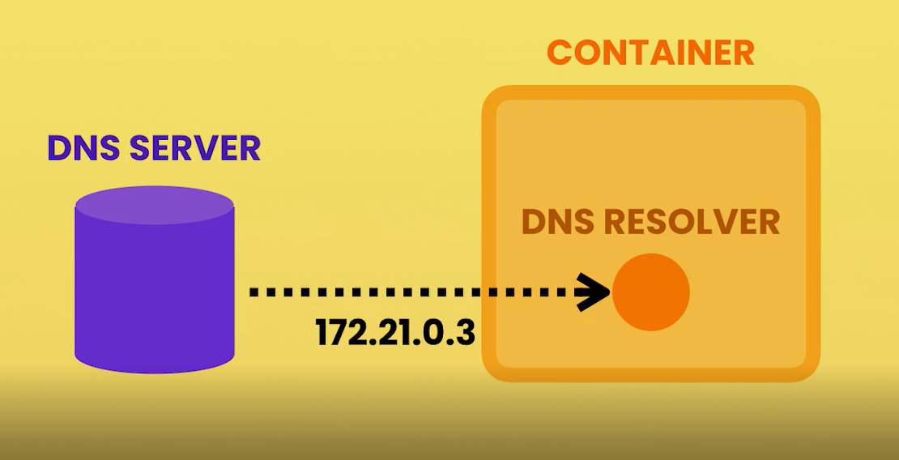

How to see the logs of all the containers.
Docker-compose logs
Live share the code bases with docker-compose in yaml file.
Though we are .dockerignore the node_modules/, still we can live share using the volume options with node_modules code also.
version: "3.8"

services:
web:
build: ./frontend
ports:
- 3000:3000
volumes:
- ./frontend:/app

api:
build: ./backend
ports:
- 3001:3001
environment:
DB_URL: mongodb://db/vidly
volumes:
- ./backend:/app

db:
image: mongo:4.0-xenial
ports:
- 27017:27017
volumes:
- vidly:/data/db

volumes:
vidly:

deployment
single host deployment (single server as old approach. If server goes down. App completely goes down)
cluster deployment ( having multiple servers or nodes, hight availability like docker swarm or Kubernetes.)

Virual private network can be bought at
Digital ocean
GCP
Azure
AWS
Docker machine:

Machine lets you create Docker hosts on your computer, on cloud providers, and inside your own data center. It creates servers, installs Docker on them, then configures the Docker client to talk to them.

