Example - Summary Screens:

Market Closed (eg. LON:UU);
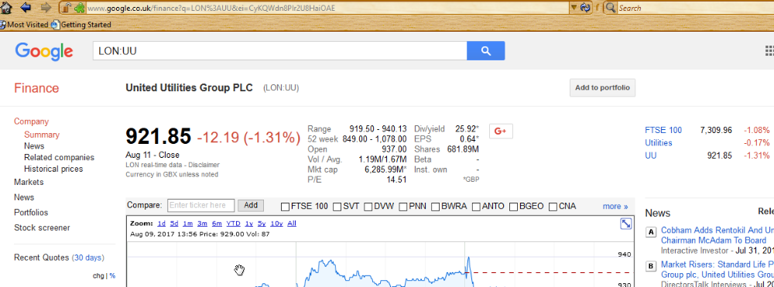

Market Open (eg: LON:UU);
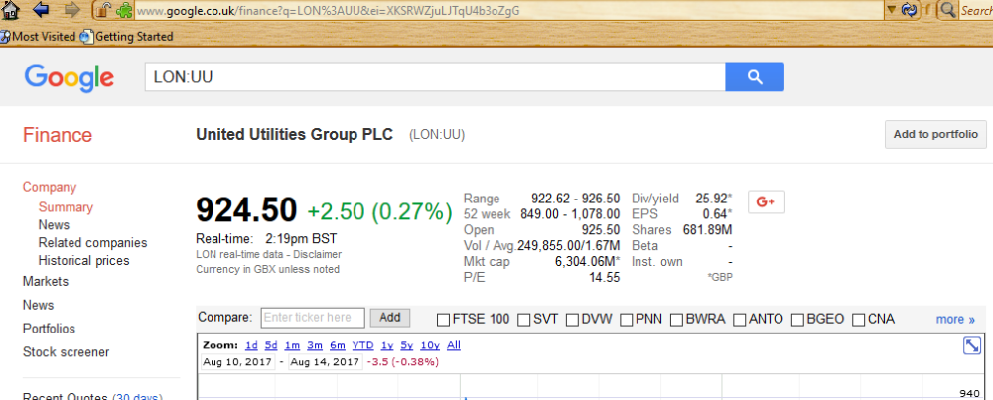

MUTF type (eg. MUTF:HFCSX);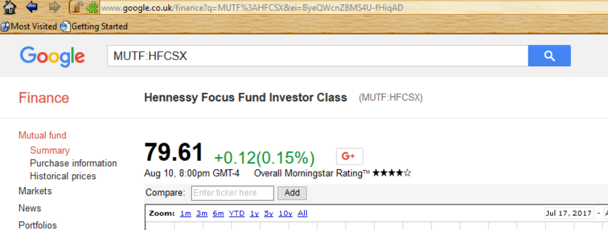

Html for Market:Symbol;

<meta name=Description content=Get detailed financial information on Advanced Medical Solutions Group plc (LON:AMS) including real-time stock quotes, historical charts and financial news, all for free!>

Note: The MARKET:SYMBOL appears in several places but this one appears on all pages for stock, mutual fund, summary and history pages.
As the market:symbol is enclosed in "("...")", it is also easy to extract the values.

Html Part for "normal stock" to see Market Closed (with date) or Market Open;

Closed;
<span class=nwp>
Aug 11 - Close
</span>

or Open;
<span class=nwp>Real-time: &nbsp;
<span id=ref_668778_ltt>3:34pm BST
</span>
</span>

Html Part for "MUTF" for date;

<span class=datetime sfe-break-bottom-4 sfe-break-right>Aug 15, 8:00pm GMT-4
</span>
<span class=nwp>Overall Morningstar Rating
<small>

Html Part to get the latest price;

Normal Stock;
<span class="pr">
<span id="ref_2884168_l">921.85
</span>
</span>

or

MUTF;
<span class=pr>80.53
</span>

Example - History Screens:

Market Open/Closed;

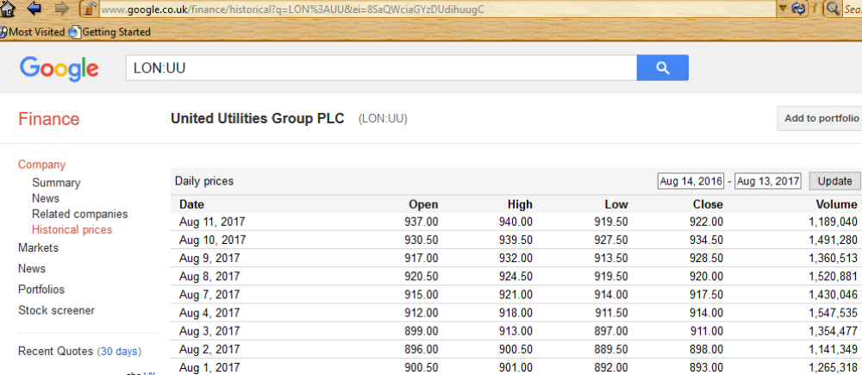

MUTF;
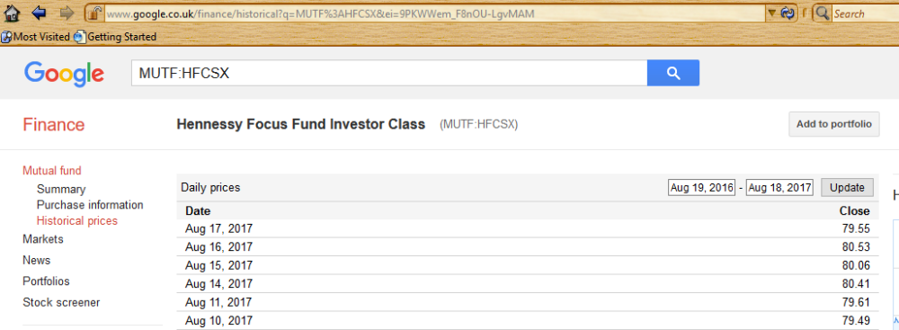

Html for Market:Symbol;

<meta name=Description content=Get detailed financial information on Advanced Medical Solutions Group plc (LON:AMS) including real-time stock quotes, historical charts and financial news, all for free!>

Note: The MARKET:SYMBOL appears in several places but this one appears on all pages for stock, mutual fund, summary and history pages.
As the market:symbol is enclosed in "("...")", it is also easy to extract the values.

Html for Price History;
<div id=prices class="gf-table-wrapper sfe-break-bottom-16">
<table class="gf-table historical_price">
<tr class=bb>
<th class="bb lm lft">Date
<th class="rgt bb">Open
<th class="rgt bb">High
<th class="rgt bb">Low
<th class="rgt bb">Close
<th class="rgt bb rm">Volume
<tr>
<td class="lm">Aug 11, 2017
<td class="rgt">937.00
<td class="rgt">940.00
<td class="rgt">919.50
<td class="rgt">922.00
<td class="rgt rm">1,189,040
<tr>
......... repeated .....
<tr>
<td class="lm">Jul 3, 2017
<td class="rgt">854.00
<td class="rgt">872.50
<td class="rgt">849.00
<td class="rgt">867.50
<td class="rgt rm">4,132,192
</table>
</div>

html for MUTF history;
<div id=prices class="gf-table-wrapper sfe-break-bottom-16">
<table class="gf-table historical_price">
<tr class=bb>
<th class="bb lm lft">Date
<th class="rgt bb rm">Close
<tr>
<td class="lm">Aug 11, 2017
<td class="rgt rm">79.61
<tr>
<td class="lm">Aug 10, 2017
<td class="rgt rm">79.49
<tr>
......... repeated .......
<tr>
<td class="lm">Jul 5, 2017
<td class="rgt rm">79.01
<tr>
<td class="lm">Jul 3, 2017
<td class="rgt rm">80.11
<tr>
<td class="lm">Jun 30, 2017
<td class="rgt rm">79.85
</table>
</div>

eg date logic;

// The screen date doesn't contain the year (eg. Aug 13,)
var ScreenDate = "Aug 13," // example screen scrape date
var Today = new Date(); // current date

// If today is in Jan, and screen date Is "Dec" then we want last year
// otherwise, we want the current year
if (Today.getMonth() == 0 && ScreenDate.substr(0,3) == "Dec") // getMonth() starts at 0
var ScreenYear = Today.getFullYear()-1;
else
var ScreenYear = Today.getFullYear();

var UseDate = new Date(ScreenDate+ScreenYear);
// UseDate is set to the date to use

