

**Airline Safety – Project Task5**

**Goal:**

The major goal of the project is to tell a story to the audience with visualization of different metrics to show airline is still one of the safest approaches to travel amidst the negative publicity in media about air travel. Airlines are still the safest way to travel, and this Fact is strongly supported by visualization.

**Data Sources:**

Primary Dataset

<https://github.com/fivethirtyeight/data/blob/master/airline-safety/airline-safety.csv>

|  |  |
| --- | --- |
| Field | Definition |
| Airline | Airline |
| avail_seat_km_per_week | Available seats and Kilometers are flown every week |
| incidents_85_99 | Number of Incidents from 85 to 99 |
| fatal_accidents_85_99 | Fatal Accidents from 85 to 99 |
| fatalities_85_99 | Number of Fatalities from 85 to 99 |
| incidents_00_14 | Number of Incidents from 00 to 14 |
| fatal_accidents_00_14 | Fatal Accidents from 00 to 14 |
| fatalities_00_14 | Number of fatalities from 00 to 14 |

Supplement Dataset: <https://www.kaggle.com/datasets/saurograndi/airplane-crashes-since-1908>

Some of the important fields to look for in the Dataset are

|  |  |
| --- | --- |
| Field | Definition |
| Operator | Operator Details or Airlines |
| Date | Date of Accident |

**Visualization Software:**

Tableau Software is used to generate visualization charts.

**Why did you choose the visualizations you did? What were your findings?**

**1 Fatal Accident for US Airlines compared during the period 1985-1999 vs. 2000 -2014**

The Visualization of the Primary Dataset as a Bar Chart Visualization reflects number of Fatal Accidents have come down during the period 00-14 compared to the period 85-99

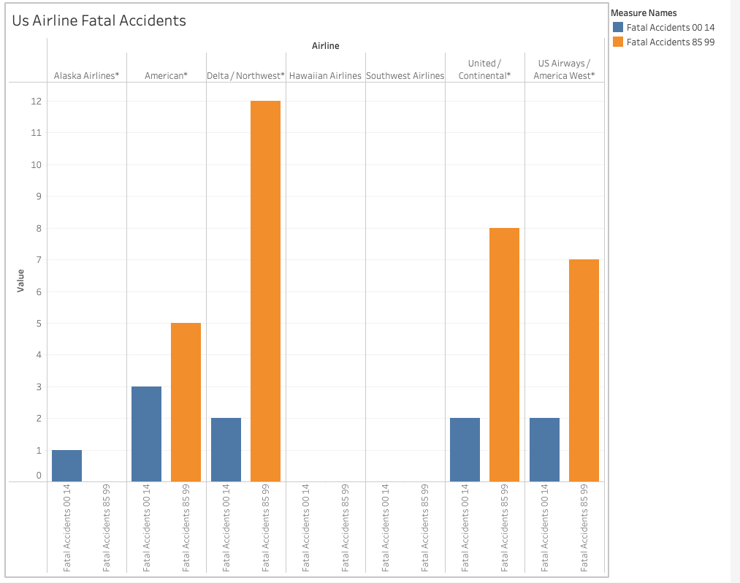

2) **Fatalities comparison from 85-99 vs. 00-14 Bar Chart Visualization**

The Visualization of Fatalities data during the time 85-99 and 00-14 indicates there has been significant decline in Fatalities during 00-14 compared to the previous terms which indicates the safety measures have improved and technological advancement with aircraft's features which reduced the number of incidents.

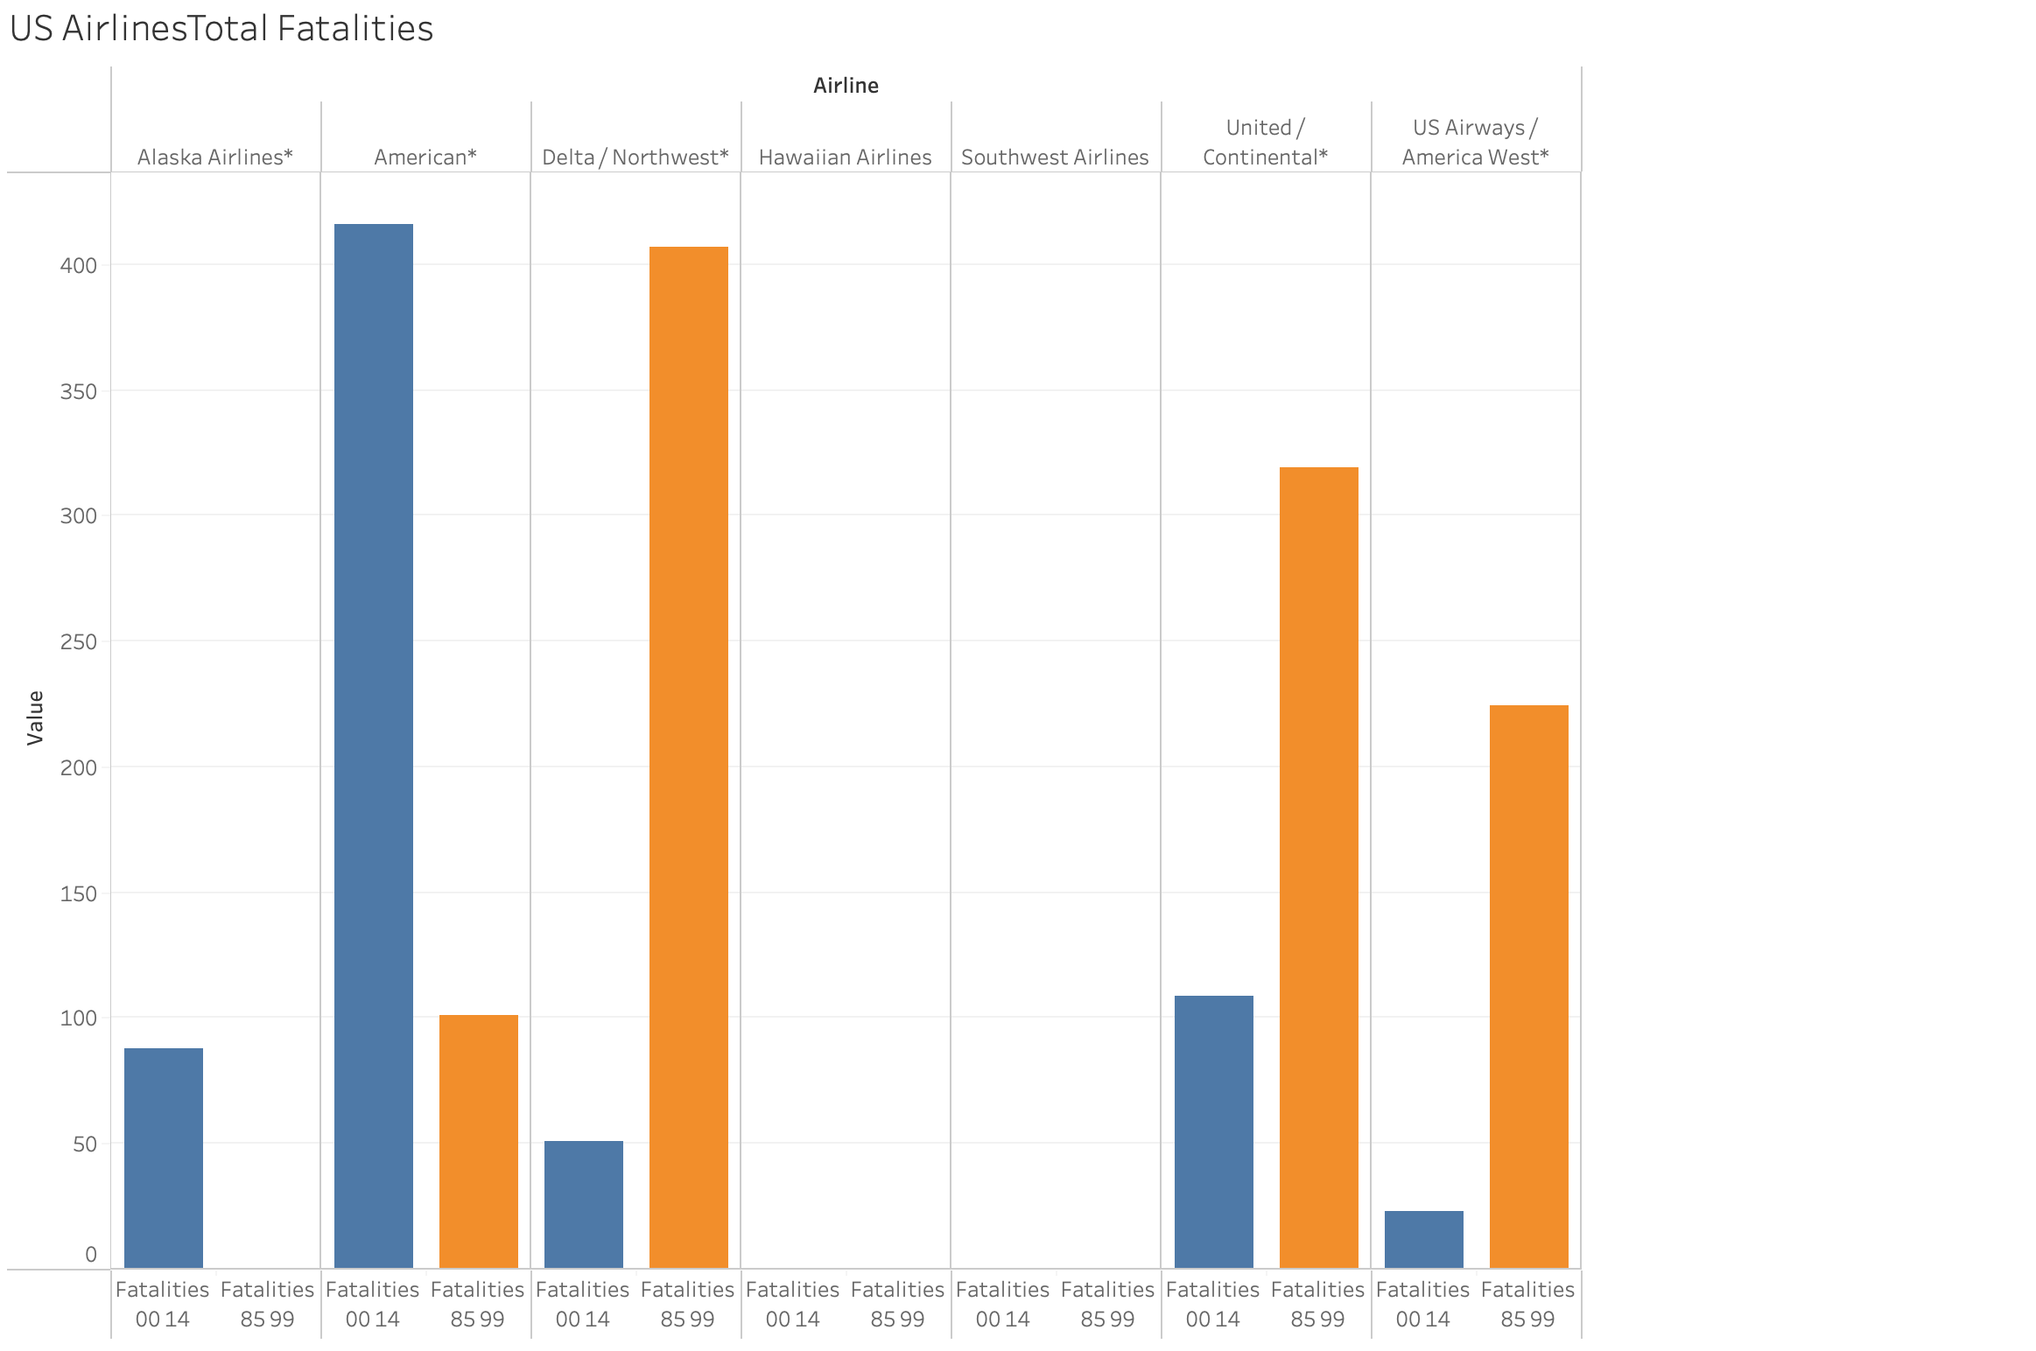

3) **Incidents from 00-14 Pie Chart Visualization**

The Pie Chart Visualization built from the Dataset "airline-safety.csv" shows there is no standard trend with incidents that happened with airlines as most of the time, Critical and Major incidents are treated as incidents which might not be accurate metrics to consider an airline's performance or Safety standards.

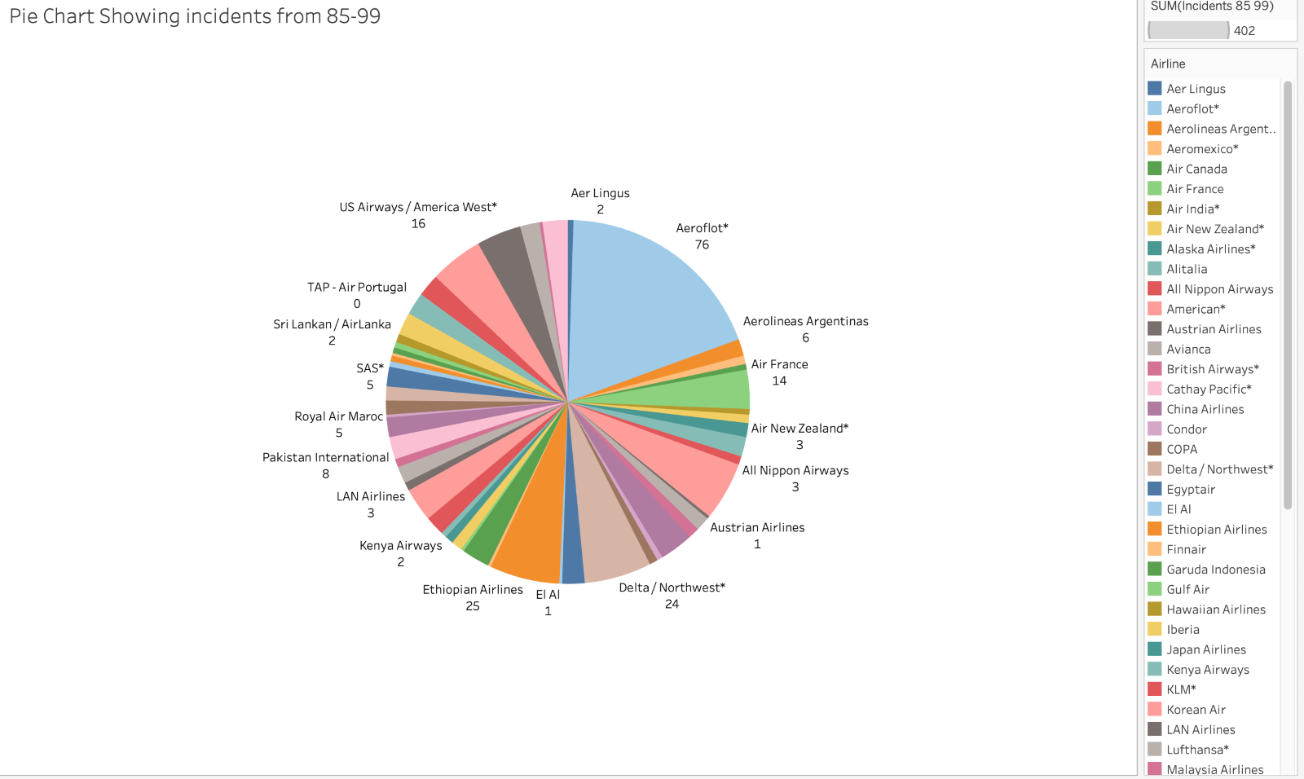

4) **Incidents from 85 –99 Bar Chart Visualization**

The Bar Chart visualization of incidents from 85-99 from the Dataset “airline-safety.csv” shows the greatest number of incidents happened with a singular airline Aeroflot followed by Ethiopian Airlines and Delta/Northwest. This indicates safety standards followed by airlines are independent of each other.

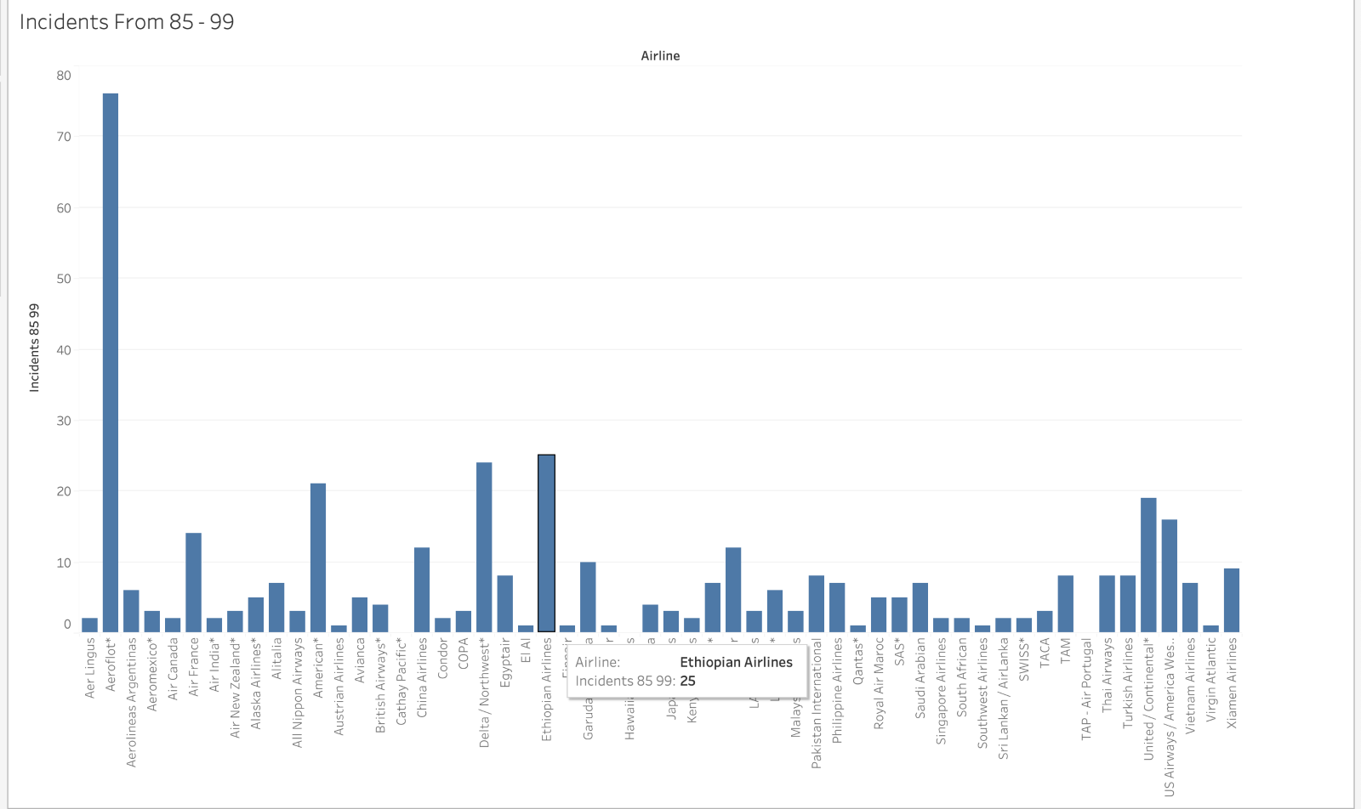

5) **Incidents from 00 – 14 Bar Chart Visualization**

The Visualization of Primary Dataset as a Bar Chart Visualization reflects there is no fixed trend with incidents which happened with airlines as most of the times Critical and Major incidents are treated as incidents which might not be accurate metric to consider airlines performance or Safety standards.

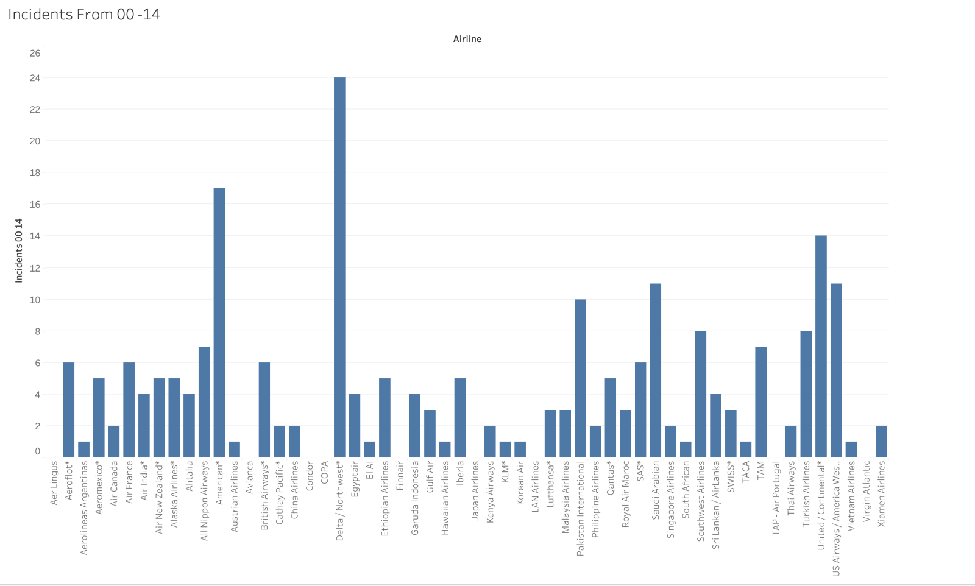

**6) Worldwide Fatal Accidents and Airline Capacities**

The Airline Metrics: Avail Seat KM per Week indicates; the airline capacities are to the brim with available seats flown and the occurrence of small number of Fatal Accidents did not impact the overall revenue generated, which indicates the elevated level of positive trust among flyers.

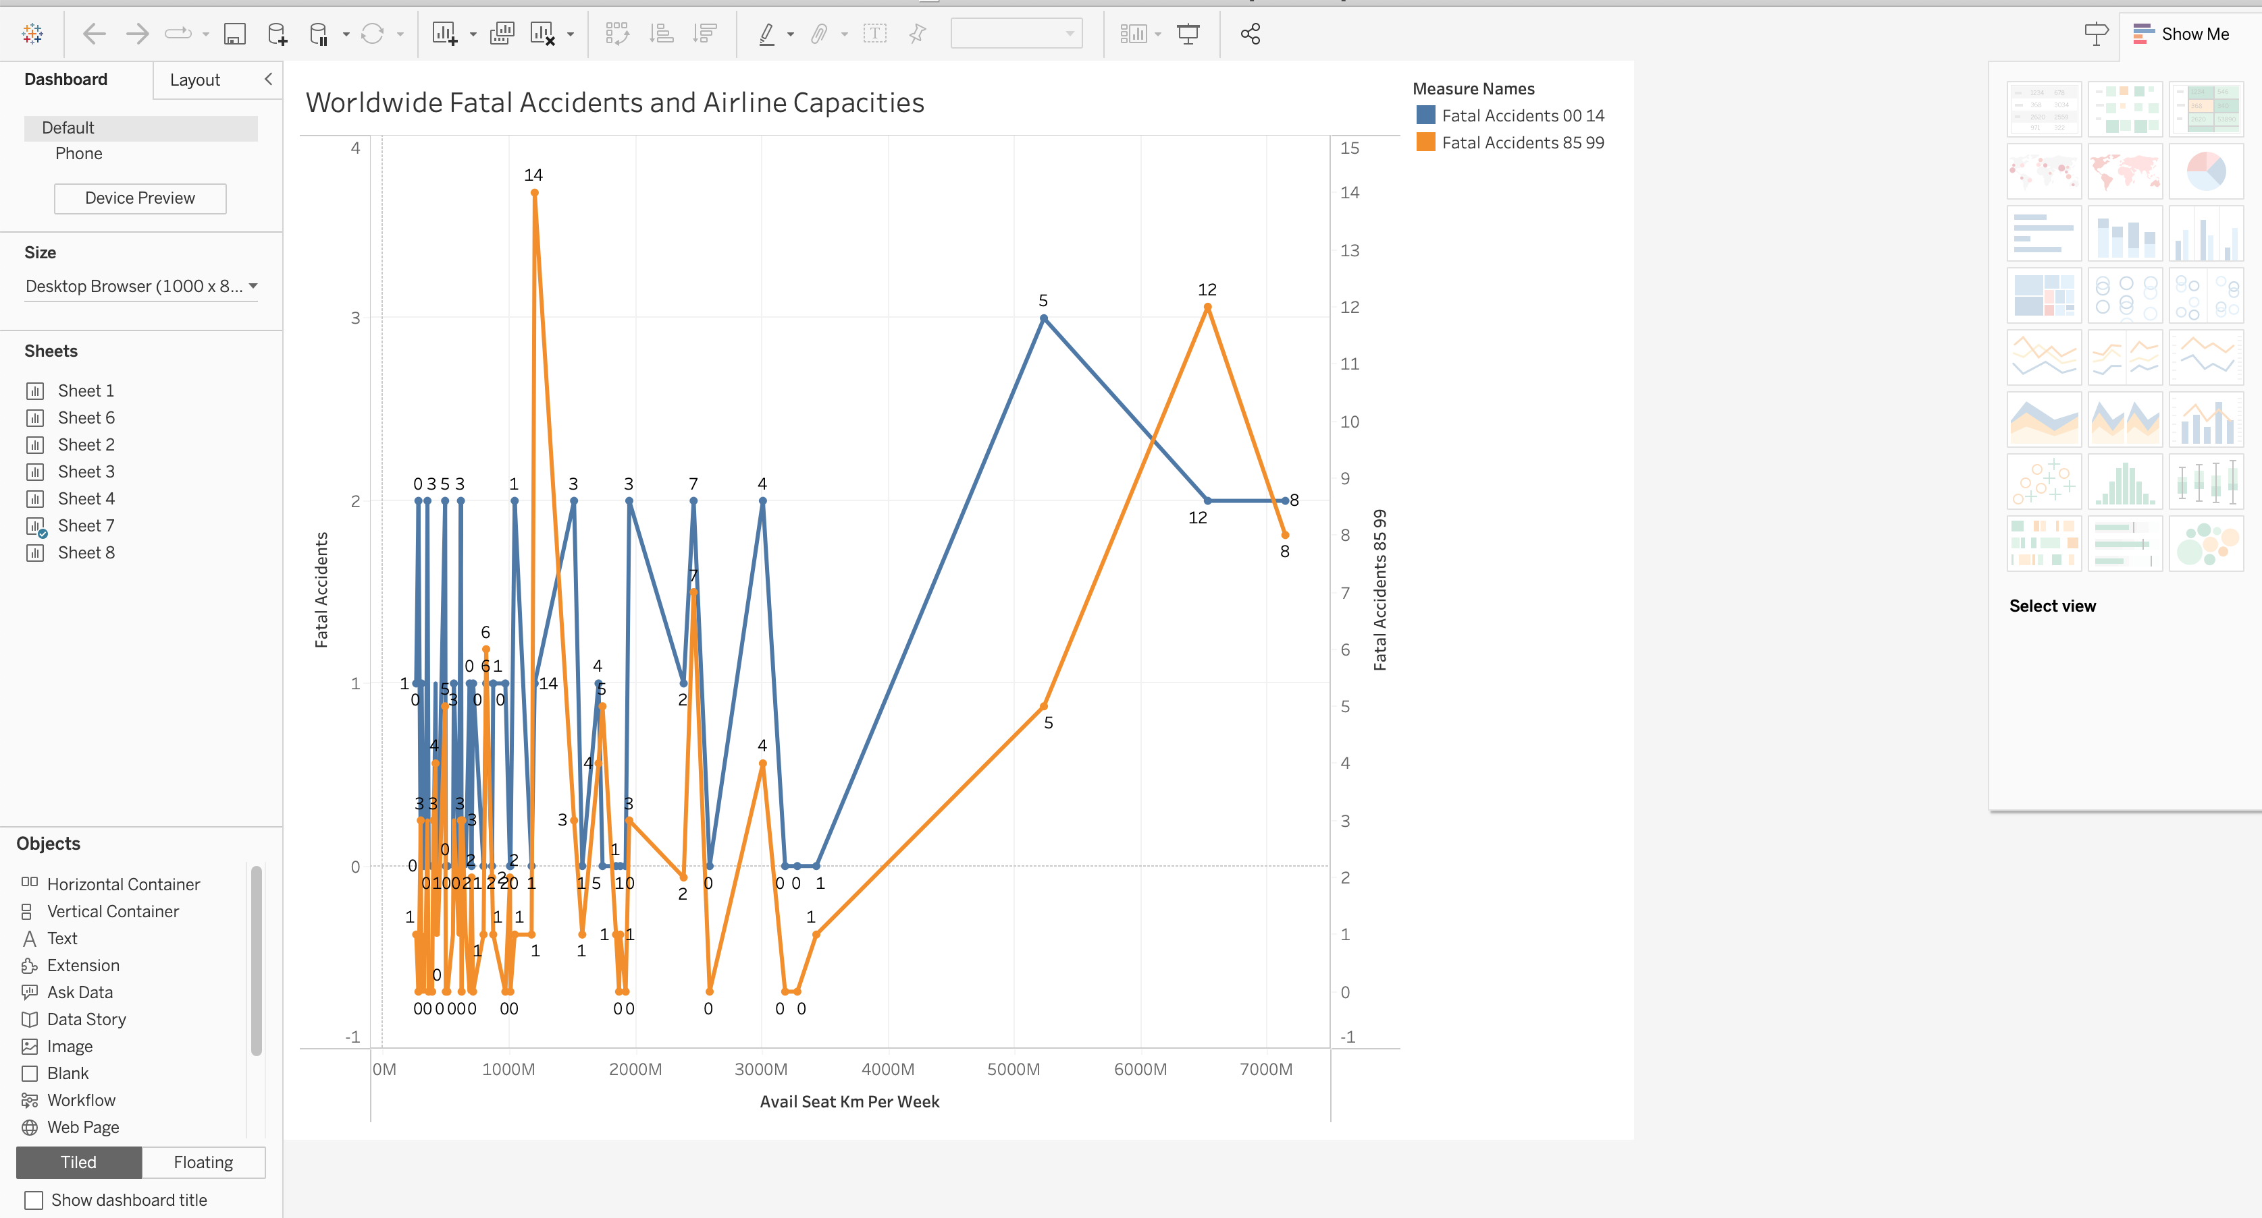

**How was this audience different than the internal teams?**

The intended audience is internal teams and teams from other groups of organizations with different executive stakeholders involved.

**What did you choose not to share with the external audience?**

The results will not be shared with external audiences as analytical results are completed for presentation to important internal stakeholders, also legal rules do not permit the Visual results to be shared external outside of organization.

**How do you plan to present to your internal team?**

The Results are presented through Infographic charts and Blog posts with different visualization charts explaining

Trends in airlines for metrics around incidents and fatalities compared over the time 85-99 and 00-14. The results clearly explain airline incidents are isolated and there is no co-relation between the incidents happening for airlines. Example Aeroflot had the highest number of incidents during the period 85-99 are due to poor maintenance of aircraft, management failure, type of aircraft used.

The infographic chart: [infographic-link](https://www.canva.com/design/DAFkXMHnSsg/GfegaLFSXdzr42_YKsTRTQ/view?utm_content=DAFkXMHnSsg&utm_campaign=share_your_design&utm_medium=link&utm_source=shareyourdesignpanel)

explains the false narration of Air Travel safety spread by Press and the visual charts explaining the results are false which number of fatal Accidents, fatalities coming down in the last few years.

The following blog post <https://airline-safetytravel.blogspot.com/p/debunking-air-travel-myths.html> explains different visualizations.

**Ethically what do you need to consider?**

* Taking only required data for visualization and recommendations
* Data is taken from Public Data Source Kaggle, so there are no data violations
* Data taken is pre-covid, so any recent changes with airline traffic or operations are not considered.
* Communicating the results appropriately with team members

**Summary:**

Air Travel is safer and improving with time the number of incidents and fatality rate have decreased significantly during 2000-2014 compared to 1985-1999. New Technological advancements and safety guidelines imposed by Federal Aviation Agencies have reduced the number of incidents. The Available seats per week have increased during the period 2000-2014 which indicates Airlines is considered as safest way to travel from flyer perspective.

**Reference Links:**

<https://fivethirtyeight.com/features/should-travelers-avoid-flying-airlines-that-have-had-crashes-in-the-past/>

<https://github.com/fivethirtyeight/data/blob/master/airline-safety/airline-safety.csv>

<https://airlinegeeks.com/2015/12/28/airline-metrics-available-seat-kilometers/>

<https://airline-safetytravel.blogspot.com/p/debunking-air-travel-myths.html>

<https://www.canva.com/design/DAFkXMHnSsg/GfegaLFSXdzr42_YKsTRTQ/view?utm_content=DAFkXMHnSsg&utm_campaign=share_your_design&utm_medium=link&utm_source=shareyourdesignpanel>