Step1:
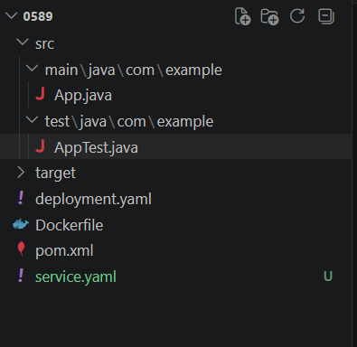

Paste this in inside App.java:
public class App {
public int add(int a, int b) {
return a + b;
}
}

Paste this inside AppTest.java:
package com.example;
import org.junit.Test;
import static org.junit.Assert.*;
public class AppTest {
@Test
public void testAdd() {
App app = new App();
assertEquals(5, app.add(2, 3));
}
}

pom.xml:
<project xmlns="http://maven.apache.org/POM/4.0.0"
xmlns:xsi="http://www.w3.org/2001/XMLSchema-instance"
xsi:schemaLocation="http://maven.apache.org/POM/4.0.0
http://maven.apache.org/xsd/maven-4.0.0.xsd">

<modelVersion>4.0.0</modelVersion>

<groupId>com.example</groupId>
<artifactId>simple-maven-app</artifactId>
<version>1.0-SNAPSHOT</version>

<dependencies>
<!-- JUnit 5 -->
<dependency>
<groupId>org.junit.jupiter</groupId>
<artifactId>junit-jupiter</artifactId>
<version>5.10.2</version>
<scope>test</scope>
</dependency>
</dependencies>

<build>
<plugins>
<!-- Required for JUnit 5 -->
<plugin>
<groupId>org.apache.maven.plugins</groupId>
<artifactId>maven-surefire-plugin</artifactId>
<version>3.2.5</version>
</plugin>
</plugins>
</build>

</project>

Step2:
mvn clean test

step3:
git init
git add .
git commit -m "Initial Maven project with JUnit test"
git branch -M main
git remote add origin <your-repository-url>
git push -u origin main

Step4:
pipeline {
agent any

tools {
maven 'M3'
}

stages {

stage('Checkout Git') {
steps {
git branch: 'main',
url: 'https://github.com/sudharshang2023-lab/recruitment_management.git'
}
}

stage('Build') {
steps {
bat 'mvn clean compile'
}
}

stage('Test') {
steps {
bat 'mvn test'
}
}

}

post {
always {
junit '**/target/surefire-reports/*.xml'
}
}
}

Step 5:
kubectl get svc

