**Assignment No. 01 (iNeuron – Full Stack Data Science – May 2023 Batch)**

**By Avinash Devidas Bagul**

1. In the below elements which of them are values or an expression? eg: - values can be integer or string and expressions will be mathematical operators.

* = Expressions (Math Operator)

'hello' = String

-87.8 = Float

- = Expressions (Math Operator)

/ = Expressions (Math Operator)

**+** = Expressions (Math Operator)

6 = Integer

2. What is the difference between string and variable?

String: String is the single or set of characters used in program.

Variable: Variable is name assigned for the value which can be used in programming

For e.g., Name = “Tom” (Name is Variable and “Tom” is string)

3. Describe three different data types.

Integer: This Data type used to store Whole Number.

Float: This Data type used to store double precision floating number means decimal valued number.

String: This Data type is used to store single or set of characters.

List: This Data type is used to store multiple element which are heterogeneous under single variable.

4. What is an expression made up of? What do all expressions do?

Expression is made up of by combining values, variables and operators which is used to complete the given operation. All operations does the specified given operation such as print function is used to display the command or the results.

5. This assignment statements, like spam = 10. What is the difference between an expression and a statement?

An expression evaluates to a single value. A statement does not.

6. After running the following code, what does the variable bacon contain?

bacon = 22

bacon + 1

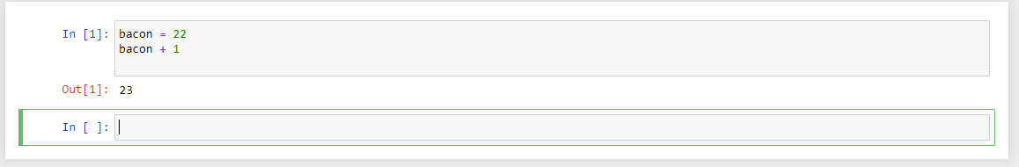

In this Variable bacon contain Integer value number 22.

7. What should the values of the following two terms be?

'spam' + 'spamspam'

'spam' * 3

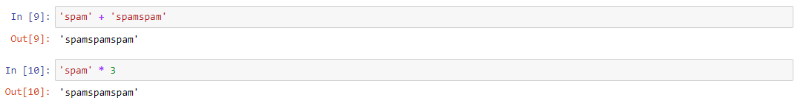

In above problems both terms have same value that is “spamspamspam”.

8. Why is eggs a valid variable name while 100 is invalid?

Because as per the rules of Python initial letter of the variable cannot be number hence “eggs” is valid variable while “100” is invalid variable

9. What three functions can be used to get the integer, floating-point number, or string version of a value?

The int(), float(), and str() functions will evaluate to the integer, floating-point number, and string versions of the value passed to them.

10. Why does this expression cause an error? How can you fix it?

'I have eaten ' + 99 + ' burritos.'

The expression causes an error because 99 is an integer, and only strings can be concatenated to other strings with the + operator. The correct way is I have eaten ' + str(99) + ' burritos.'.