Avinash Cosmetics: Full Stack E-commerce Application

Capstone Project Documentation

Submitted by: Avinash Sahebrao Bhamare
Roll Number: 23051980
Batch/Program: B.Tech CSE
Date: April 20, 2026

1. Problem Statement

Traditional cosmetics shopping requires customers to visit physical stores, which is time consuming and offers limited product comparison. Customers cannot easily browse products by category (lipsticks, foundations, skincare, etc.), check real time stock, or place orders from home. Store owners struggle to manage inventory, update product details, and process orders efficiently. There is no centralised system to handle user authentication, role‑based access, or order history.

Key problems identified:
- Lack of online product catalogue with category filtering.
- No real‑time stock validation – customers may order out‑of‑stock items.
- Manual order processing leads to errors and delays.
- No separation between customer and admin functionalities.
- No secure authentication mechanism (resolved with JWT).

To address these issues, we propose Avinash Cosmetics – a full‑stack e‑commerce web application that allows customers to browse cosmetics, add items to a cart, place orders, and allows administrators to manage products and inventory.

2. Proposed Solution

Avinash Cosmetics is built with Spring Boot 3.1.5 (backend), React 18 (frontend), and MySQL 8 (database). It provides a seamless online shopping experience with two roles:

- USER – Register, login, browse products by category (Skincare, Makeup, Haircare), view product details, add to cart, update quantities, check out, view order history.
- ADMIN – Add, edit, delete products, manage stock, view all orders.

The application follows a RESTful architecture. The frontend communicates with backend APIs via JSON. JWT (JSON Web Token) is used for stateless authentication. All sensitive data (passwords) are encrypted using BCrypt. The backend uses a three‑layer architecture: Controller (HTTP handling), Service (business logic), Repository (database operations). The frontend uses React components, hooks (useState, useEffect), React Router for navigation, and Axios for API calls.

3. Key Features

User Authentication: Registration, login with JWT token, password encryption (BCrypt)
Product Browsing: View all products, filter by category (Skincare, Makeup, Haircare), product details page
Shopping Cart: Add items, update quantity, remove items, real‑time total calculation
Order Management: Place order, automatic stock reduction, view order history with status (PENDING, SHIPPED, DELIVERED)
Admin Panel: Add new product, edit/delete existing products, update price and stock
Validation: Backend @NotNull, @Email, @Min; Frontend form validation for empty fields, invalid email
Error Handling: Global exception handler with meaningful messages (e.g., "Insufficient stock")

The database contains 30 products (10 per category) with whole‑number prices (e.g., Rs 30, Rs 40) to enhance user experience. The DataInitializer automatically populates the database when it is empty.

4. Screenshots

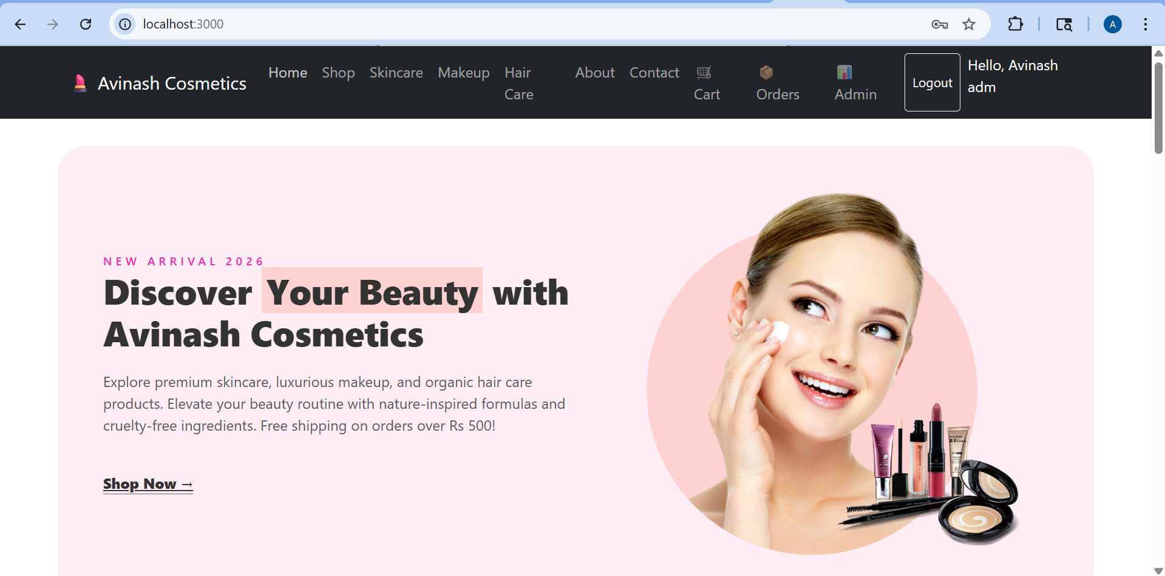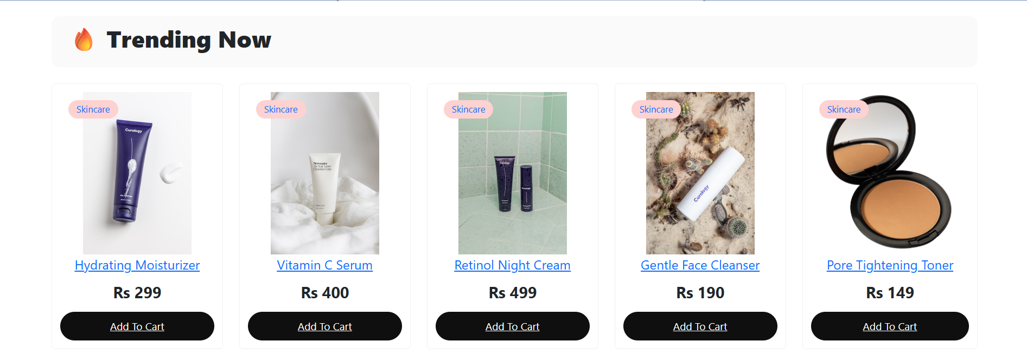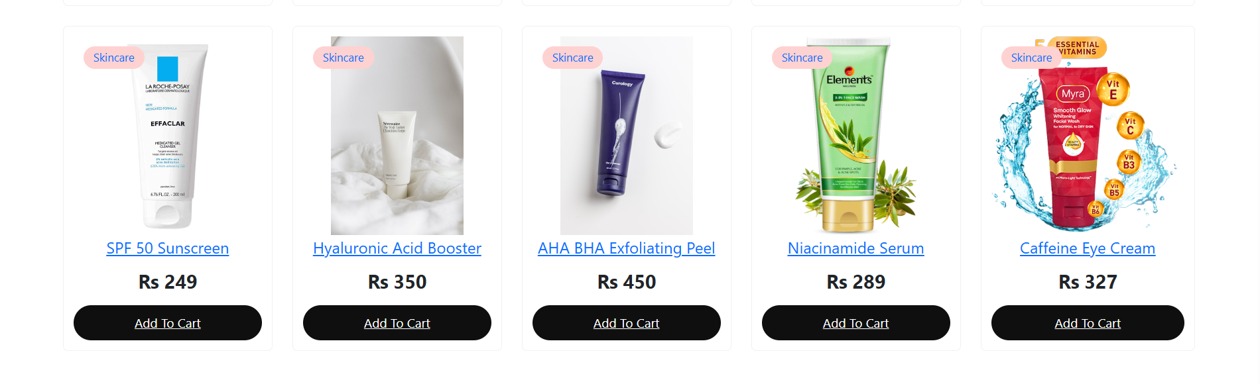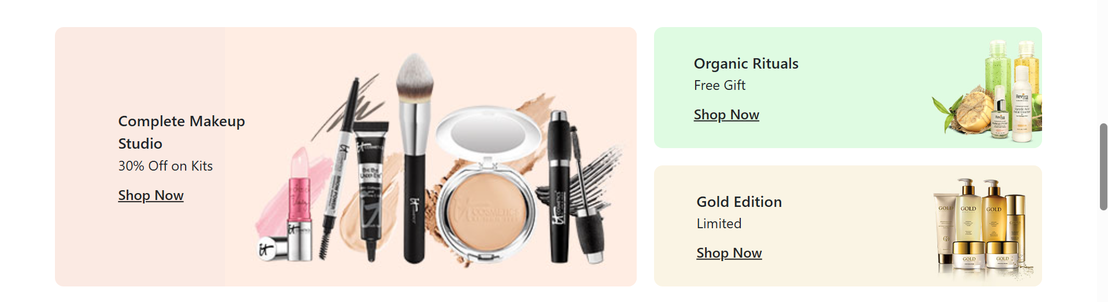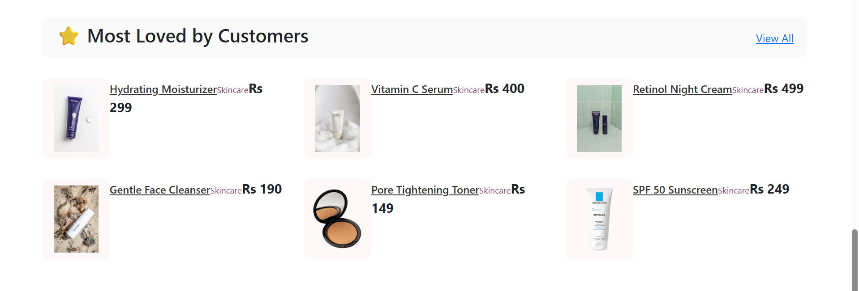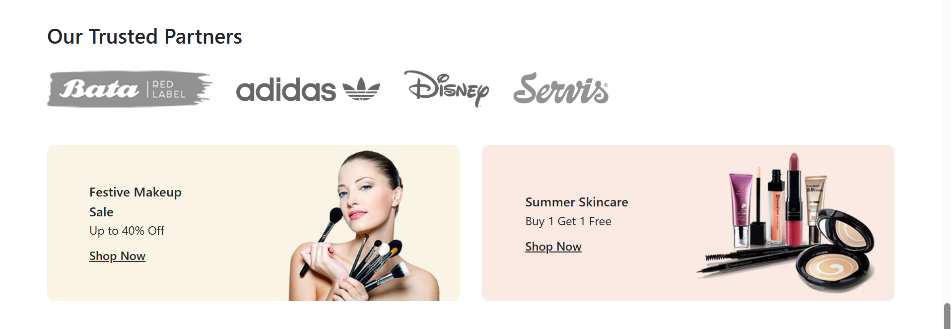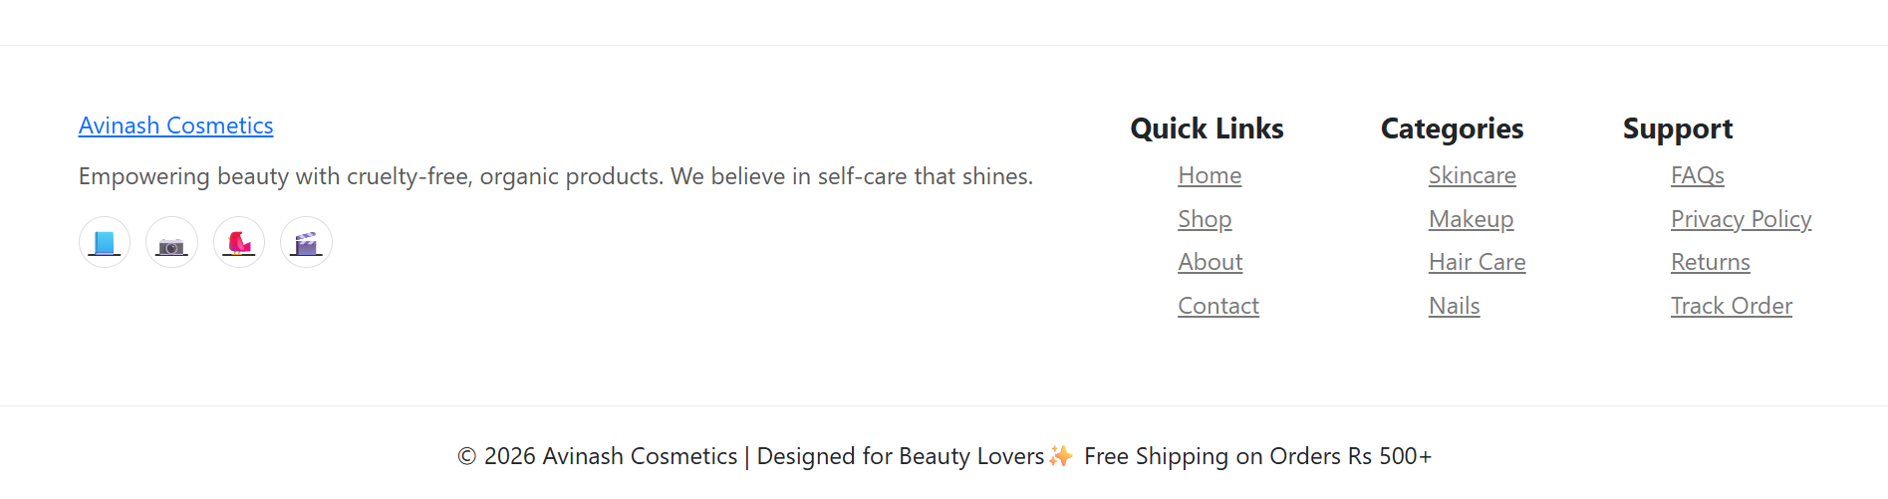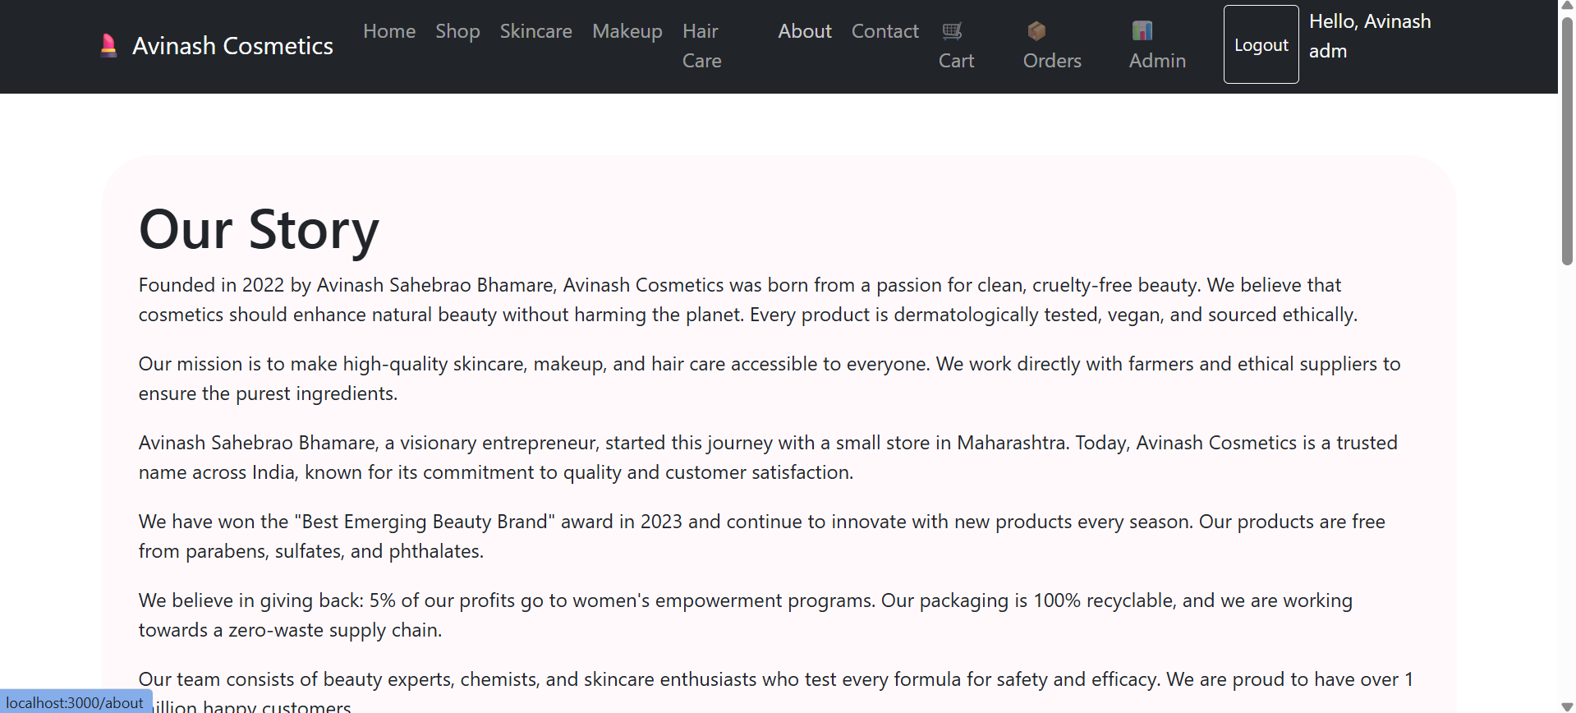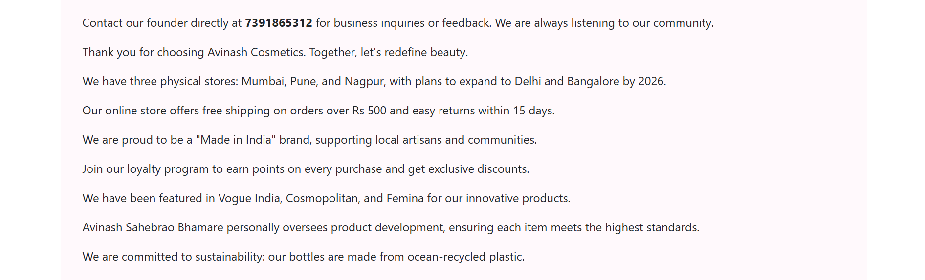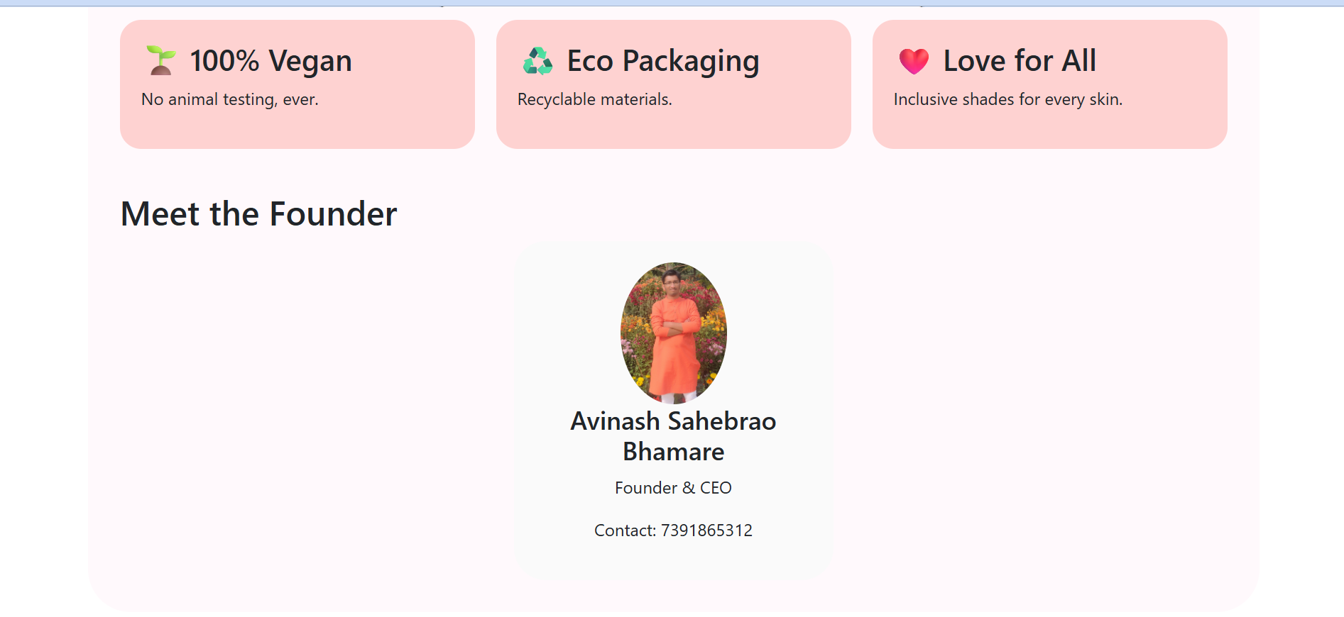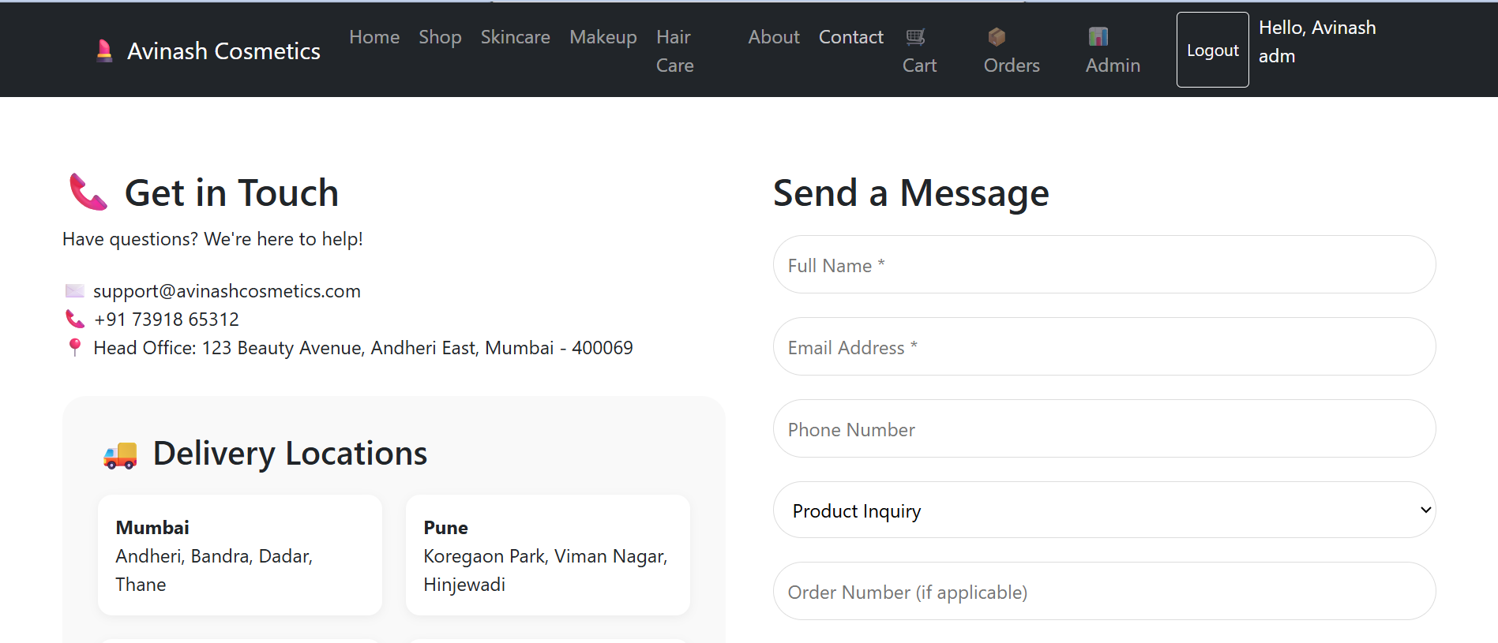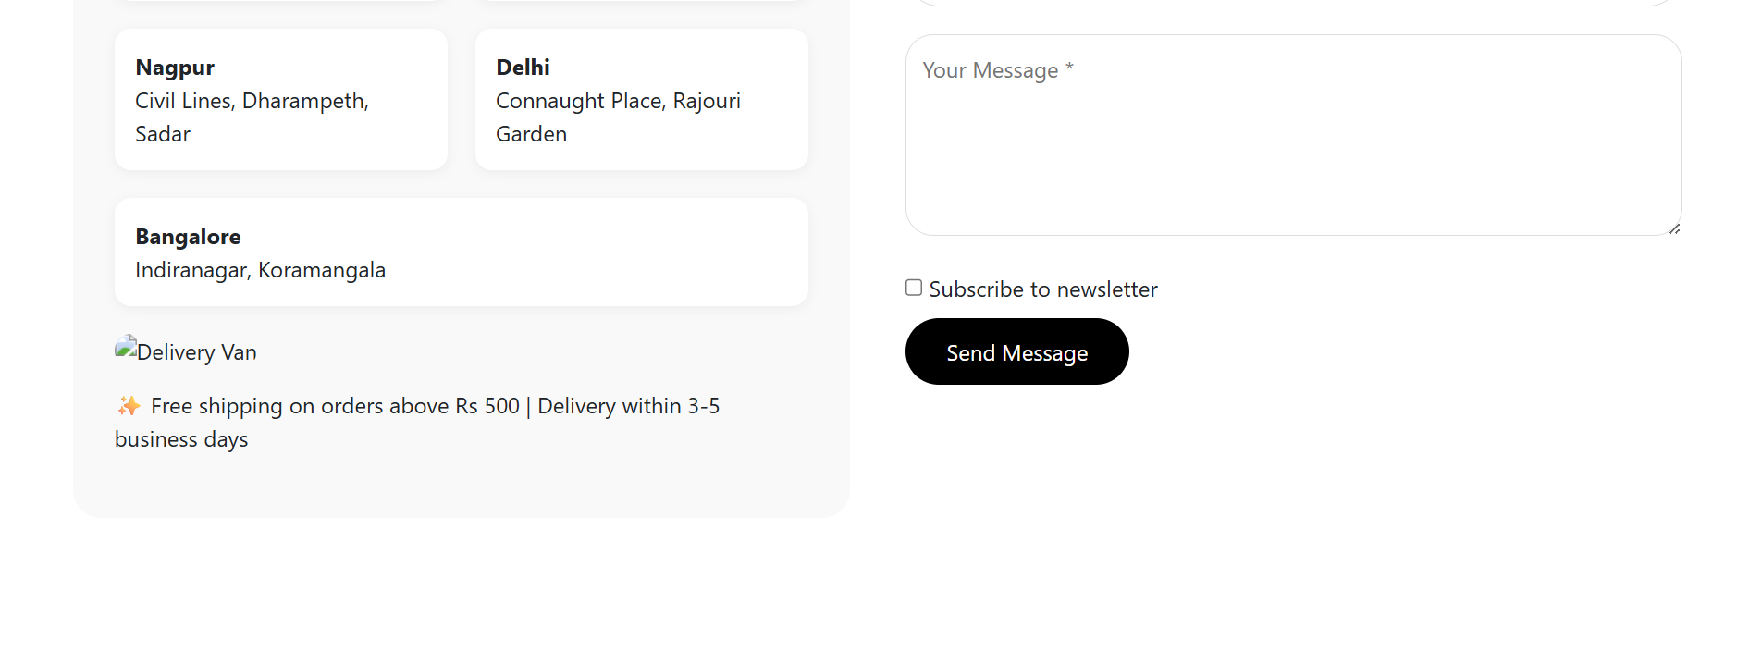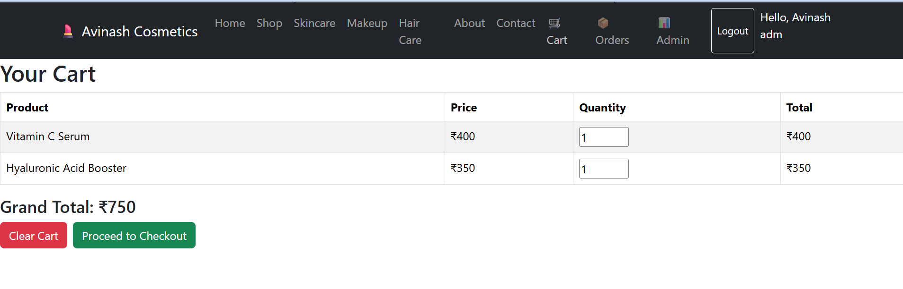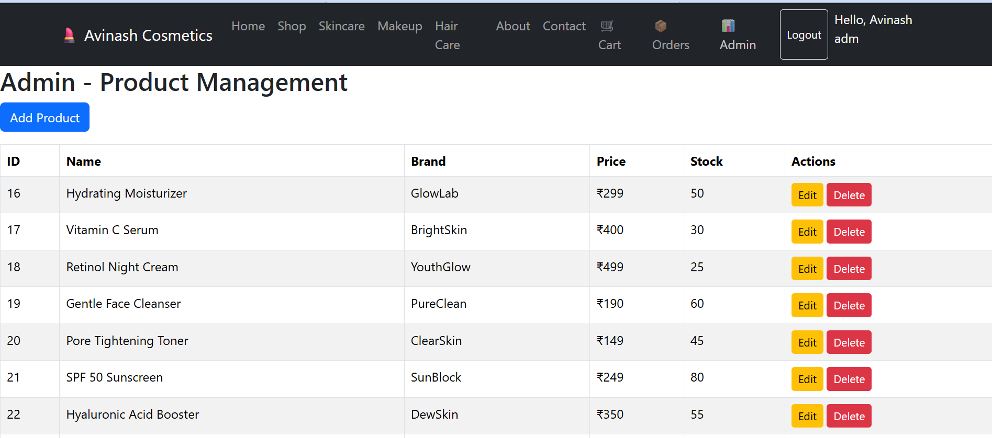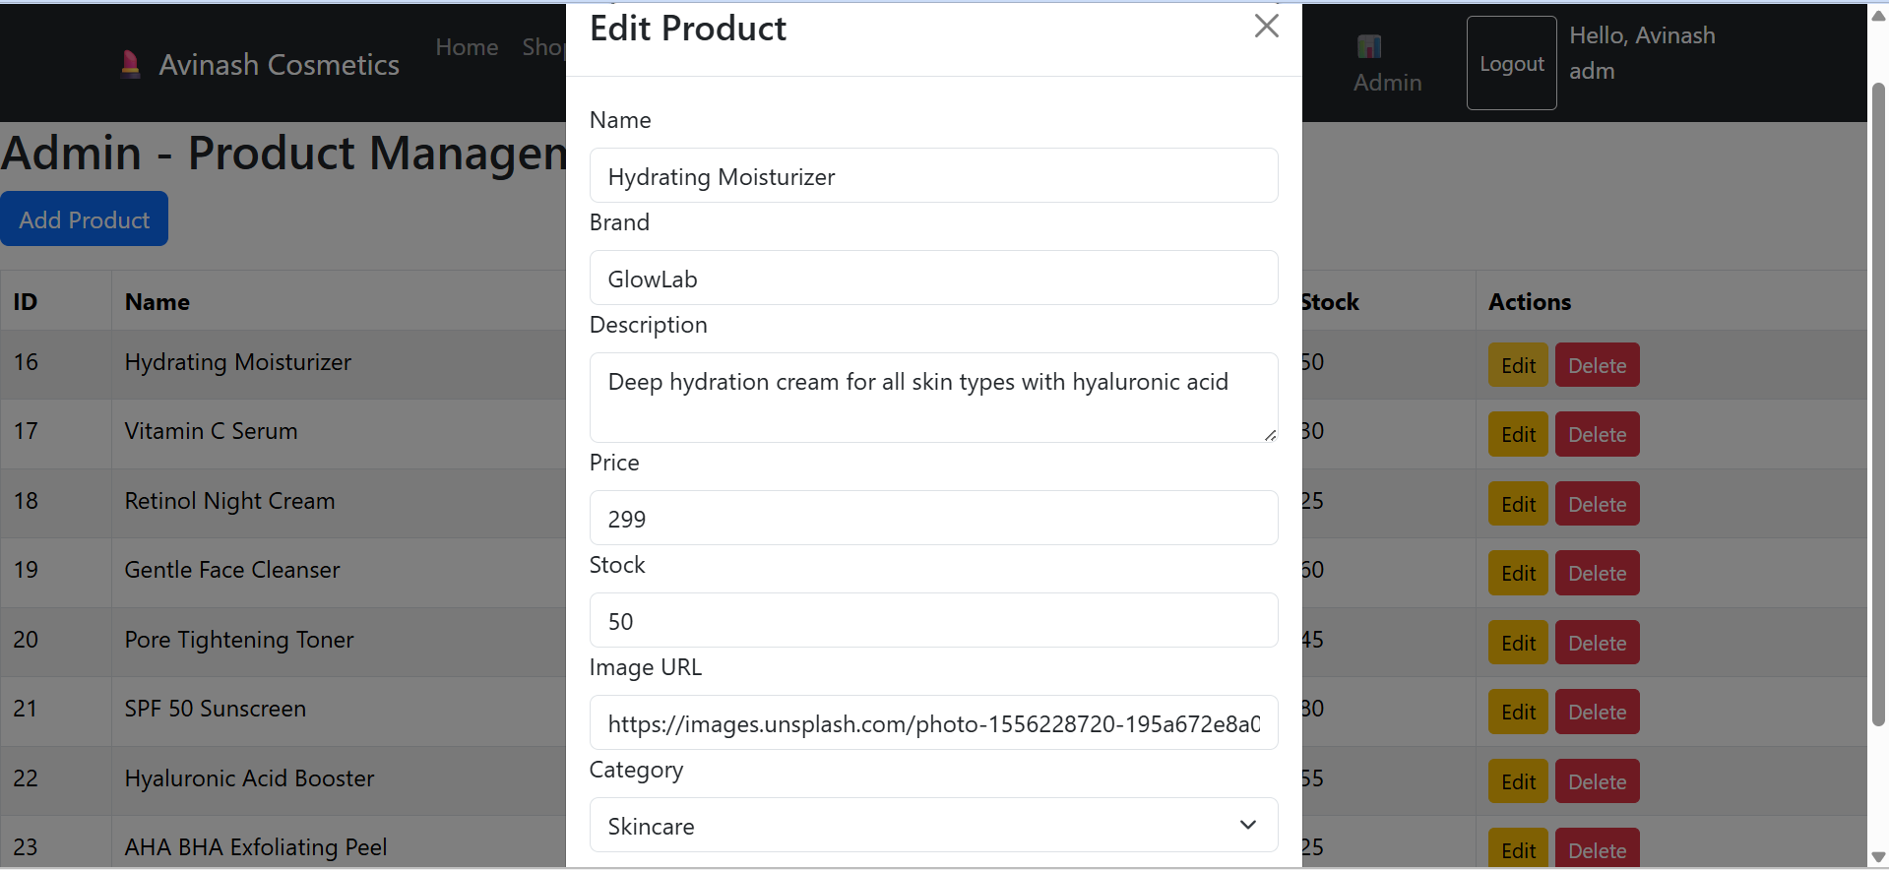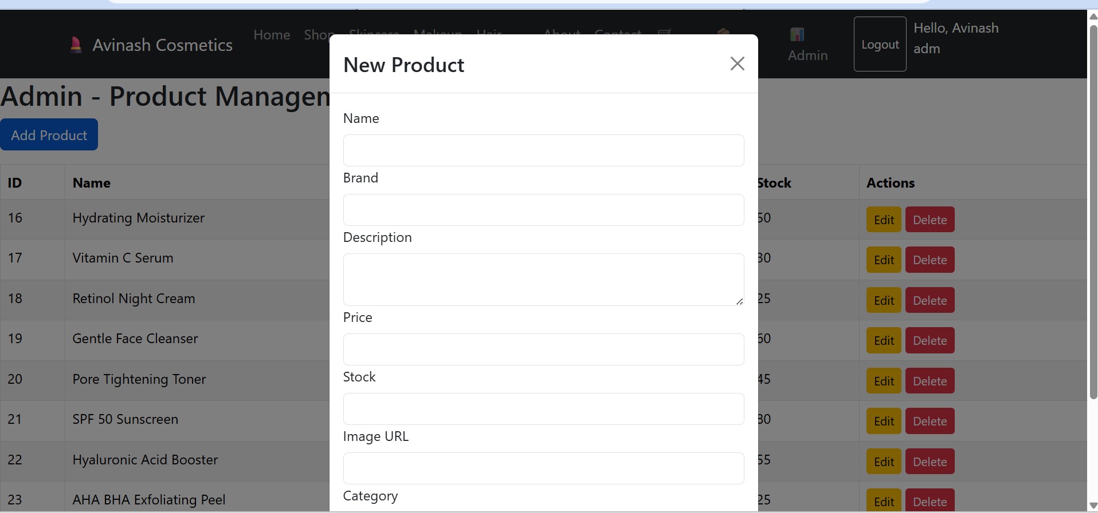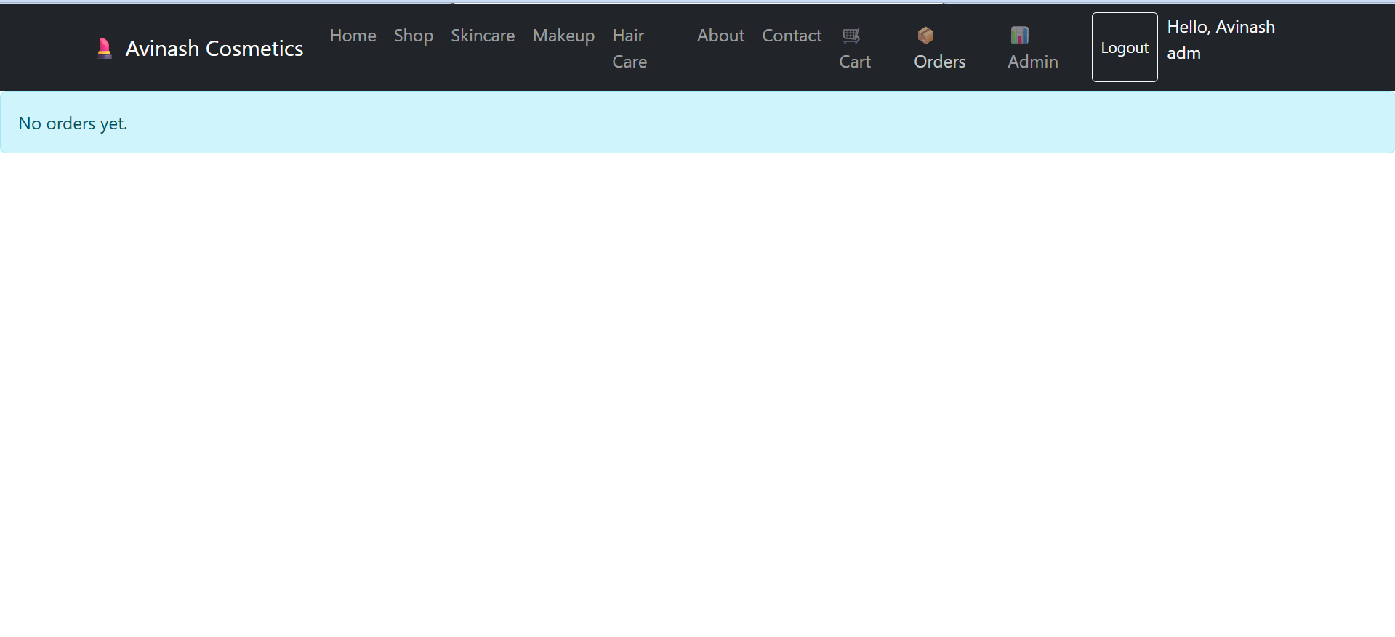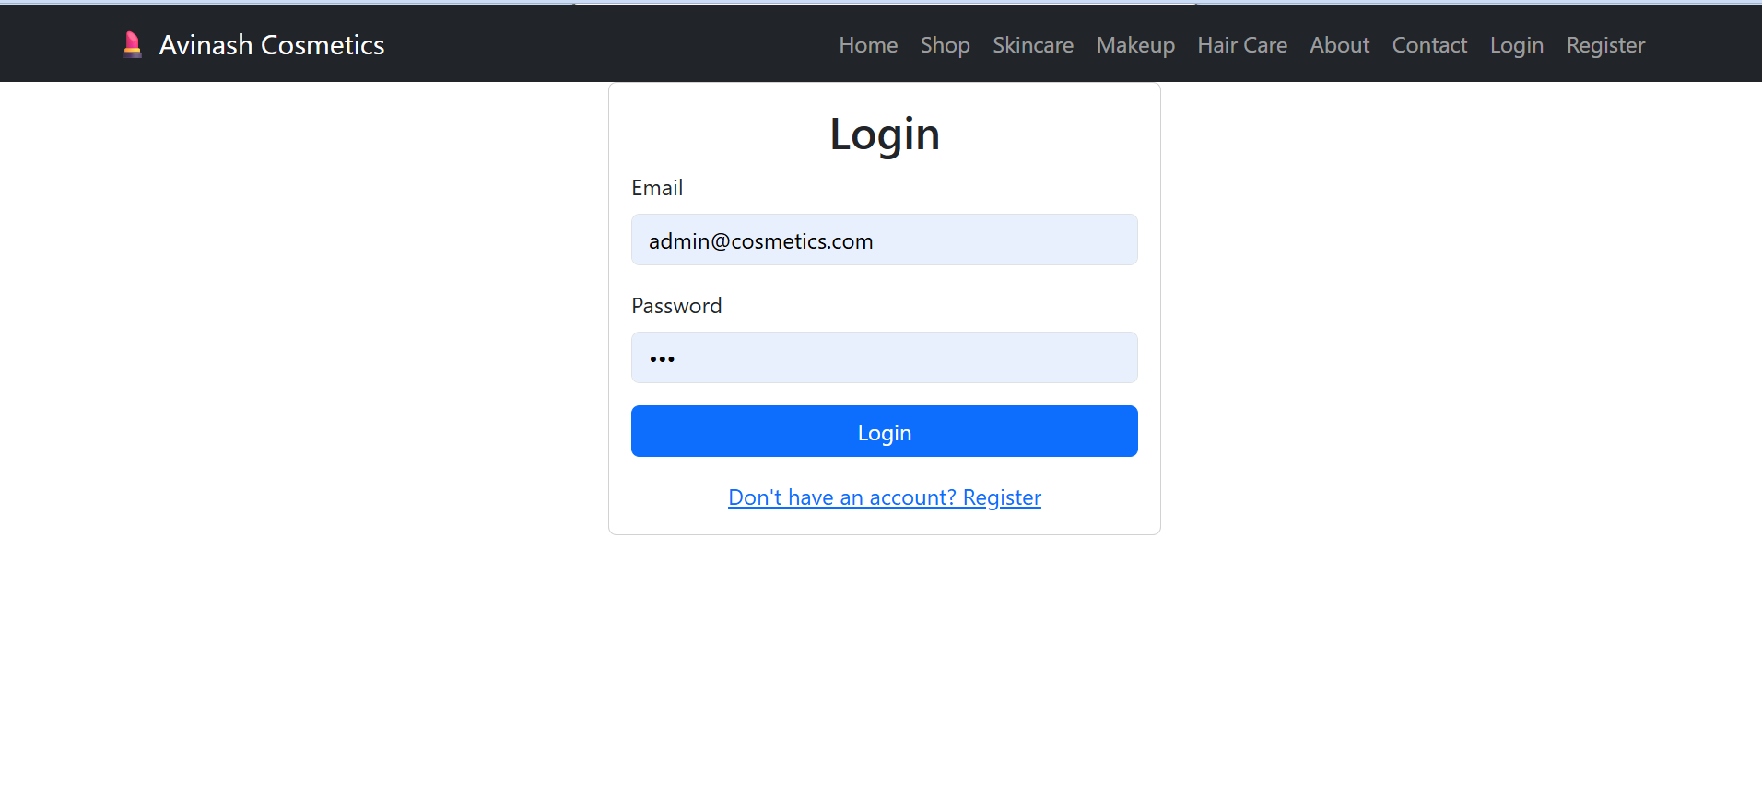
5. Technology Stack

Backend: Spring Boot 3.1.5, Spring Security, JWT, Spring Data JPA (Hibernate), Hibernate Validator
Frontend: React 18, React Router DOM 6, Axios, Bootstrap 5, Custom CSS
Database: MySQL 8.0, JDBC connector
Build Tools: Maven (backend), npm (frontend)
Testing: Postman (API testing), browser console
Version Control: Git, GitHub

6. Unique Points

1. JWT Authentication – Secure token‑based authentication with role‑based access (USER/ADMIN). No session storage on server, making the application stateless and scalable.
2. Real‑time Stock Validation – When a user places an order, stock is checked and reduced immediately, preventing out‑of‑stock orders.
3. Automatic Table Creation – Hibernate’s ddl-auto=update creates database tables from entity classes automatically; DataInitializer seeds 30 products on first run.
4. Clean Layered Architecture – Separation of concerns: Controller → Service → Repository → Entity, enhancing maintainability.
5. Responsive UI – Bootstrap ensures the application works seamlessly on mobile, tablet, and desktop.
6. Whole‑Number Pricing – All product prices are stored as integer values (e.g., Rs 30, Rs 40) for a cleaner user interface.
7. Password Encryption – BCrypt hashing ensures no plain‑text passwords are stored in the database.
8. CORS Configuration – Allows the frontend (running on http://localhost:3000) to communicate with backend APIs (http://localhost:8080) during development.

7. Future Improvements

- Payment Gateway Integration – Add Razorpay/Stripe for real payments.
- Product Reviews & Ratings – Allow users to rate and review purchased products.
- Wishlist Feature – Save products for later purchase.
- Email Confirmation – Send order confirmation emails using JavaMailSender.
- Search & Filters – Search by product name, filter by price range or brand.
- Admin Dashboard – Visual charts for sales and low stock alerts using Chart.js.
- OAuth2 Login – Enable sign‑in with Google or Facebook.
- Pagination – Load products in batches for better performance.
- Image Upload – Allow admin to upload product images instead of using URLs.

8. Conclusion

Avinash Cosmetics successfully implements a complete end to end e-commerce workflow: user registration, product browsing (30 products across three categories), cart management, order placement, and admin product management. It follows industry best practices with Spring Boot security, React hooks, and RESTful API design. The project is fully functional, tested, and ready for deployment.

