**Course Number:** CS 329E

**Group Number:** 8

**Group Members:**

* Henry Vuong hv3594
* Stepan Ulyanin su2652
* Jose R. Vazquez Canteli jrv966

**Application Name: IEL App**

**Application Description:**

The application will ask students on campus in which room they are at given moment in time. They will also be asked to rate on a scale from 1 to 9 how cold or hot they feel. The user will be able to set the frequency with which he or she wants to be asked (i.e. three times a day), and the hour interval (i.e. from 1pm to 5pm). Additionally, the students should be able enter, whenever they want, their location and thermal comfort even if they have not received a notification to do so. The application will send the data to a server to be stored. The data from the responses that the students provided randomly is managed differently than the data the users provided on purpose.

The application can track the users by GPS, and tell them which buildings and rooms will provide them with the highest amount of points for providing their feedback. The users will also be able to track how many points they have earned, and the feedback they have already provided. Then they will be able to exchange the points by gift cards. This user feedback can then be used by the facility managers of the university, and by the IEL Laboratory at UT, to adjust the temperature of the rooms more effectively to maximize comfort and save energy whenever it is possible.

**Mockups & Operational Descriptions**:

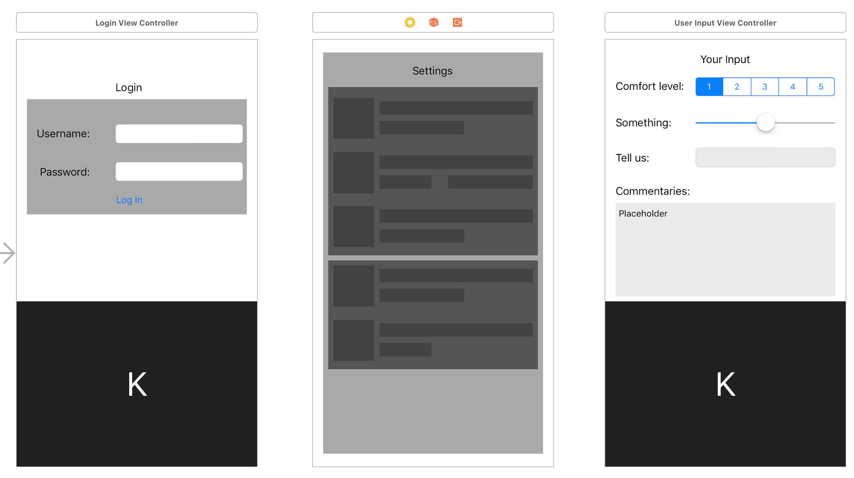

**1. Login screen:**

The user enters the username and password to log in. The user can only be signed up by a member of our laboratory. This is to avoid too many users signing in (more than the laboratory can pay for).

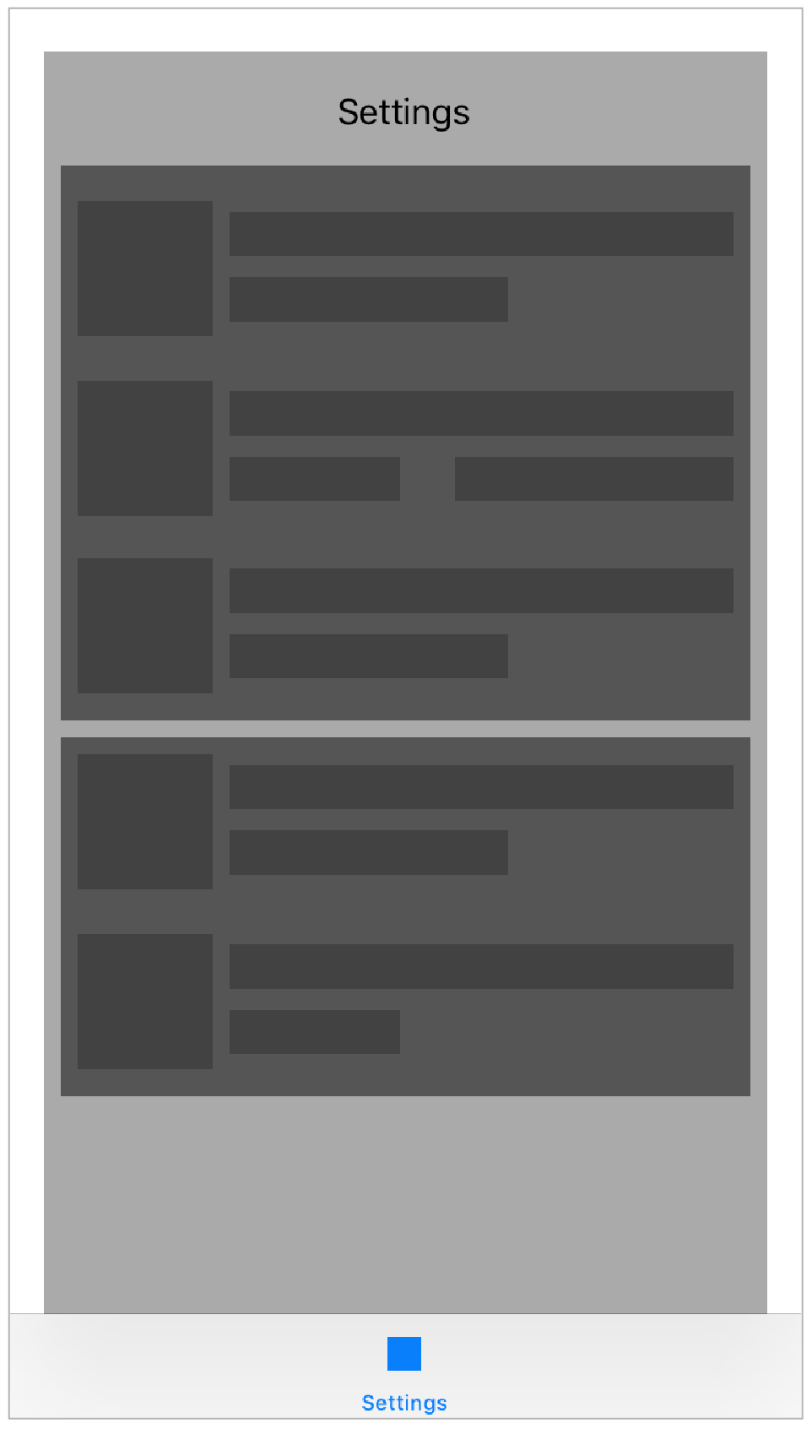

**2. Settings screen:**

The user can adjust with what frequency they want to be randomly asked to enter they thermal comfort and whether the user wants to activate the GPS.

**3. User Input screen:**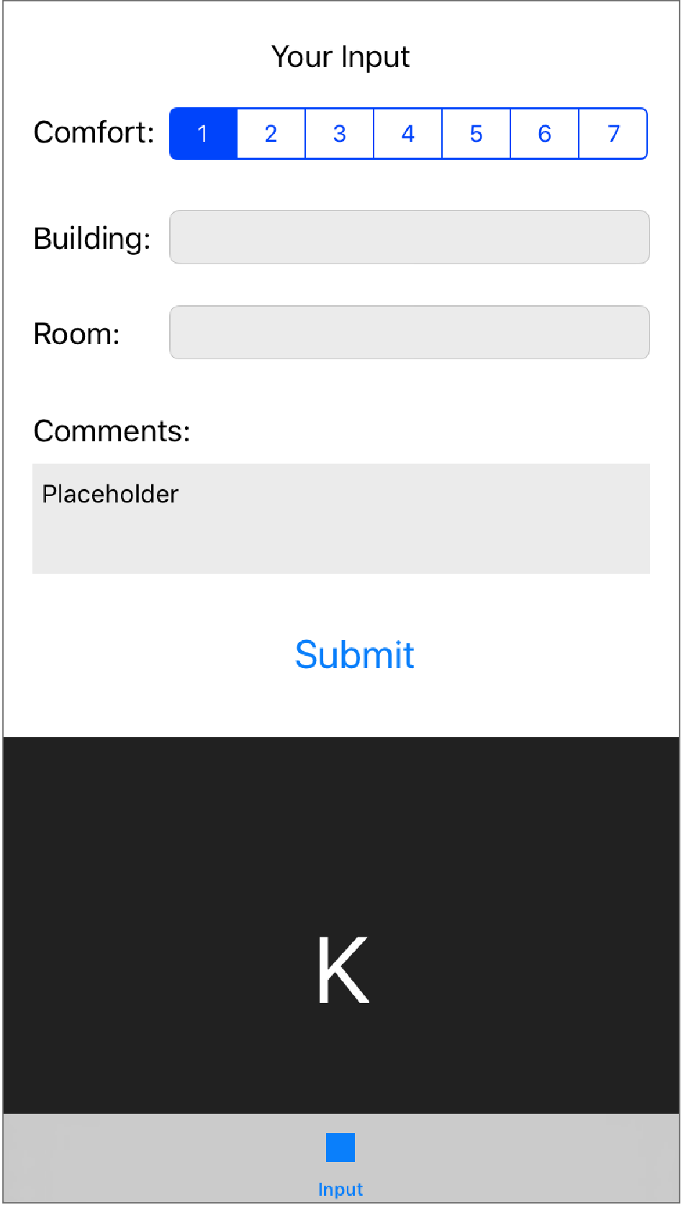

Input thermal comfort on a scale from 1 to 7 and the room where they are located. They can also write any comments.

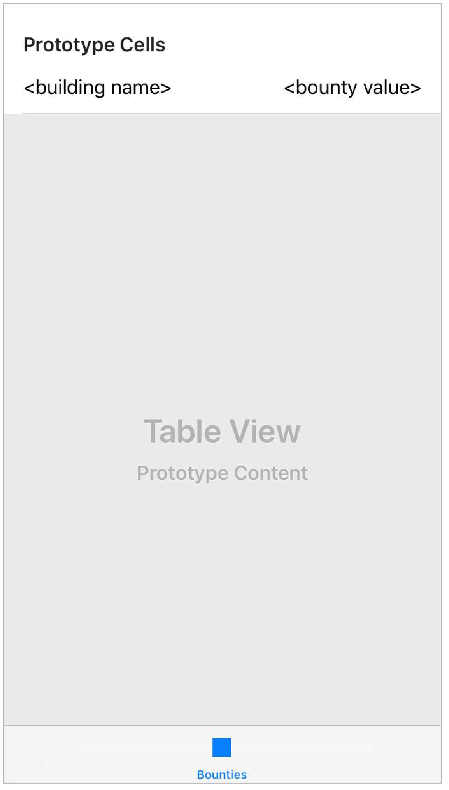

**4. Bounty screen:**

Users can see which buildings will provide them with the highest bounties if they report their thermal comfort in it.

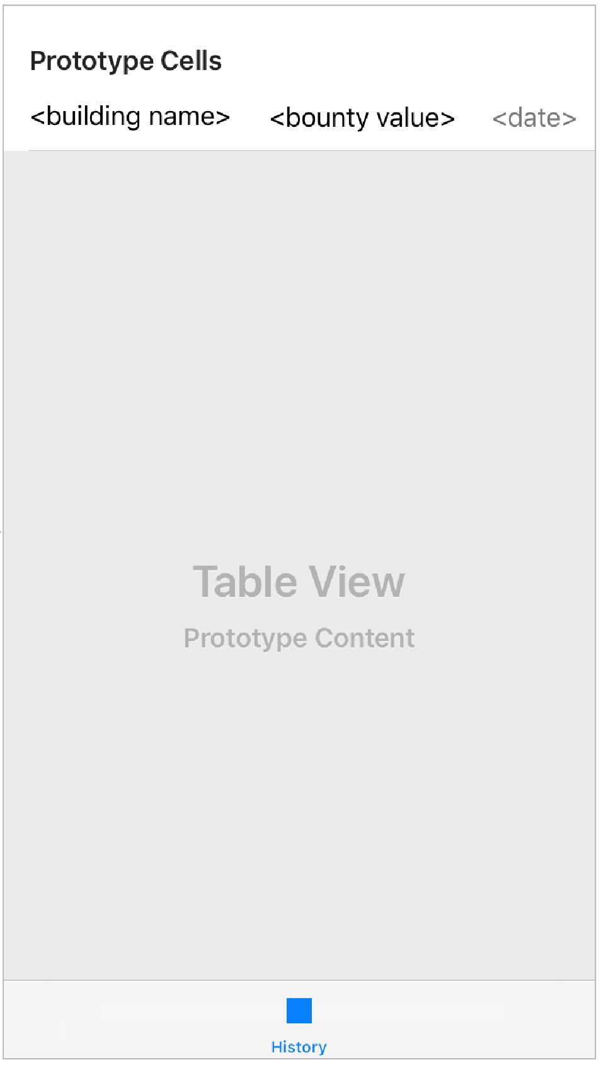

**5. History screen:**

Users can keep track of their activity (feedback or bounties gained)

**Application Flow Diagram:**

