Project Documentation Phase
Team ID | 6ab5122914835f68f9373e5d
Team Leader | Avinash A
Team member | Anthony Nickson S
Project Title | Streamlining IT Procurement: Automating Standard Laptop Orders with Flow Designer
Project Overview
The Streamlining IT Procurement: Automating Standard Laptop Orders with Flow Designer project demonstrates how ServiceNow Flow Designer can automate the standard laptop ordering process. The implementation combines a Service Catalog trigger, a Create Catalog Task action, and flow assignment to a catalog item so that configuration tasks are generated and assigned without manual effort.
Configuration Summary
The flow named Standard laptop task belongs to the Global application and runs as the System user. It uses the Service Catalog trigger and a Create Catalog Task action that maps the Requested Item record, sets the short description and description to “Laptop need to Configured”, assigns the task to the Hardware group, and sets Approval to Approved. The flow is assigned to the Standard Laptop item in Maintain Items as its process engine, replacing the other automations.
Business Rules Demonstrated
The project demonstrates automated task creation after request approval, consistent assignment of configuration work to the Hardware group, and reduced manual intervention in the procurement process. These controls help ensure laptops are configured promptly and reduce user wait times.
Flow Components Used
The documented components include the Standard laptop task flow, the Service Catalog trigger, the Create Catalog Task action, and the Standard Laptop catalog item. Each component has a specific purpose in starting the process, creating the task, and linking the automation to the item being ordered.
Testing Documentation
Testing covers flow assignment, order placement through the Service Catalog, request approval, and Catalog Task creation. The expected results are documented so that the implementation can be demonstrated consistently.

Milestone-1
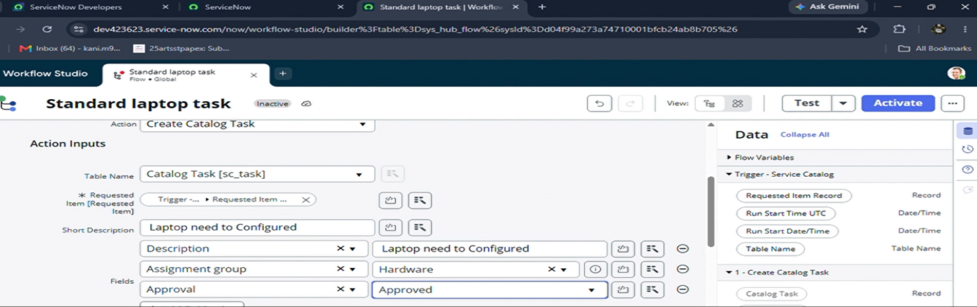
Milestone-2
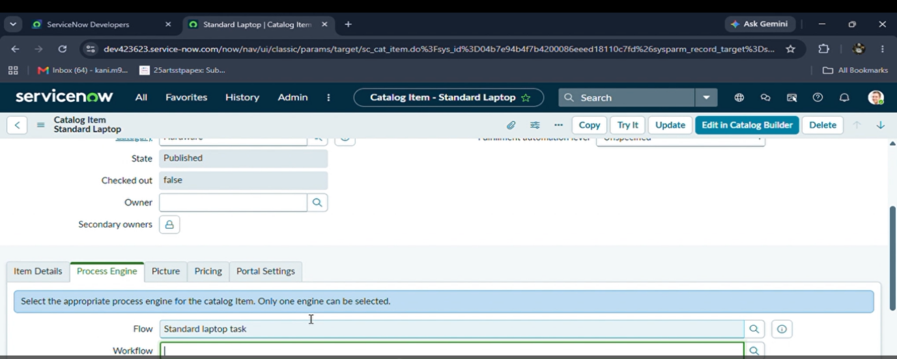

Milestone-3
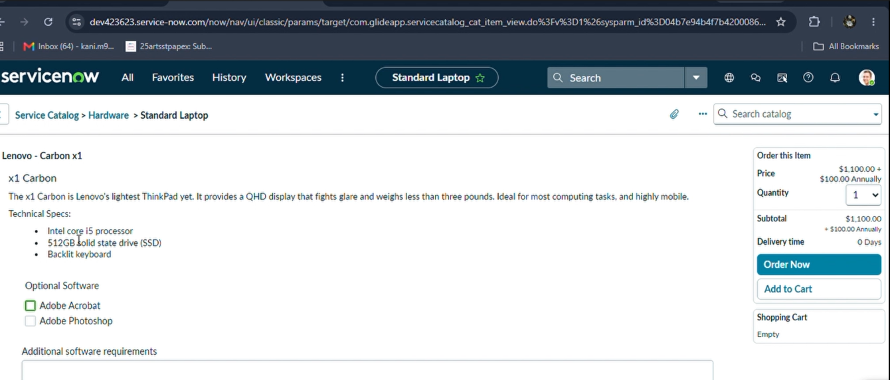

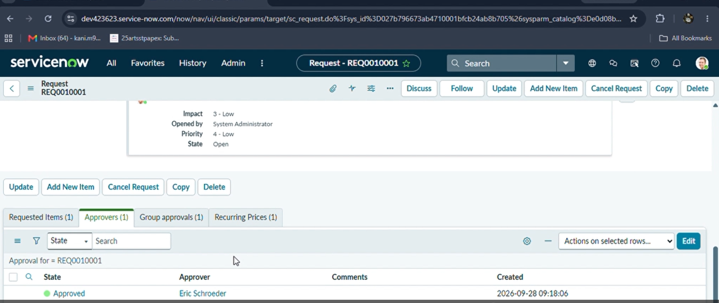

Conclusion
By automating the standard laptop procurement process with ServiceNow Flow Designer, the project addresses inefficiencies and reduces manual overhead. The workflow ensures timely configuration of laptops, minimises user wait times, and improves productivity within the IT department. The documentation provides a consolidated reference for the flow configuration, expected behavior, and testing activities, and can be used to explain the implementation during project review or demonstration.

