- Website Common observations:

- Menu bar should be on top of the website which is generic and user-friendly approach.
- Every time clicking on available menu options system redirects to same screen location which is confusing for user as redirection to actual screen is not clearly visible.
- User interface is not user friendly as it is very dark in colour which can makes uncomfortable to users.
- The contact section at the top should follow standard website practices, instead of mentioning the telecom provider (e.g. Jio Number, Airtel number, etc.), the site should display clear contact details such as Phone number along with an official email address. This improves professionalism and user trust.
- The Feature image of Packers and movers shows haven’t utilised the banner section completely and image information details are also in unreadable colour combinations.
- ‘Email’ field under ‘Want to shift house form section’ is not clearly visible for users which shows some irrelevant icons and also the filled data is not visible to user.
- Menu bar options not consistent with the details added such as – some says Packers and movers Bangalore and some says packers Mumbai.

- Smoke check on home screen:

- ‘Get Free Quote’ is not clickable.
- Call 8121951331 link is navigating to top of the page.
- SKYWING Cargo menu option redirect user to incorrect URL.

- Menu wise Defects:

Home Screen: https://sheetal.net/
Functional Issues:
Defect 1:
System allows to enter invalid information into all available fields and shows ‘Something Went wrong’ screen on clicking on ‘Submit’ button.
Steps to reproduce:
- User on Home screen
- User enters invalid details in all available fields
- User clicks on ‘Submit’ button.
Actual Result: System shows ‘Something went wrong’ error message.
Expected Result: System should show error message as ‘Please enter valid details’ and shows field level validation for all fields.
Evidence:
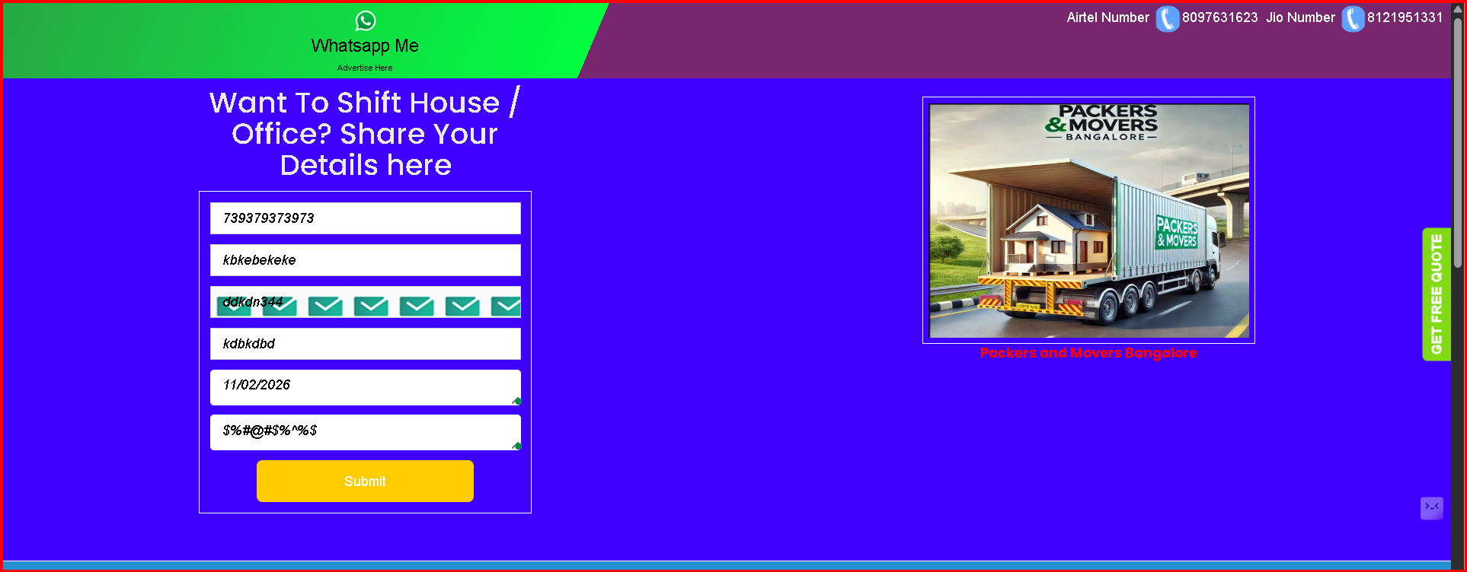
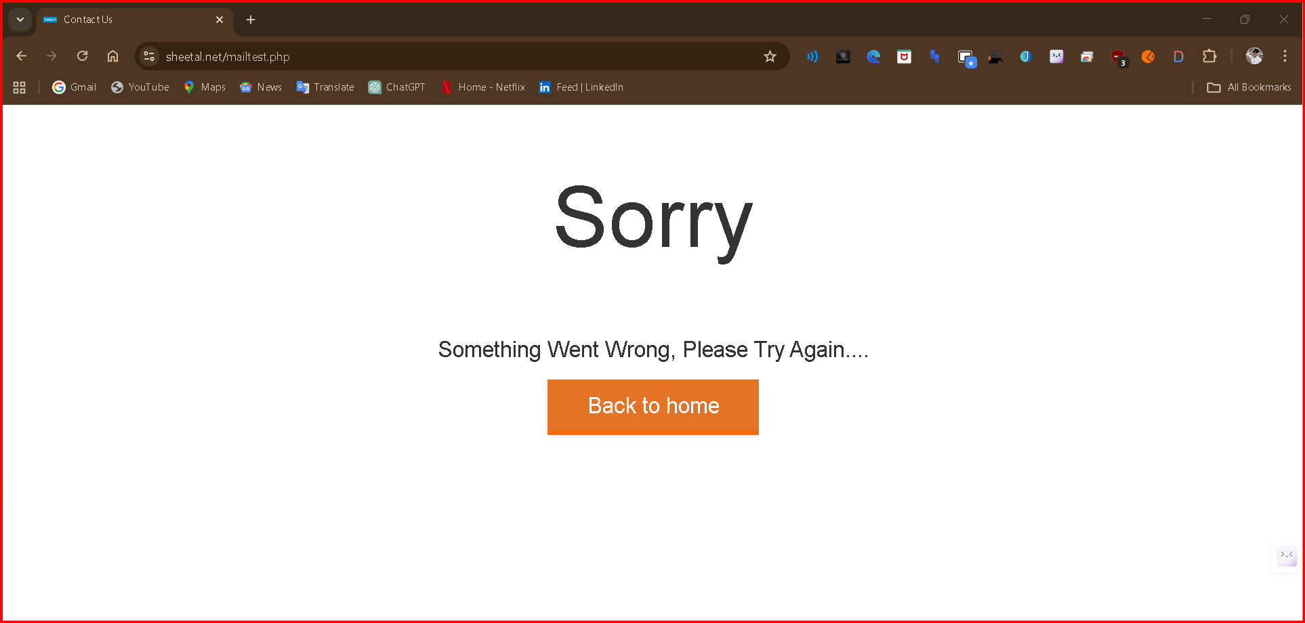

Packers and Movers Bangalore: https://sheetal.net/packers-and-movers-bangalore.php
Functional defects:
Defect 2:
System does not show title of the menu after successful redirections to ‘Packers and movers Bangalore’
Steps to reproduce:
- User on Home screen
- User clicks on ‘Packers and movers Bangalore’
Actual Result: System does not shows Page title to confirm the correct redirection
Expected Result: System should show Page title as ‘Packers and movers Bangalore’ title
Evidence:
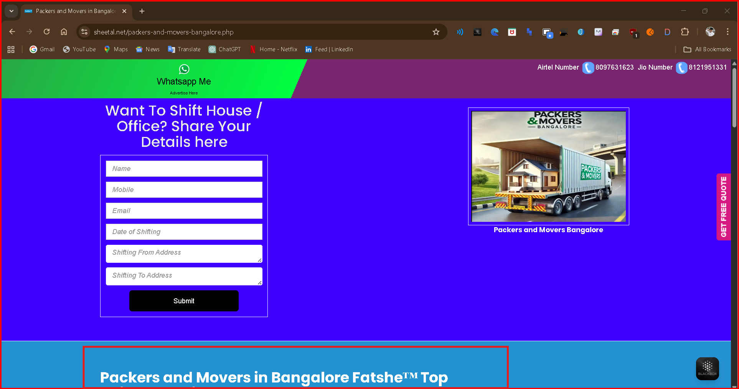

Defect 3:
Breadcrumb is not clearly visible to user.
Steps to reproduce:
- User on Home screen
- User clicks on ‘Packers and movers Bangalore’
Actual Result: Breadcrumb is not visible.
Expected Result: System should show Breadcrumb clearly to user
Evidence:
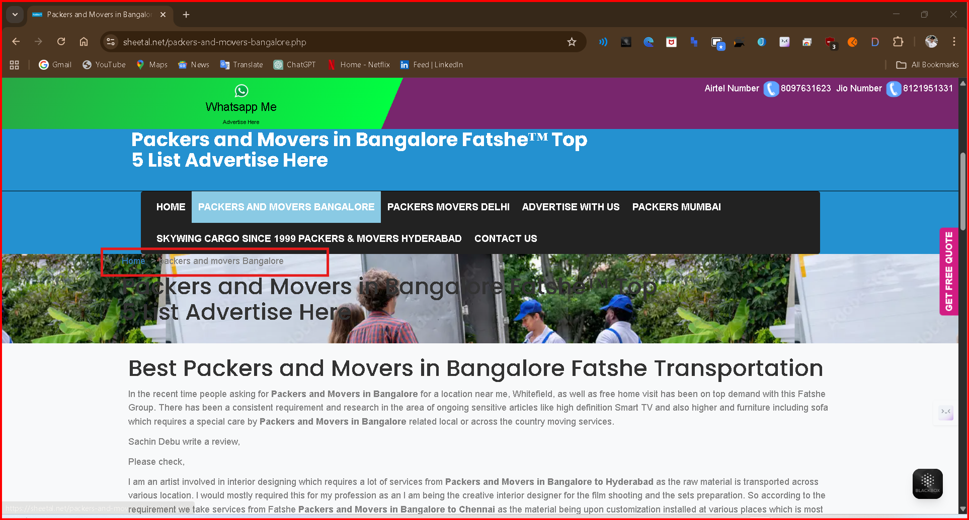
Defect 4:
Text on the Banner is not visible correctly
Steps to reproduce:
- User on Home screen
- User clicks on ‘Packers and movers Bangalore’
- Navigate to banner of the Packers and movers Bangalore’ screen.
Actual Result: Text on Banner is not visible
Expected Result: System should show text on the banner clearly
Evidence:
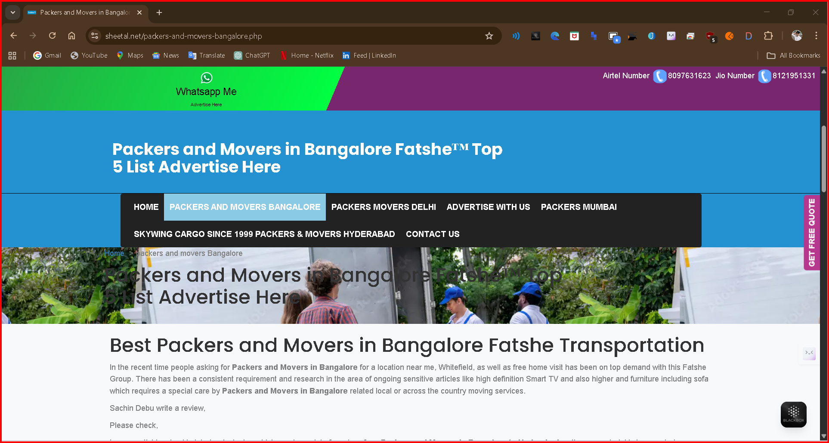

Packers Movers Delhi: https://sheetal.net/Best-Packers-Movers.php
Defect 5: [UI Observations] - System shows two hyphens
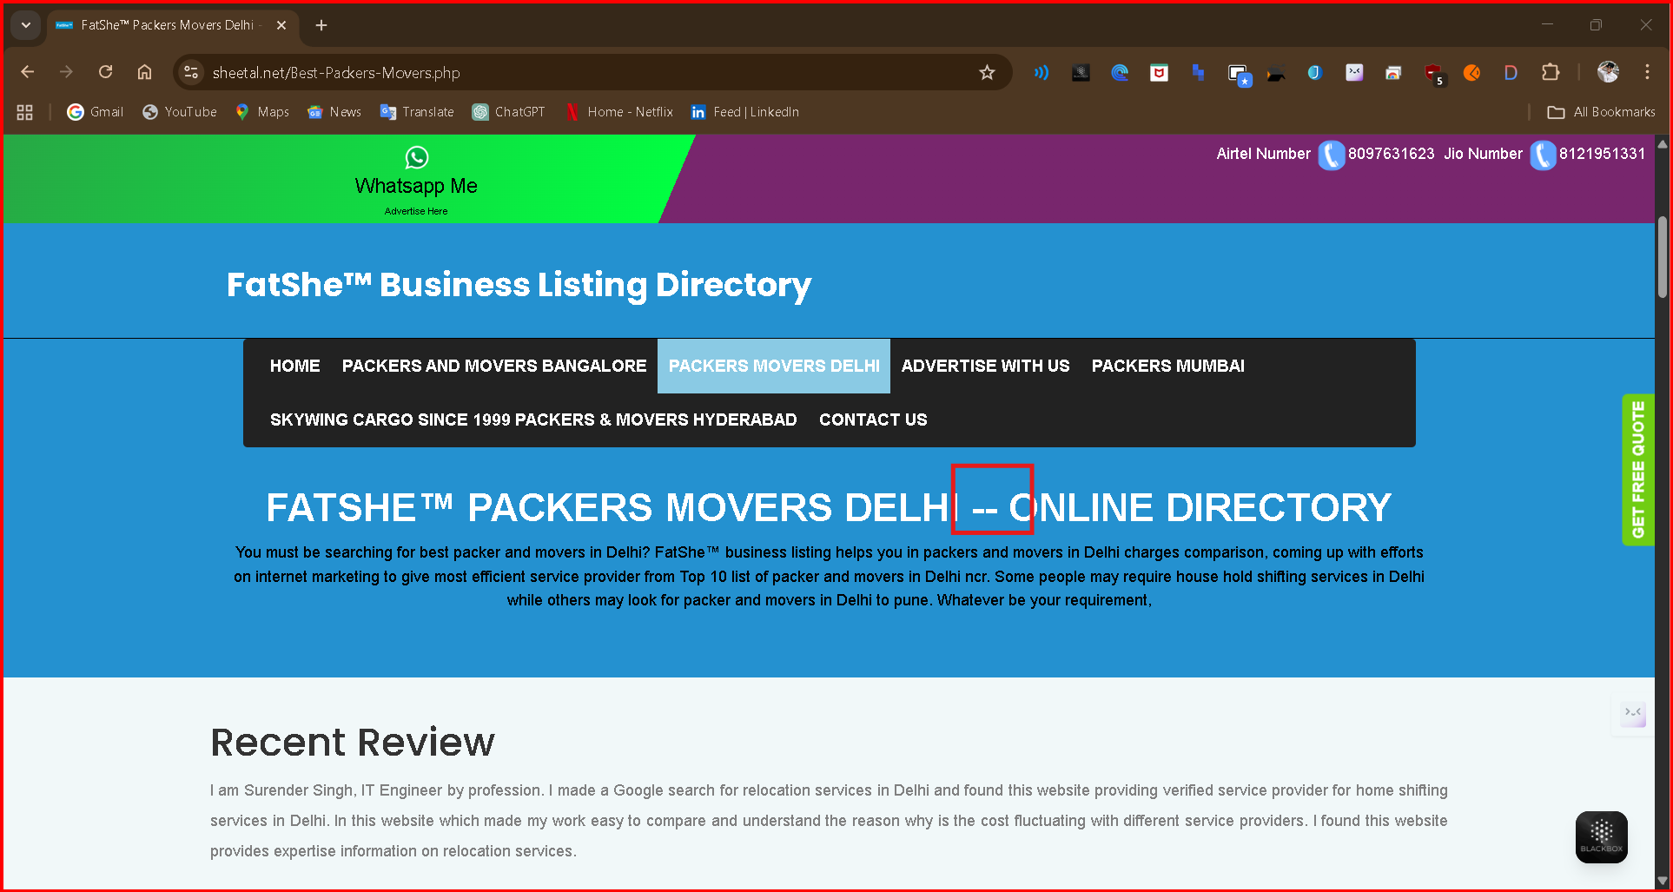

Defect 6: City or area names should be in Capitalize each word format
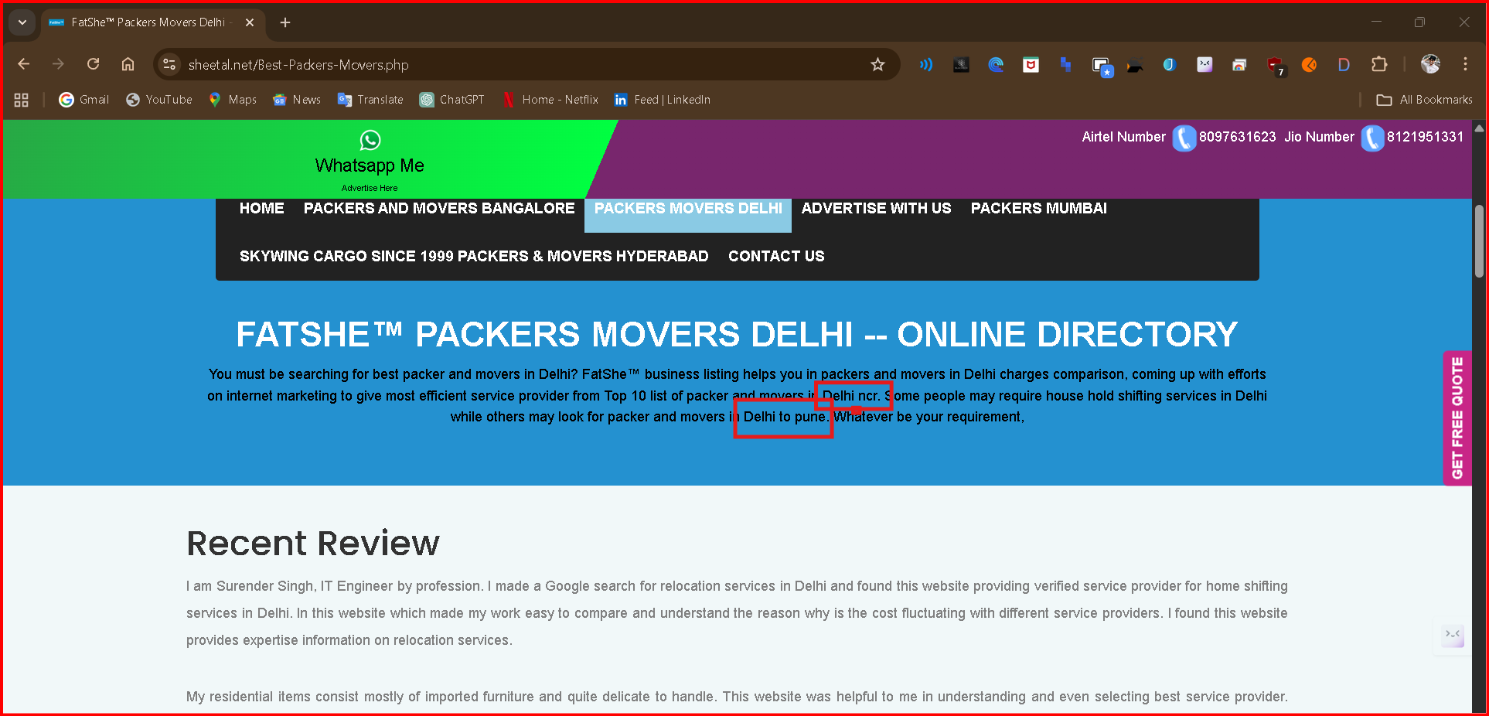

Packers Movers Delhi: https://sheetal.net/advertise-with-us.php

Defect 7: System does not highlight correct menu options after clicking on ‘Advertise with us’ title
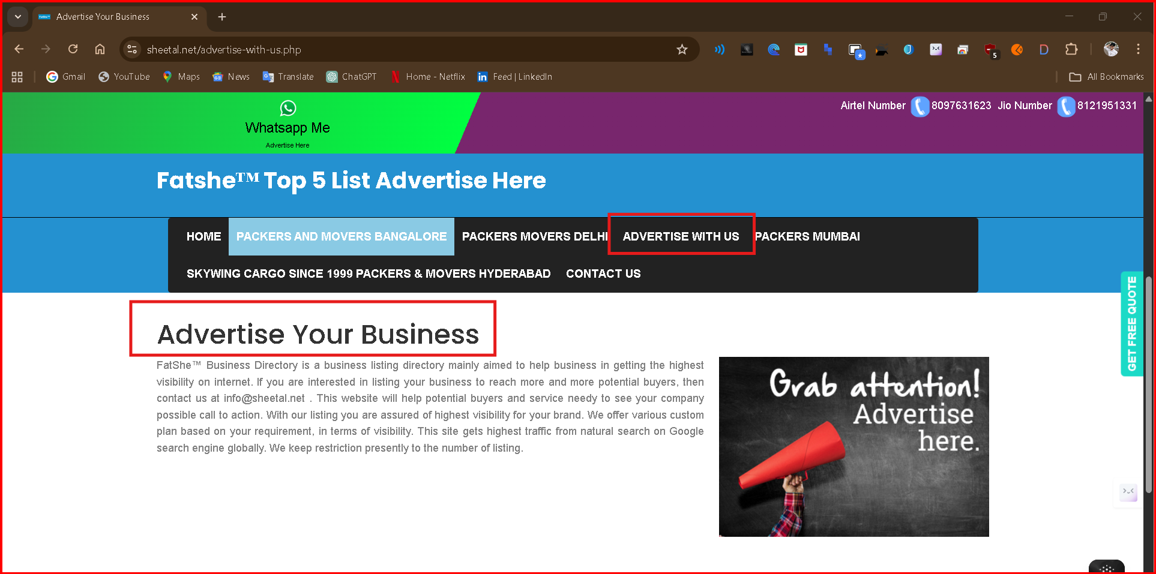

Packers Mumbai: https://sheetal.net/packers-movers.php

Defect 8 : Menu link labeled “Packers Mumbai” does not reflect correct page name or URL content
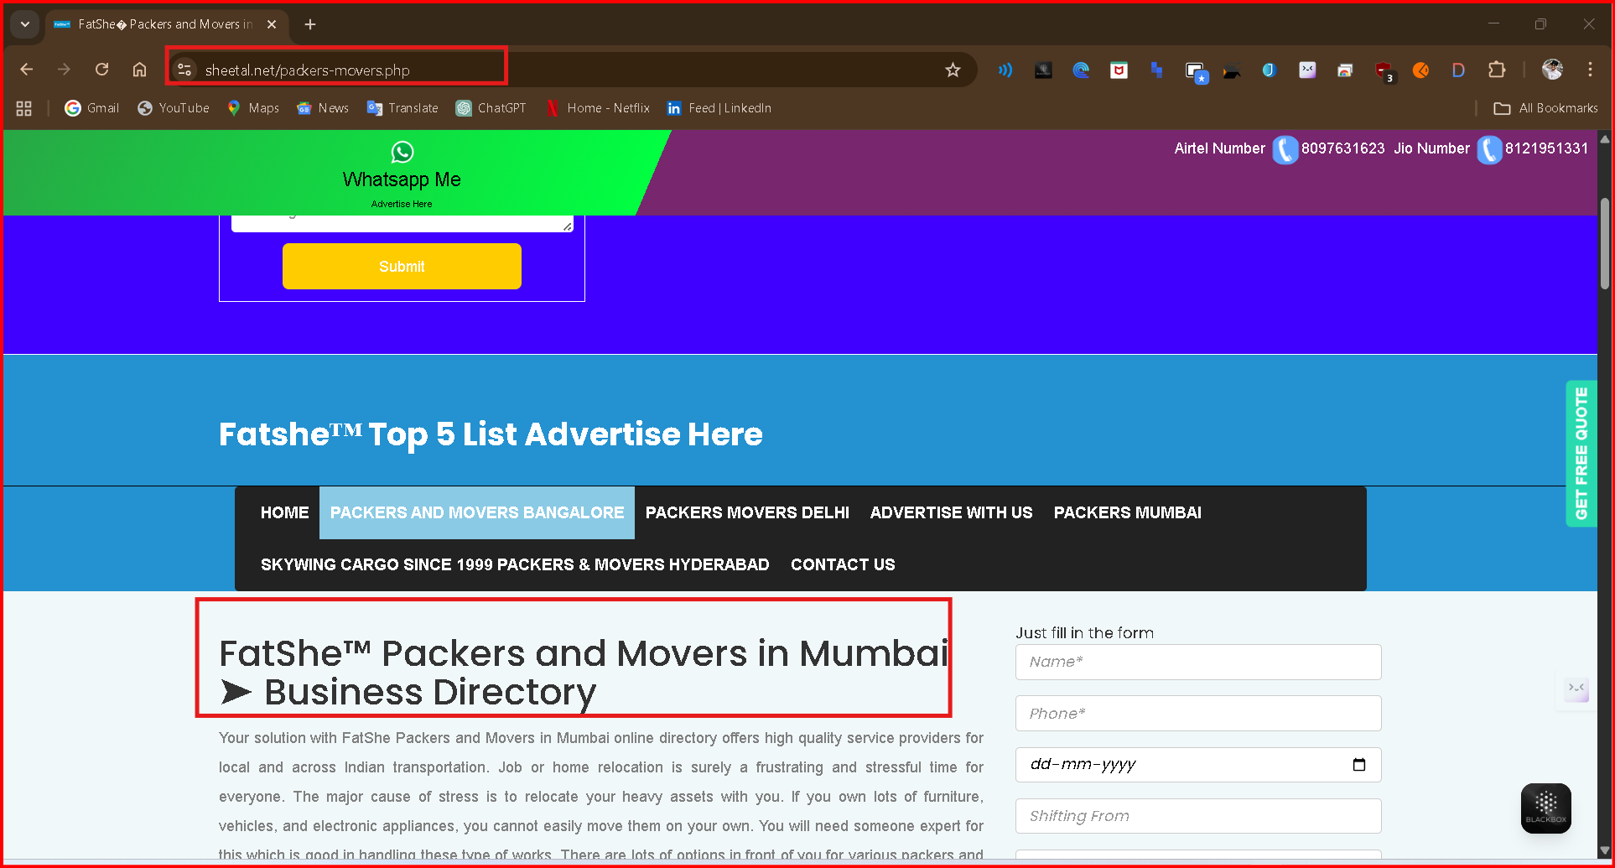

Defect 9: System allows to submit the ‘Just fill in the form’ without entering data.
Steps to reproduce:
- User on Home screen
- User clicks on ‘Packers Mumbai’ Manu options.
- User clicks on submit button without filling data into form ‘Just fill in the form’ form.
Actual Result: System allow to submit the form with empty fields
Expected Result: System should not allow to submit with empty fields.
Evidence:

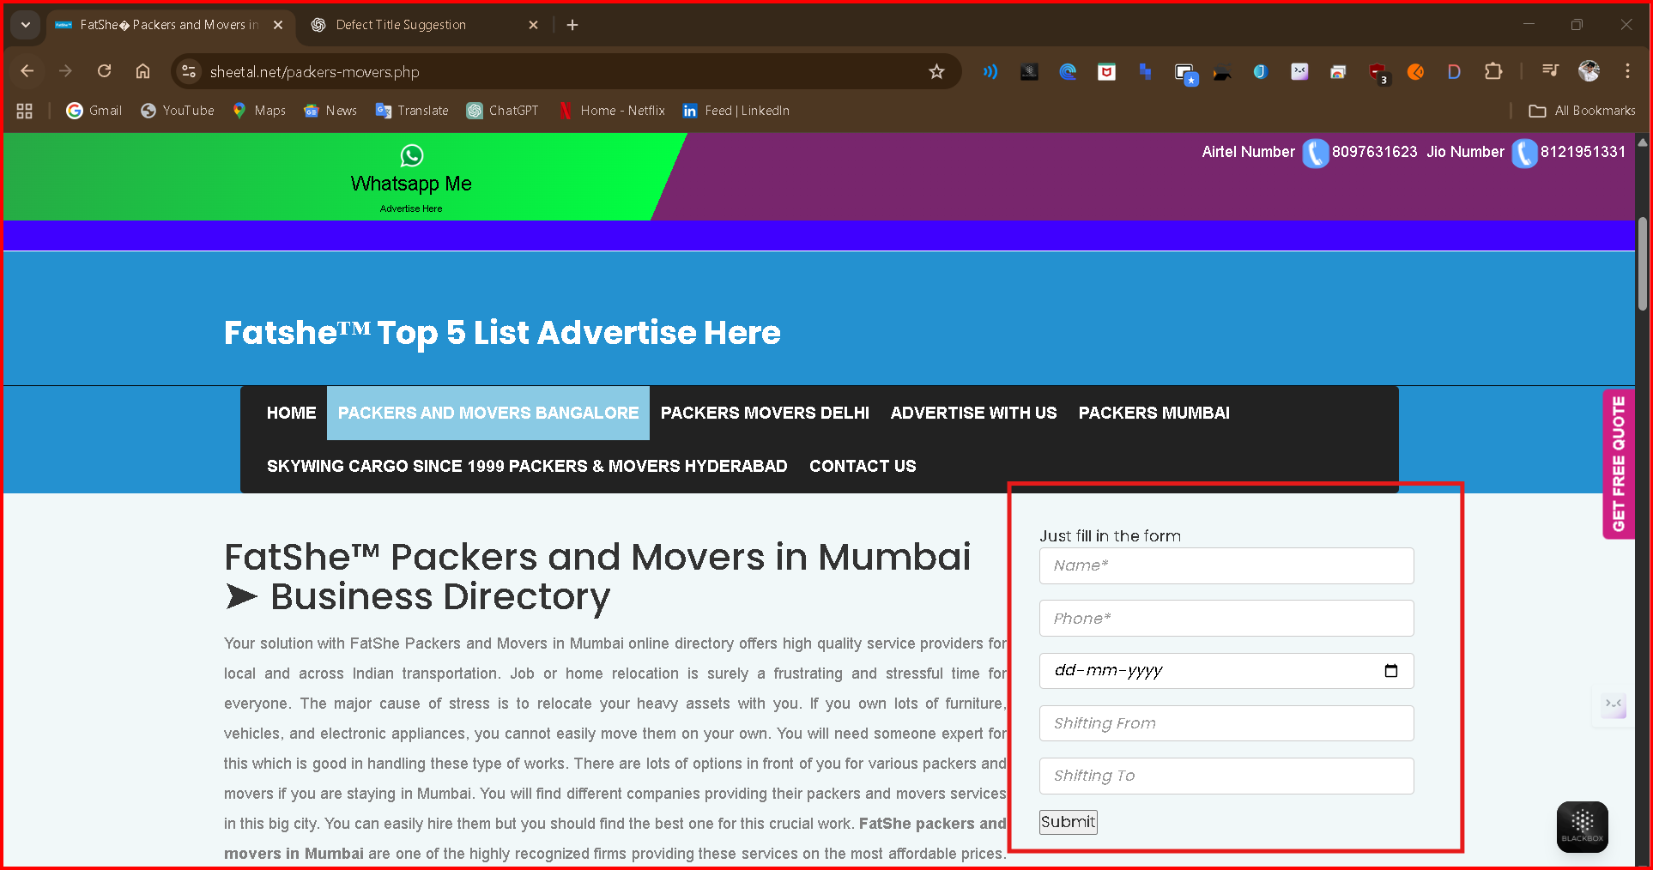
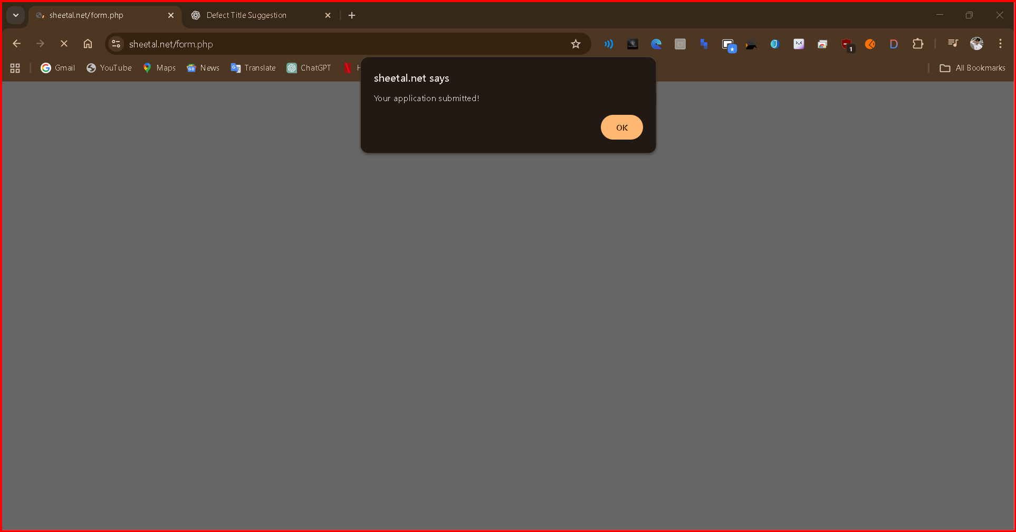

Skywing Cargo Since 1990 Packers and Movers Hydrabad: https://sheetal.net/packers-movers.php

Defect 10 : Clicking on menu link redirects users to a “Website Status: Suspicious” warning despite the website being safe
Steps to reproduce:
- User on Home screen
- User clicks on ‘Skywing Cargo Since 1990 Packers and Movers Hydrabad’
Actual Result: System redirects user to suspicious warning message
Expected Result: System should redirect user to relevant screen.
Evidence:

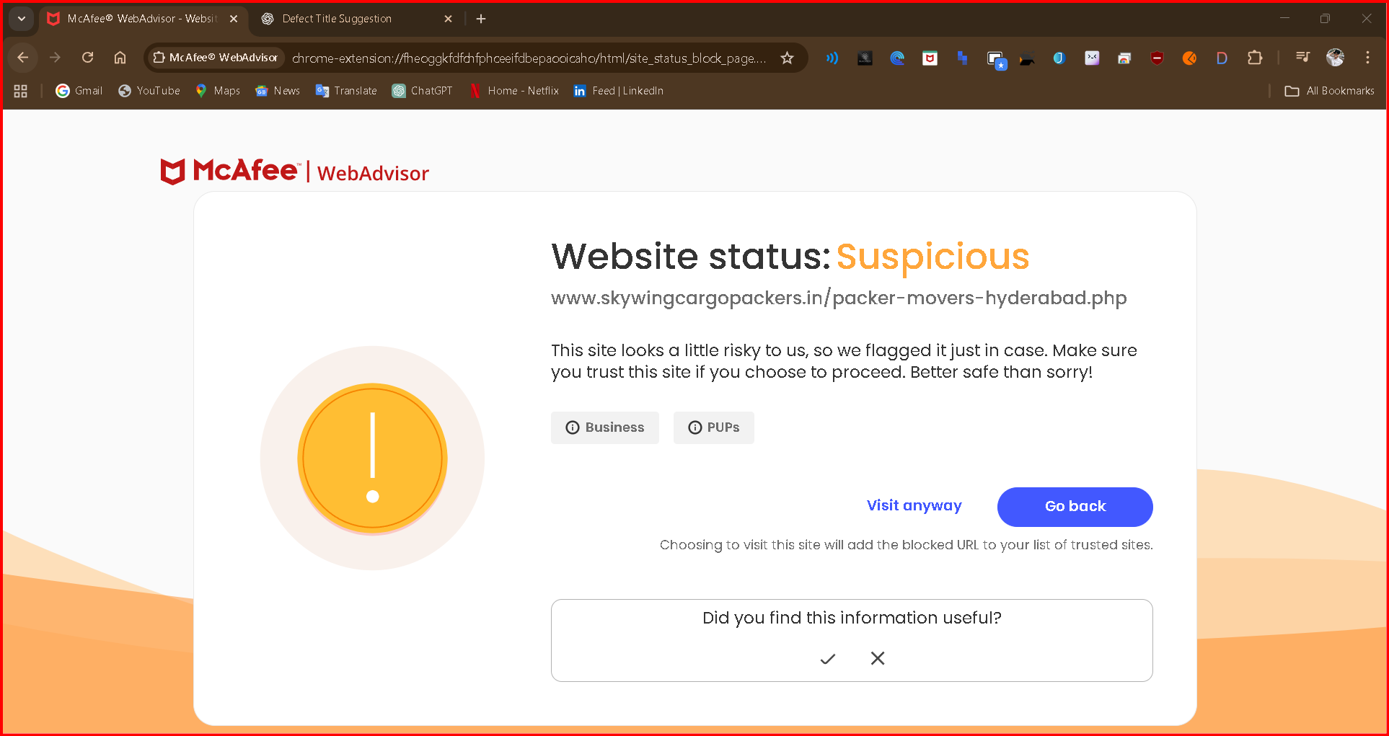

Contact US: https://sheetal.net/contactus.php

Defect 11: Incorrect menu option is highlighted when clicking on “Contact Us”

Steps to reproduce:
- User on Home screen
- User clicks on ‘Contact Us’
Actual Result: System does not highlights the Contact us menu option
Expected Result: System should highlights contact us menu option.
Evidence:
