Avinash – Web Scrapper - Assignment

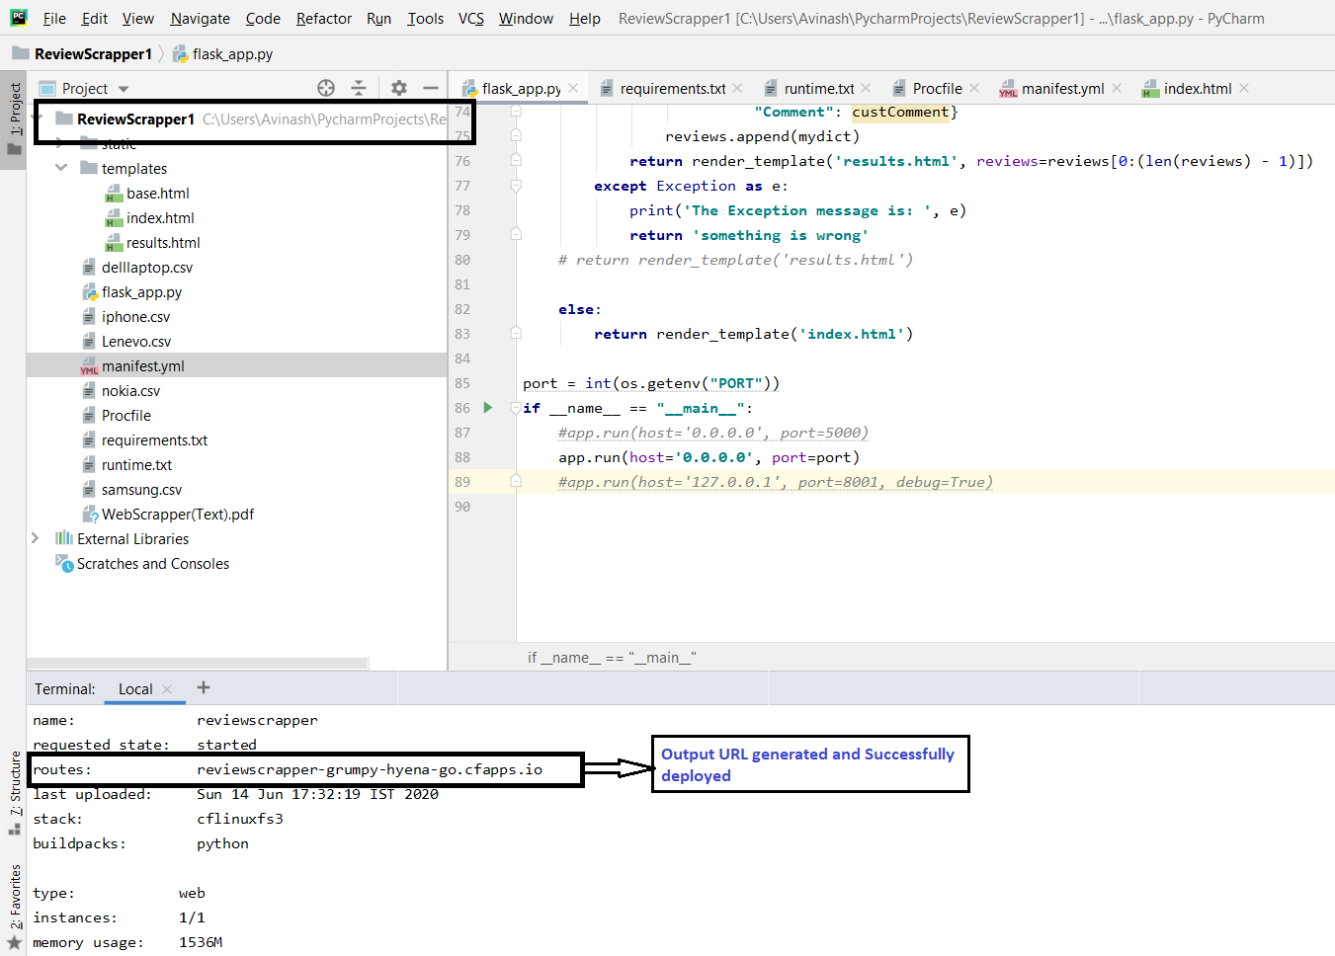

Deployed In PIVOTAL Web Services

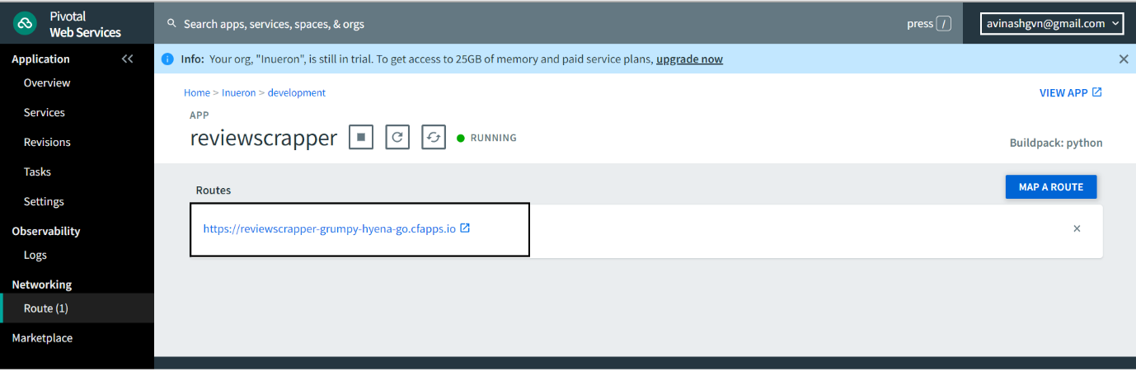

URL: <https://reviewscrapper-grumpy-hyena-go.cfapps.io/>

Successful launch

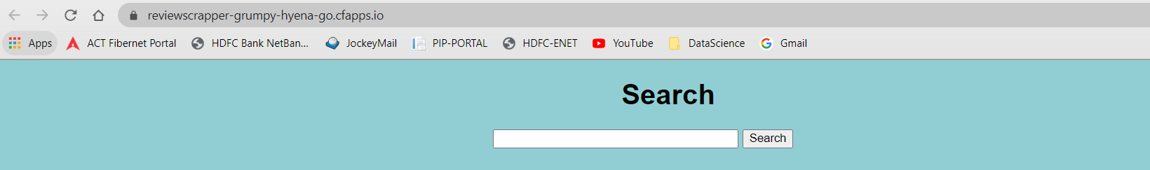

Scrapper Reviews

