Task001:

What do you understand by data structures?  
- data structures is the way of storing and access the data in more efficiency, minimizing the time complexity and space. It defines how data is organized, managed and stored.

Task 2:

What are the types of data structures you know .. list them out..

Linear data structure: Arrays, linked list , stack , queue.

Non linear data structure: Trees , graph , heap , hash.

Task 3:

What all operations can we do in Data structures?

Access   
search  
Insertion   
Deletion  
modification

Task 4:

What are static and dynamic arrays? Explain or summarize key points in a table like

Size, performance, memory, flexibility, limitations  
  
static array – int arr[] = new int[10];  
Dynamic array – ArrayList<Int> list = new ArrayList<>();

| **Feature** | **Static Array (int[], String[])** | **Dynamic Array (ArrayList, Vector)** |
| --- | --- | --- |
| Size | Fixed at creation time | Grows or shrinks automatically |
| Performance | Faster (less overhead) | Slower (due to resizing & boxing/unboxing) |
| Memory Use | Efficient; exact size allocated | May use extra memory for future growth |
| Flexibility | can't change size | can add/remove elements easily |
| Index Access | Fast (O(1)) | Fast (O(1)) |

Limitations Difficult to resize,fixed type slower than array

Task 5:

What is the binary value of a?

Hint ascii value is 97..

97 ÷ 2 = 48 remainder 1

48 ÷ 2 = 24 remainder 0

24 ÷ 2 = 12 remainder 0

12 ÷ 2 = 6 remainder 0

6 ÷ 2 = 3 remainder 0

3 ÷ 2 = 1 remainder 1

1 ÷ 2 = 0 remainder 1

Binary = **1100001  
8 bit = 01100001**

Task 6:

Types of Computer memory with examples.. Explain ..  
1. cache memory - temporary storage area, it is used for read only. ex- chrome cache memory.  
2.RAM – random access memory, it is part of main memory used for read and write both.  
3.ROM- Read only memory, if you once memory allocation done cant be change and it is non volatile memory.  
4.EPROM - Erasable Programmable Read Only Memory.

5.EEPROM - Electrically Erasable Programmable Read Only Memory.

6.Virtual memory – it is part of main memory also called secondary memory.

Task007:

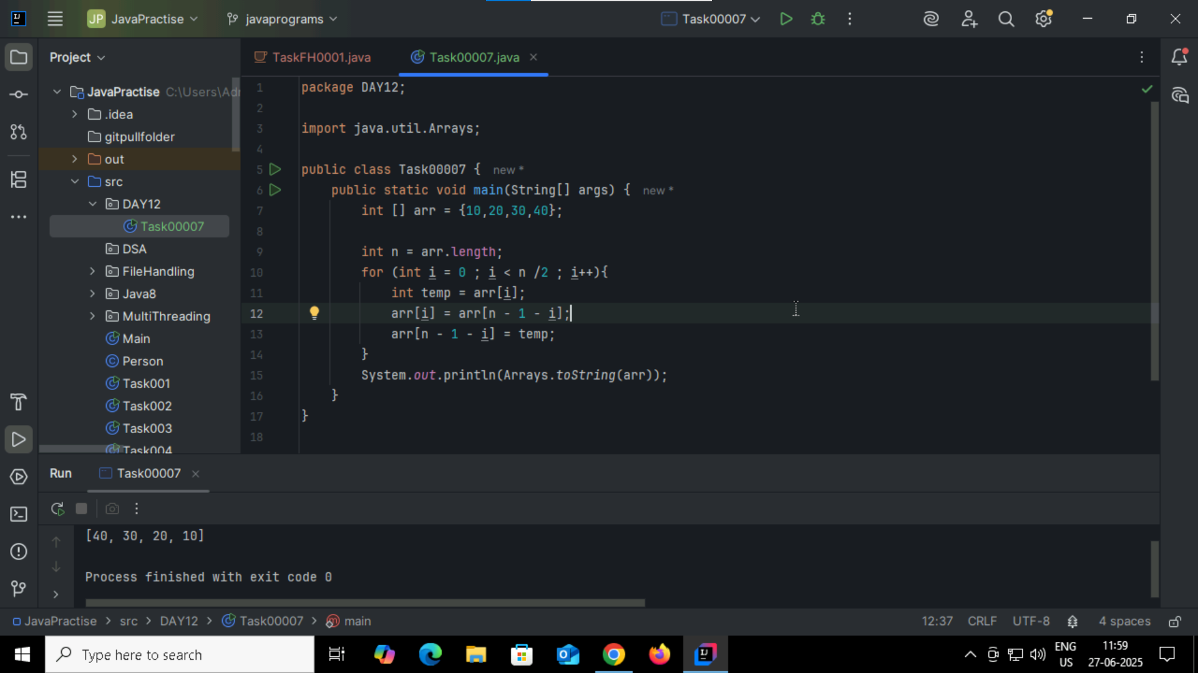

Task008:

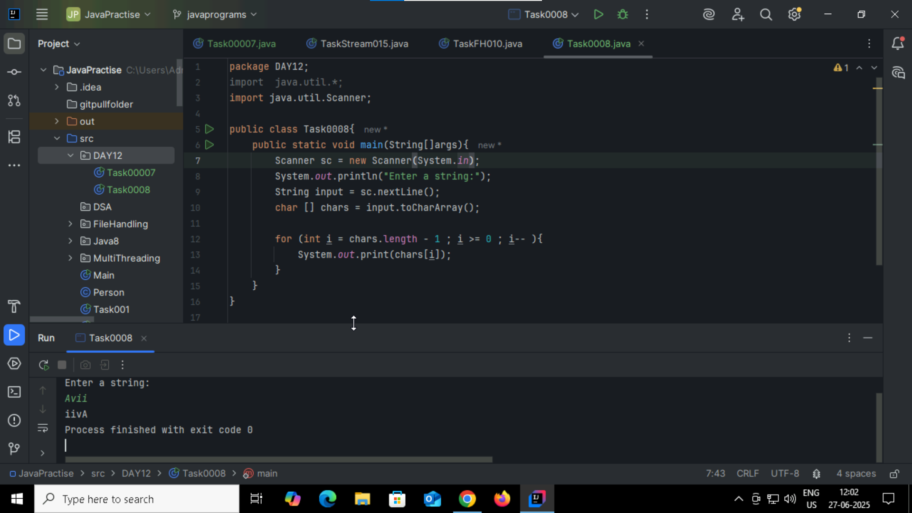

Task009:  
leetcode/ hackerrank account creation.

Task010: this code is performing the **merging of two sorted arrays into a single sorted array.**Home task :  
  rewrite the code in such a way that it has to take unsorted list and then ,merge in an array the sorted list.

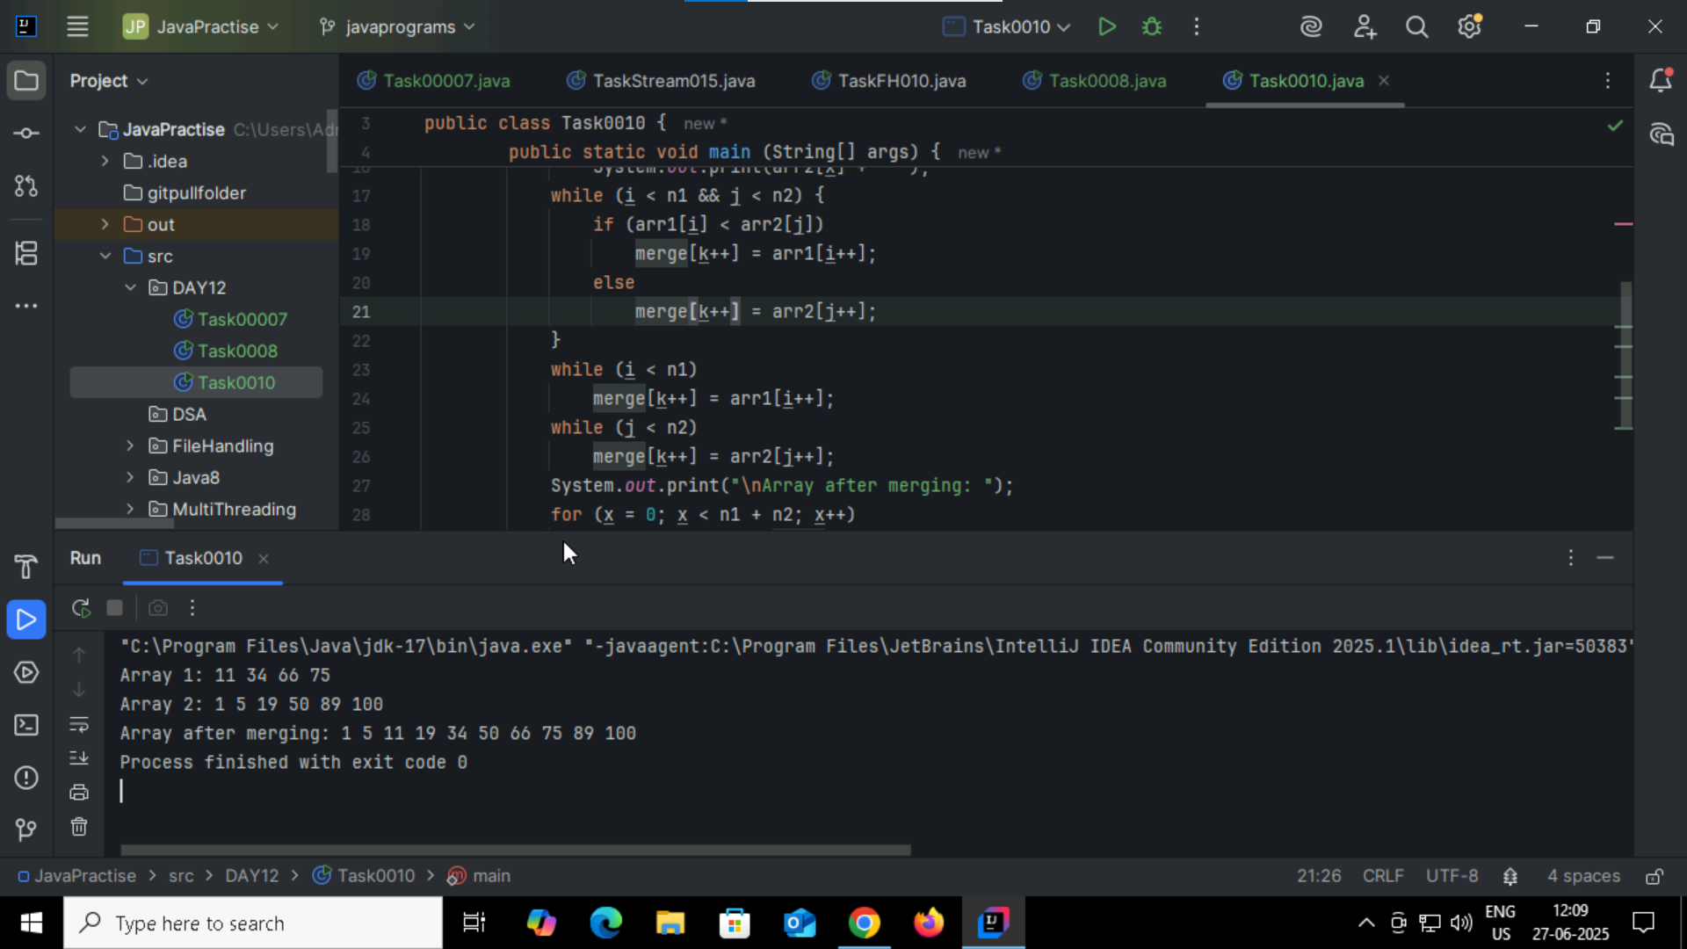

Task0011:

What do you understand by Hash table?  
  
it is a data structure that stores data in key-value pairs, it helps to allows user to fast retrieval of values based on the keys. While storing data to avoid collision we will use linear probing.   
in this we have put and get to access and storing data and also while storing we have concept that is wrap around means while searching for empty index if index completes it will go again starting of the index to check empty index.

In this even though we stored in different index it will be reflect or reference in original index where user wanted to store

Task012: Hashtable

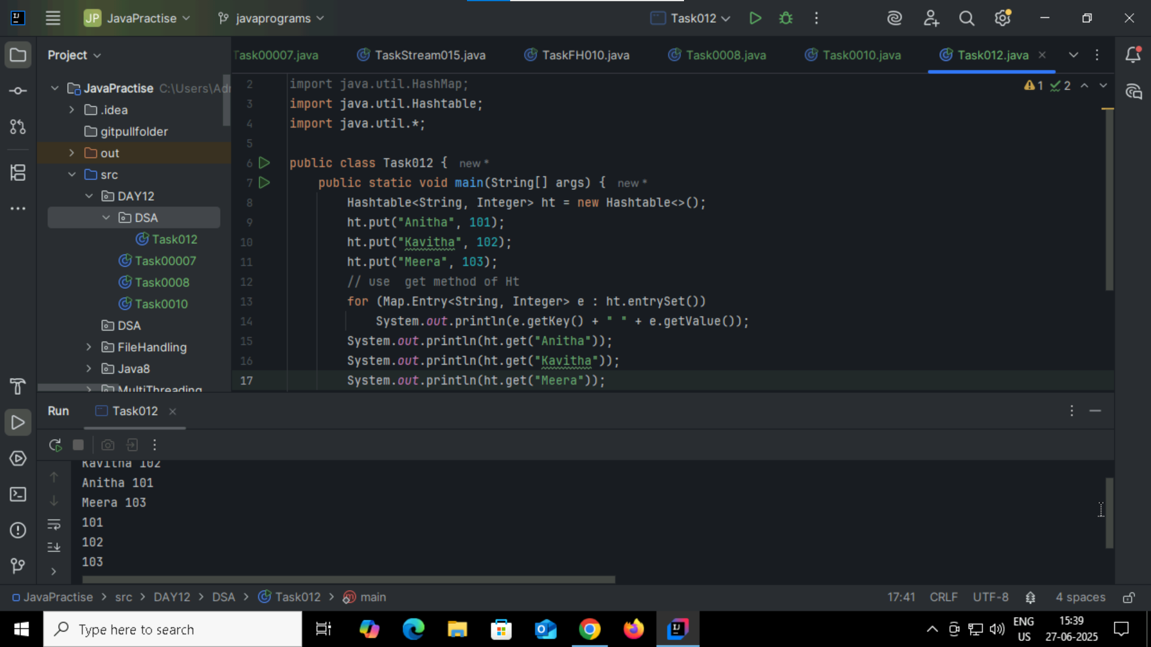

Task013:HashMap   
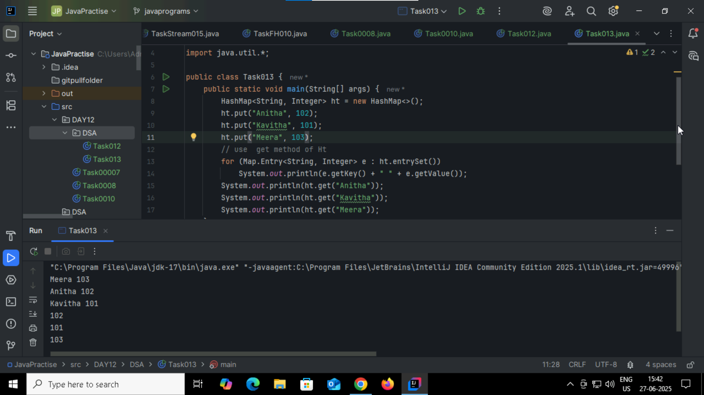

**Task014: difference**

**HashTable** - synchronized – threadsafe - we can access only one thread at a time - won’t allow null keys and values – linked list internally available.

**HashMap** - Asynchronized – not threadsafe - we can access multiple thread at a time - allow 1 null key and multiple null values - linked list internally available here also.

Task15:HW

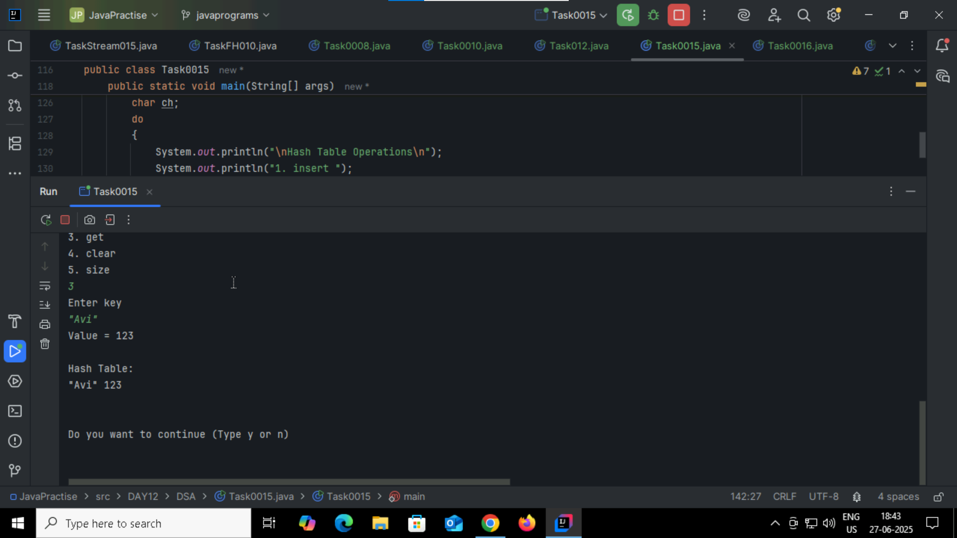  
Task16:

