Task001:

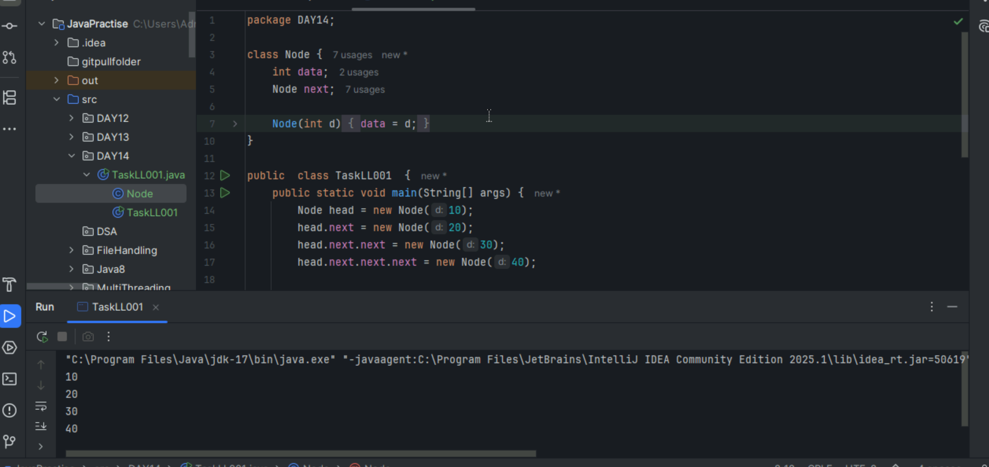

Task002:

What you mean by traversing  
only traverse it will visit each node if you use display then only it will display the output.  
  
Task003:

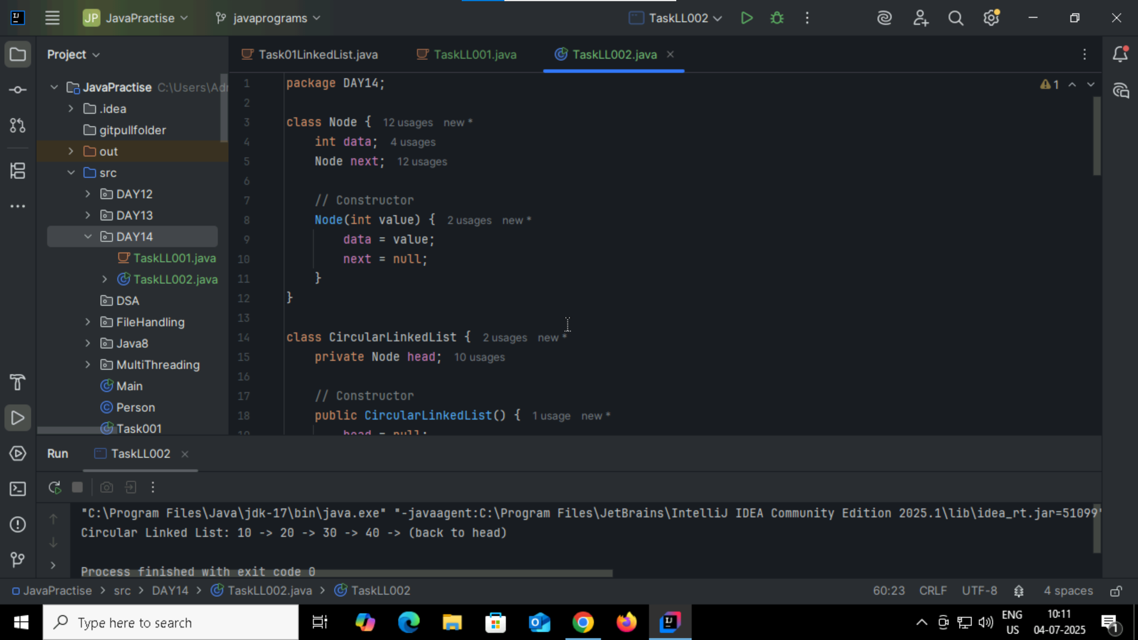

Task004:

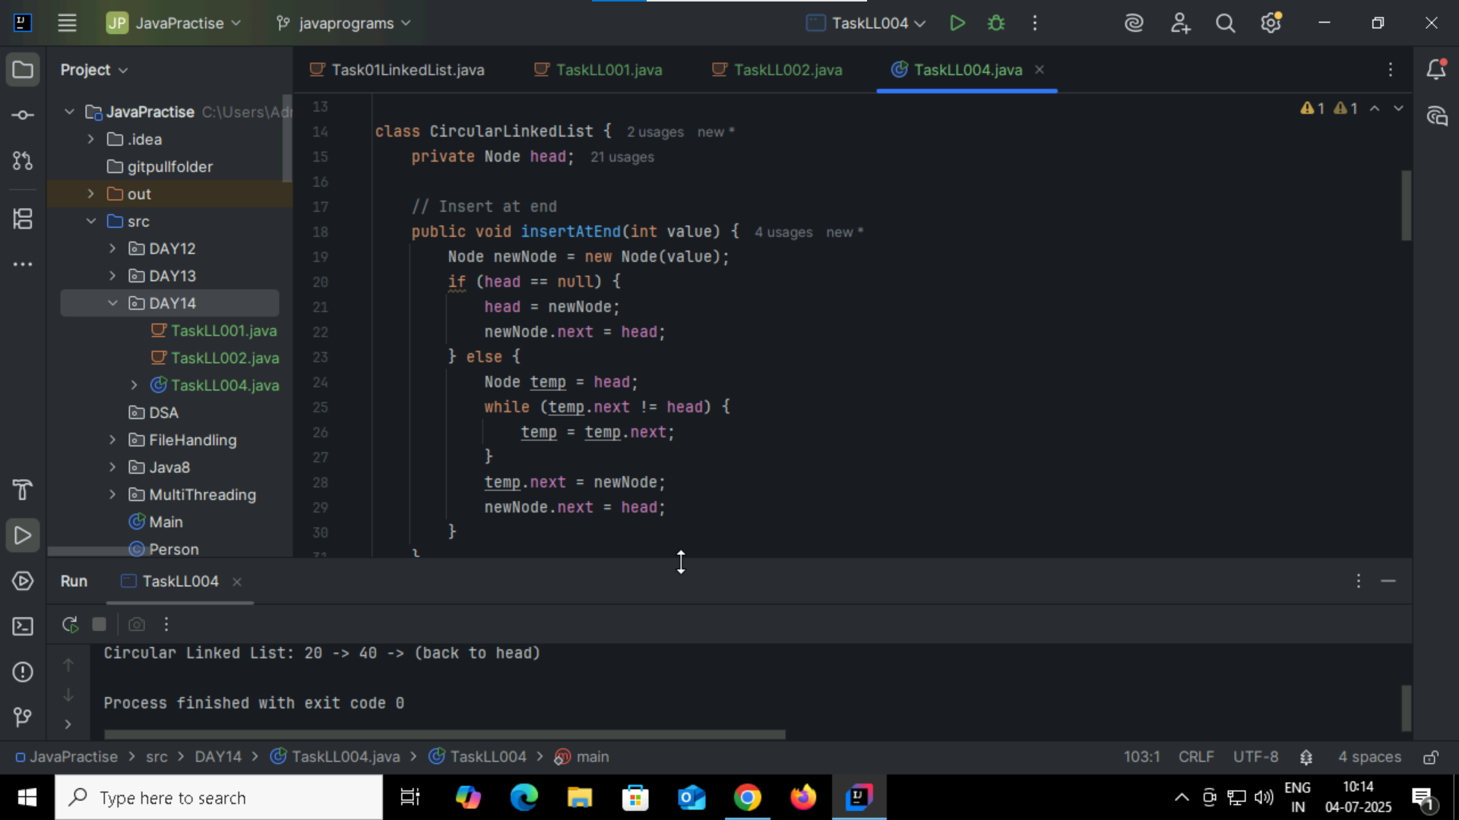

Task005: Stack

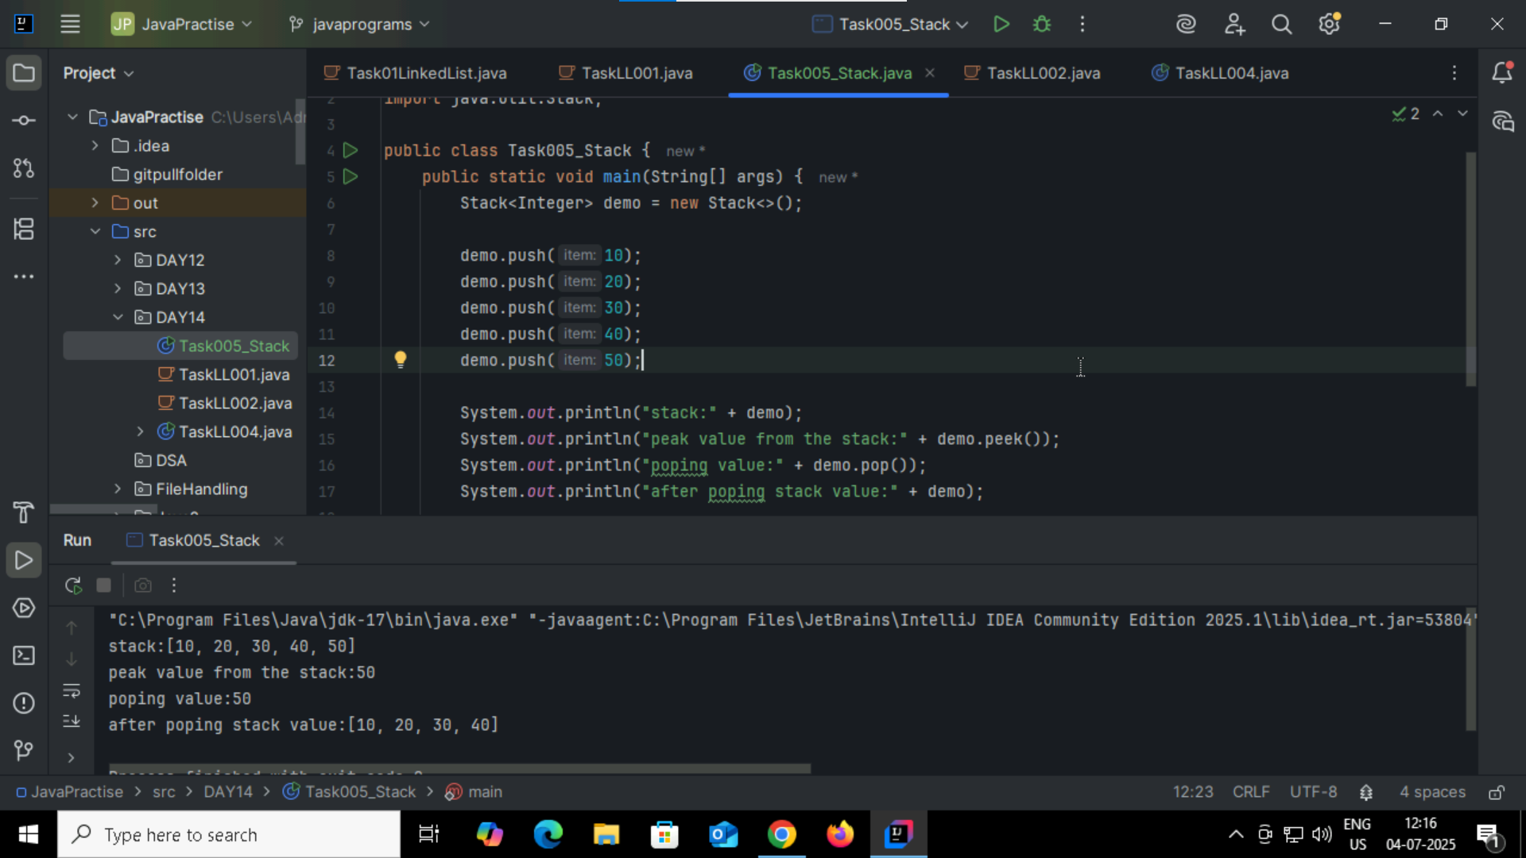

Task006:stack postion of the data/value  
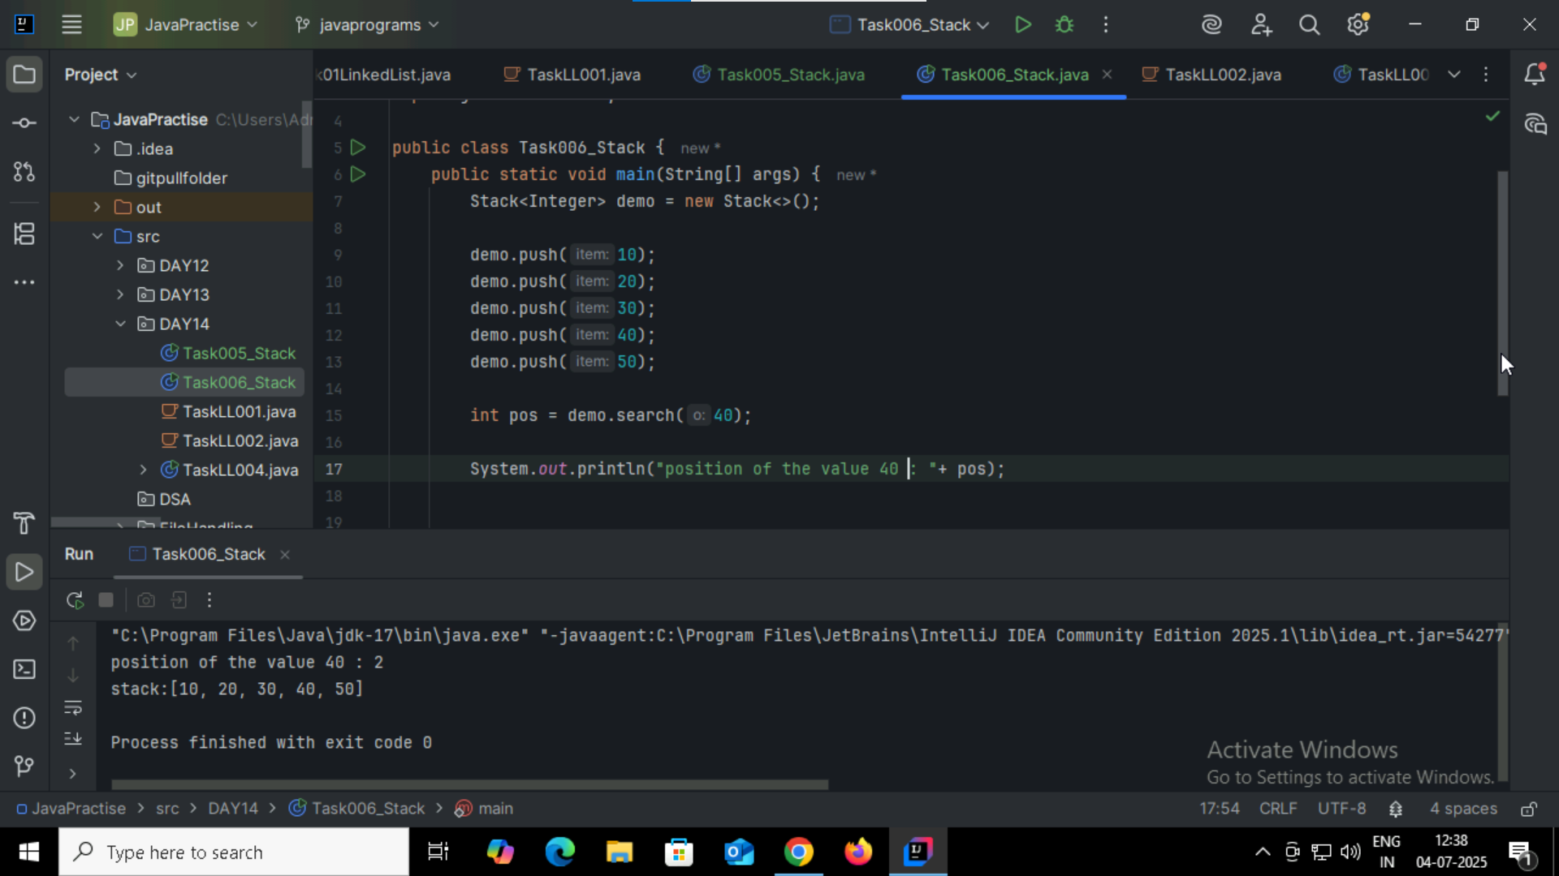

Task007: pop()

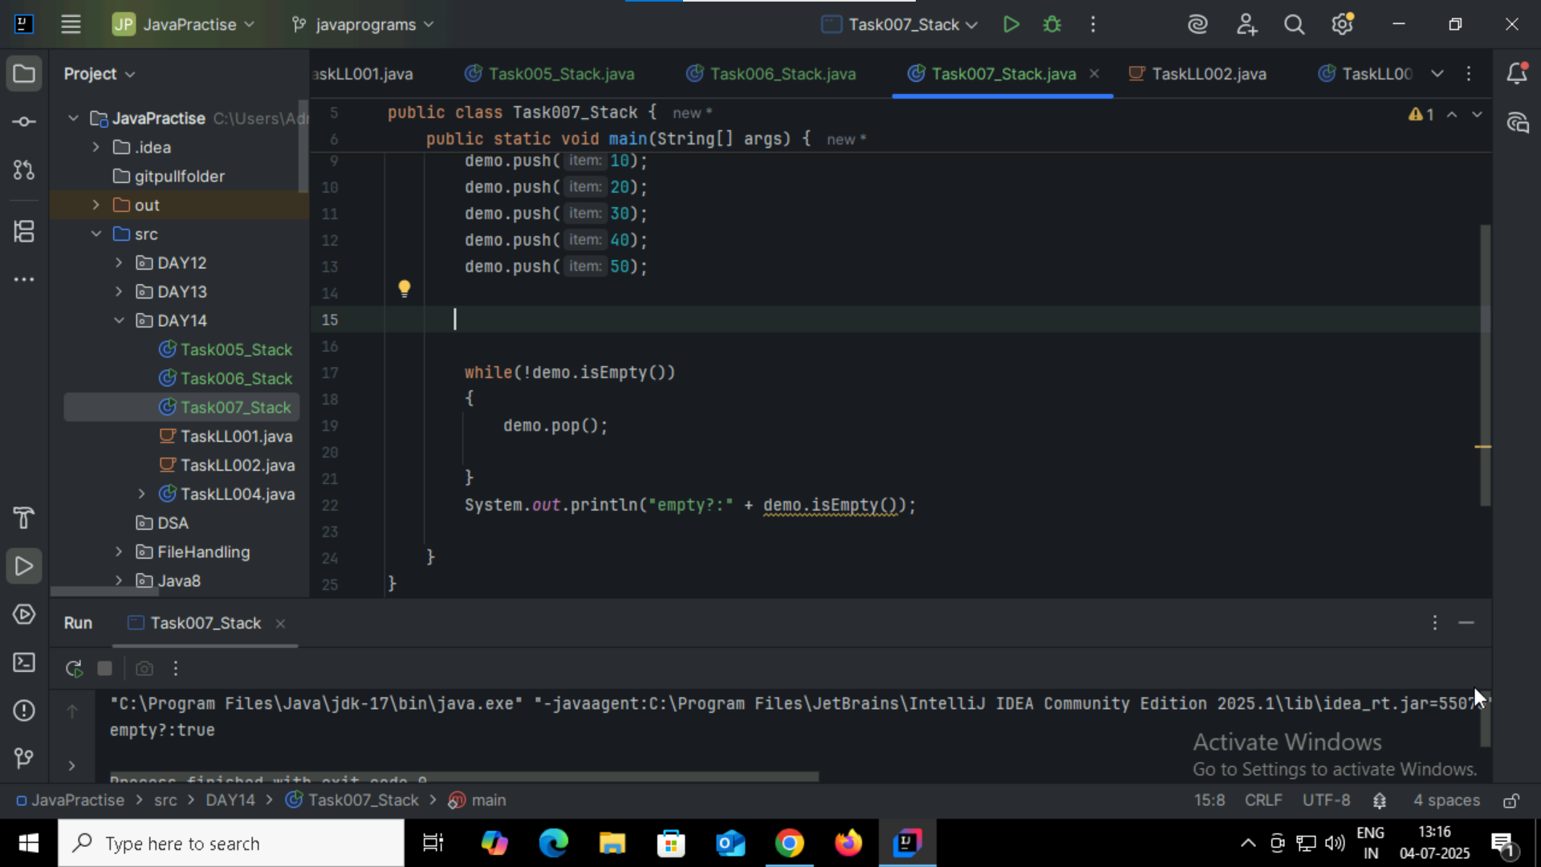

Task008: Peek()  
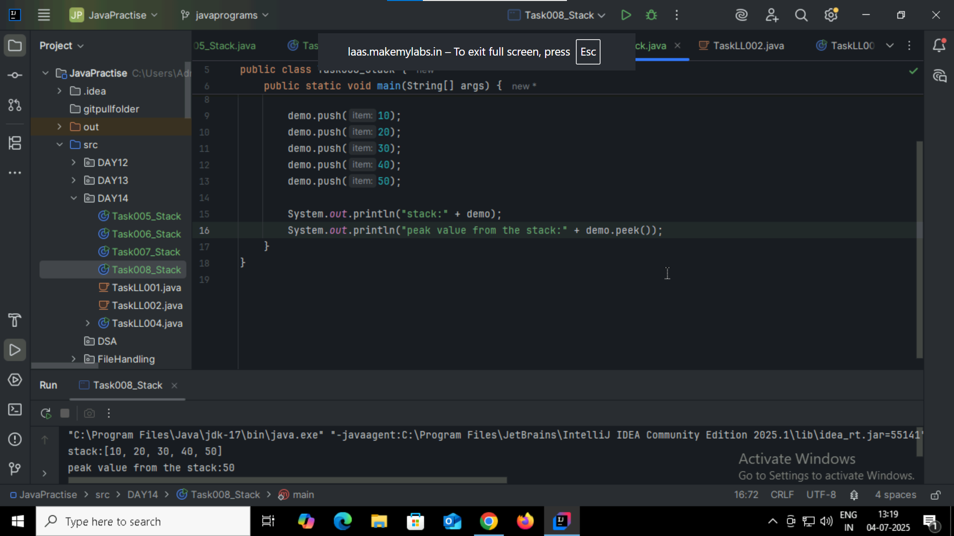

Task009:  
List of the method of stack:  
push() peek() isEmpty() search()  
pop()  
  
Task010: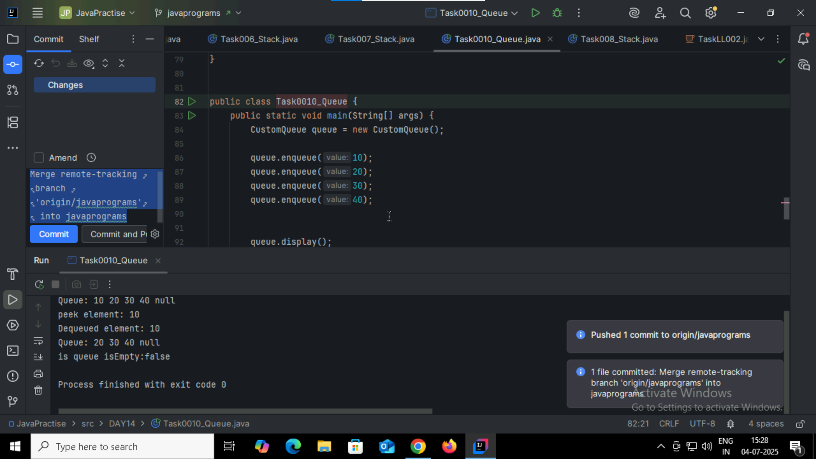

Recursion problems:

Task011:

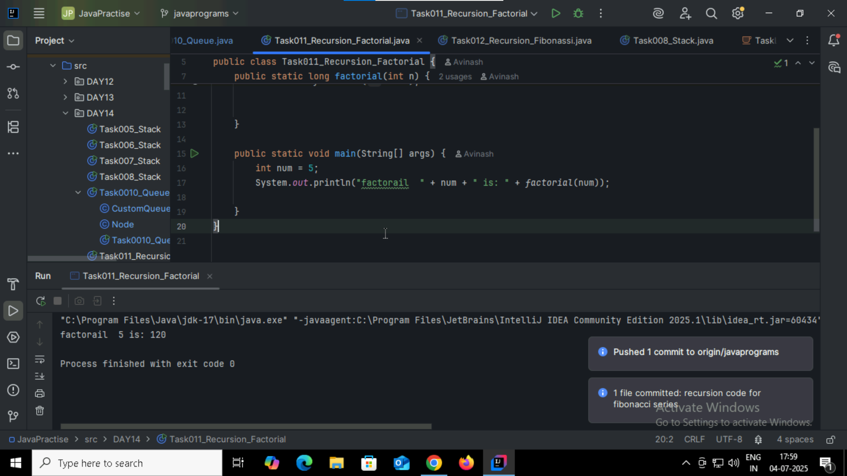  
Task012:

