Task001:

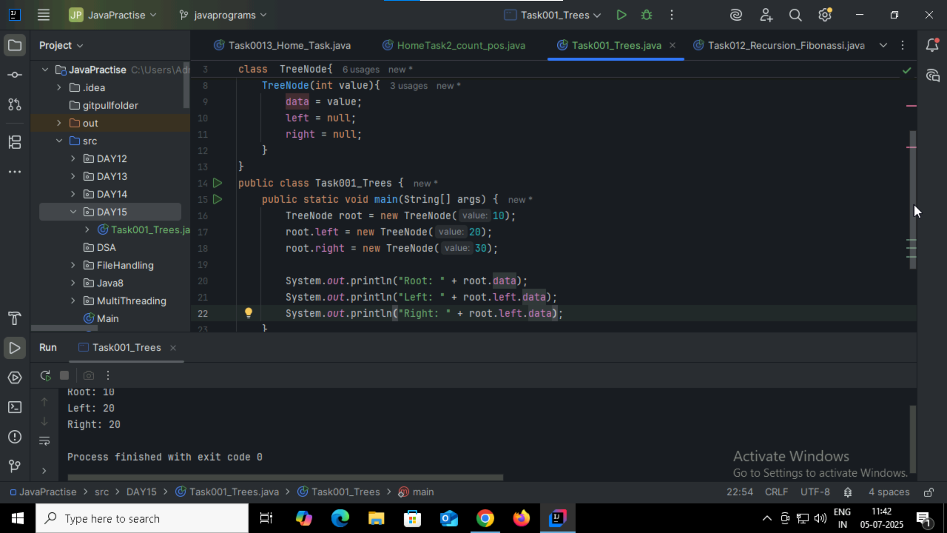  
Task002:

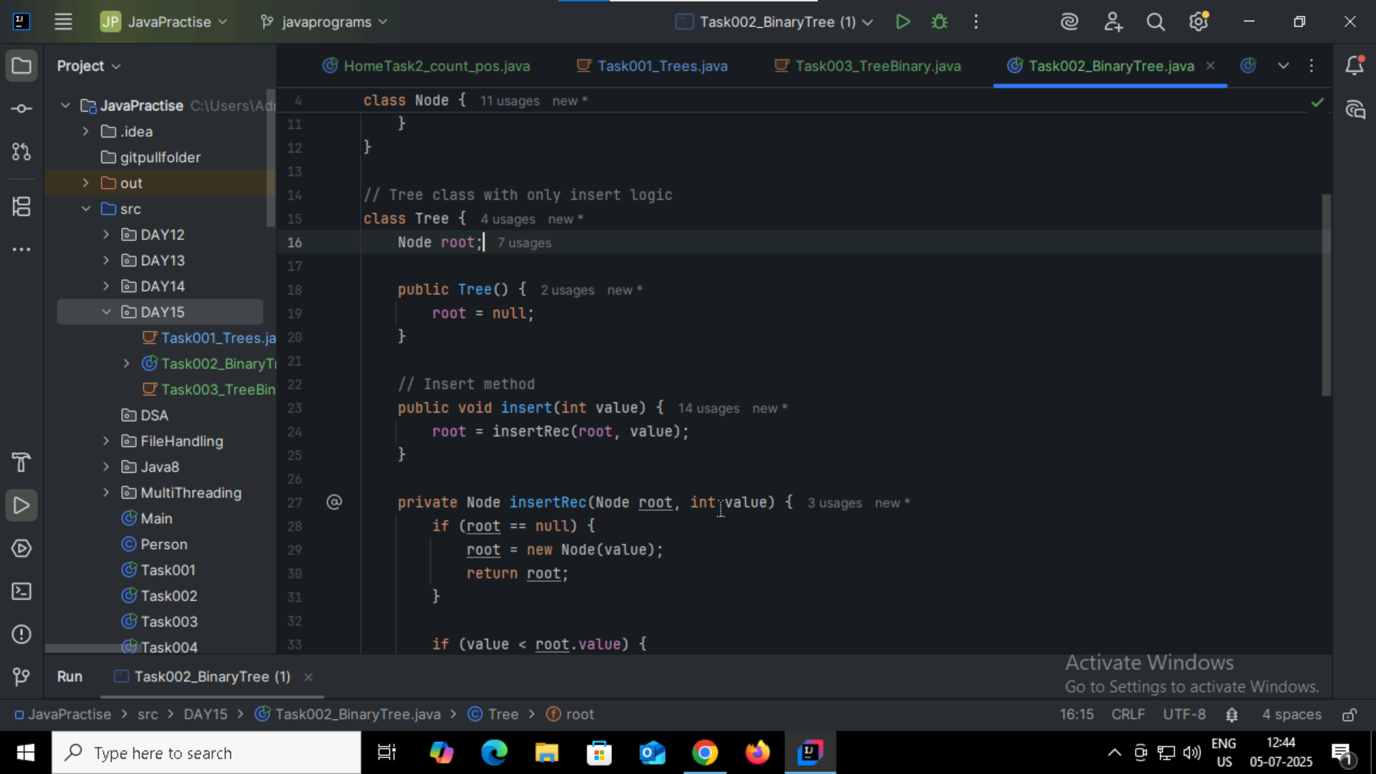

Task003 and 04:

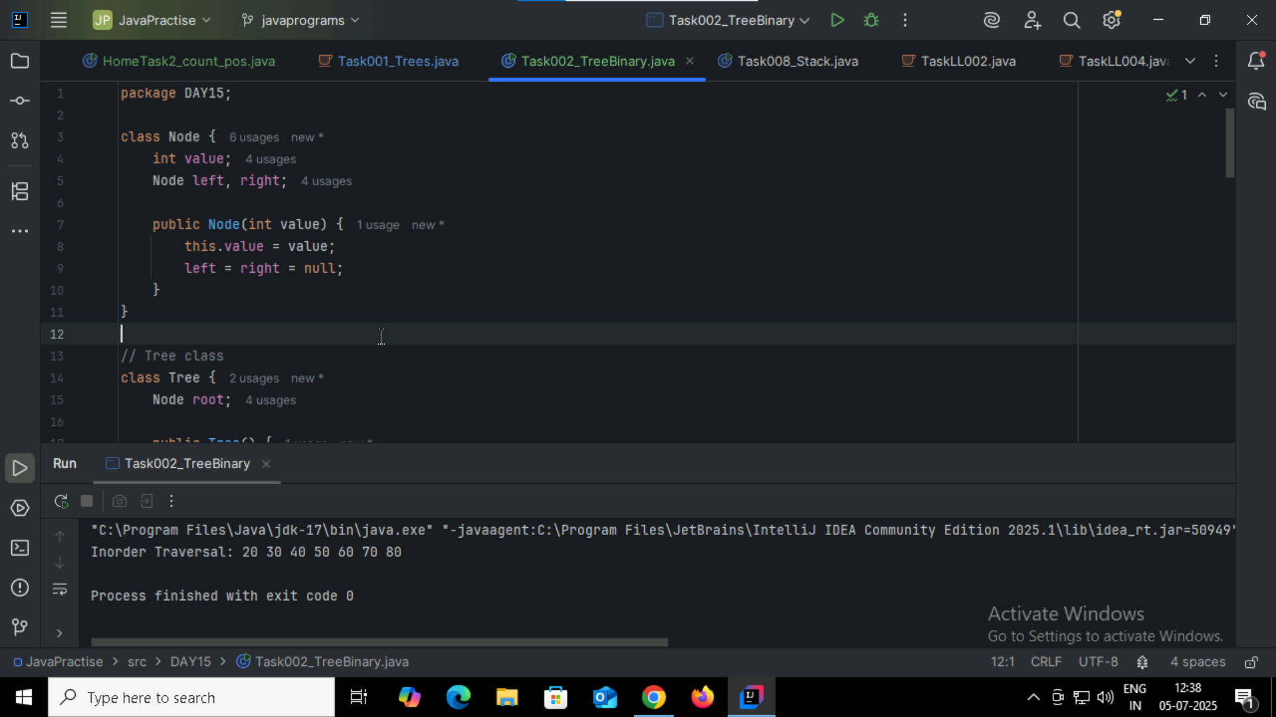

Task 05:  
Application of Trees

Hierarchical Data Representation

Binary Search Tree

Heaps

Tries

Segment Trees

B-Trees / B+ Trees

Decision Trees

Syntax Trees

Routing and Network Trees

Task 06

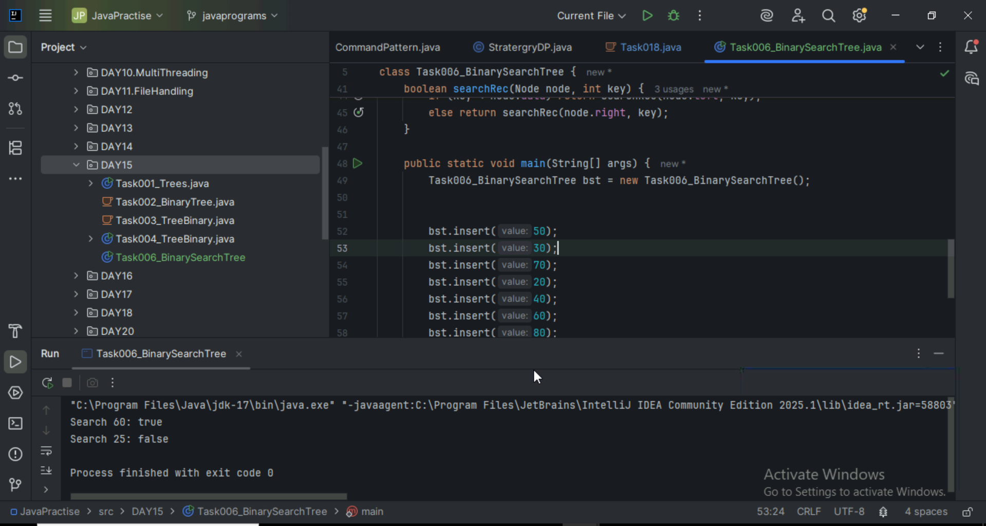

Task 07

Types of Binary Trees

1. Full Binary Tree

2. Perfect Binary Tree

3. Complete Binary Tree

4. Balanced Binary Tree

5. Binary Search Tree

6. Skewed Binary Tree

Task 08

Application of Graph Data Structure

Social Networks

Google Maps and Navigation

Web Crawling

Recommendation System

Computer Networks

Dependency Resolution

AI/ML learning

Circuits and Electric Networks

Task 09

Types of Graphs

Directed Graph

Undirected Graph

Weighted Graph

Unweighted Graph

Cyclic Graph

Connected Graph

Disconnected Graph

Sparse Graph

Complete Graph

Task 10

