Task001: Abstract Factory Design  
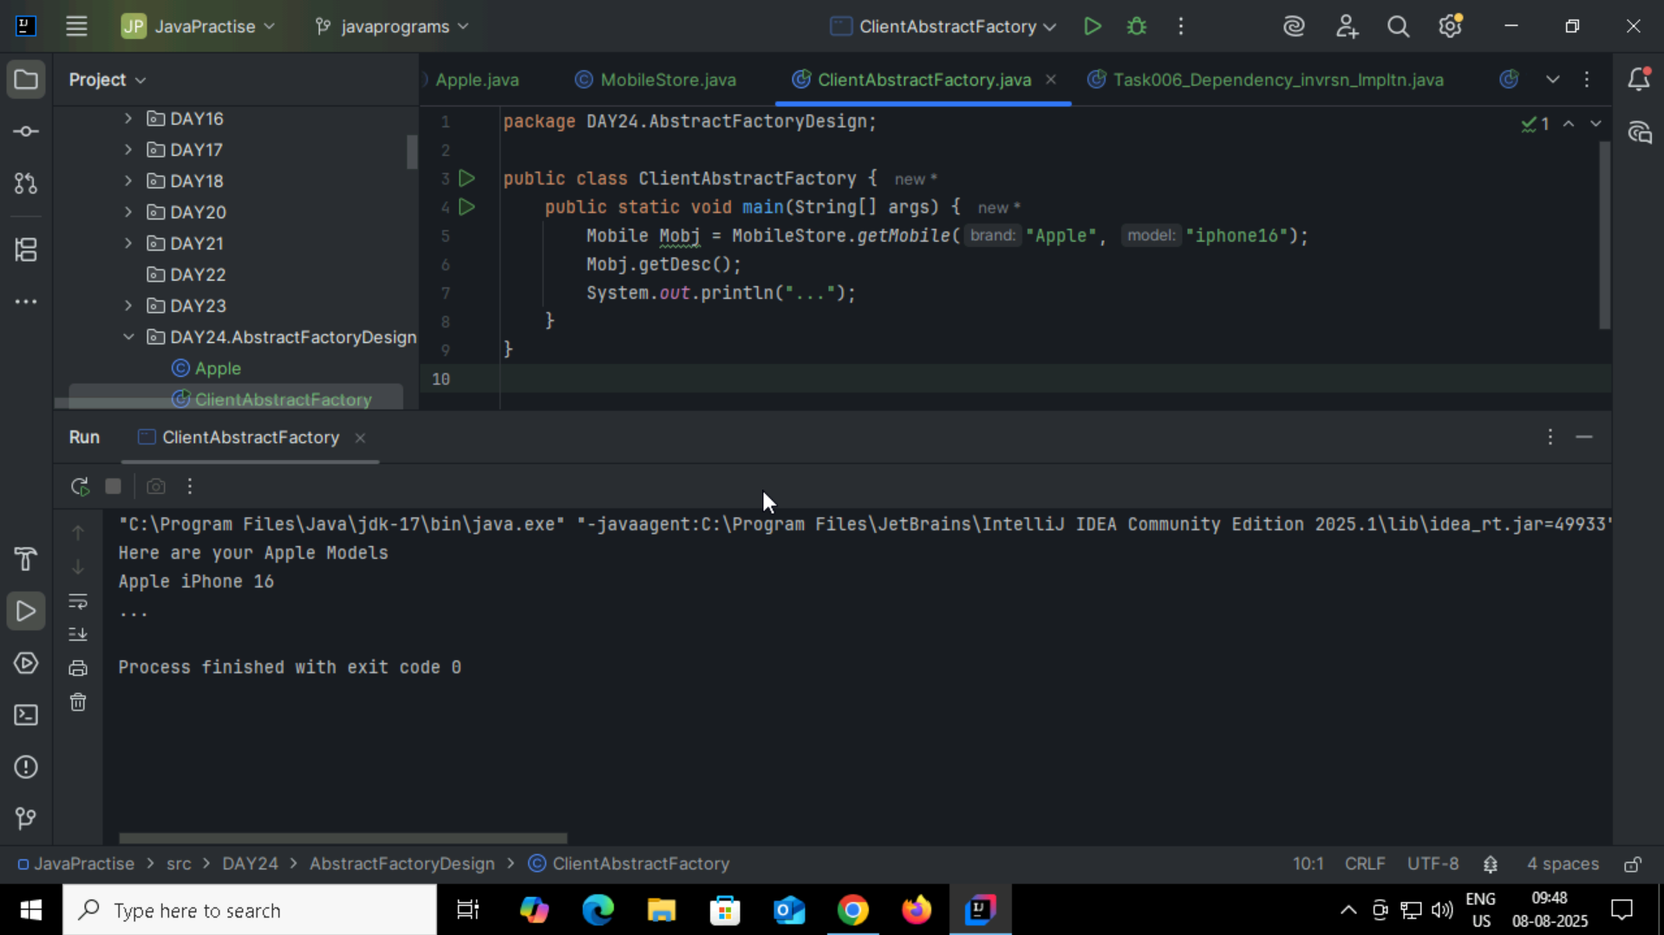

Task002: Builder Method Design Pattern  
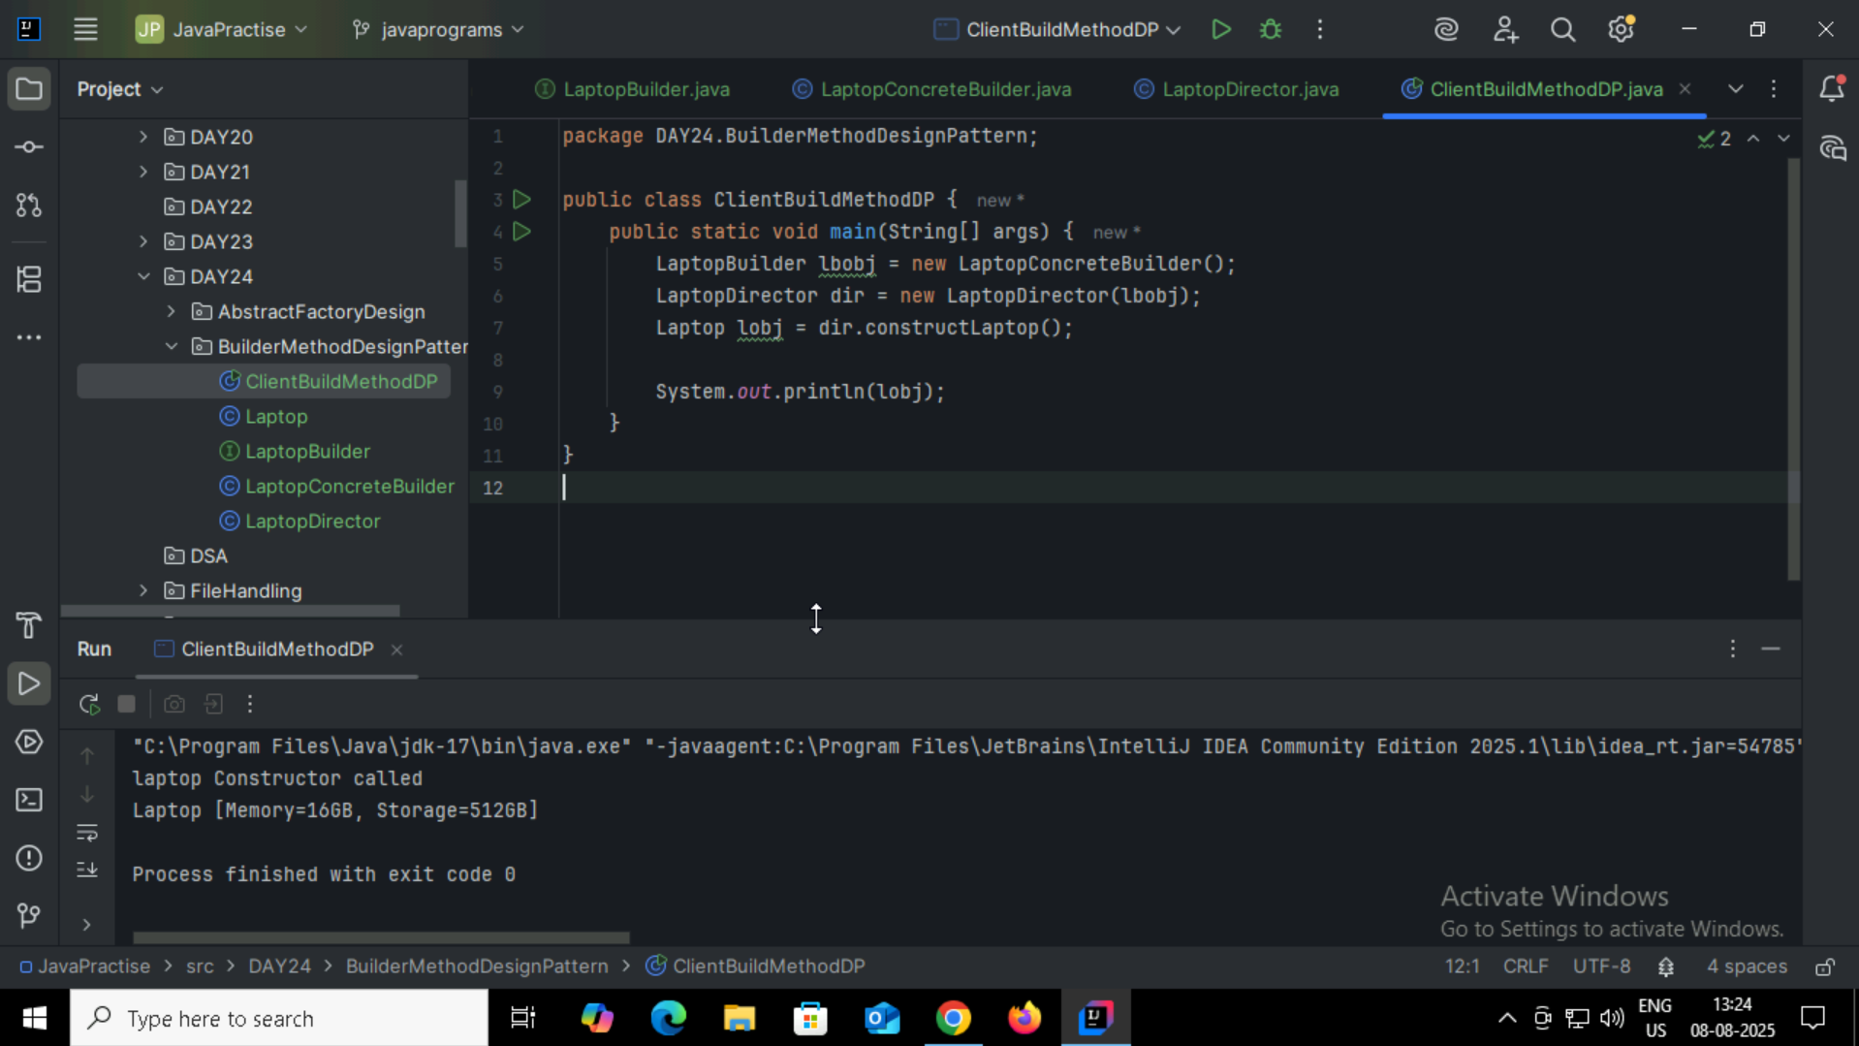

Task003:Client Prototype Method Design Pattern  
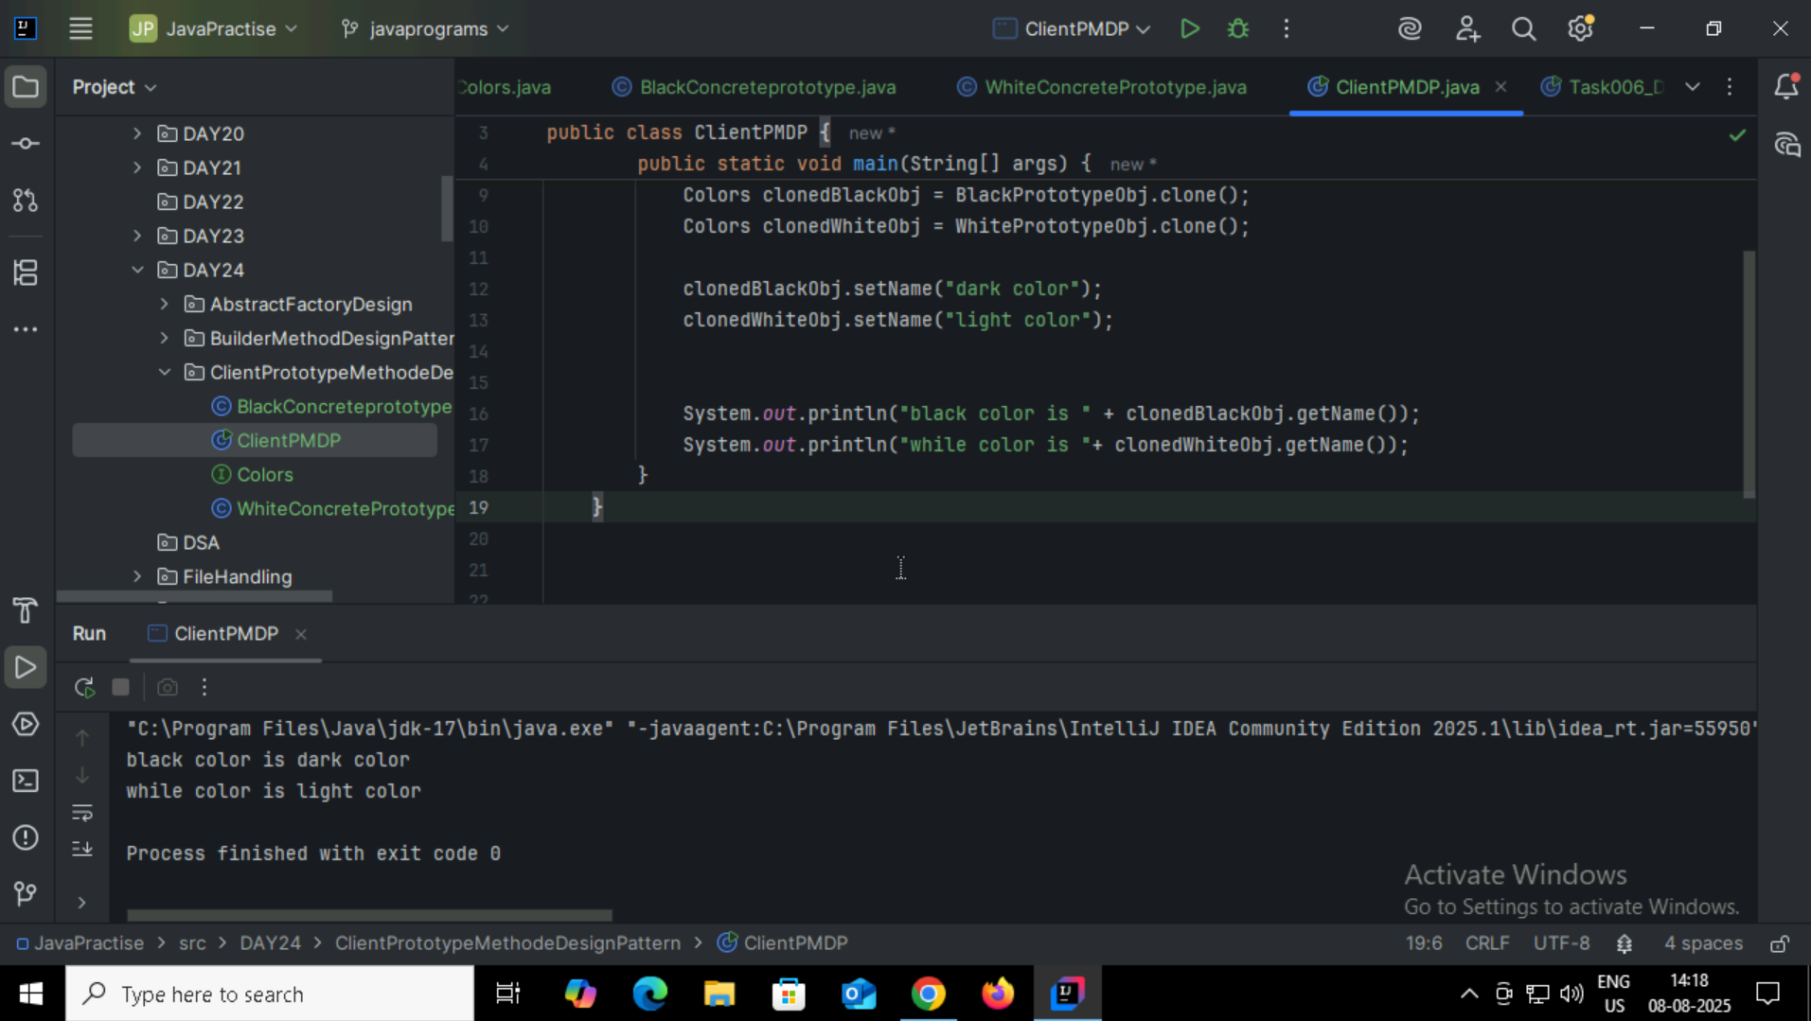

Task004: Adapter Method Design Pattern  
