Dynamodb with AWS  
  
Step 1:

Create an account as root user in Amazonaws

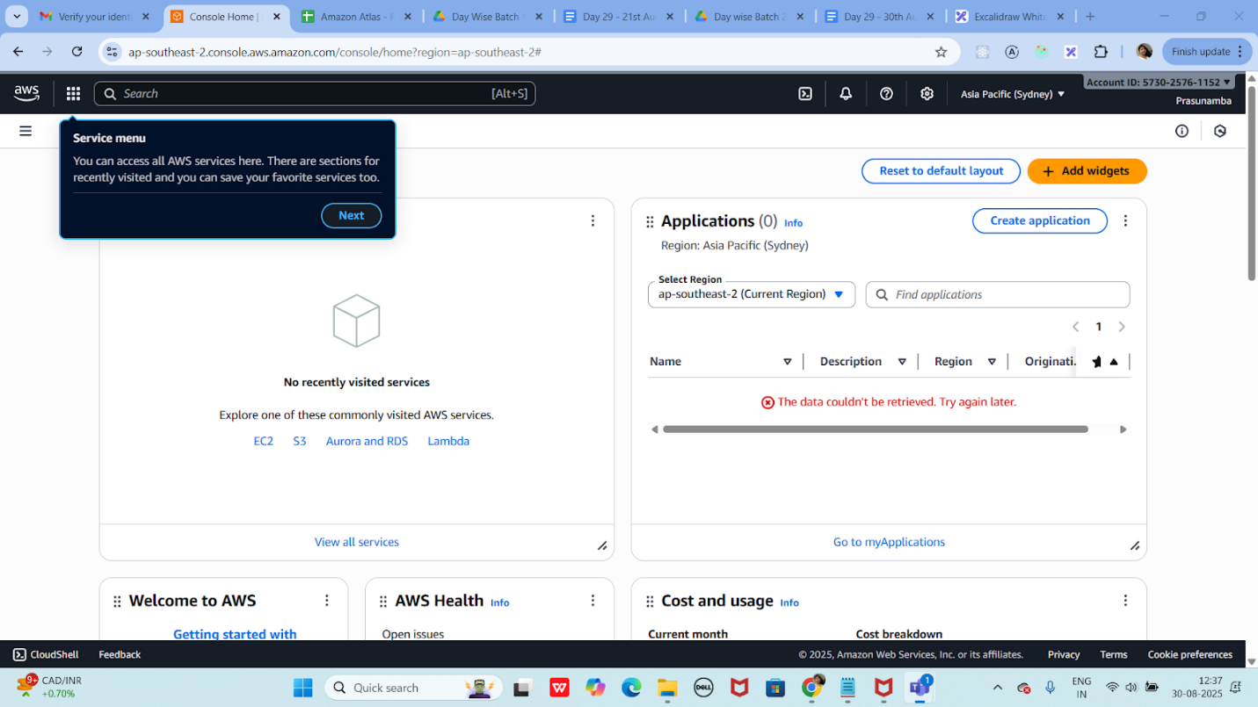

Step 2:

SDK install (JDK nee to be there)

Open cmd in the same location where you installed SDK

java -Djava.library.path=./DynamoDBLocal_lib -jar DynamoDBLocal.jar -sharedDb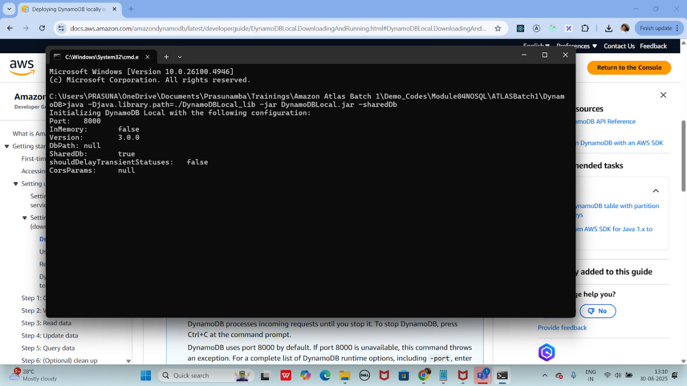

Step 3:

NoSQl workbench – DynamoDB

