Task 01:

Create a table using AWS Management Console

10.38 to 10.43

Task 02:

Use all the CRUD operations using AWS Management Console.

Task03:  
Creating table in Cloudshell  
aws dynamodb create-table --table-name EmployeeSpet --attribute-definitions AttributeName=EmpName,AttributeType=S AttributeName=EmpAddress,AttributeType=S --key-schema AttributeName=EmpName,KeyType=HASH AttributeName=EmpAddress,KeyType=RANGE --provisioned-throughput ReadCapacityUnits=1,WriteCapacityUnits=1  
  
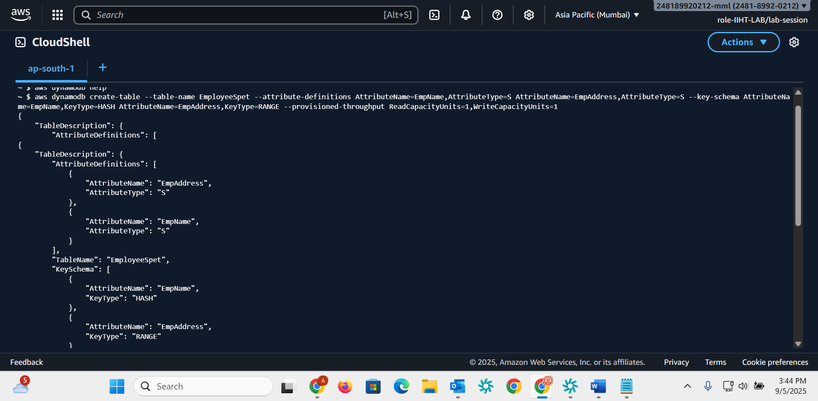

Task004:  
Adding values  
aws dynamodb put-item --table-name EmployeeSpet --item '{"EmpName":{"S": "Prasunamba"}, "EmpAddress":{"S": "India"}, "email": {"S": "Prasunamba.mk@gmail.com"}}' --return-consumed-capacity 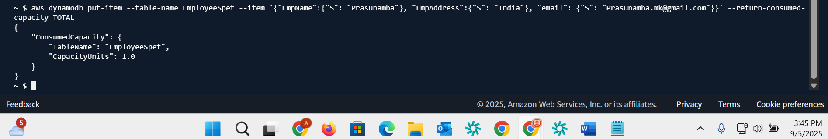

Task05:  
creating table using wizard   
aws dynamodb wizard new-table  
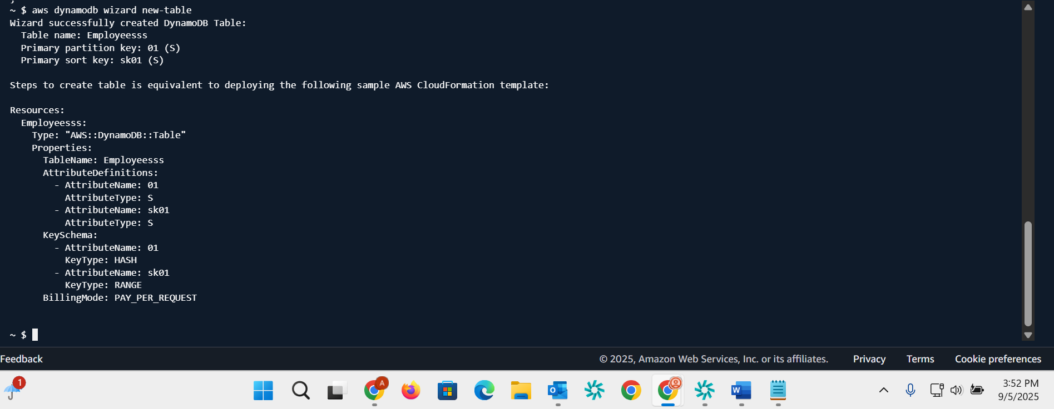

Task006:  
delete

aws dynamodb delete-table --table-name Custtomer  
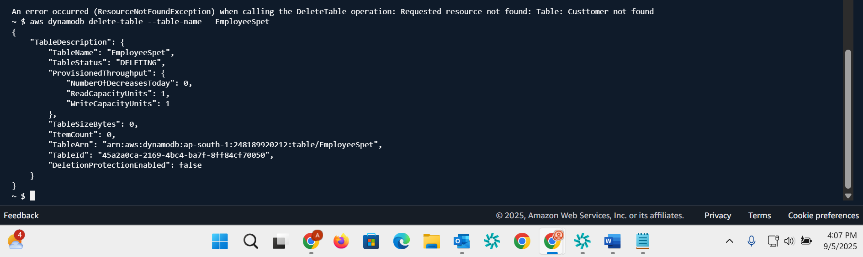

Task007:  
list of tables  
aws dynamodb list-tables  
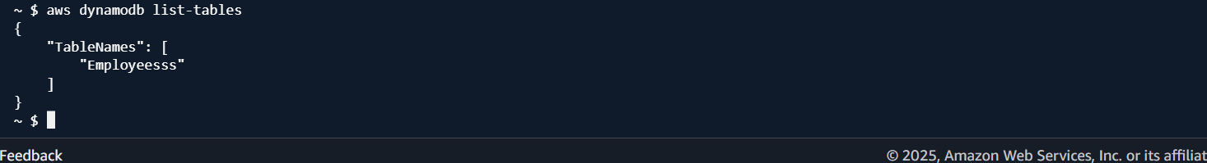

Task008:  
aws dynamodb describe-table --table-name Student  
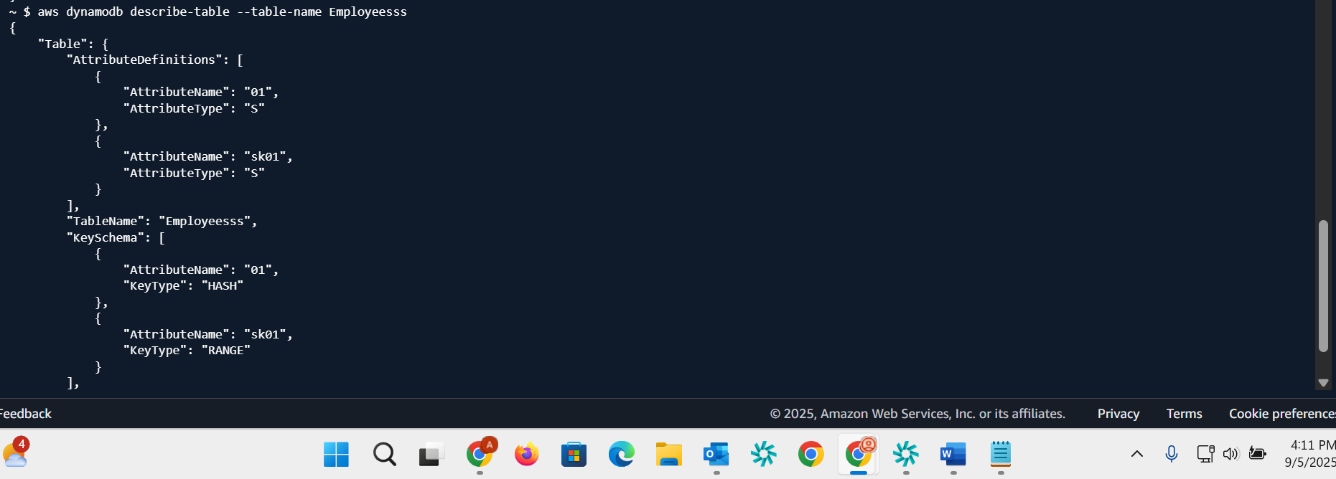

Task009:

aws dynamodb create-backup --table-name Student --backup-name StudentbkUp  
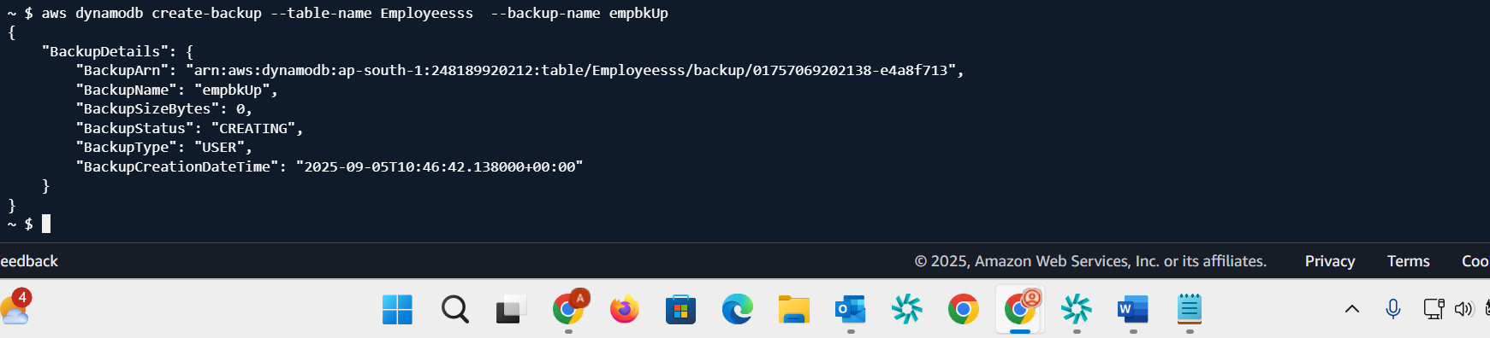

Task010:

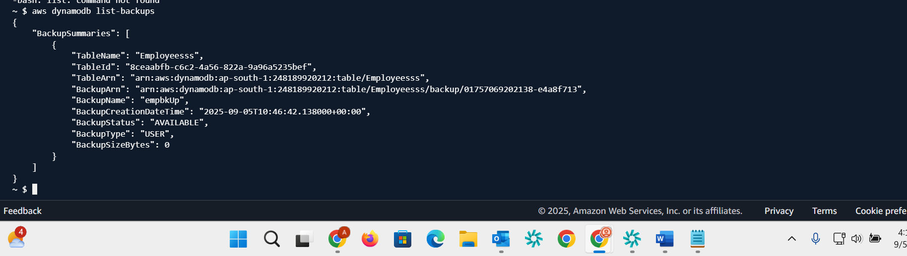

Task011:  
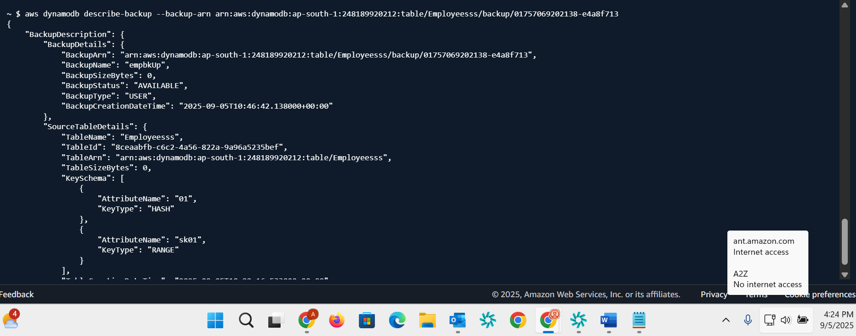

Task0012:  
aws dynamodb restore-table-from-backup \

--target-table-name restoreStudent \

--backup-arn arn:aws:dynamodb:ap-south-1:248189920212:table/Employeesss/backup/01757069202138-e4a8f713  
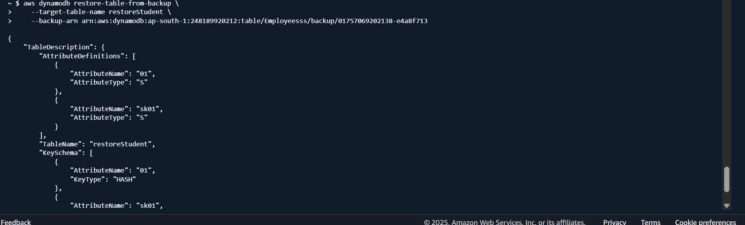

Task013:  
aws dynamodb scan --table-name Employeesss  
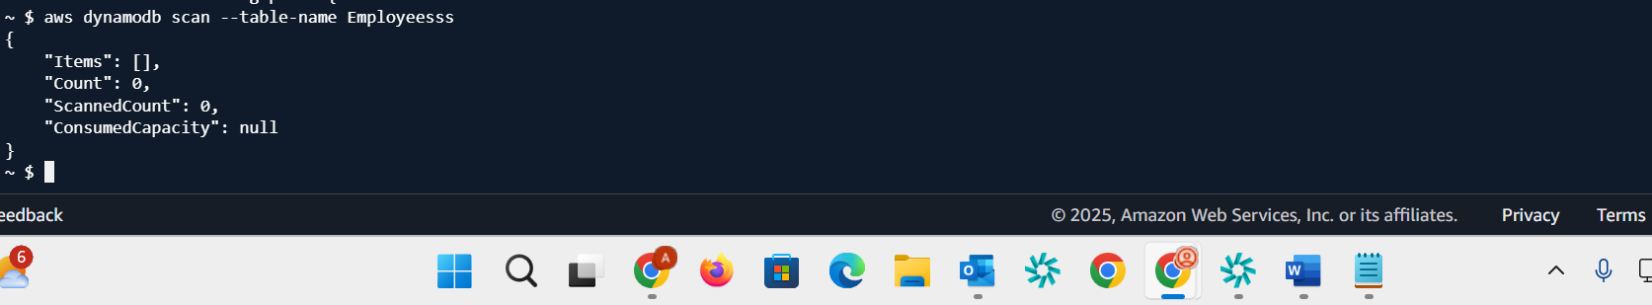

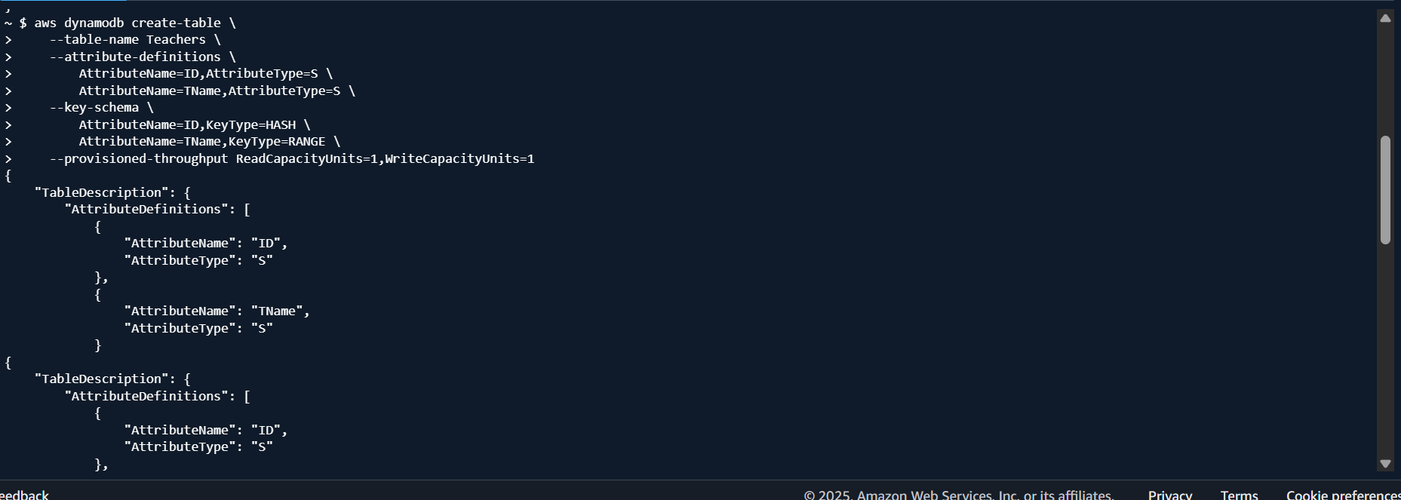

Task15:  
get – item  
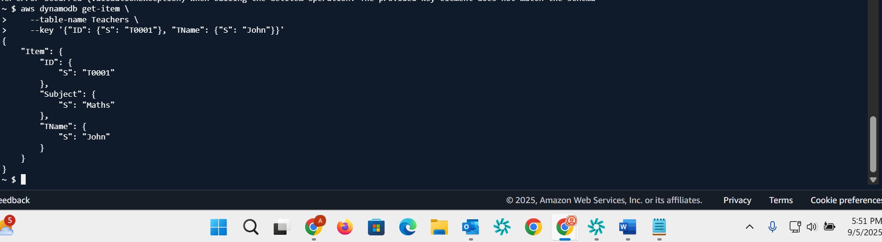

Task16:  
get set of items

