**GIT & GitHub**  
 17/05/2025  
**Git hub commands:**

Git status

Git init

Git add “filename”

Git commit -m “type msg”

Git clone url

Git remote add origin url

Git push origin main

Git config –global user.email “email id”

Git config –global user.name “name here”

Git status

Git log

You can follow this mostly this will work

**Git steps  for VMs**

1. Navigate to d drive
2. Create folder “ATLAS” or any thing
3. Copy address/location of the folder
4. Create a file “test.txt”
5. Navigate to git bash terminal
6. Type cd d://ATLAS
7. git init
8. git config —global user.email “<your email>”
9. git config —global user.name “<your name>”
10. git add . && git commit -m “your message”
11. git pull <url of your repo>
12. git add origin “url of your repo”
13. git push
14. login popup will come, authenticate
15. done

**12 git remote add "url of repo"

Git Tutorial:

<https://docs.google.com/document/d/1SXfPIwDttDk-XP5_mX7YizIuJGQ2vKMX/edit?usp=sharing&ouid=103020917863623365252&rtpof=true&sd=true>

Task 1:

Create a repository in git hub  
  
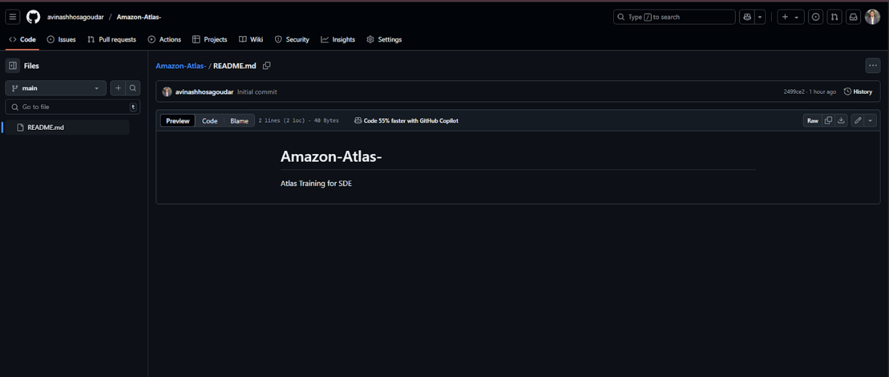

Task 2:

Add a file to your repo using GUI   
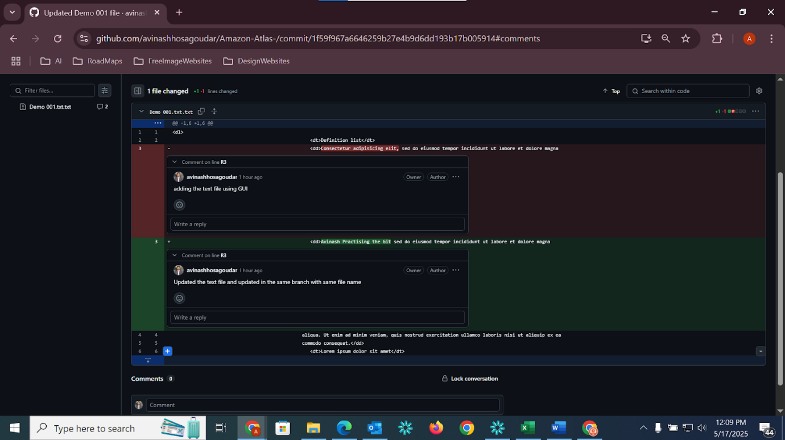

**Task 3:**

Create a folder in your vm and create a test file 1 and 2 and try to push file1 to the repo

(use git commands)

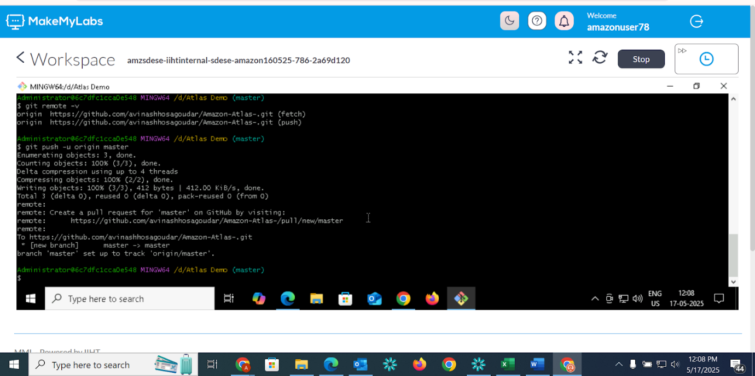

1.**Git show  command:**

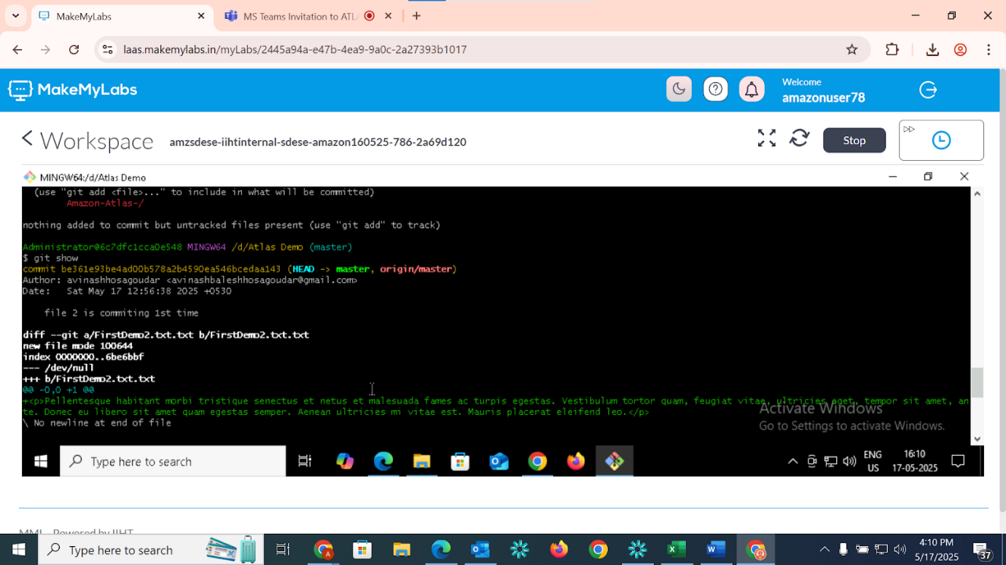

**2.Branching:**

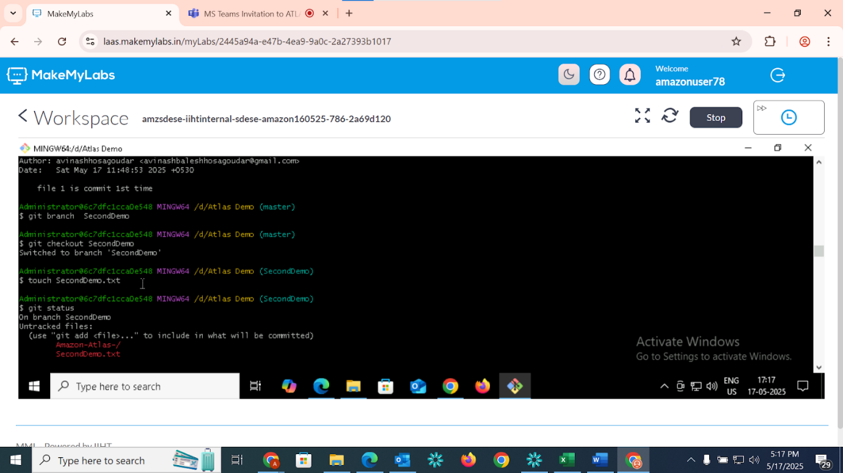

**3.git merge:**

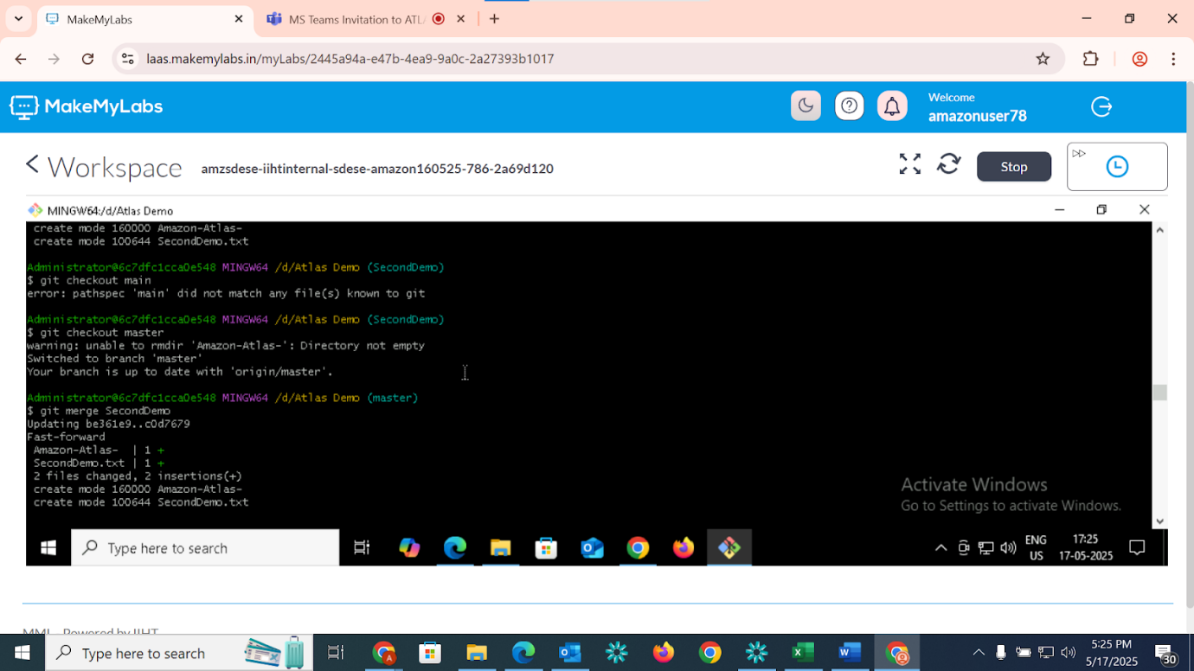

**4.git stash :**

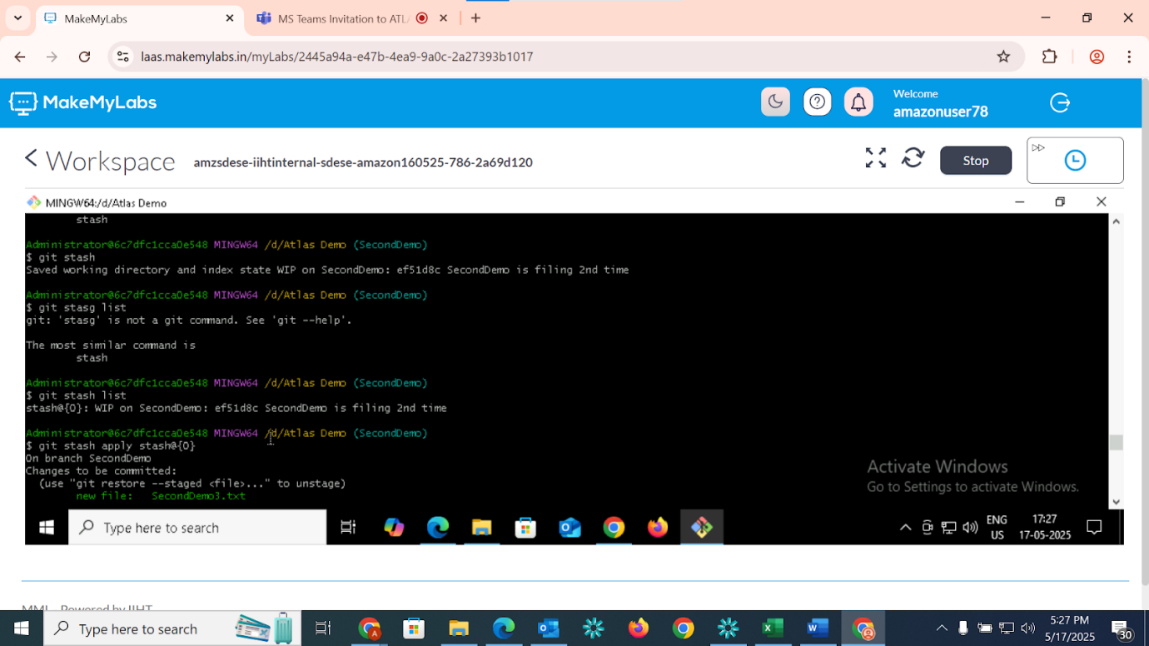

**5.git reset   :**

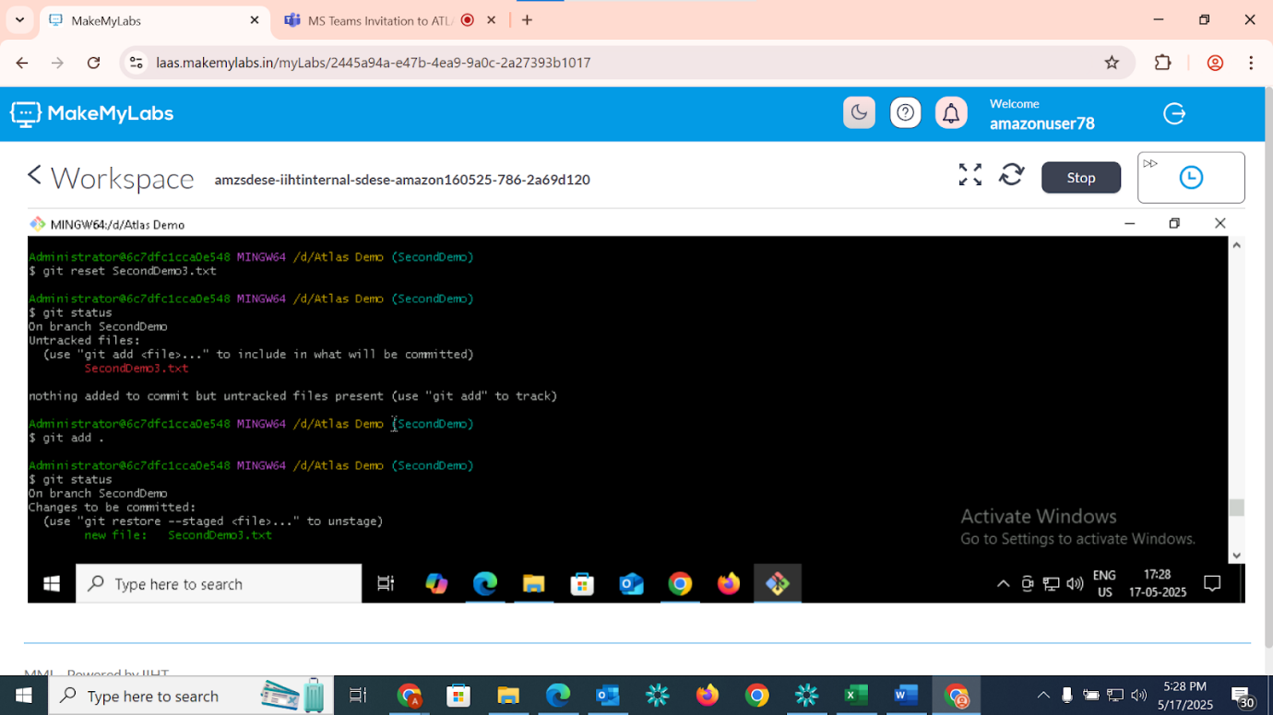

**6.git revert**:

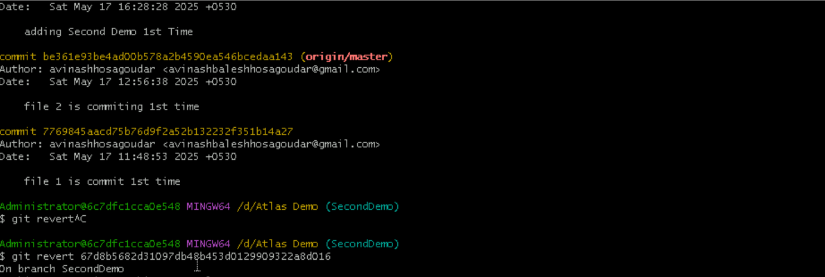

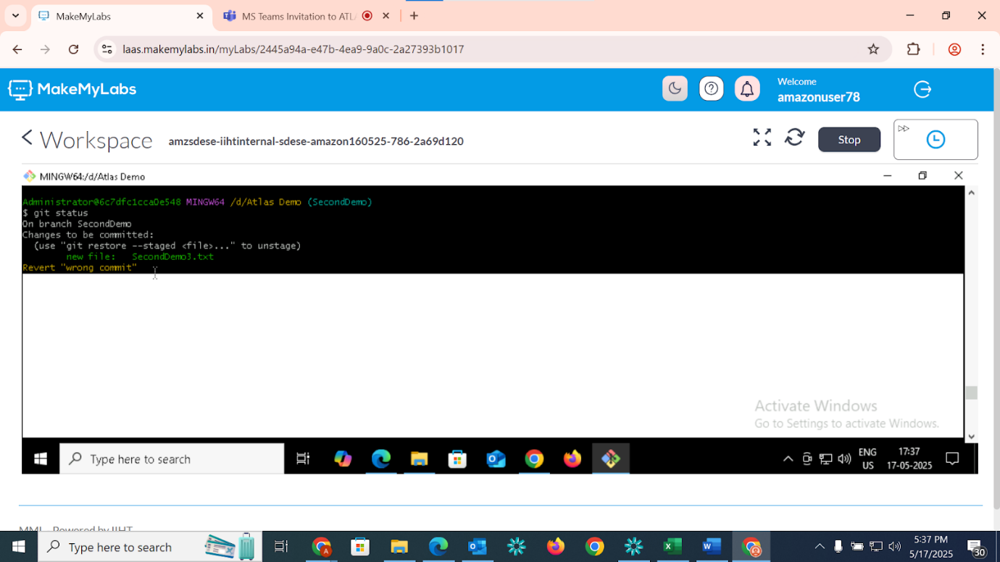

**7.Tag:**

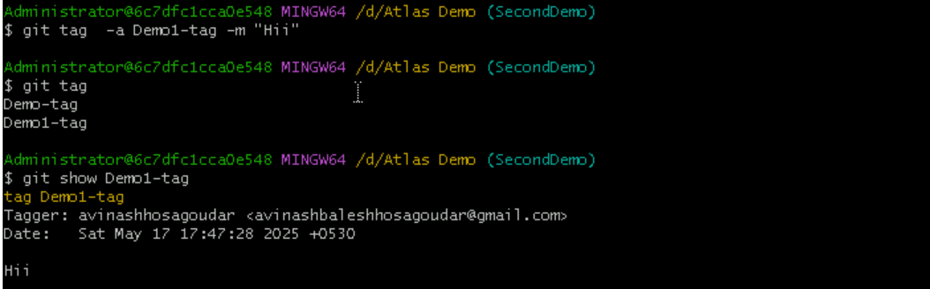

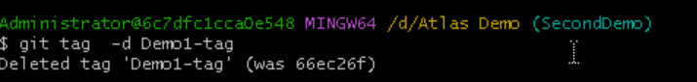

#after committing the branches to push  in repo

git commit --amend -m "message"

git push --force branch_name  
  
  
**8.Merge and pushing into Repo:**

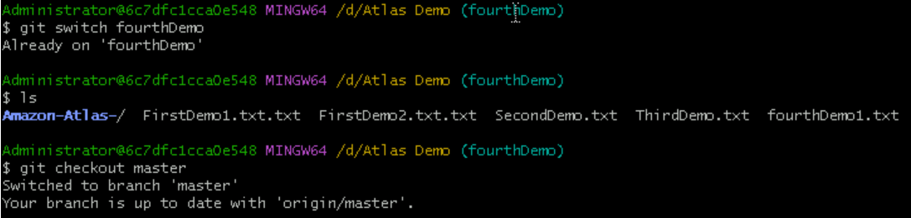  
  
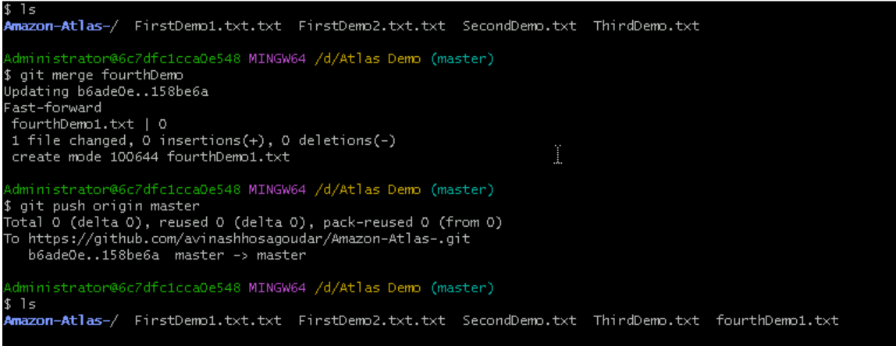



**9.Removing Untracked File :**

git clean -n   #(ask for delete yes or no)  
git clean -f   #(forcefully)  
  
Tried to remove Untracked file but it’ all clean

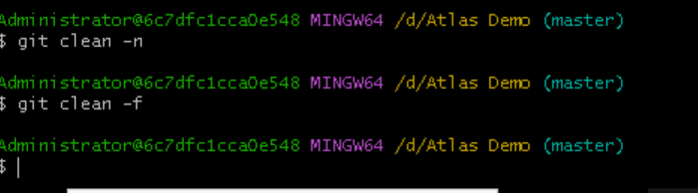

**Thank You**