**Cloud and Jenkins** 23/05/2025  
  
Cloud and Advantages:  
  
**Cloud :**   
  
 Cloud is basically  called Cloud computing which  we can access the services like, storage , database, networking and Software and etc.  
  
Advantages:   
1.Scalability : we can scale the resource on our requirements.

2.Accessibility: we can access it from anywhere, any device.  
3.Security: Built- in security , encryption and safe of the data.  
4.performance :  high performance, better than local server.  
5.collaboration: it helps to teams work collaboratively.  
  
  
Installing  Jenkins and Tomcat :   
#to check jenkins installed or not  
In cmd =       **Java  -jar  jenkins.war**  
  
#check jenkins server is working or not in browser with **localhost:8081**

#To get password of jenkins:  
**c>programData>Jenkins>.jenkins>secrets**

**#**Jenkins installed successfully  
Jenkins running on port:

[**http://localhost:8081/jenkins**](http://localhost:8081/jenkins)

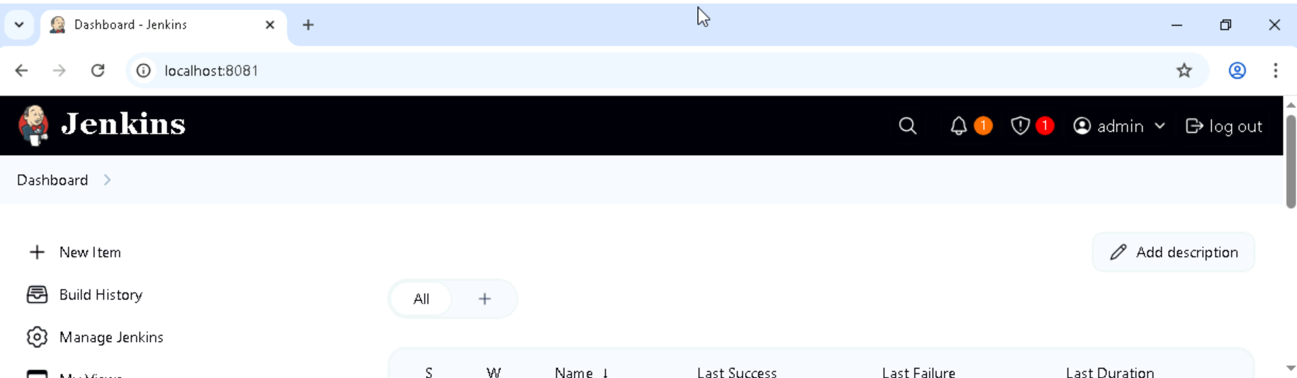

#download the latest Tomcat version and paste it in program files

step1- downloaded the latest version of Tomcat in local system  
step2 – install and add the path to environment variable   
ste3 – Tomcat running on port   
  
[**http://localhost:8080**](http://localhost:8080)

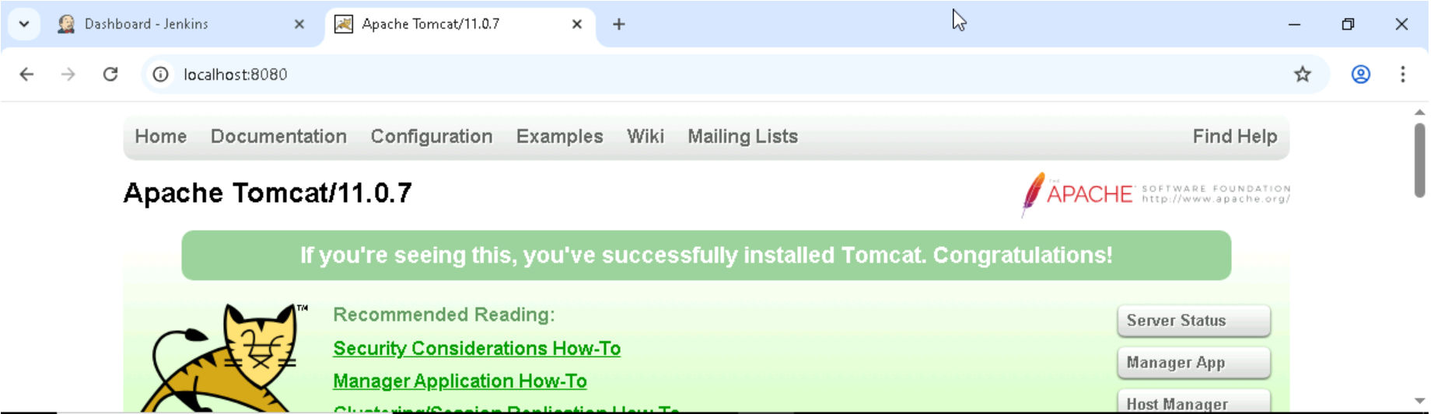 **installed Plugins:**

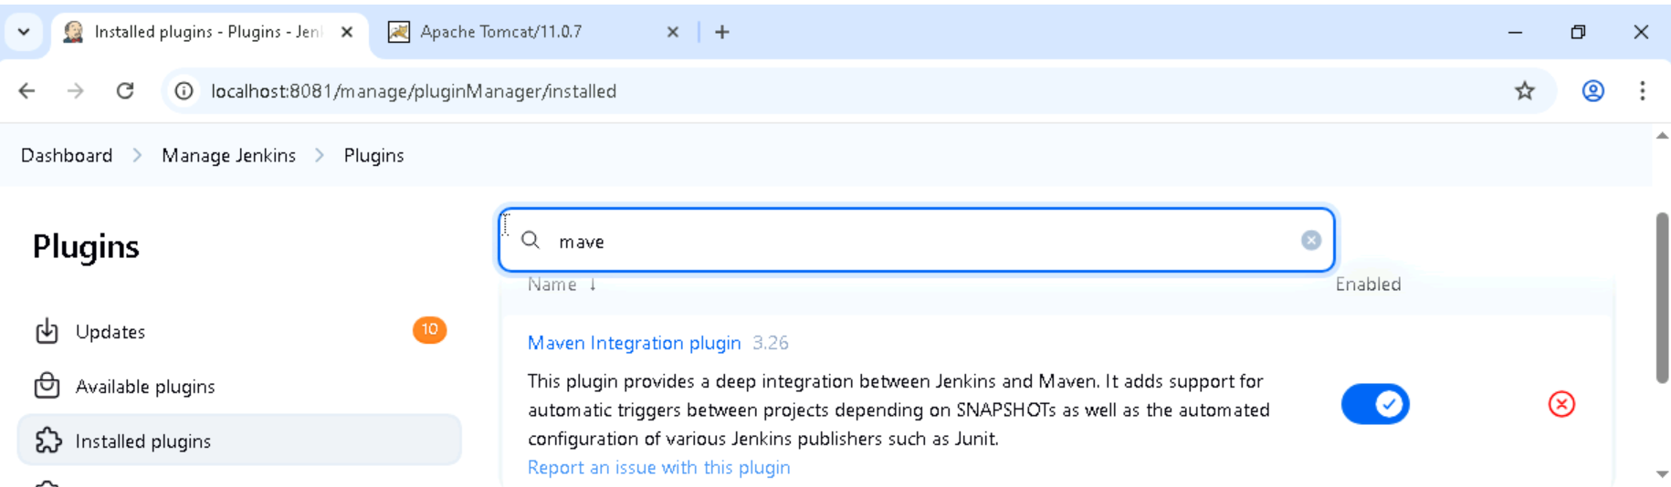

**Installed Junit:**

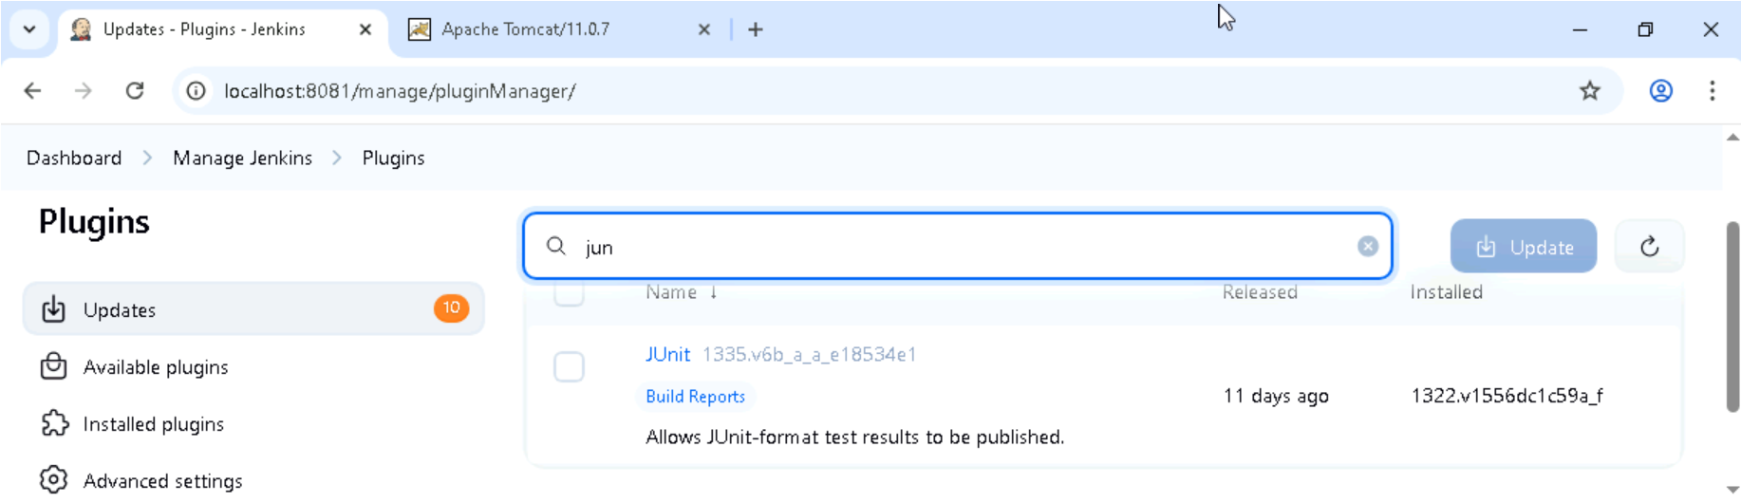  
  
  
 Jenkins intsall — Done

Tomcat setup — Done

Git setup — Done

Maven Setup — Done

Configuration –Done - JENKINS_HOME" environment variable

Management –Done

Setup Build Jobs  — Done

created Jobs:

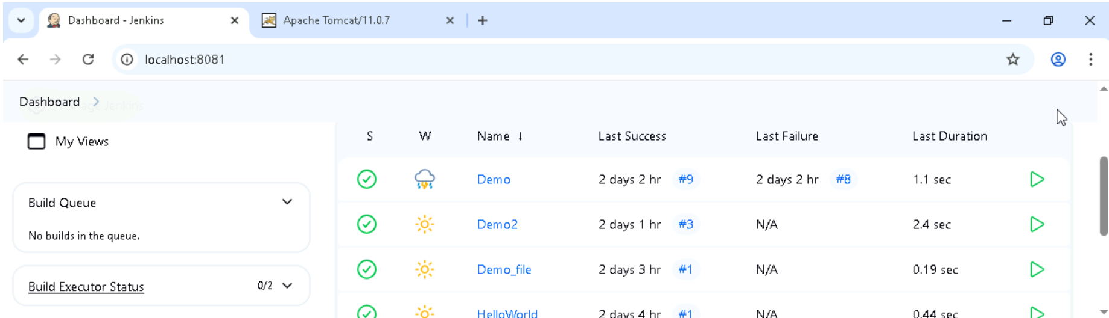

Build and Test:

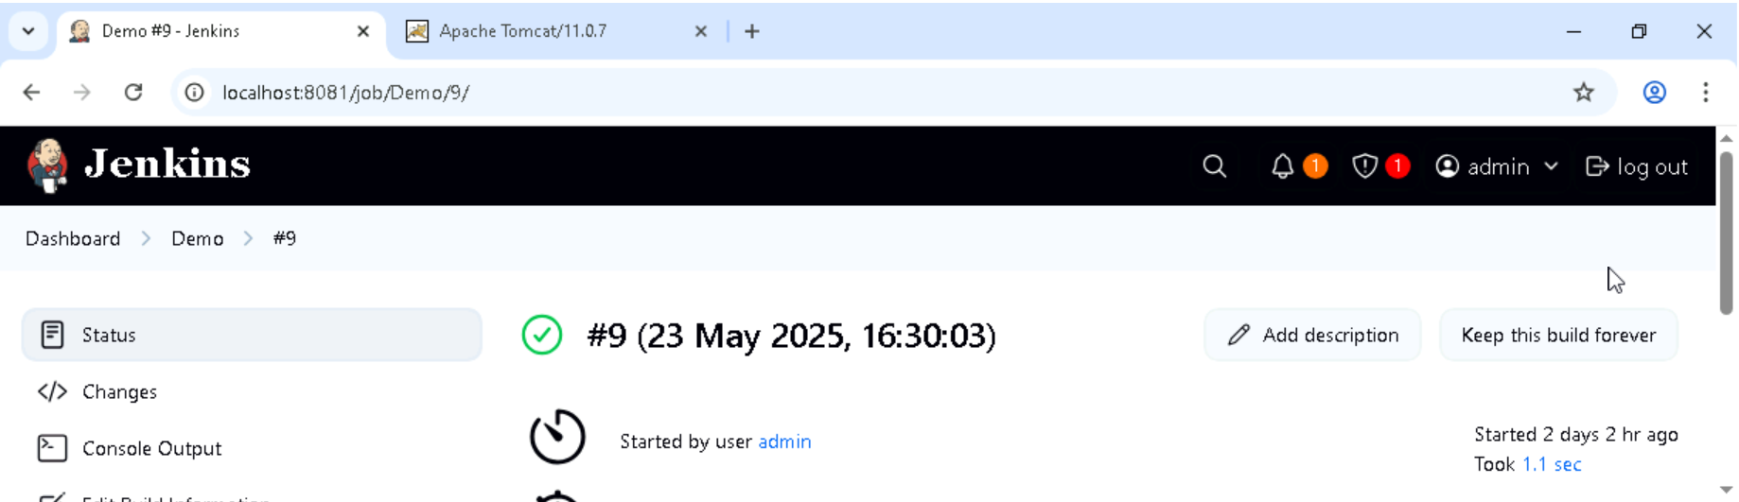

#imported the files from the git direct to jenkin  
#done Testing the Part

**I have followed and completed all the steps and tasks from the document as instructed by Meher.**

# Sample java Program

# Java Program - Demo001

public class Demo001 { // Driver class

public static void main(String[] args) {

// main is a method

// The code execution starts from here and ends here

System.out.println("Hi, I’m displaying my msg from main method");

A obj1 = new A();

obj1.method1();

B obj2 = new B();

obj2.method2();

}

}

class A {

void method1() {

// method1 is a method of class A

System.out.println("Hi, I’m displaying my msg from method1 method");

}

}

class B {

void method2() {

// method2 is a method of class B

System.out.println("Hi, I’m displaying my msg from method2 method");

}

}

Thank You