MongoDB  
 24/05/2025  
  
 **MongoDB:**  
 this a type of Nosql and Document base Database.

This is the way of the storing data in the local system because of security. Privacy and utilising the memory allocation so if you want access the files and data in ur understanding language for that mongo have platform like mongo compass and You can access also through the command prompt.

|  |  |  |
| --- | --- | --- |
| **Layer** | **Format** | **Description** |
| Application layer | JSON | You write/read JSON using MongoDB shell/driver |
| Internal conversion | BSON | MongoDB converts JSON into BSON |
| Storage engine | .wt files | BSON is stored inside collection-*.wt files |
| Recovery | Journal | Write-ahead logs to prevent data loss |

# #Installing Mongdb step1 – download Mongodb latest version step2 – set the path to environment Variable step3 – download the mongosh step4 – set the path to environment Variable step4 – open cmd and type - mongod to run server step5 – open another tab of cmd type - mongosh to work with mongodb ---------------------------------------------------------------------------------------------------------------------------------------

# MongoDB Commands Executed Successfully

1. use firstdb

2. db.students.insertOne({name: "Avinash", age: 26 , Job: "employee"})

3. db.createCollection("teachers")

4. db.teachers.insertMany([])

5. db.teachers.find()

6. db.teachers.find().forEach(printjson)

7. db.deleteplist.insertMany([])

8. db.deleteplist.deleteOne({ product: "sheet" })

9. db.deleteplist.find({ product: "sheet" })

10. db.deleteplist.insertMany([])

creating db and creating Collections:

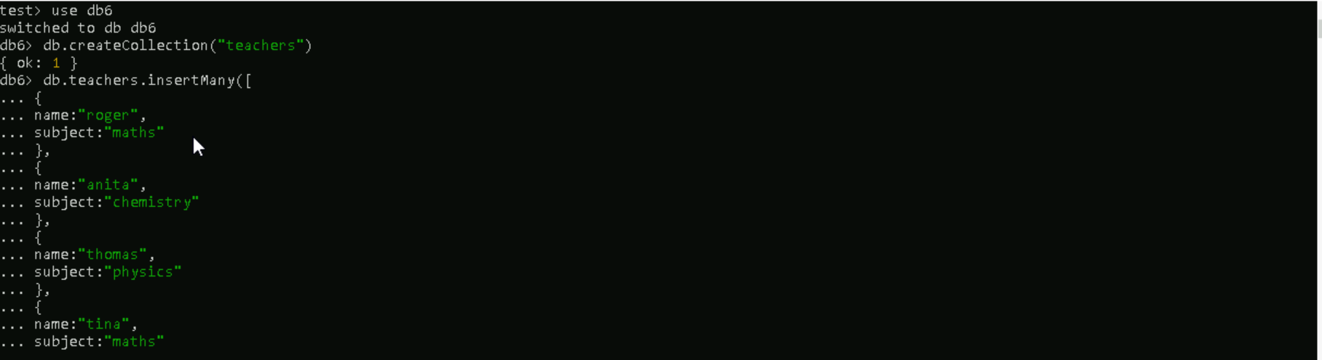

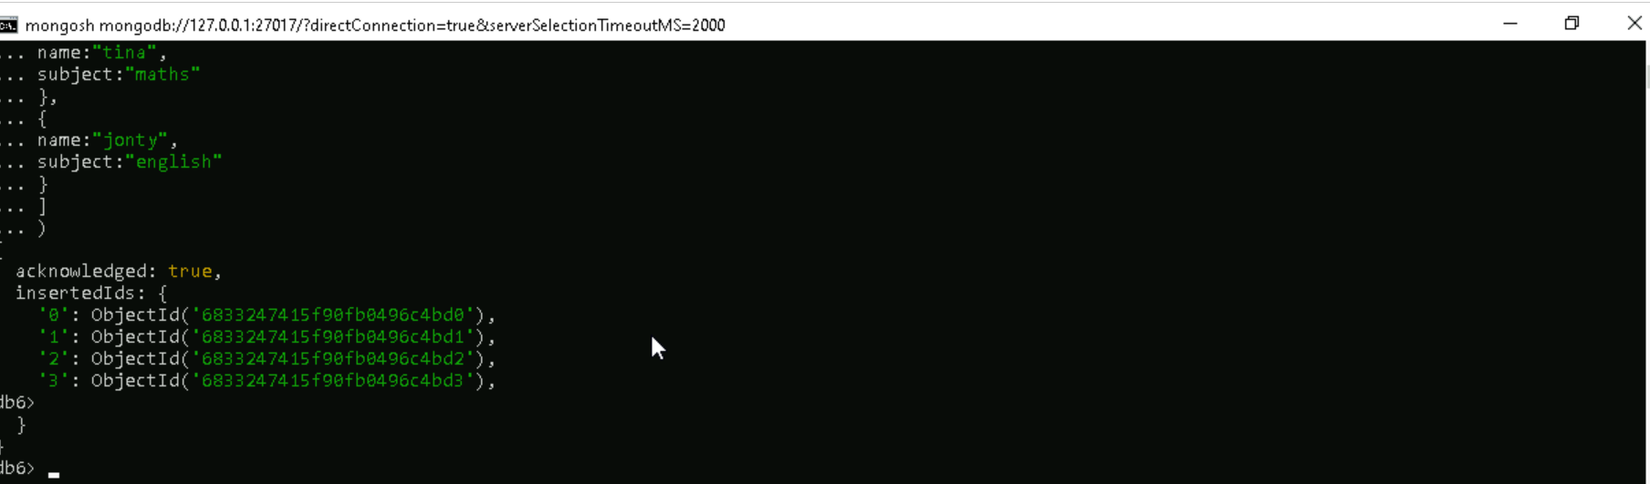

**1.find()**

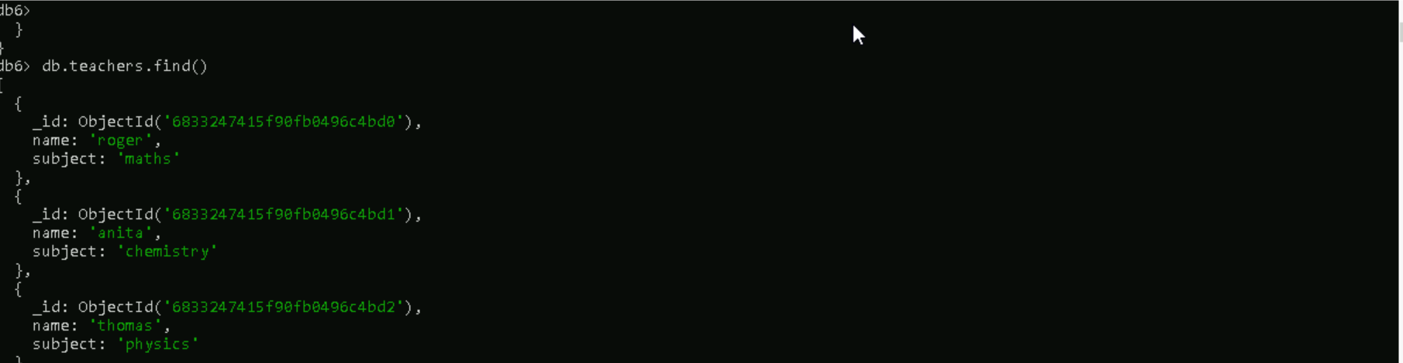

**# operations:**

deleteOne() , remove() and deleteMany()

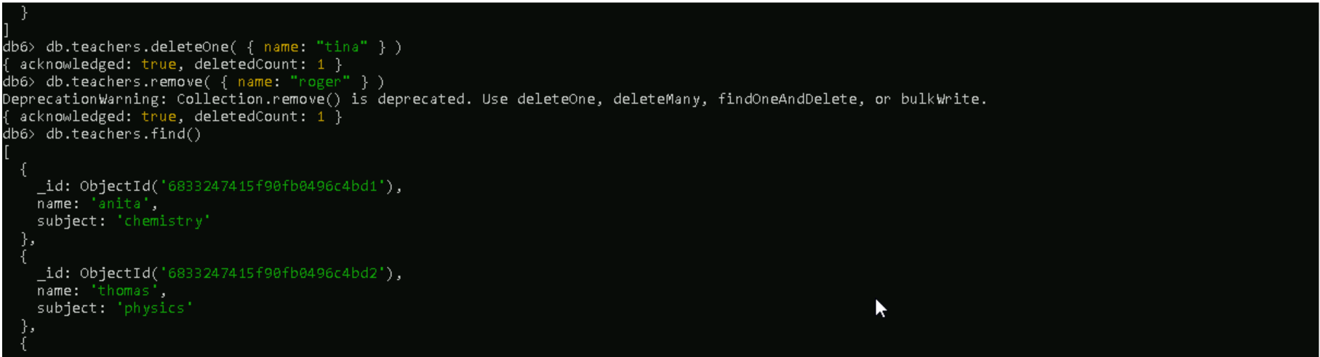

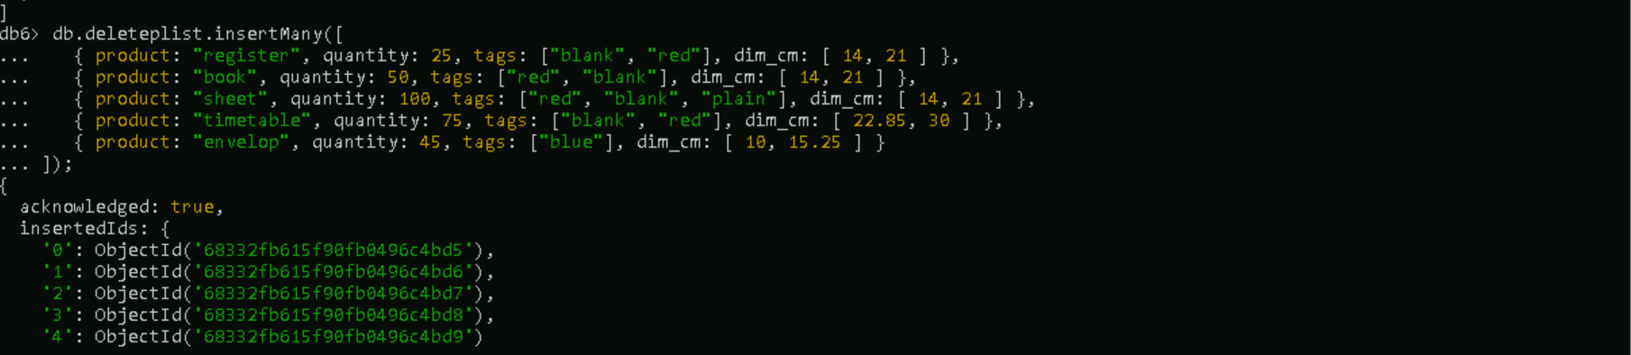

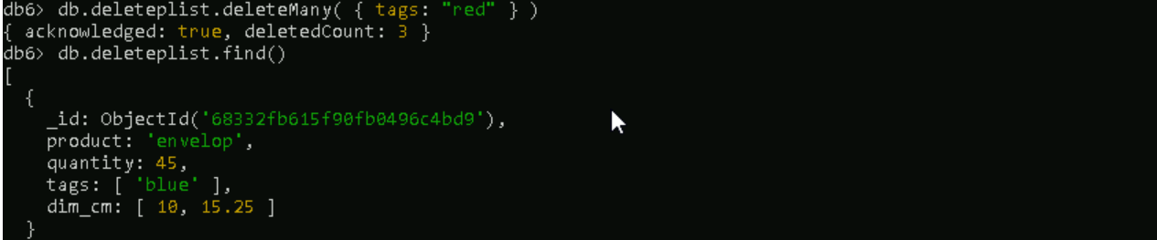

Update()

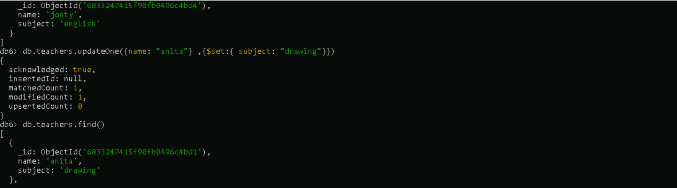

Aggregate function:

1.upsert :   
2.$sort:

3.$match  
4.count()

5.distinct()  
6.$Group:  
7.$merge:  
8.$project:  
  
Pipeline()  
  
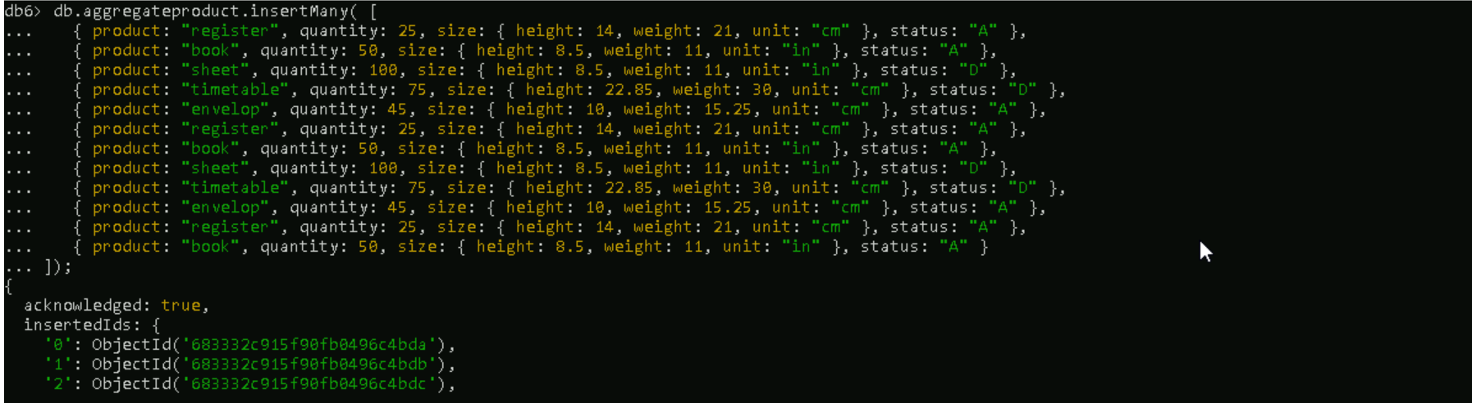

$match & $group:

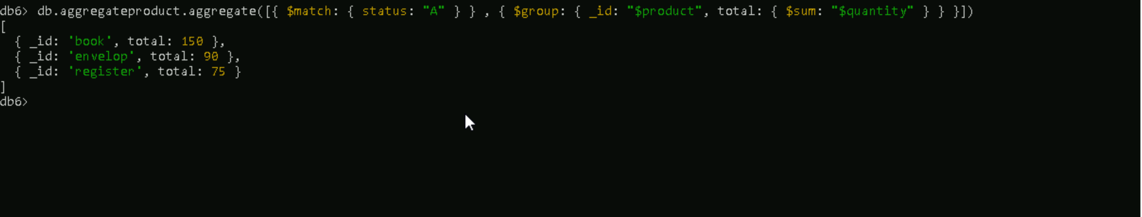

$sort:

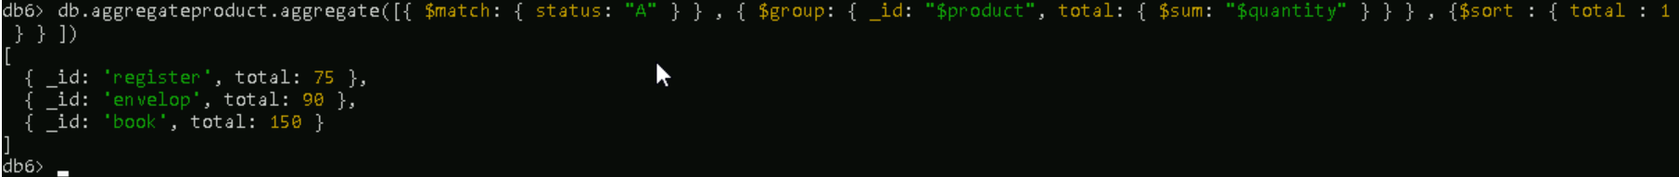

$project:

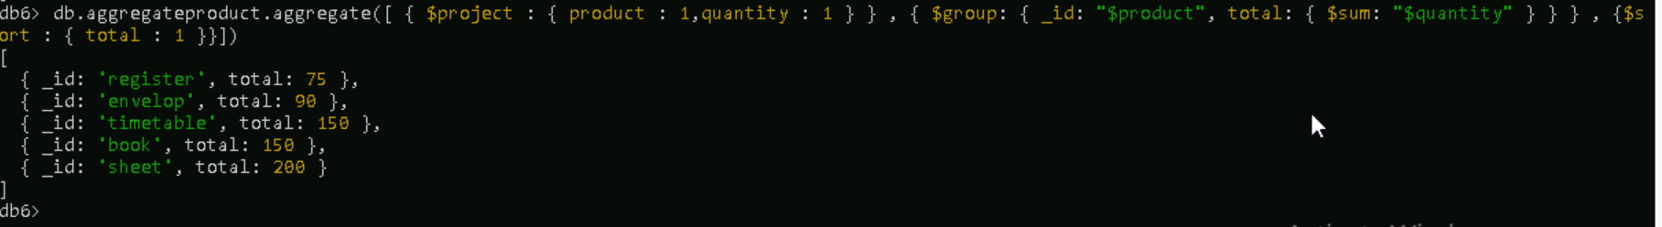

$upsert: It checks if the data is present—if it is, it updates the existing document with the new data; if not, it creates a new document in the collection.  
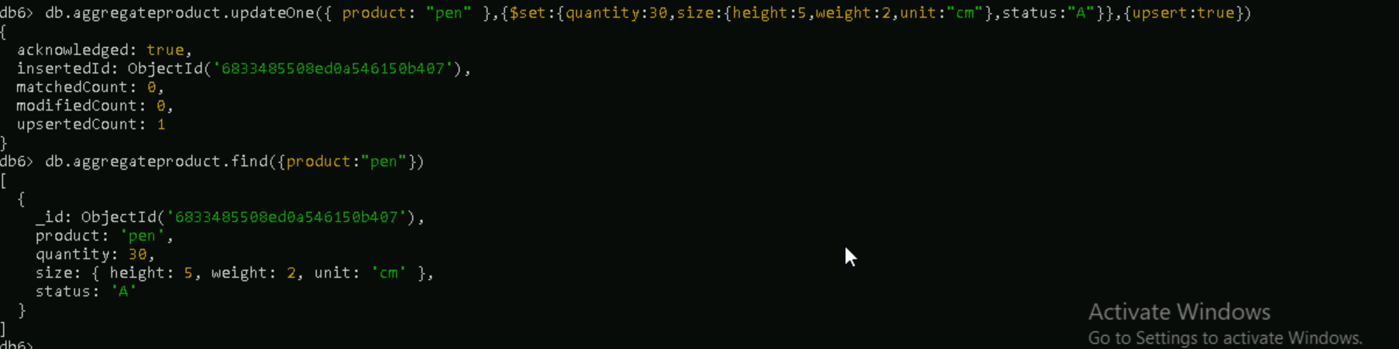

$merge:  


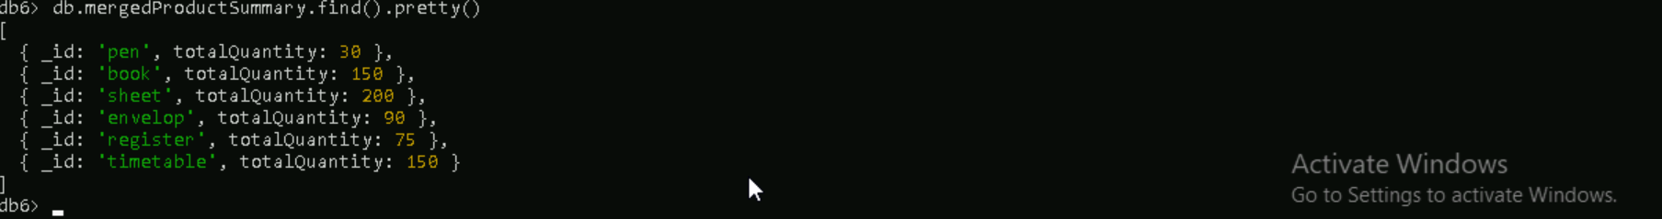

Count()  
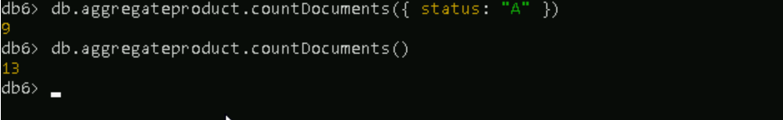

Distinct()

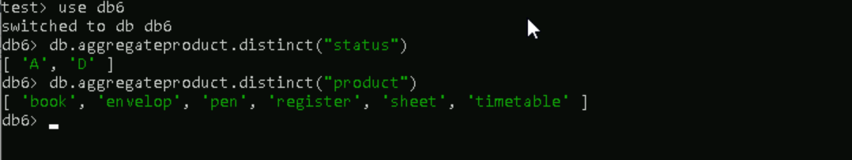

limit()

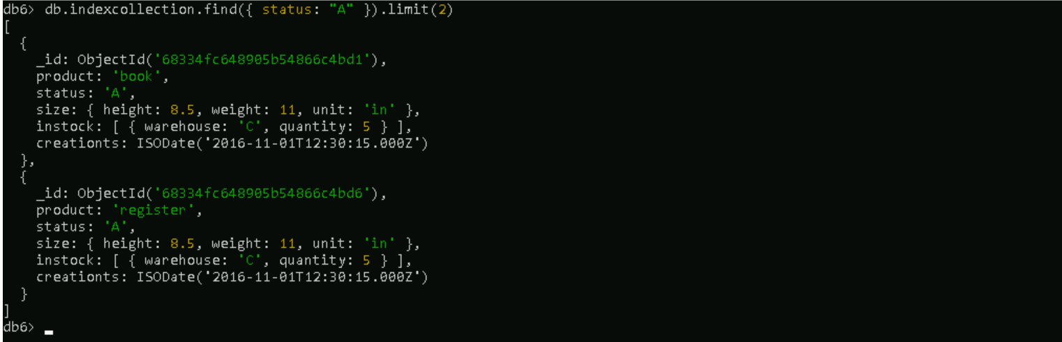

# **Indexing and Regex**

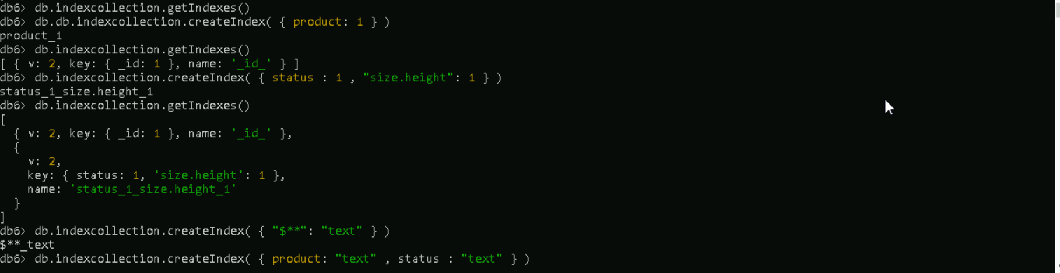  
  
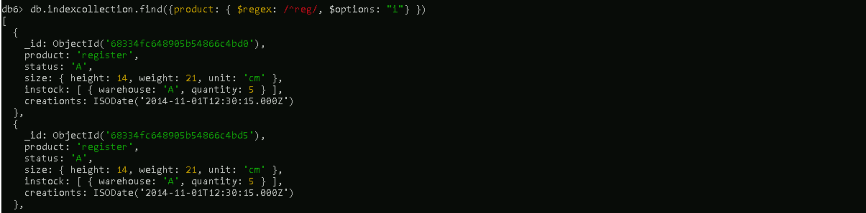  
  
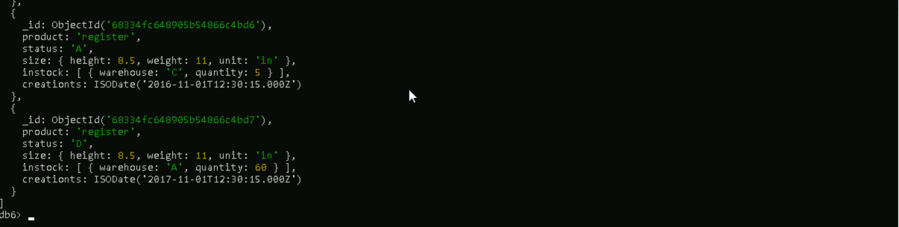  
  
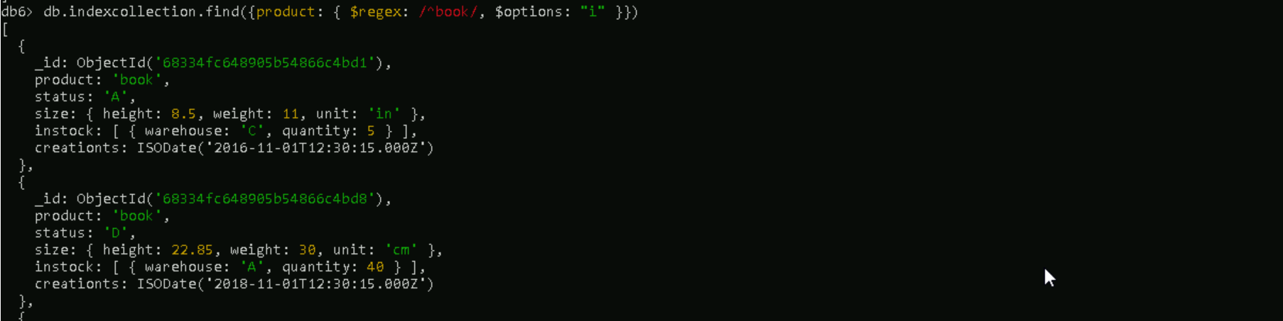  
  
  
  
  
  
 Thank You