**LINUX**  
 30/05/2025

**Task 1:**

Create a Directory with the Name Linux Practice.

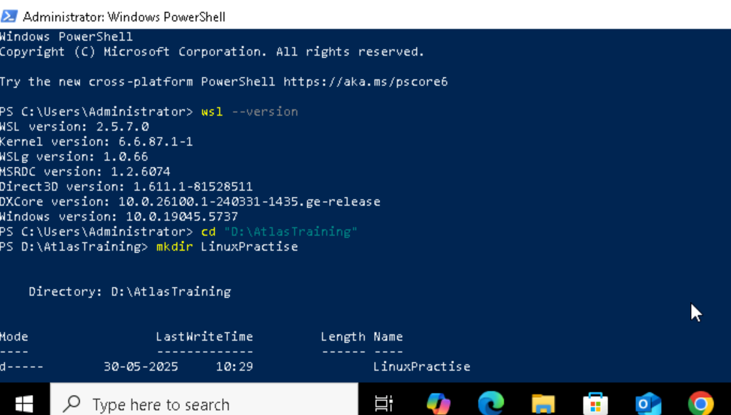

**Task2 and 3 :**

Change to the directory

 Hint: use cd .\LinuxPractice\

Ceate a file name TestFile1.txt and add the content to it.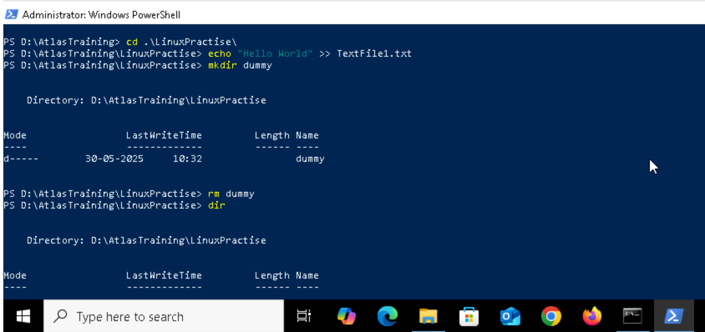

**Task 4:**

Create a Folder named Dummy and try to delete it.

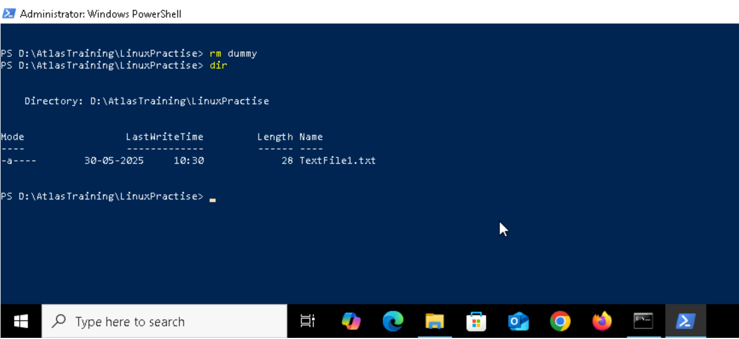

**Task 5:**

Plz check the working directory (Hint : pwd)

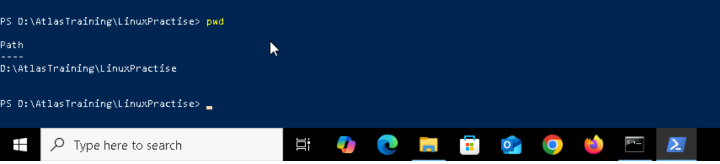

**Task 6:**

How do you check all the files and directories in the directory you are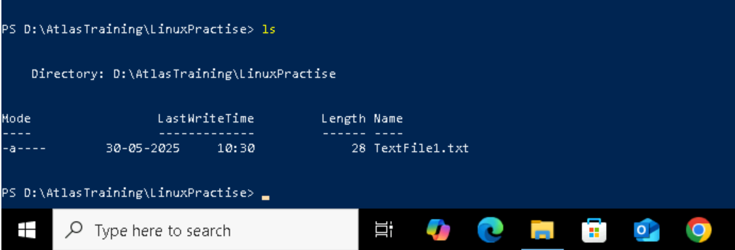

**Task 7:**

Create five files named TestFile2.txt.. TestFile3.txt… and so on till TestFile6.txt

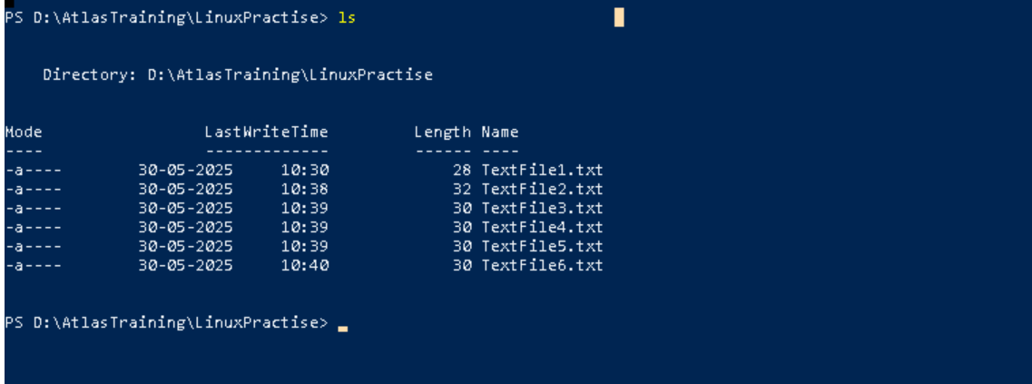

**Task 8:**

Copy all files from Dir 1 ti Dir 2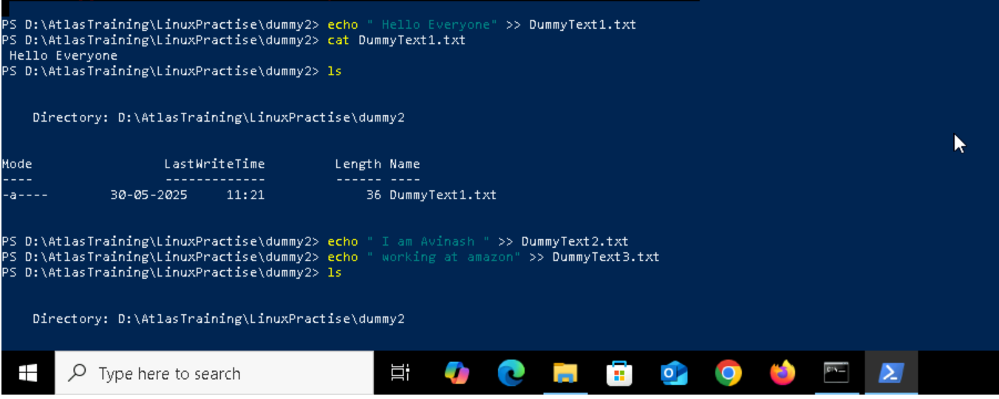

**Task 9:**

Move all files from Dir 2 to Dir 3 (finally ur Dir 2 should be empty)

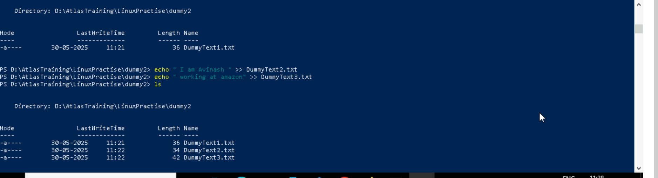

Copied Successfully: 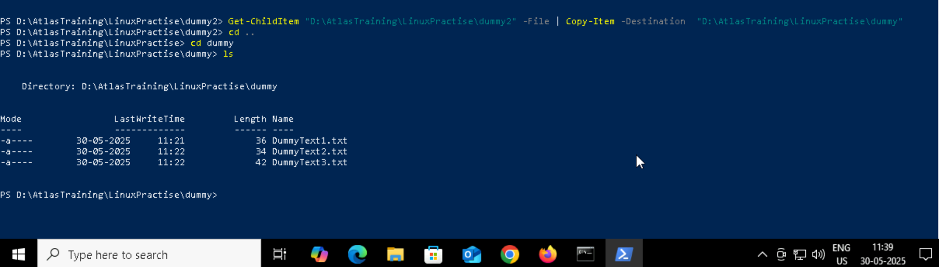

**Task 10:**

Can you plz show me the diff between **rm** and **rmdir** commands with screen shots ?  
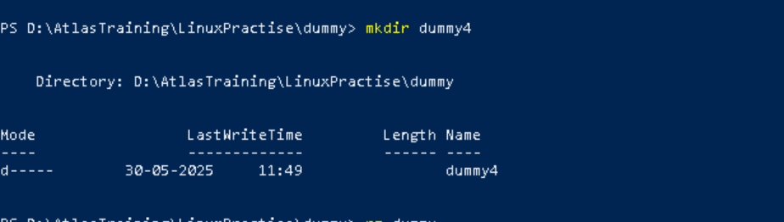

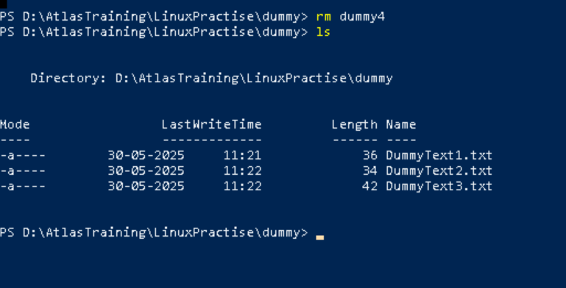

**Task 11:**

Now use specifically use cat command to create a file

And add the dummy text of 2 to 3 paragraphs from the above link Lorem Ipsum.

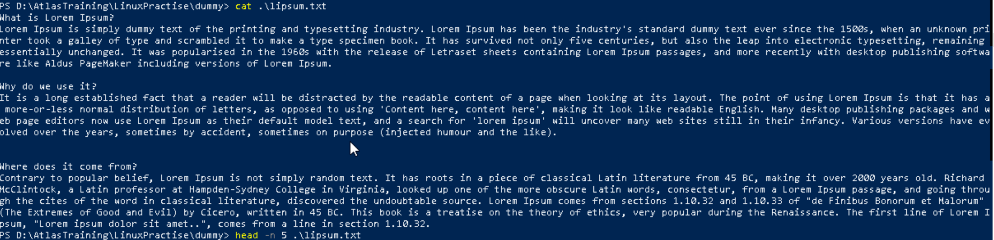

**Task 12:**

How to get only the top part of your file..

Hint: use head / I am using powershell so head command is not available in this so used Get-Content “filename” | Select-Object -First 5

powershell

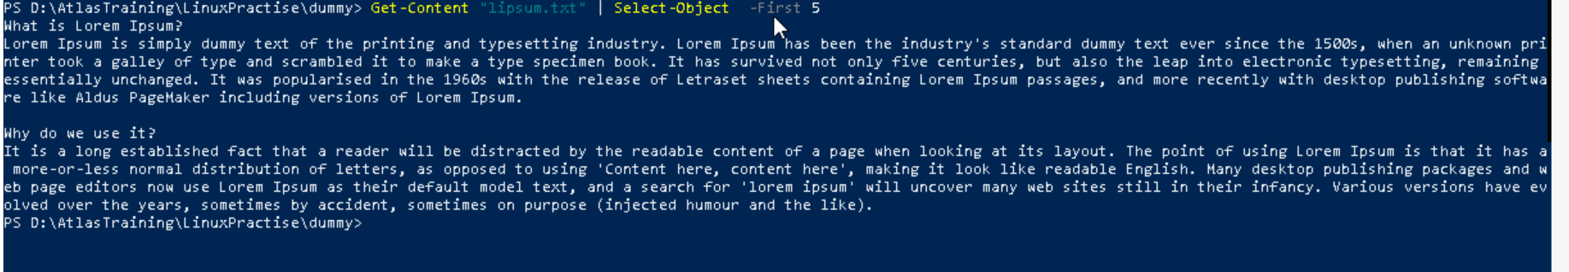  
gitbash   
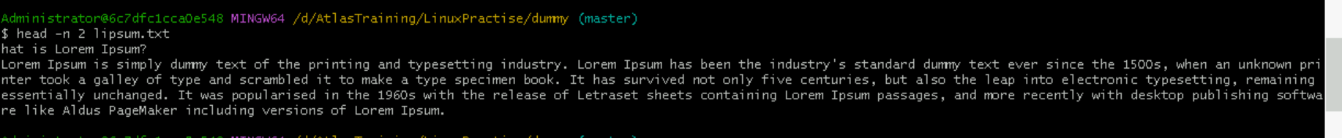

**Task 13:**  
How to get only the last part of your file

Hint: use tail / I am using powershell so head command is not available in this so used Get-Content “filename” | Select-Object -Last 5

powershell

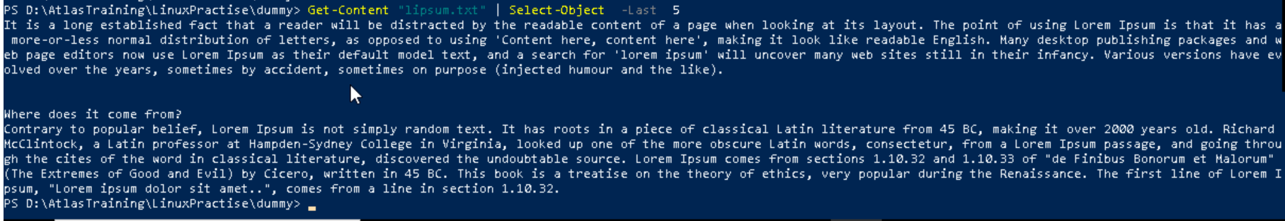

gitbash



**Task 14:**

Plz add dummy text of 5 to 6 pages in to the same file .# after “ Vim filename “ edit ur text for saving use :wq

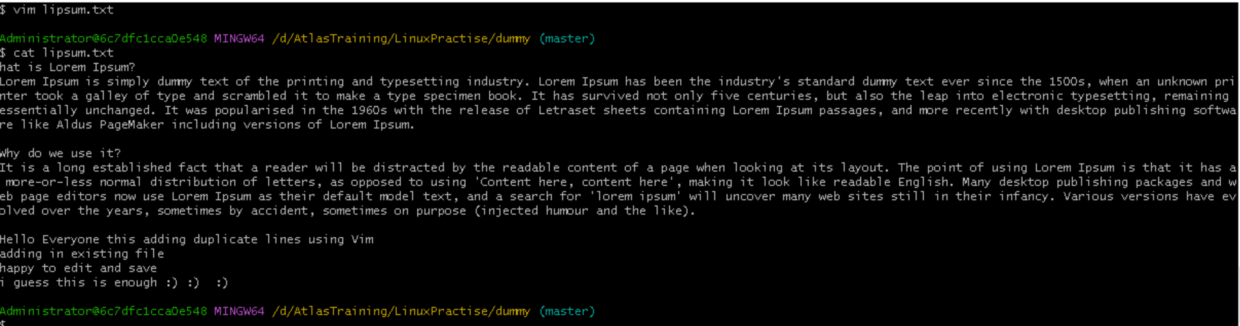

And

Now show the file in page by page

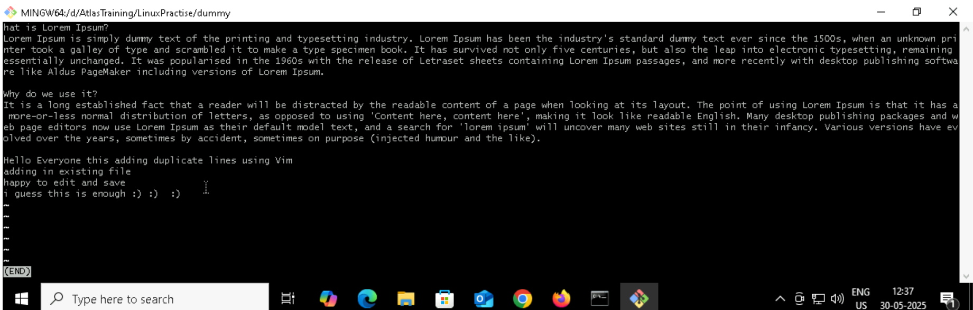Hint : use less command

**Task 15:**

Use more command on the above file and find out the diff between less command and more command.  
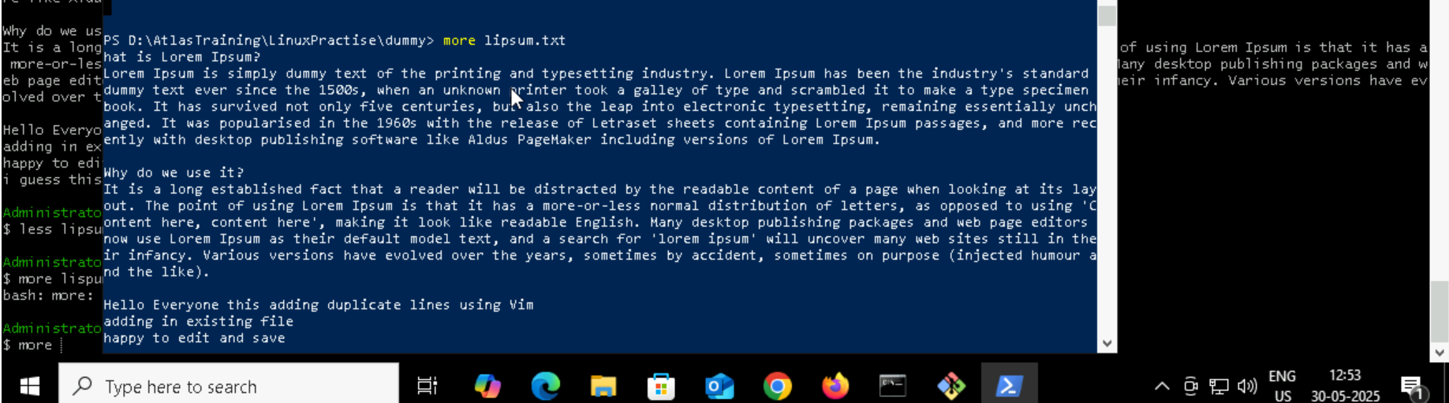

Difff b/w less and more is   
less - we can scroll backward , real time viewing , powerfull  
more – we cant scroll backward, slower and we cant see real time

**What is e in echo command..?**

The e in the echo command is an option that enables the interpretation of backslash escape sequences. These sequences allow you to insert special characters and formatting into the output.

**Task 16:**

Can you use echo command with -e and see the diff.. Also take a ss and paste .  
# -e helps to add special characters like we can give text line and tab commands .

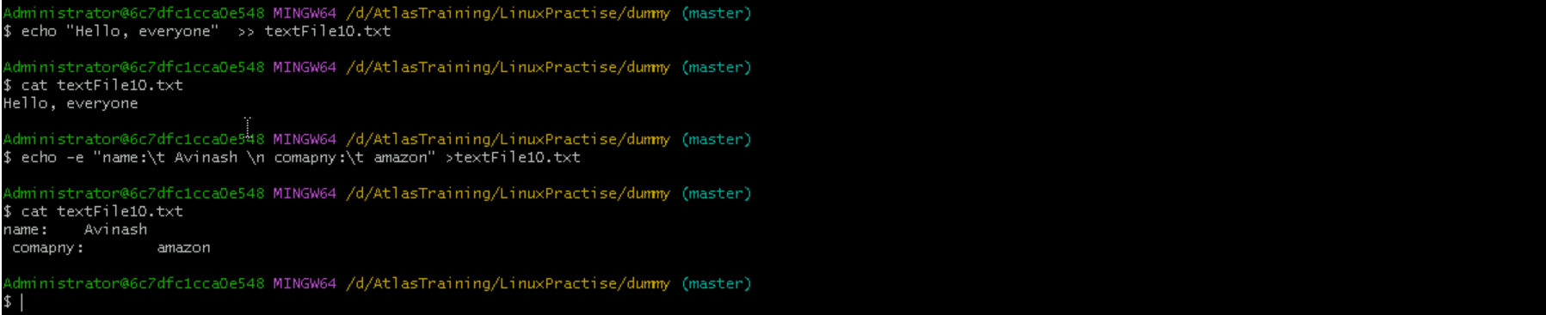

**Task 17:**

What is diff between ls and ls -l command .. ss plz  
# “ ls -l “ command helps to check file history and mode of the file / where ls helps to get presented files in directory

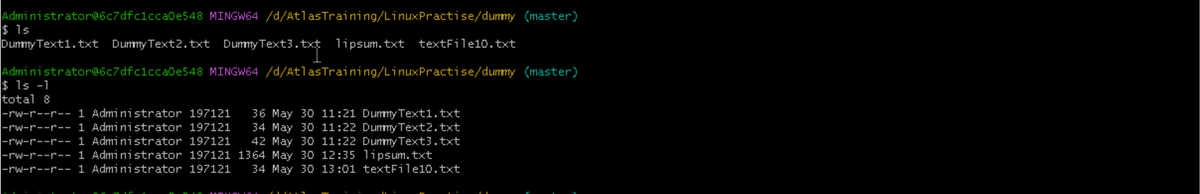

**Task 18:**

Create  a file using **touch** command , **cat** command and **echo** command and take ss (screen shot)..

Also write the difference between touch , cat and echo commands.

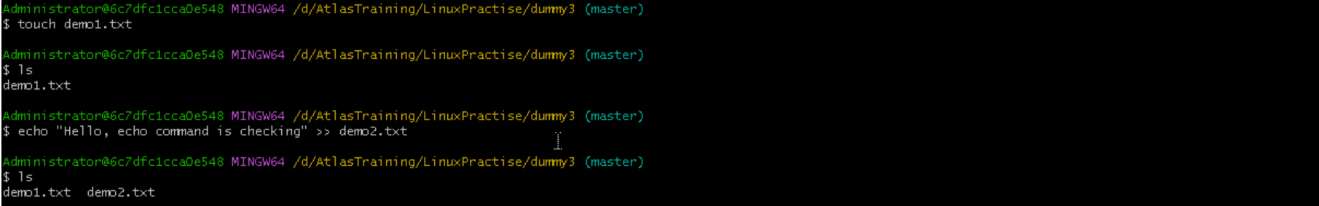

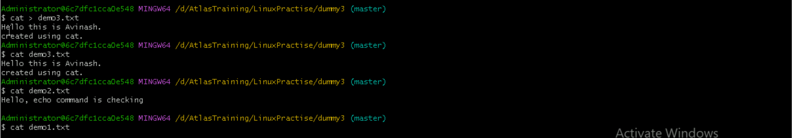

**Diffecrence :**

command syntax use  
1. touch touch file.txt Ceates Empty File

2. echo echo “message or text” > file.txt Creates file with one line

3. cat cat > file.txt we can type into the file

**Task 19:**

Can you guys try to display the calendar by using a command..

Hint: use cal  
  
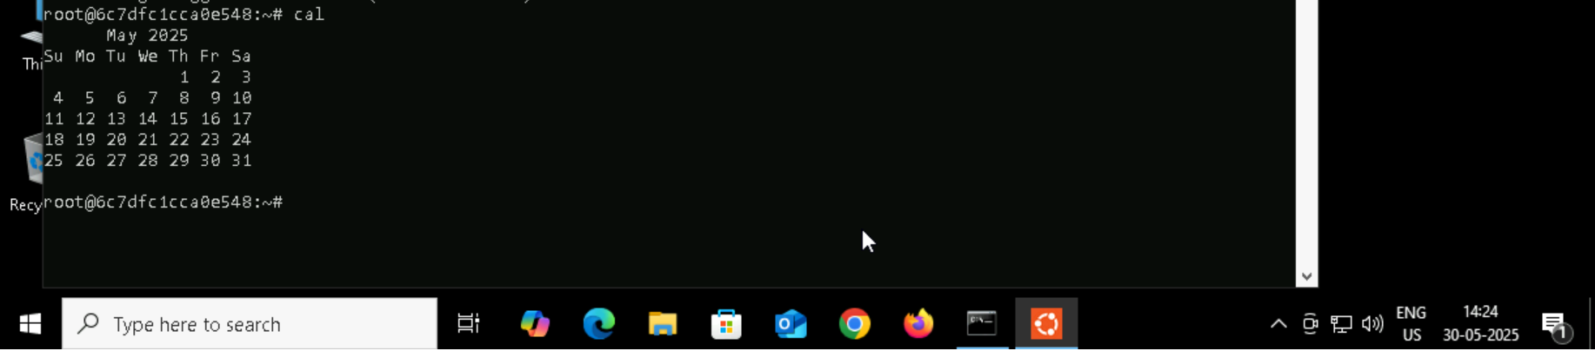

**Task 20:**

Can you go back to 1 directory .. at a time  whats the command   
cd ..

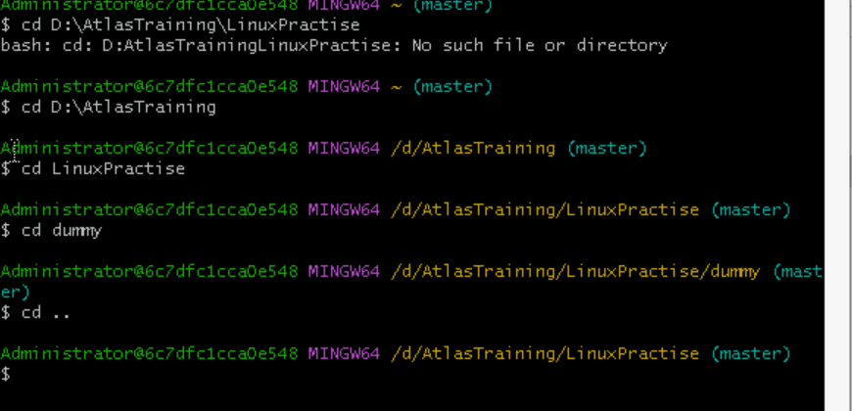

**Task 21:**

How to know whose user u are working on ?

Hint: use whoami command

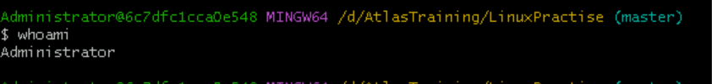

**Task 22:**

Try to find out who is peeping into your system..

Hint: Use users, who and w commands with ss

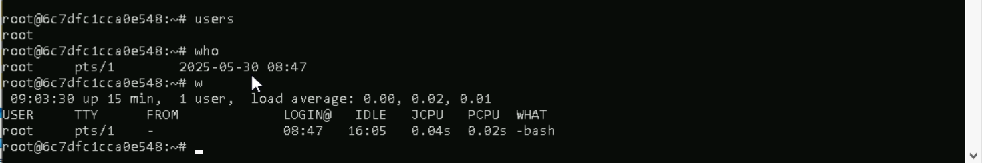  
who - Shows who is logged in, their terminal, and login time  
w - Shows who is logged in and **what they’re doing**users- Lists all currently logged-in users (usernames only)

**Task 23:**

Can you guys try to check how much disk space is consumed..

Hint : use this command : df -h  
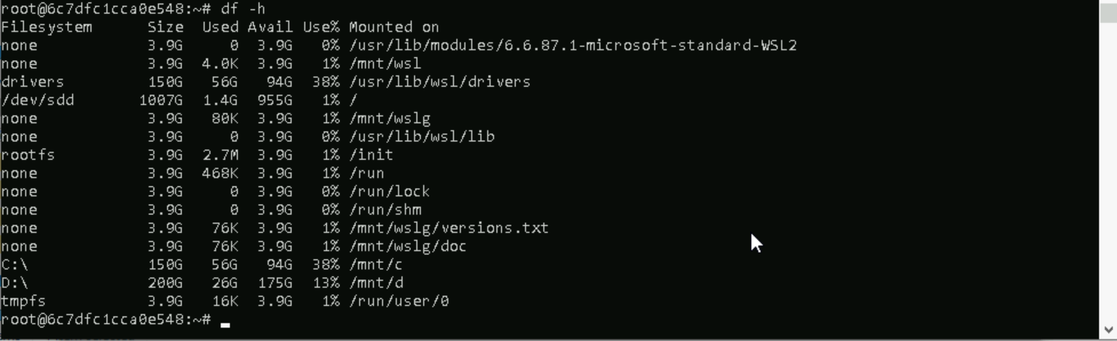

**Task 24:**

In the **ls -l** listing example, every file line begins with a **d**, **-**, or **l**. These characters indicate the type of the file that's listed.

Can you plz try using the below commands

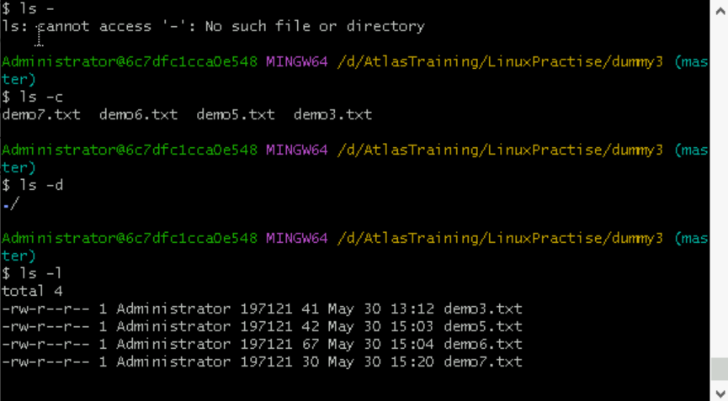

**Task 25:**

Find the list pf all files ending with .txt

Hint : use * in ls

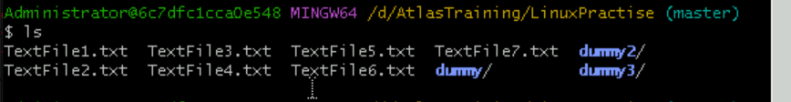



**Task 26:**

In Linux all the hidden files starts with . (period)

How to check all the hidden files in Linux..

Hint : use  ls -a  
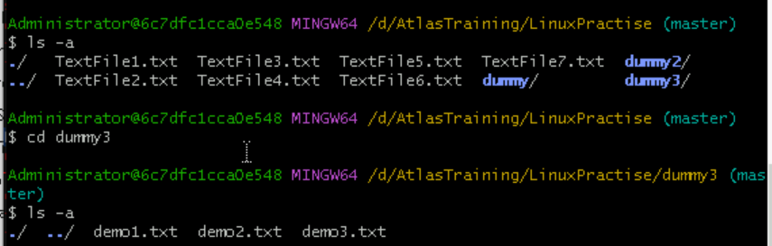

**Task 27:**

What is the difference between . and .. in linux

Line 1 line for each

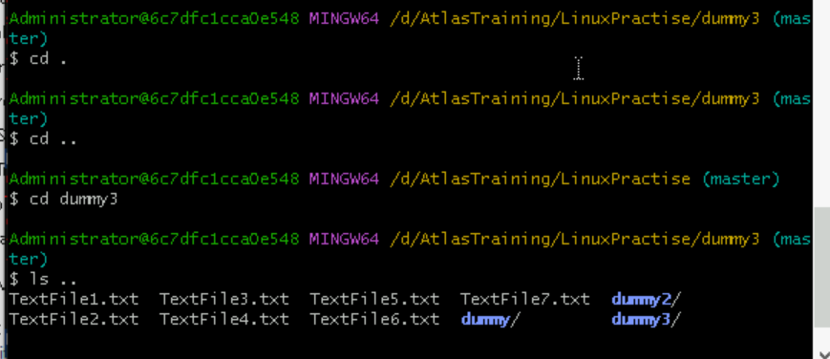

* (.) - . refers to same current directory ex: cd . and ./filetext.txt
* (..) - .. refers to to parent directory we can move to parent directory , we can see files from the parent , we can copy from cp ../filetext.txt

**Task 28:**

Can you create a file using vi editor and show the details in ss

Hint:

 Esc is for come out of the edit mode

Press two keys Shift &plus; ZZ together to come out of the file completely

* I - to insert

To move inside the file

* **l** key to move to the right side.
* **h** key to move to the left side.
* **k** key to move upside in the file.

**j** key to move downside in the file.

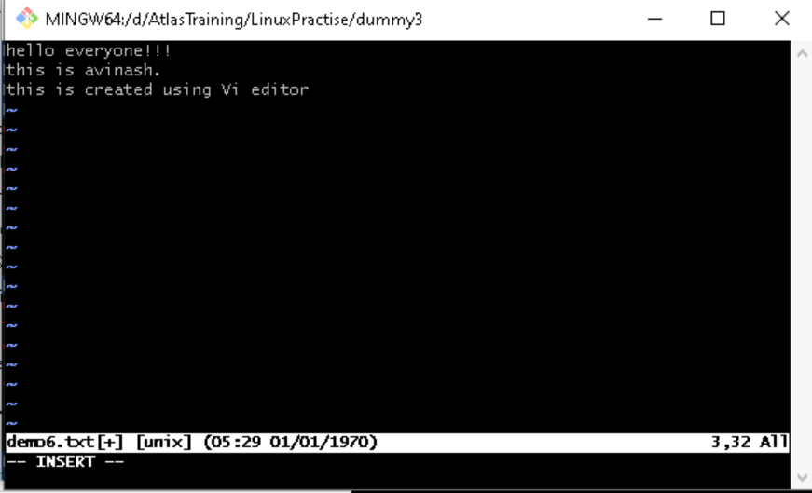

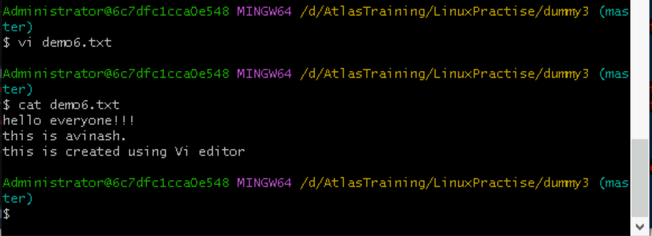

**Task 29:**

How to find the no of words in the file

Hint: use wc #refering above file only 3 is line 11 is words 67 characters:  
  
Here is the detail of all the four columns of wc command  −

* **First Column** − Represents the total number of lines in the file.
* **Second Column** − Represents the total number of words in the file.
* **Third Column** − Represents the total number of bytes in the file. This is the actual size of the file.

**Fourth Column** − Represents the file name.

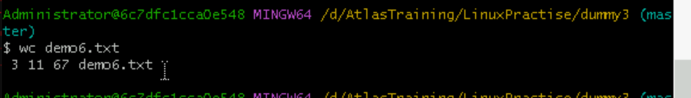

**Task 30:**

What is the use of cat -b myfilename.txt command?  
it will show the content from the files line by line with the numbers

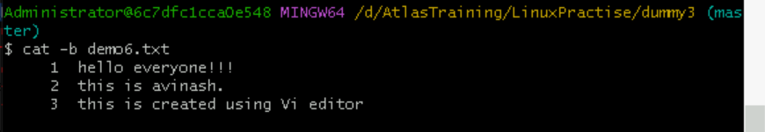

**Task 31:**

Can I use the wc with 2 or more files?

Wc file1 file2 file3

Yes we can

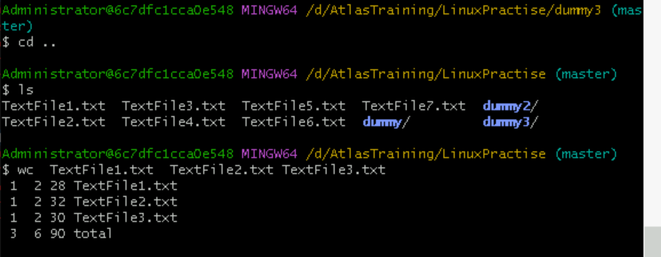

**Task 32:**

How to copy content of one file to another file

Hint: use cp:

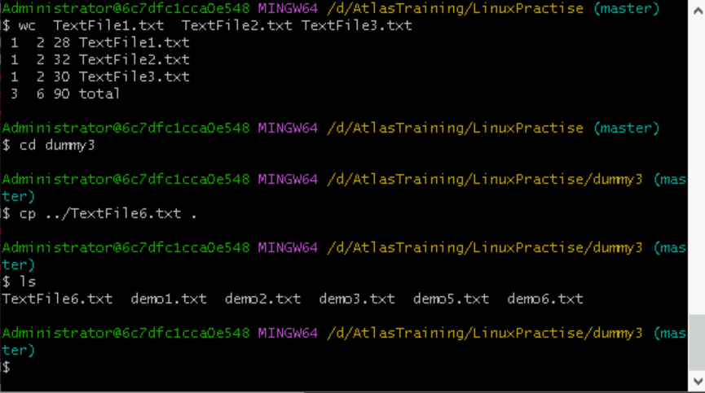

**Task 33:**

Now I want to rename my file with MYFILENEW can i do that if so how ?

Hint use : mv

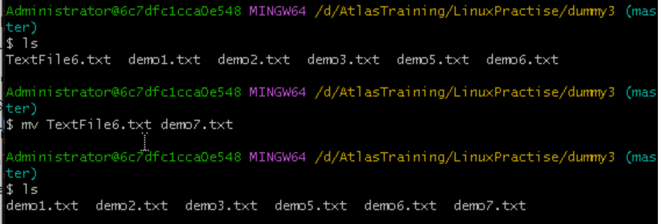

**Task 34:**

Can i remove or delete multiple files in linux..? How?

Deleting selected files : rm fil1.txt file2.txt delete all files: rm *.txt

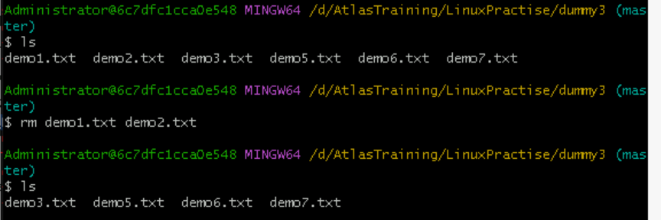

**Task 35:**

In directory / slash is root  …  can you try cd / what is it doing?

It will move to home directory directly  
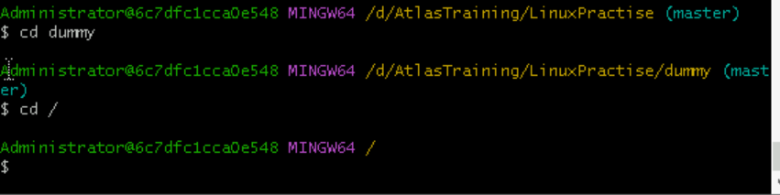

**Task 36:**

What is the way go go to home directory ?

Hint : use cd ~  
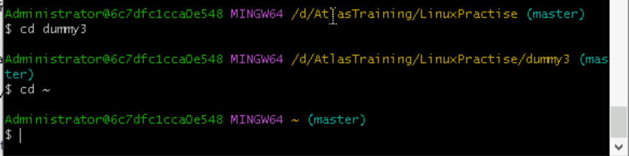

**Task 37:**

If i want to move to different users home directory

Hint : use ~username

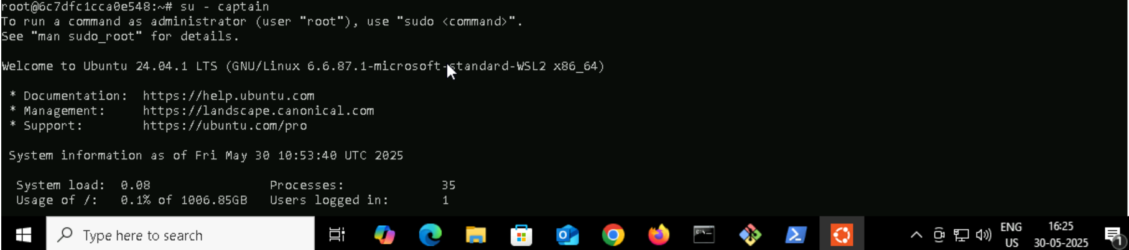

Switched to captain user:

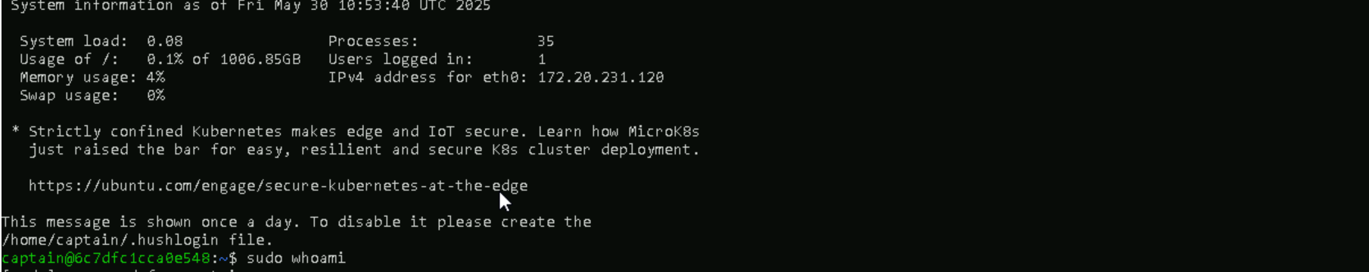

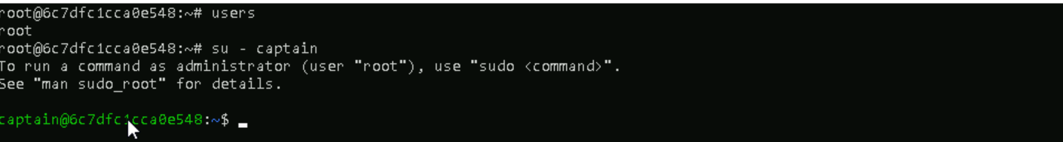

**Task 38:**

Chmods:

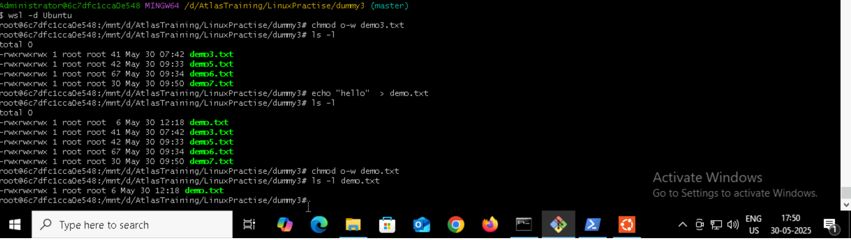







**#users in different users home directory**  
command: cat /etc/passwd #it is working for me in ubuntu  
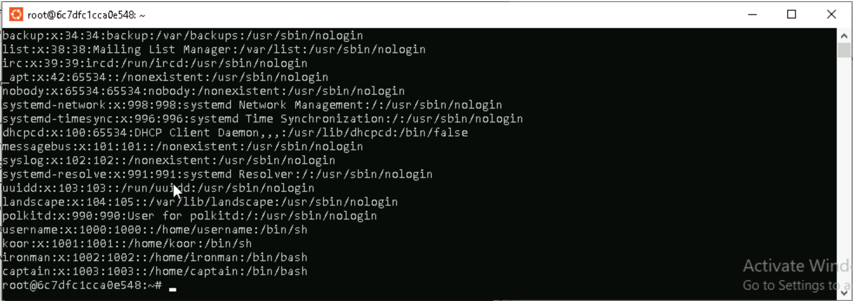

**Thank You**