**Linux and Bash Scripting  
 31/05/2025**

**Task 1:**

RegEX Symbols in linux

^ - start of the string

$ - end of the string

\\ - escaped blackslash

\S - Non-whitespace

\s - space

a* - 0 or more of “a”

a - matches with the character “a”

abc - matches “abc”

a+ - 1 or more of “a”

a? - 0 or of “a”

**Task 2:**

If you are aware of Linux OS.. can you tell me the feature of Linux.

Linux is Operating System , it is free source, it interact between software and hardware and it is widely used in servers and embedded systems. It supports multi tasking and multiple user can work on the same system at once. We can use like in graphical user interface as well as command line also is there.  
  
features:  
*open source freely available.

*Security and privacy  
*Portable : runs on laptop, desktop, mobile.

*High performance: fast

*customizable  
  
**Task 3:**

What is Kernal ? can you explain about it in your words..

Kernel is core part of an OS, the kernel acts as a bridge b/w the hardware and the software of the system . it manages the computers hardware and software resources. It manages the running programs, managing memory and handles input and output devices.

* File management
* Process management
* I/O management
* Memory management
* Device management etc.

**Task 4:**

BASH in Linux full form and Explanation

BASH is Bourne Again Shell. It is command line shell scripting , it allows users interact with operating system using shell scripts, user can perform the operations over the OS.

**Task 5:**

difference between LInux and Windows:  
  
 Linux windows

linux is open source closed source

more security less security chances of volunabilrity

more efficient less efficient

linux case sensitive windows are in case sensitive

linux is faster than windows compare to windows slower

less cost more cost

**Task 6:**

What are the basic components of Linux? Describe each in detail with diagrams.  
 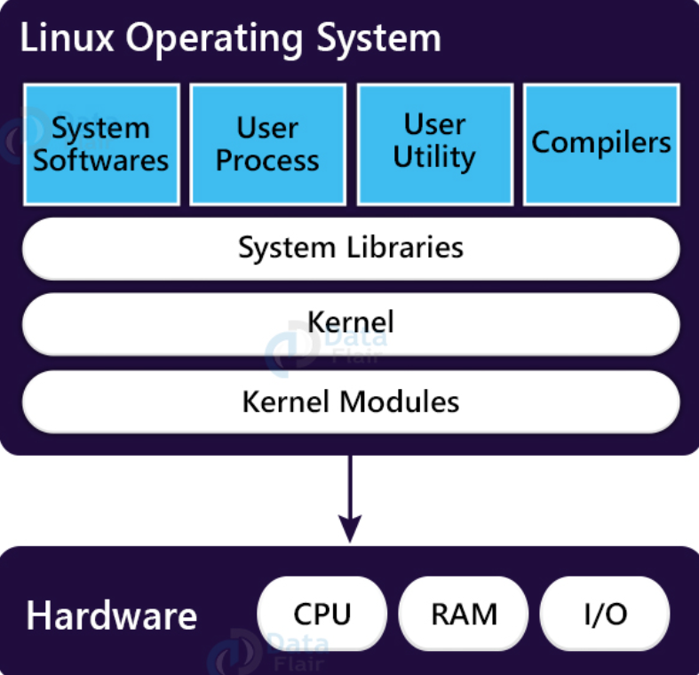

Kernel: it is core of the OS, interacts directly with hardware. Like acts as bridge b/w the h/w and s/w.

shell: it provides interface b/w user and kernel, basically takes user commands and passes them to kernel.  
  
System libraries: pre written code/programs that can use to perform various task like I/O, memory management.  
  
System utilities: basic tools program that can helps to perform task like : ls , mv , cp.  
  
Hardware: physical components of the computer.  
  
**Task 7:**

Is it legal to edit Kernal ? when do you think we have to in case?  
yes we can , when adding new drivers , to remove unused features and speed up the system.

**Task  8:**

What is LILO? Explain

Lilo is stands for Linux Loader. It is basically boot loader used in older linux system to start the operating system.  
  
**Task 9:**

What is shell? How many shells are there and what are they ? can you explain.

shell is program that helps provide user interface for intercating with the operating system. It responsible for collecting input from the user and execute the task/ program.  
 (bourn shell) sh - original unix shell, known for speed and simplicity

Bash - most commonly used for scripting   
 c shell Csh - it is more user friendly for programmer because it similar to C program  
Z shell Zsh - it is more powerfull, lot of new features and plugins.  
k shell Ksh - it is basically korn shell , it has features that components of bash and C shell.  
  
  
**Task 10:**

What is swap space?  
in linux portion of hard disk used as virtual memory when RAM is full to prevent the system from crashing.  
  
**Task 11:**

What is Mount ? how do you mount and unmount file system in Linux?  
  
it is command used to make storage device accessible at specific location in directory tree.  
we can use unmount command to detaches file system from the directory tree.it helps to prevent data loss.  
  
**Task 12:**

What is chmod command ? how to use it?  
chmod command is used to change file or directory permissions modes like read(r) , write(w) , execute(x) a file.  
using chmod command we can change permission   
ex: chmod u+x file.txt # it will give permission to the user  
 chmod g-w file.txt # it will remove permission from the group   
  
we can check permissions here like using below command  
command: ls -l

**Task 13:**

Can you add a new user account? Crate a new user in different ways and paste ss  
creating the user: sudo adduser username  
giving priviliges to new user: sudo usermod -aG sudo username  
switch user: su - username

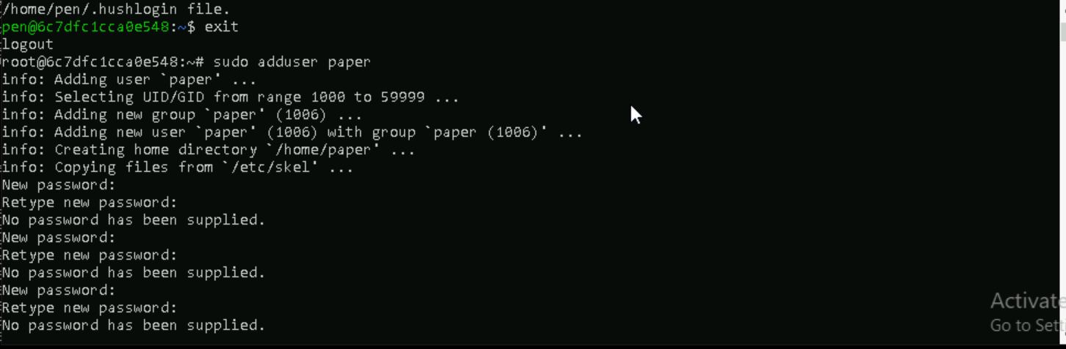

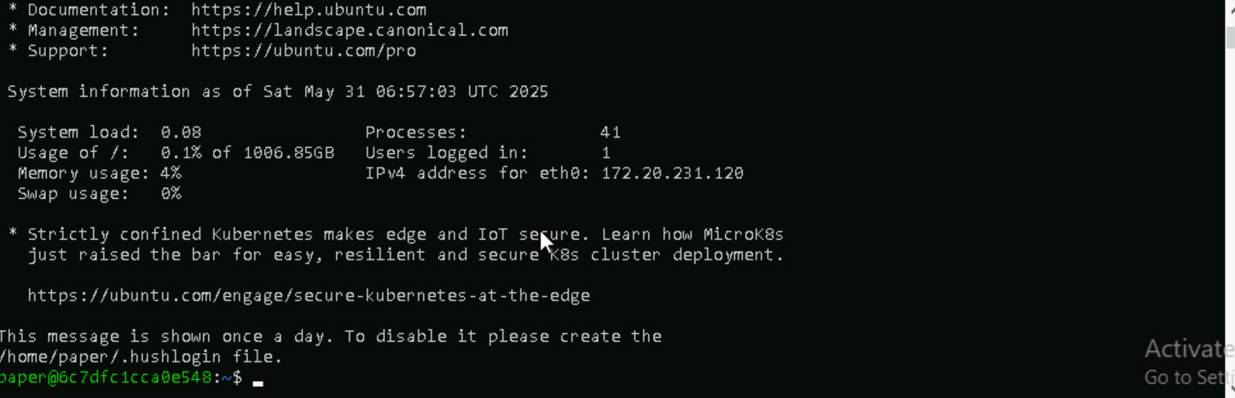

**Task 14:**

Can you change the password of a user?

How do you do that? Plz share ss

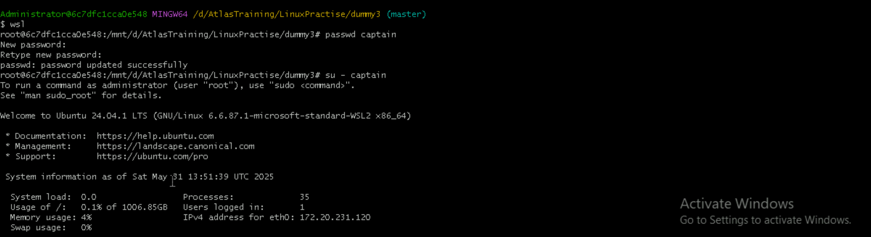

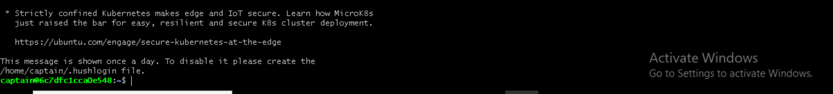

**Task 15:**

What is diff between Process and Thread?

Process Thread  
independent program in execution with own memory multiple threads run inside a single process  
has its own memory shared memory with other threads in the same process

It is slower it is fast

One is crashing don’t affect others one thread crash it affects whole process

**Task 16:**

Doc 14 Linux Grep commands in docs to study folder. # grep -i “word” filename it will give the all lines which contains word is present   
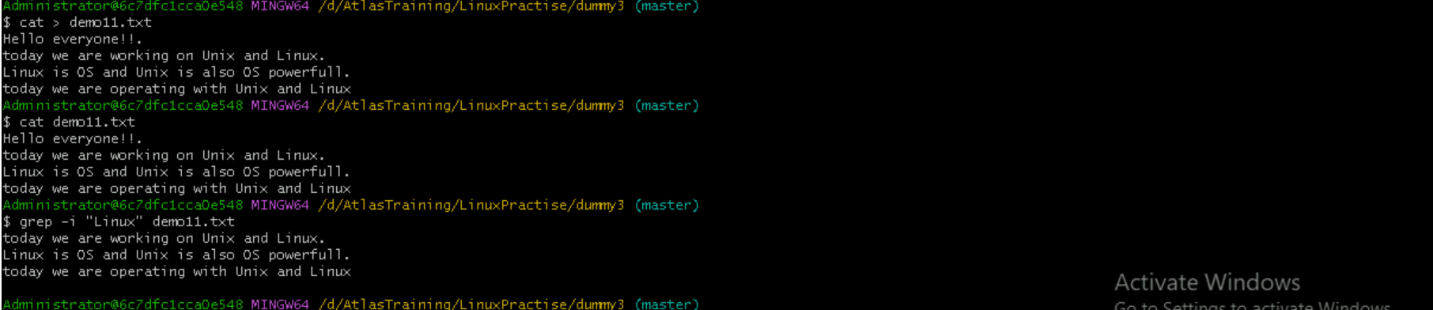

grep -c “word” file name filename it is case sensitive and it will give output how many matching words present.



grep -l “Unix” file name it will give all the files name which includes word Unix



grep -w “Linux” filename



grep -o “word” filename

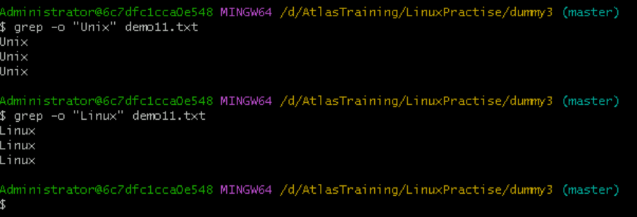

grep -n “word” filename



grep -v “word” filename It will give the lines which is not word presented



grep “^Linux” filename  
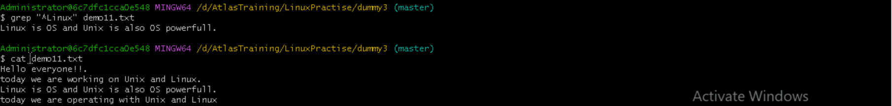

grep “Linux$” filename

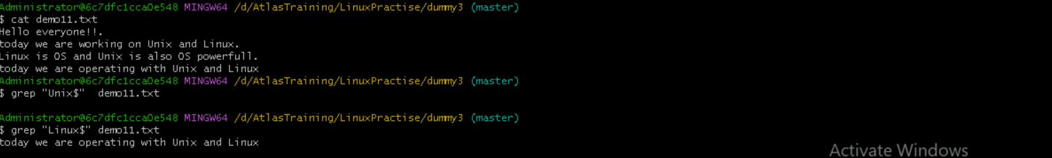

grep -e “Linux” -e “linux” -e “lionx” filename

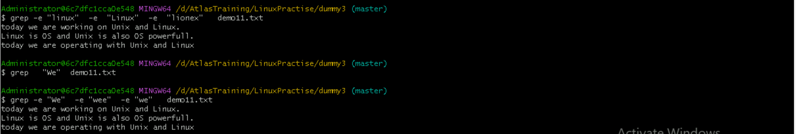rep -f filename filename

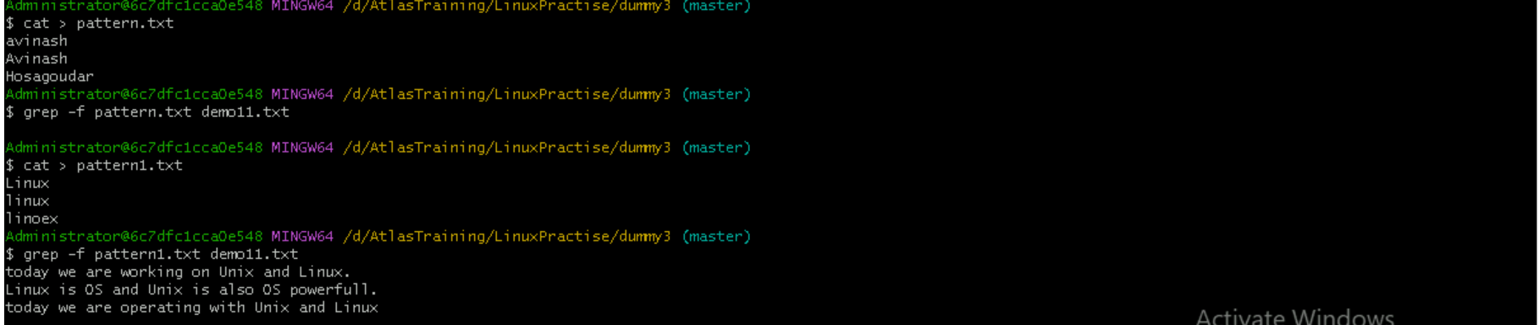

grep -A1 Unix demo11.txt

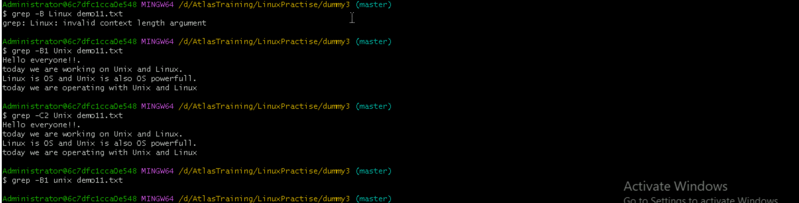

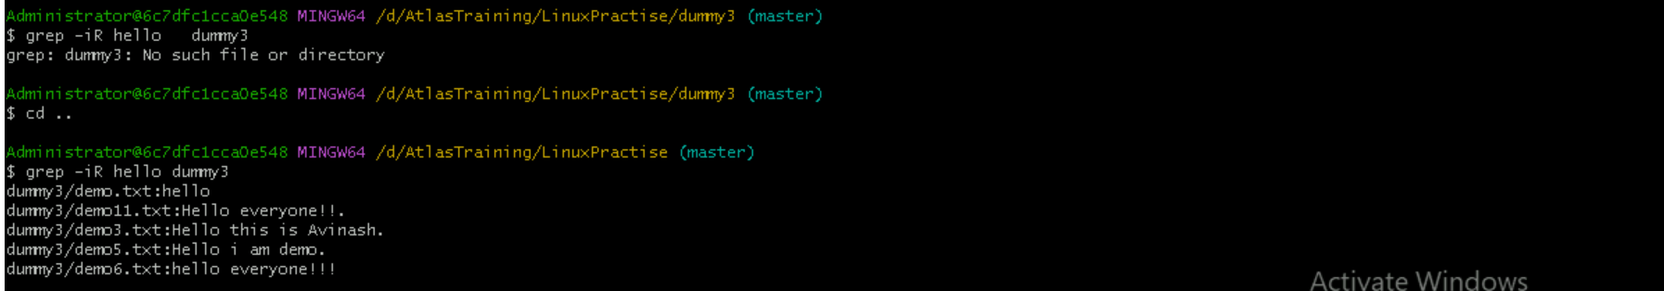



**Task 17:**

**Awk:**

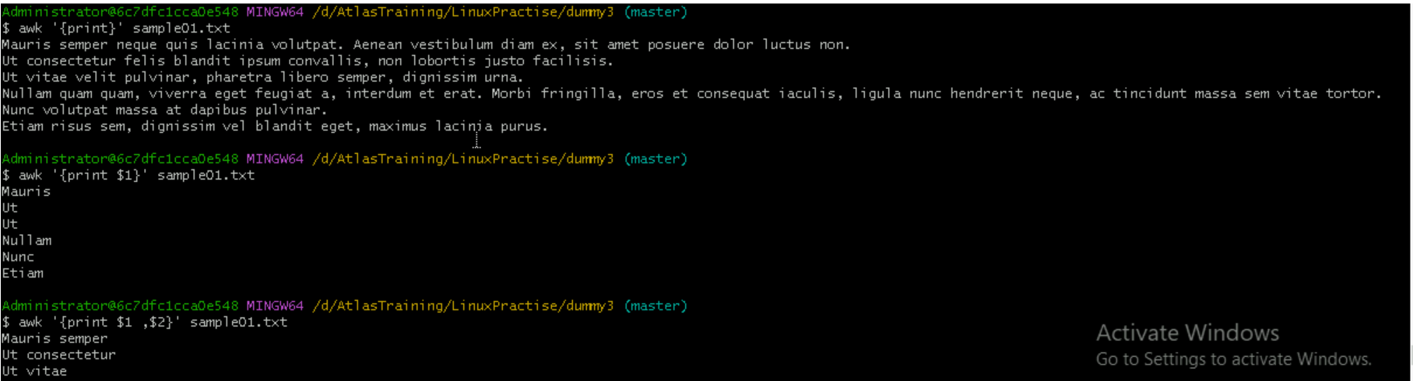

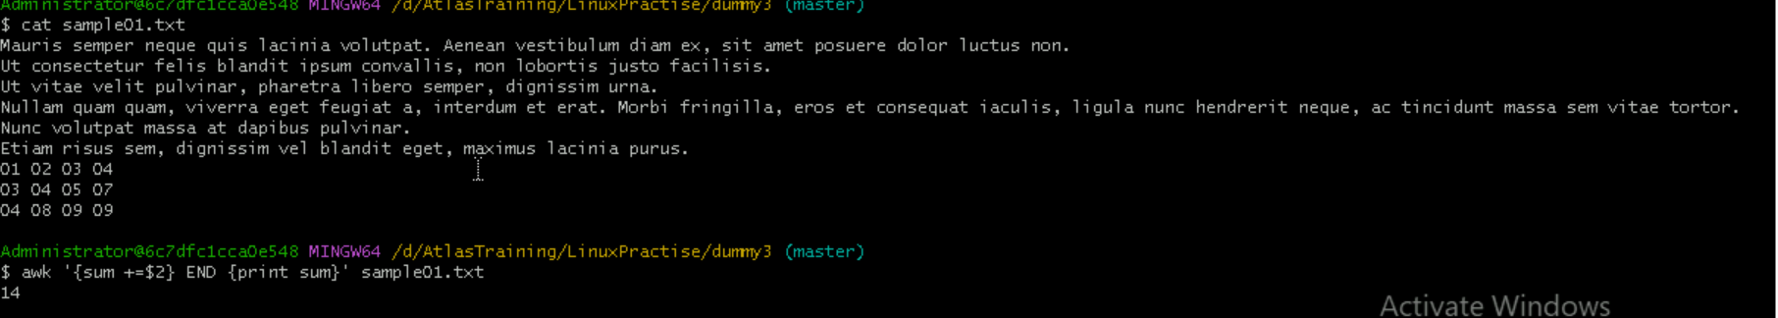



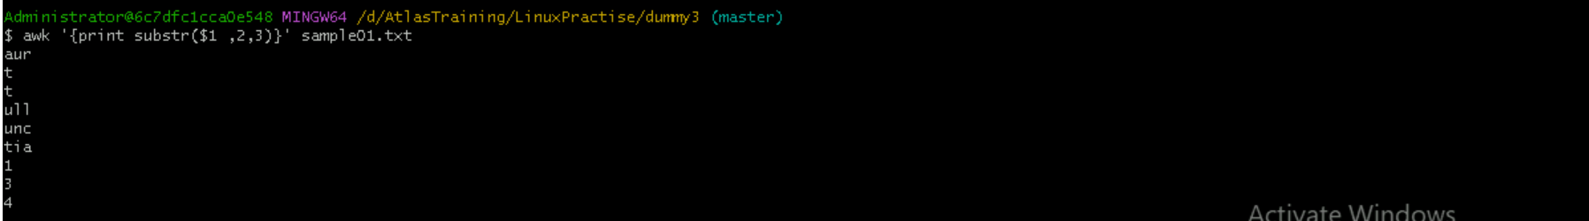

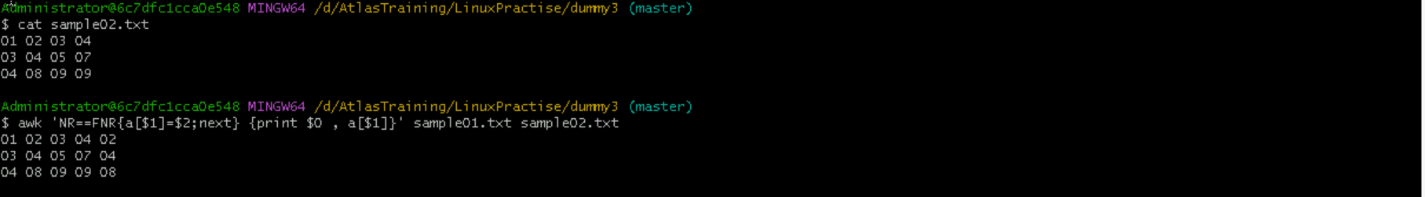



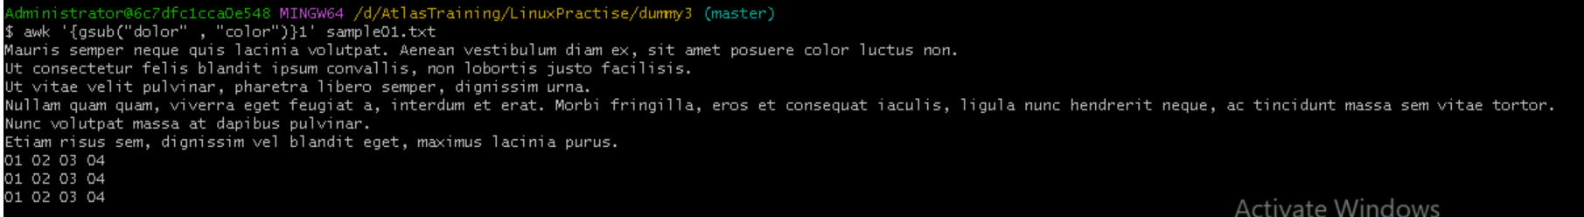

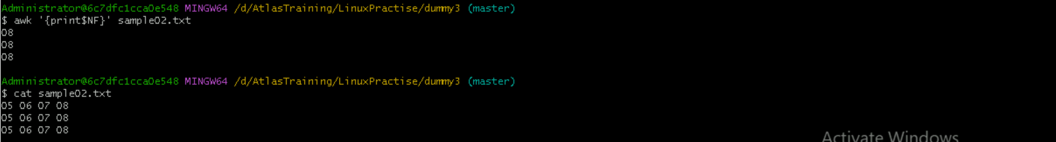



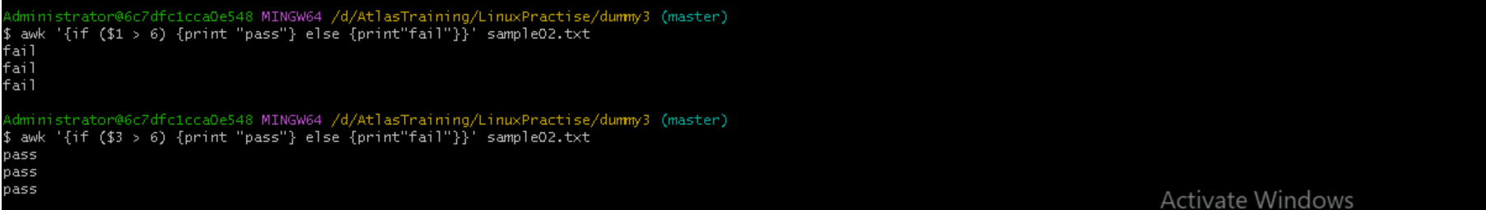

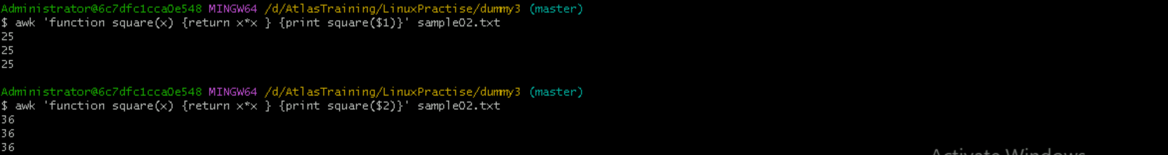

**Task 18:**

How to check file access permission in Linux?

Hint use:

 Ls -l

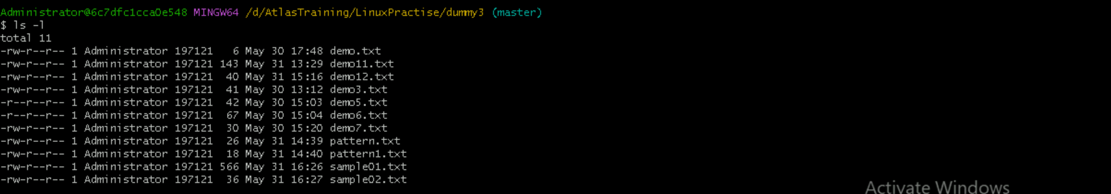

**Task 19:**

What are the default permissions for a new file ?

Plz find out for

Owner   → rw- (read &write)

Group → r—(read only)

All and others → r—(read only)

**Task 20:**

What is the command to change the permisssion to read only for the owner, group and all other users

HInt: chmod 444 filename

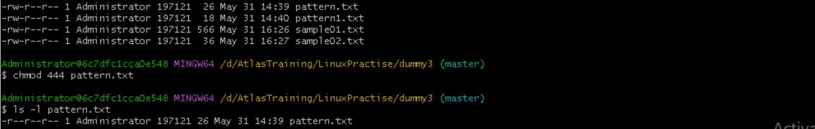

Symbolic links:

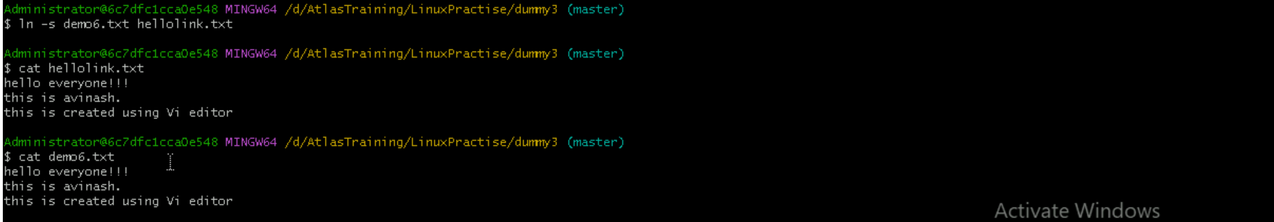

**Task 21:**

Can you change the file permissions to match the following:

* owner: Read and Write
* group: Read

other: no permissions (None)

**Task 22:**

What was the command for changing the file permissions to -rw-r-----?

Hint : use chmod 640 filename # we can’t remove read permission



**Task 23 and 24**

Change chmod.exercises permissions to -rwxr-x--x

Change the file permissions to match the following:

owner: Read, Write and Execute

group: Read and Execute

other: Execute  
What was the command for changing the file permissions to -rwxr-x--x

Hint : use chmod 751 filename



**Task 25:**

Guys what will this command do?

chown -c master file1.txt

it will change the owner and or group of a file or directory  
  
**Task 26:**

Can you define what is  a process  
A process is an instance of a program that is currently in memory.  
  
**Task 27:**

What is command to check foreground process and background process

Background process: jobs , bg %[job_id]  
foreground Process: fg %[job_id] , command &

**Task 28:**

Can you list all the running processes?

Hint use ps



**Task 29:**

What will ps -f command do ? plz try n check .. ss required.  
it shows running processes



**Task 30:**  
  
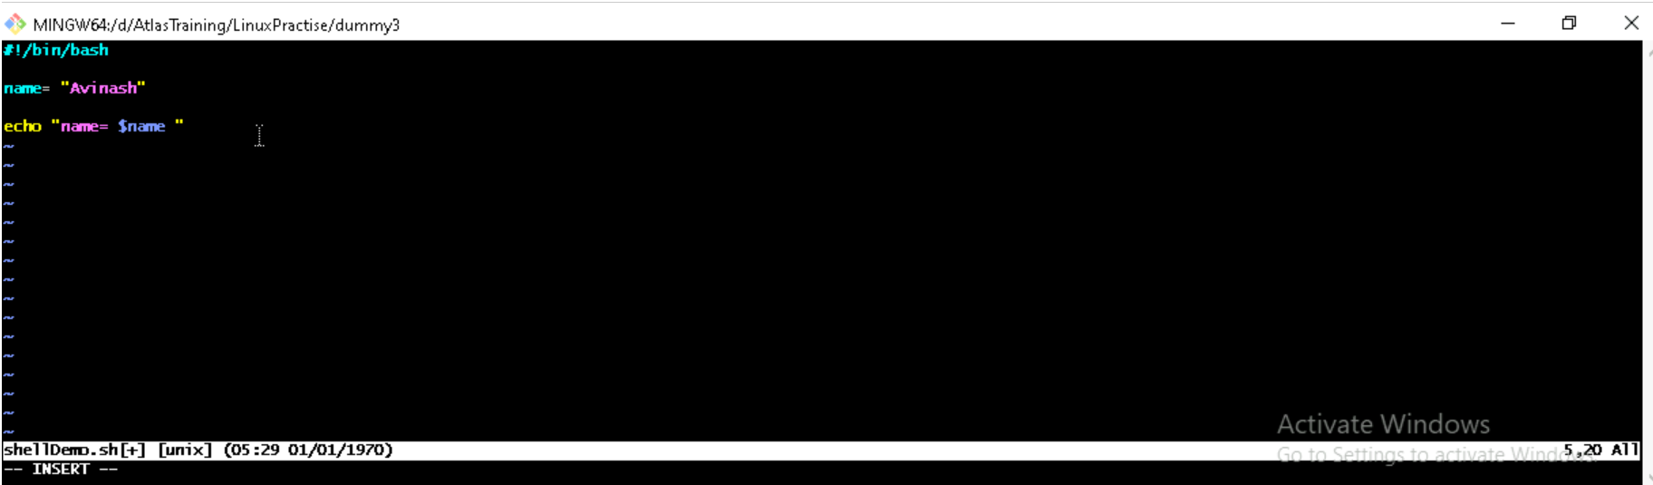



**Task 31 and 32:**

Now will unset or delete the variables  
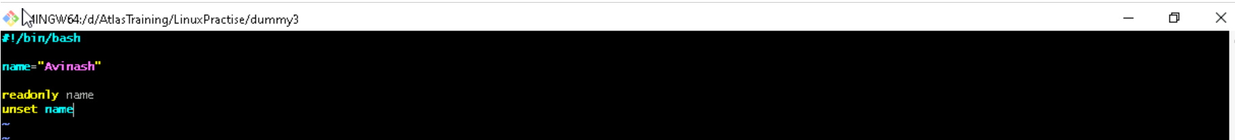



**Task 33 &34:**

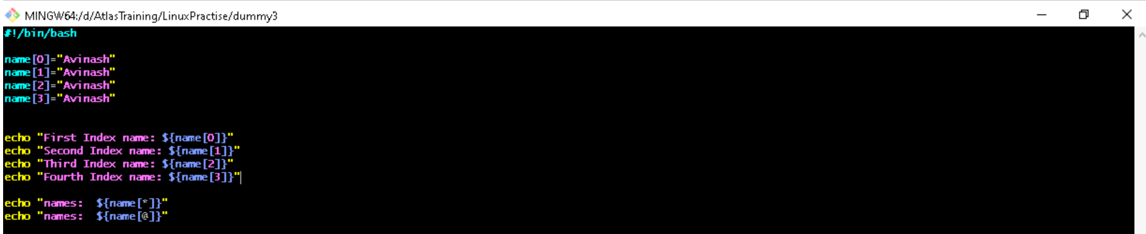

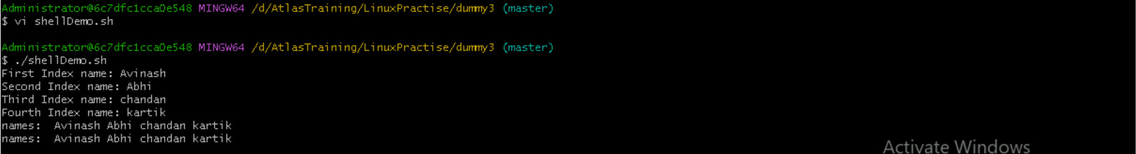

**Task 35:**

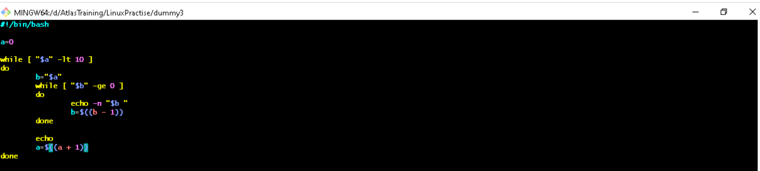

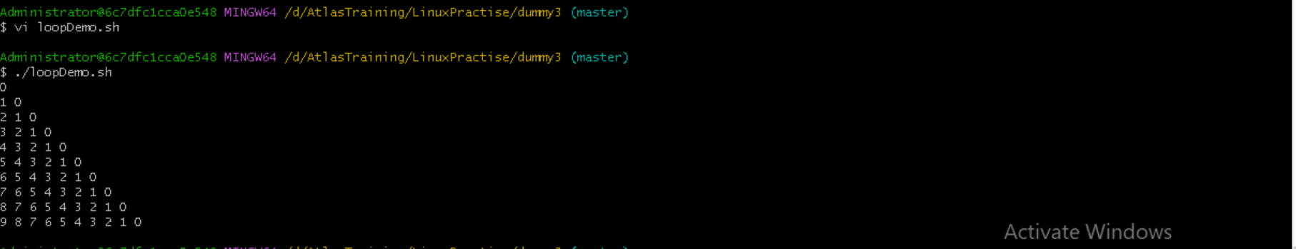

**Thank You**