JAVA:  
  
studied about compiler, variable, datatypes(primitive &non primitive) , method, static  
  
  
tried C language for checking static keyword how it works:

#include <stdio.h>  
void add() {  
    int x = 10;  
    static int y = 20;  
    x++;  
    y++;  
    printf("%d\n", x);  
    printf("%d\n", y);  
}

int main() {  
    add();  
    add();  
    add();  
    return 0;  
}  
  
o/p: 11   
 21  
 11  
 22  
 11  
 23

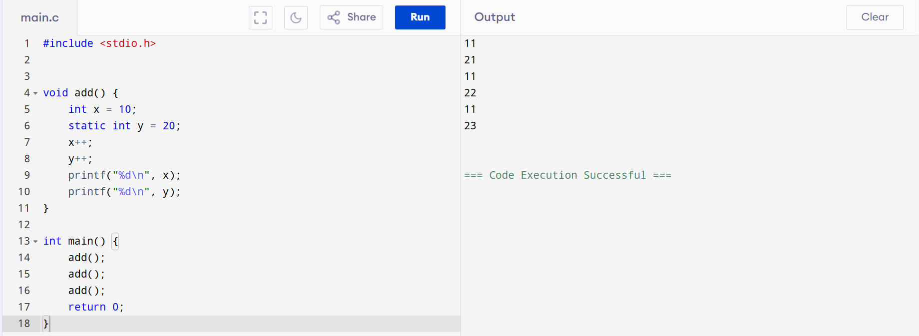

Task 001:

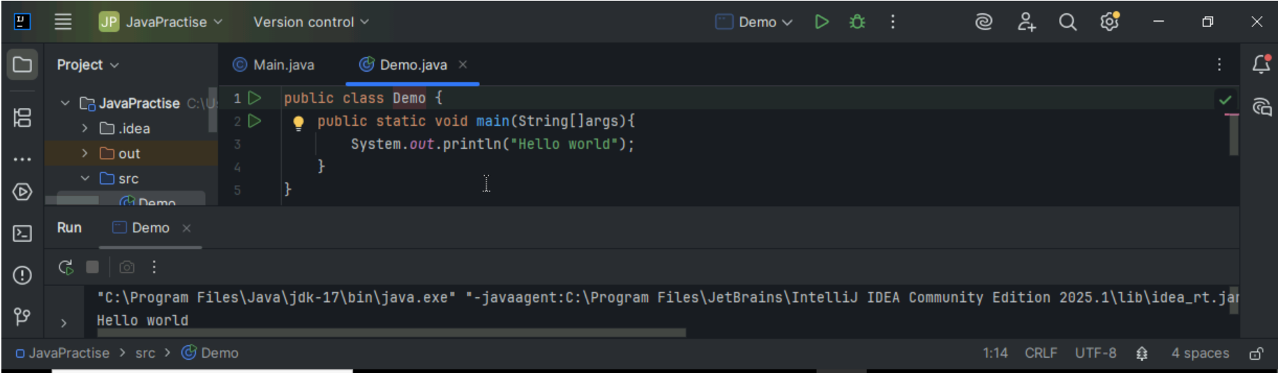

Task 002:

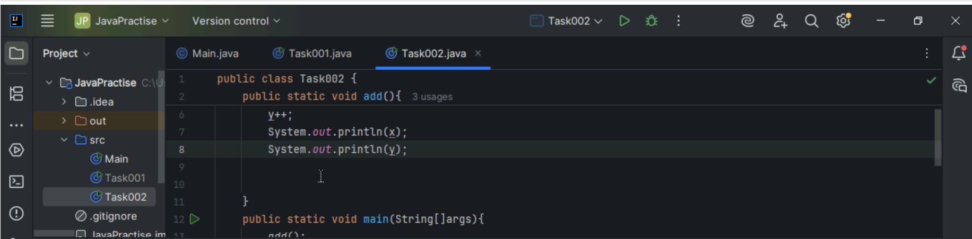

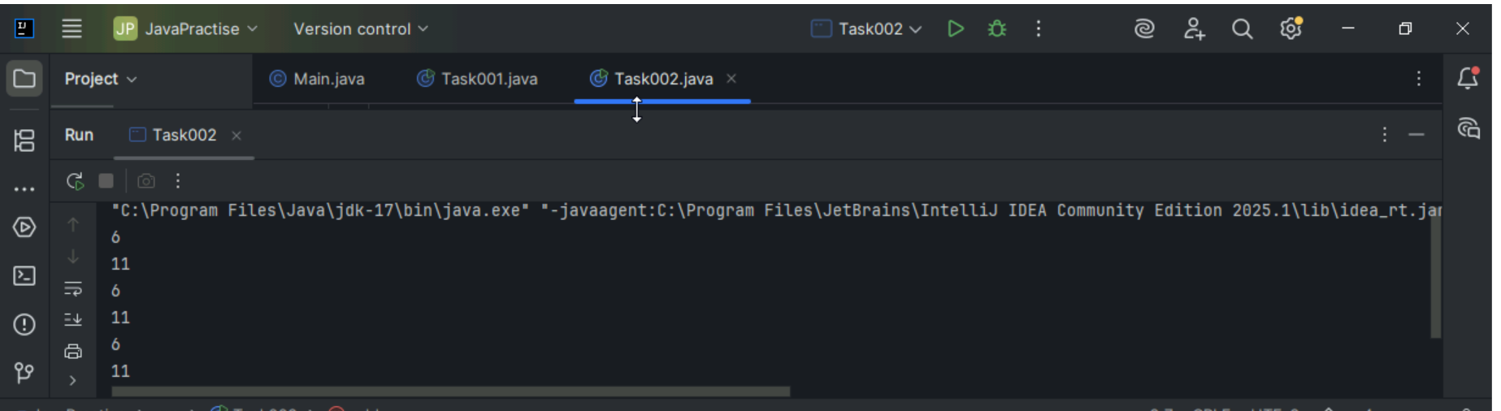

Task 003:

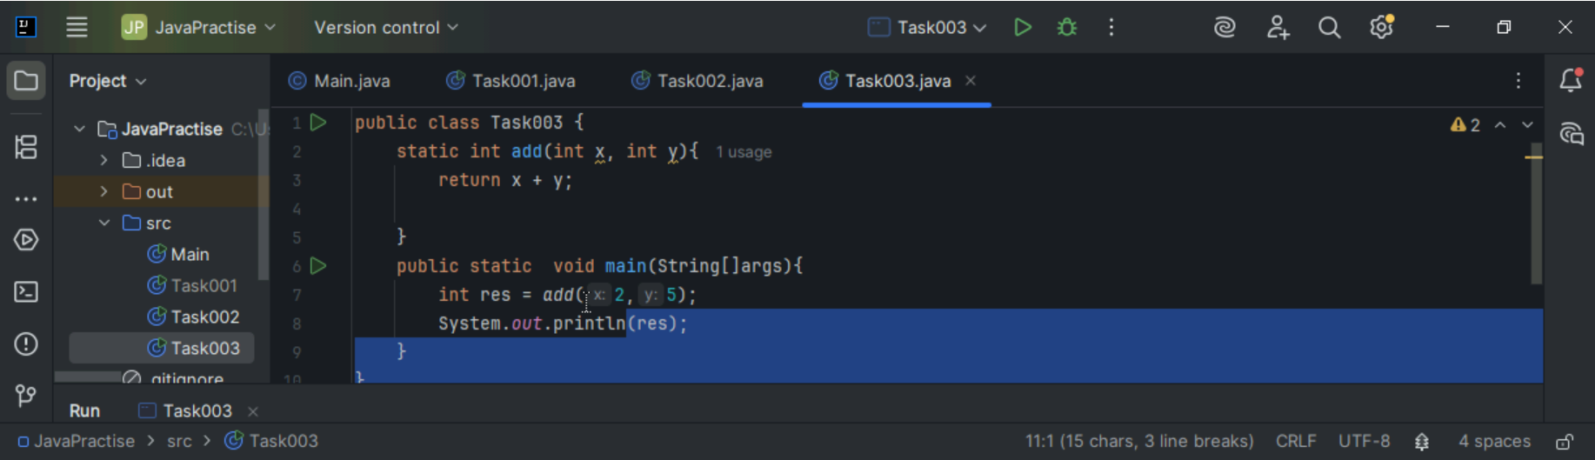



Task 004:

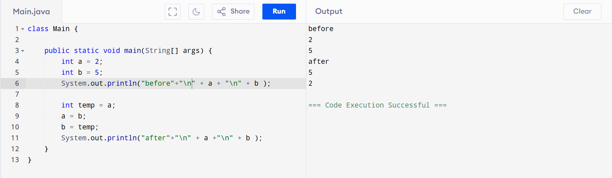

Task 005:

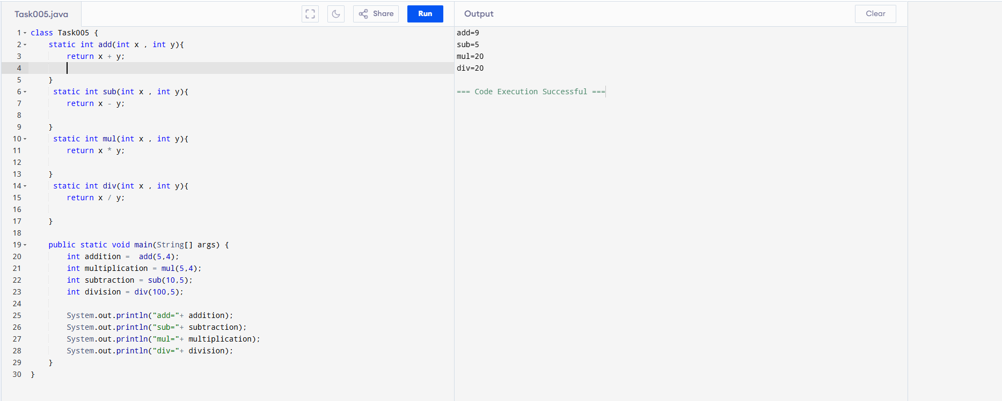

Task 006:

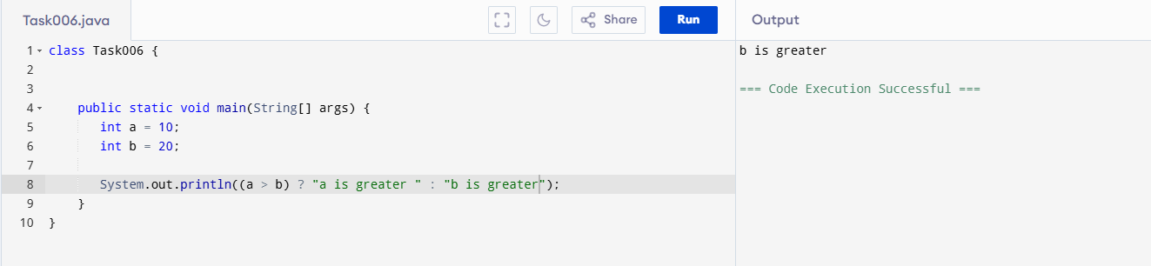

Task 007: Write a program to take input from the user and display it to the user

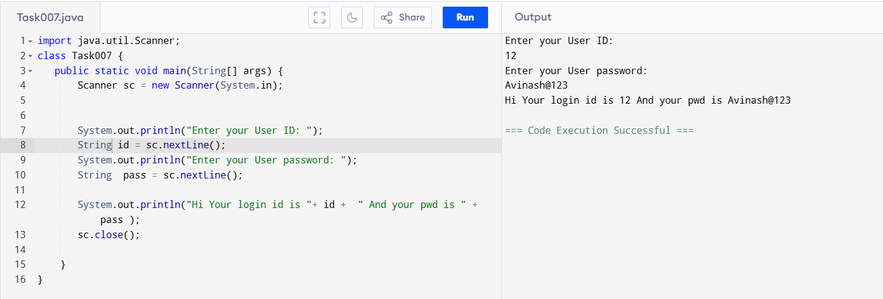

Task008: Write a program to create a class named Customer

Call the customer class in Task008 class using an object.

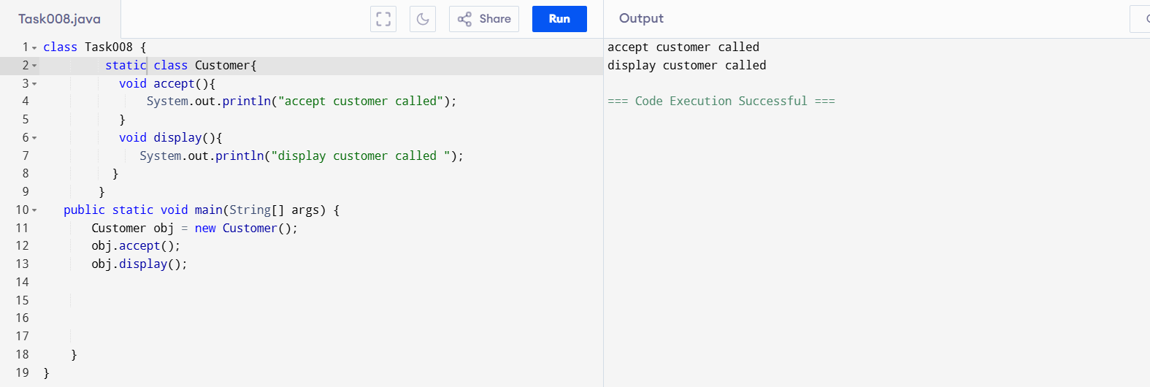

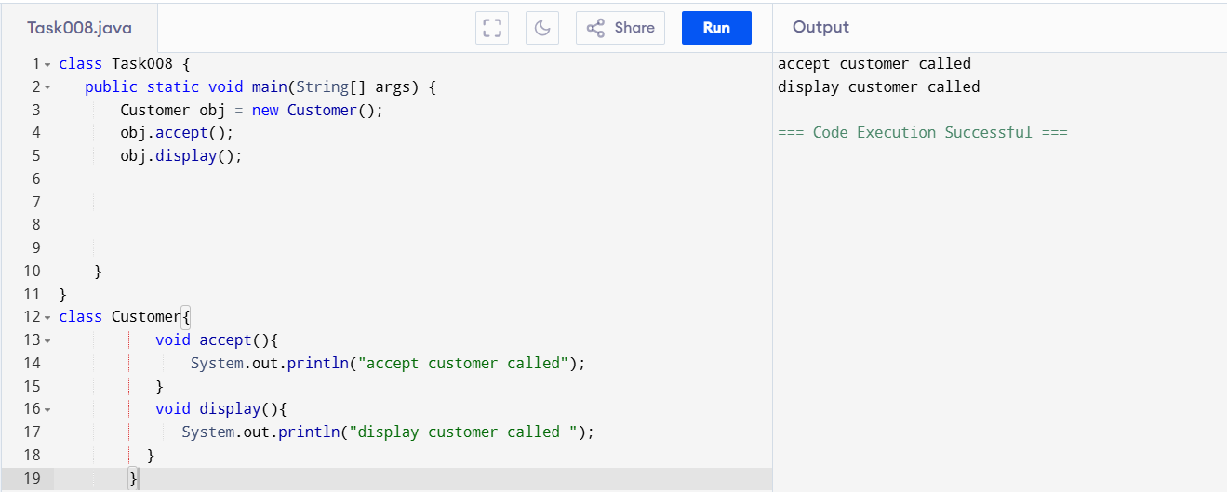

Task009:

Wap to check the greater of 2 numbers  
  
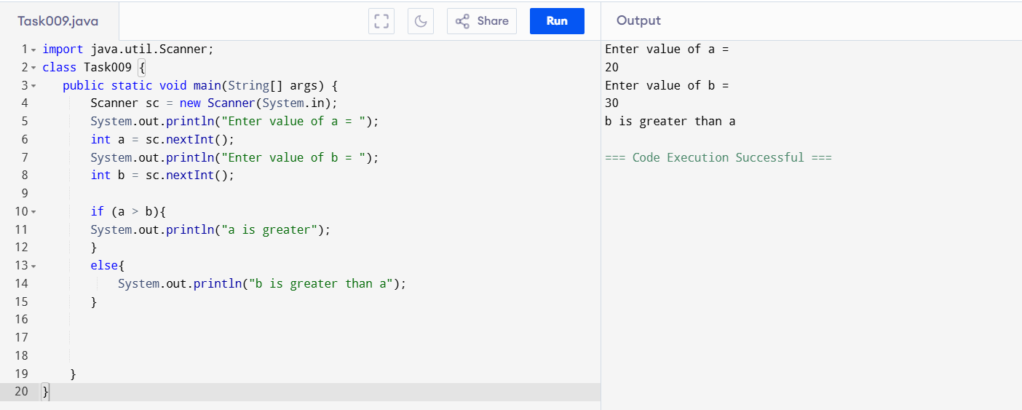

Task 0010: Wap to check greater of 3 numbers 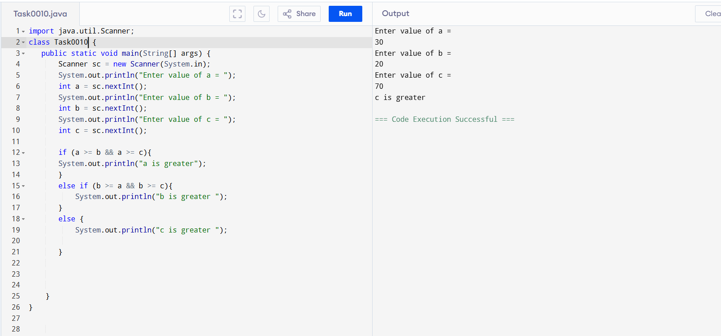

Task11:

Wap to check if  week days

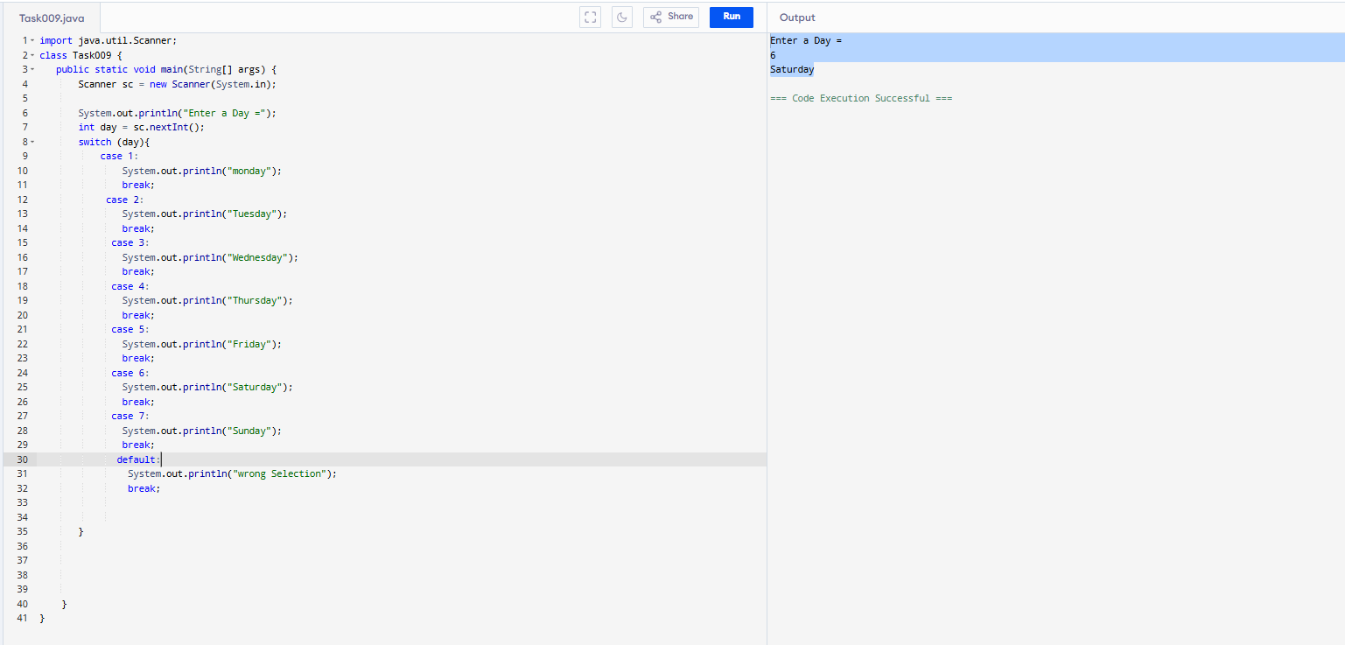

Task 012: while loop

Wap to check loginid and password validation

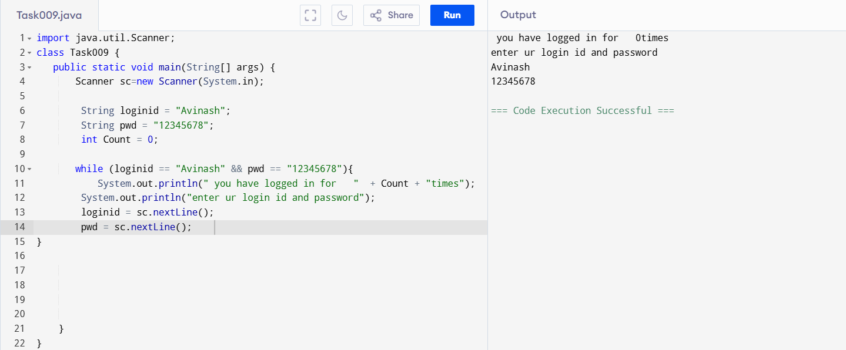

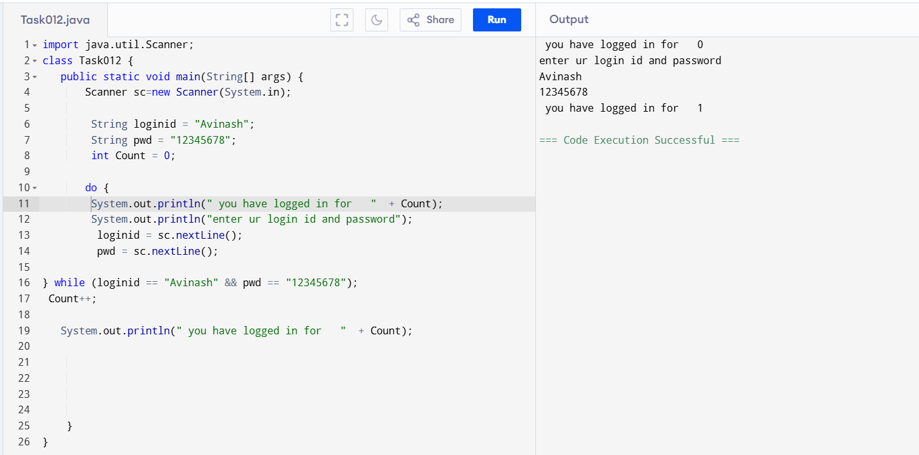

Task 13:

Wap to display numbers from 10 to 1 .. skip 7 and 5.

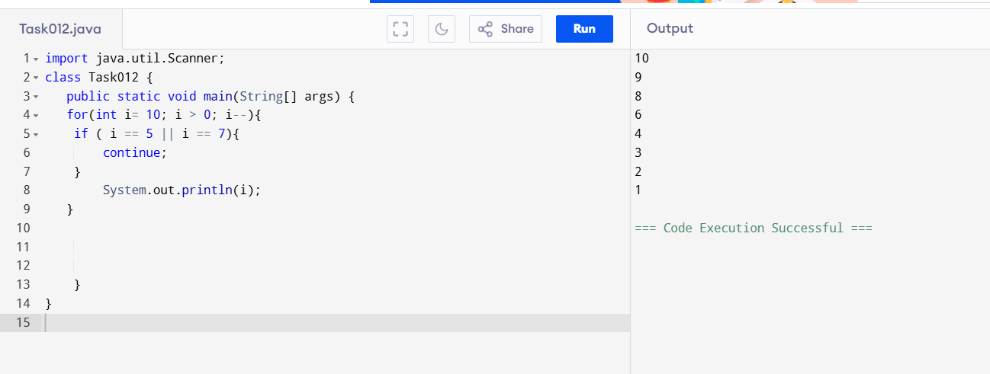

Task 014:

Arrays:

Try the below code and display the output…

Now play with it try to access arr of 5th index and see the output…and try to access arr of -1 index and see the output..

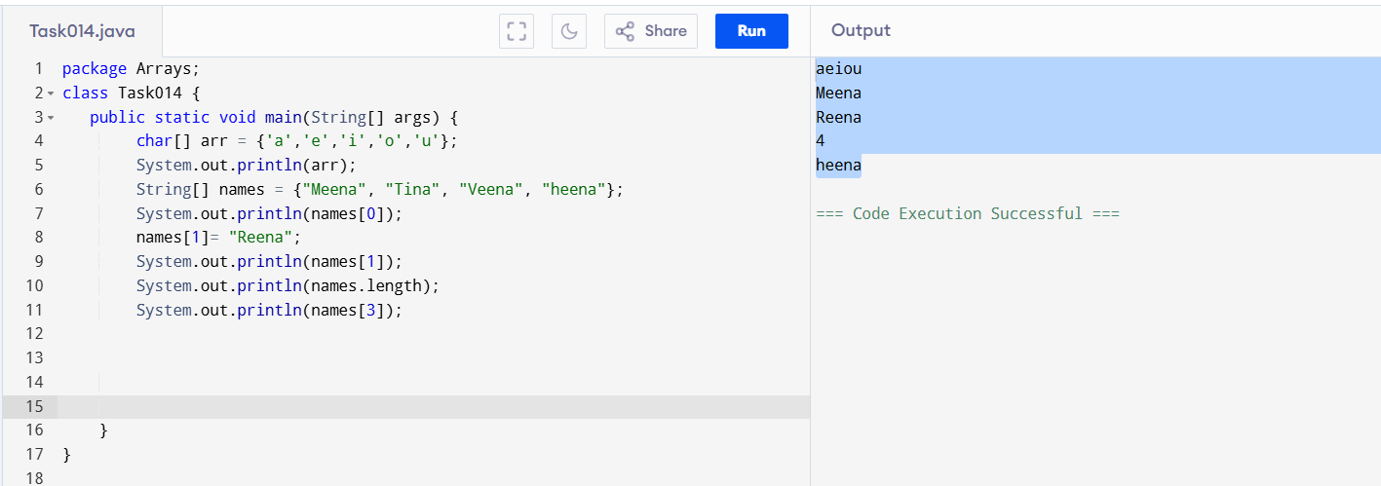  
  
Strings:

Task 015:

String – non primitive data gtype —> collection of characters or any value within “ ”

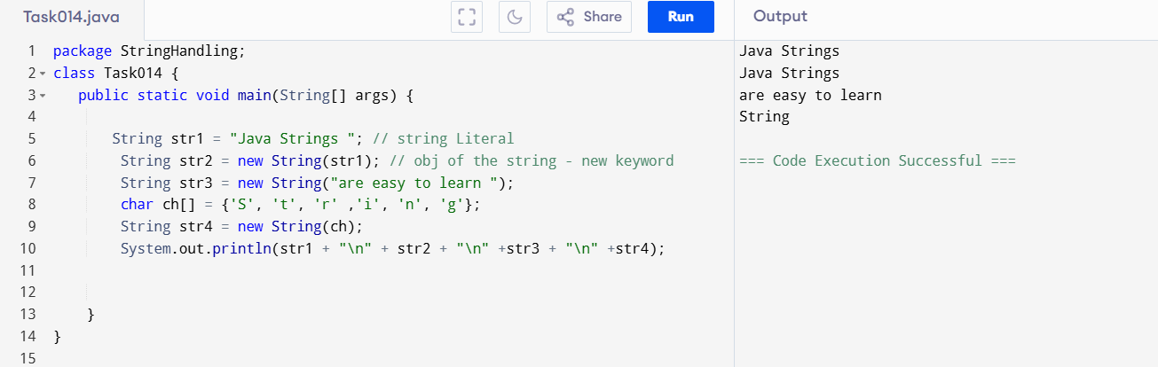

Task16: ENumeration

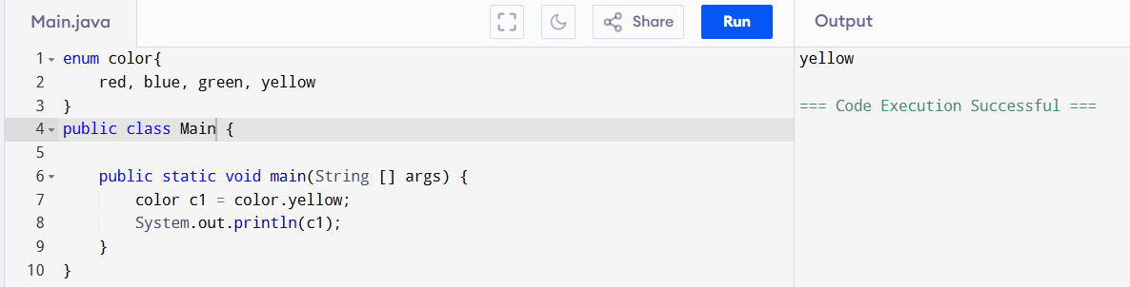

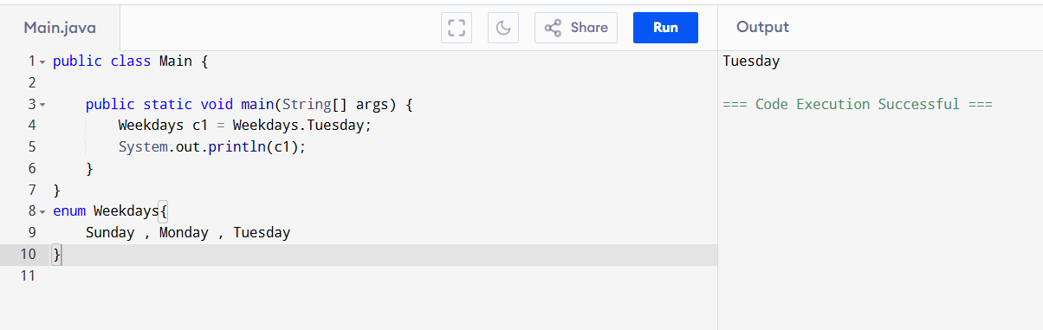

Task 017:

Getter and setter

We cannot access the name from the person.java due to name filed is declared as **private**

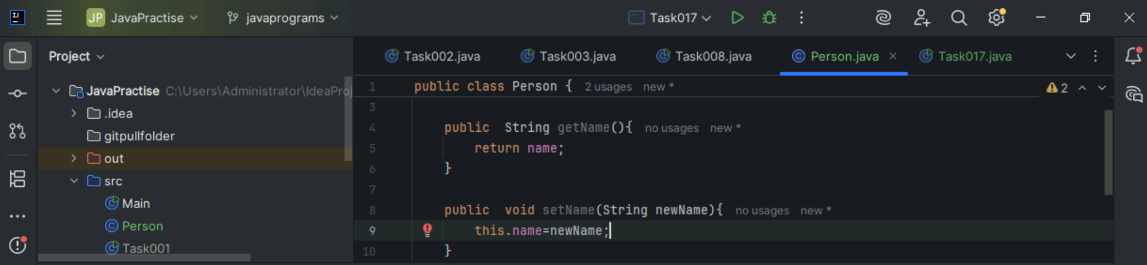  
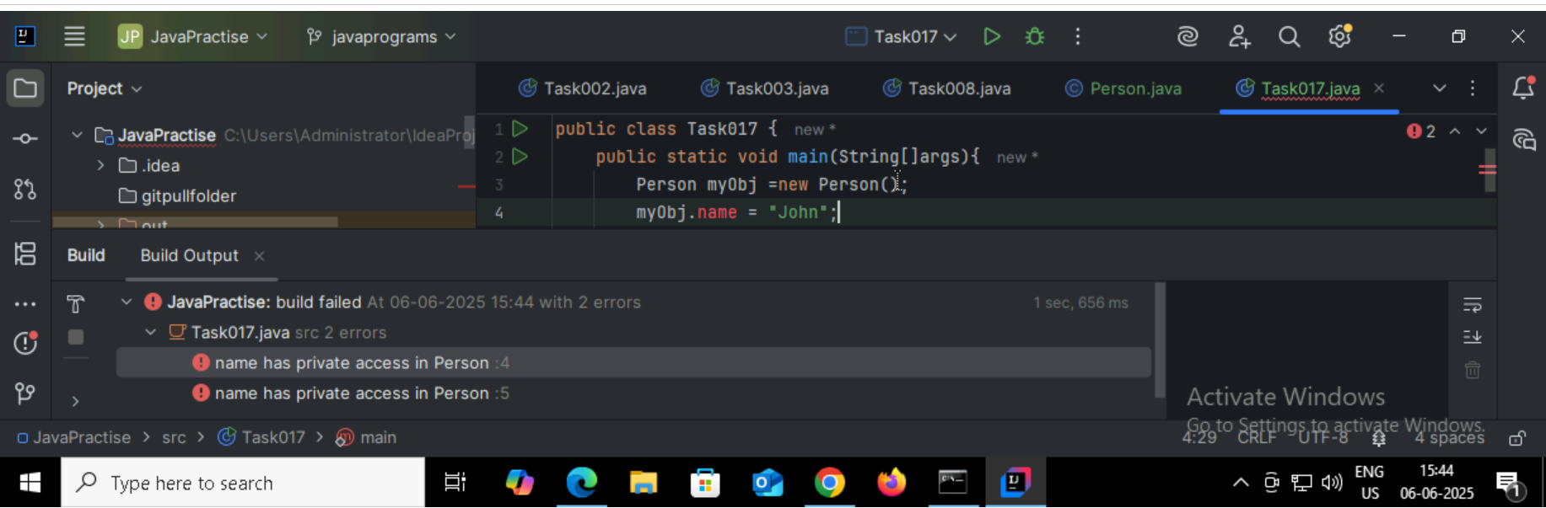

Task 018

Now create one more program named Task018.java

O/p: Avii  
using getter and setter we can access the variables

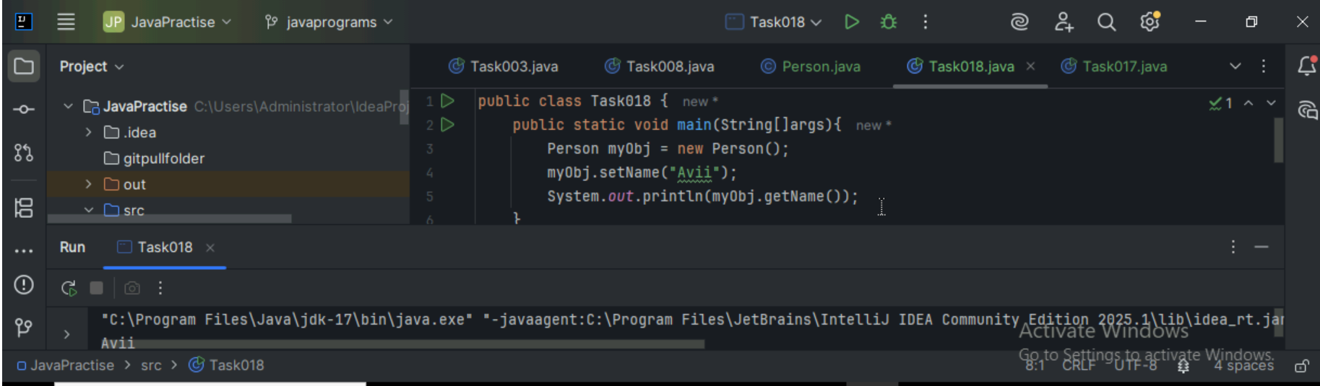

Task:20  
Shallowcopy – it will affect the original one  
deepcopy – it will copy / clone the original one so it wont affect original

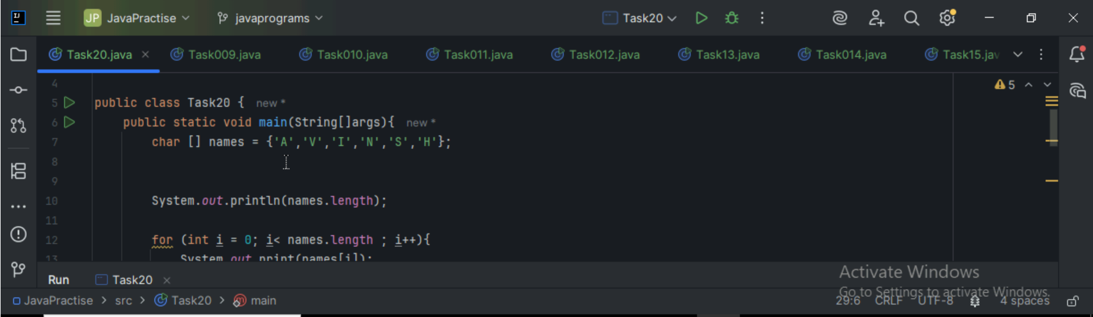

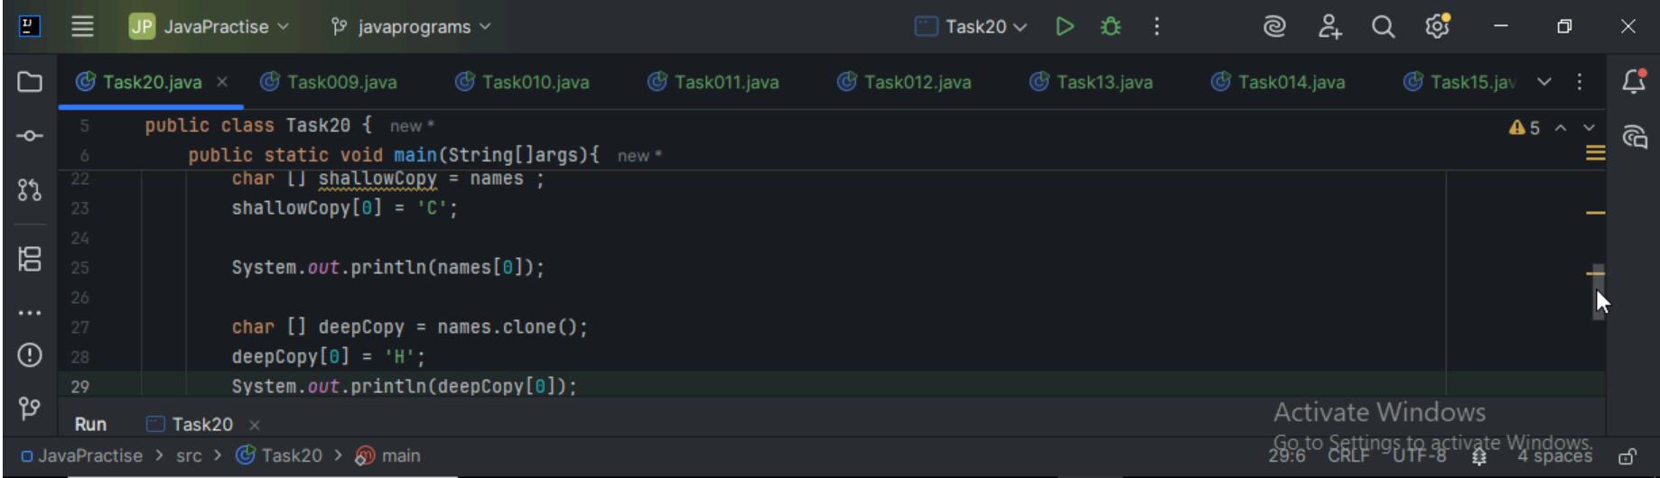



Task 19:

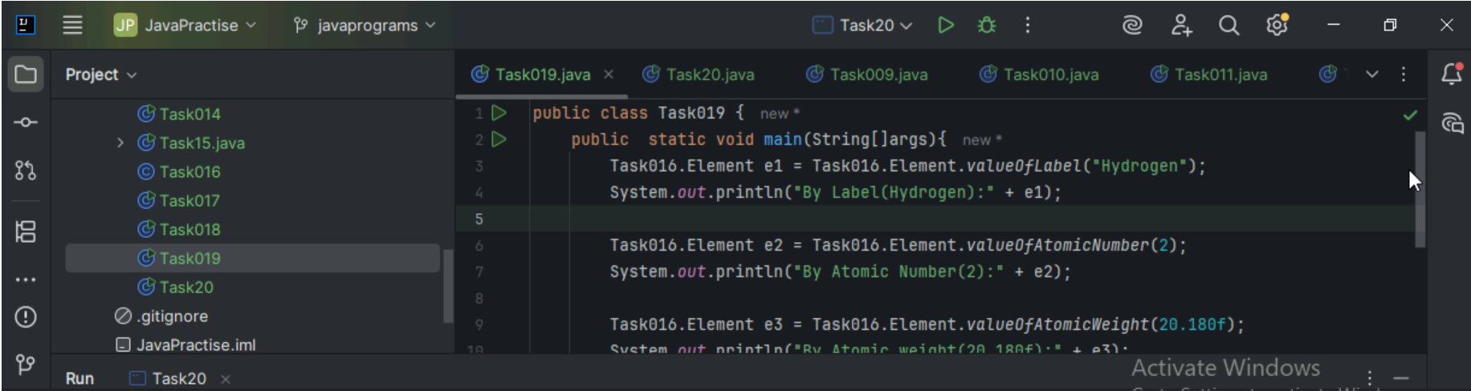

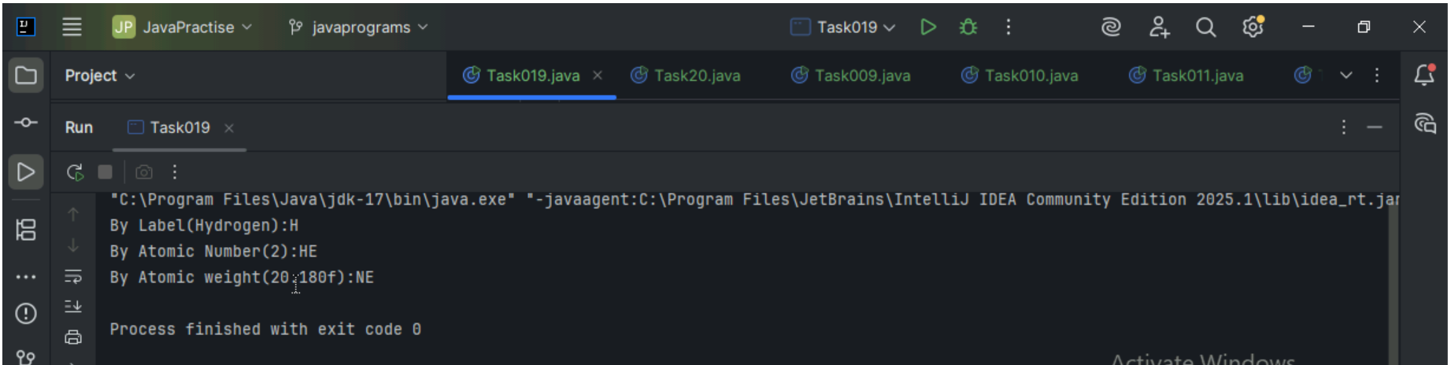

Thank You---