**Jenkins**

Setting up server:

**Step 1:** Download the Jenkins WAR File.

Link: <https://jenkins.io/download/>

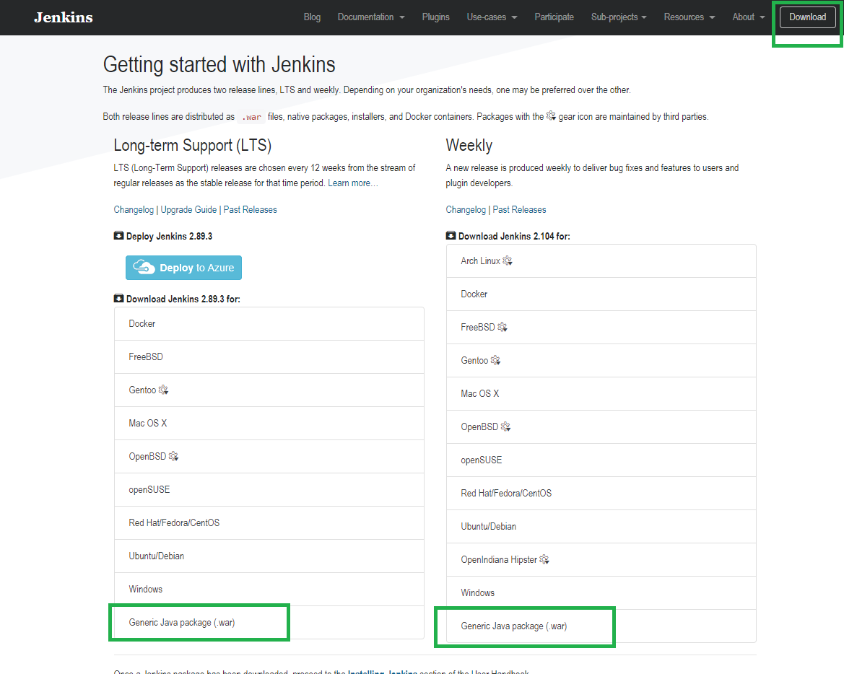

**Step 2:** Open a Command Prompt (CMD or Terminal) from the directory(folder) where the file got downloaded and run the below command.

java -jar jenkins.war

or you can specify your port

java -jar jenkins.war --httpPort=8080

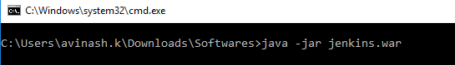

Step 3: Open the browser tab and run the browse to below URL,

<http://localhost:8080>

(Port number according to your input default it will be 8080).

**Step 3:**

Configure Jenkins by creating an admin account, provide username and password.

**Step 4:**

Once you create an account, login into Jenkins.

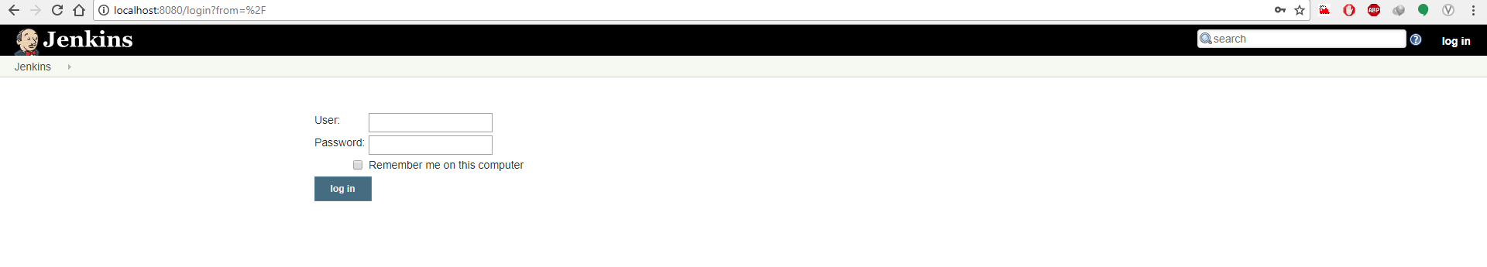

**Step 5:** Create new item.

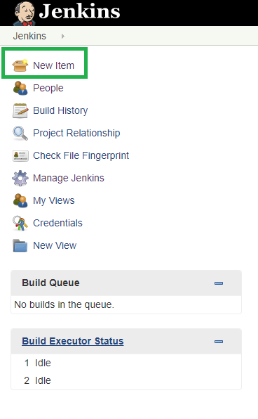

**Step 6:** Enter the project name & select free style project.

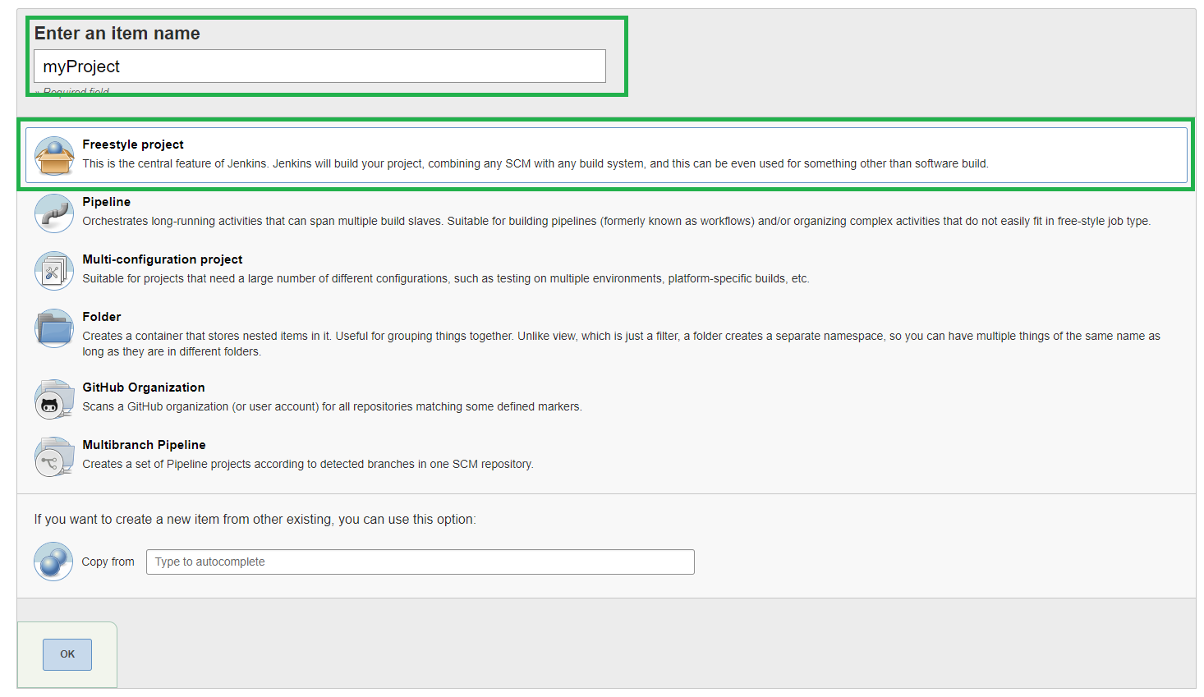

**Step 7:** Configure your repository from where you must take checkout of your code.

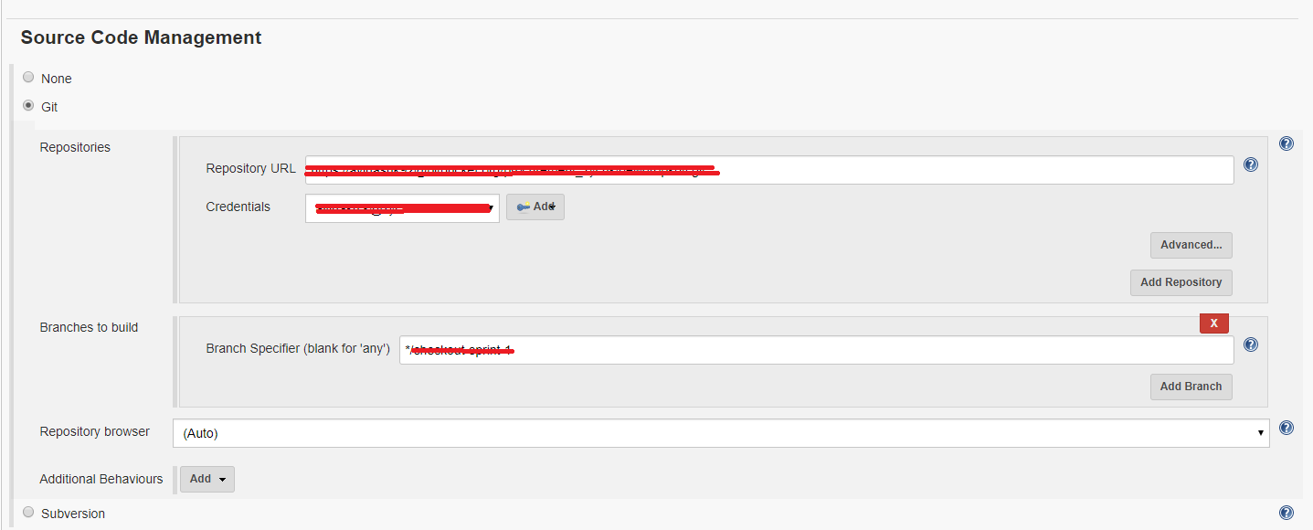

**Step 8:** Add build commands as windows batch command. Here execute npm command and run the server.

