NAME : K.Avinash
REG NO: (192412662)
COURSE NAME : 5G 6G COMMUNICTION (ECA5601)
DATE : 13/08/2026

EX NO: 15 | AI-based Traffic Prediction for 5G Networks

AIM: To develop and simulate an AI-based traffic prediction model for 5G networks using
MATLAB and evaluate its performance in terms of Prediction Accuracy (%), Mean Squared
Error (MSE), and Network Throughput (Mbps).
Procedure:
- Generate or import a dataset representing actual 5G network traffic over different time intervals.
- Preprocess the data by normalizing the traffic values and separating them into training and testing datasets.
- Develop a simple AI-based prediction model (e.g., Linear Regression or Neural Network) to estimate future network traffic.
- Predict the traffic values using the trained AI model and compare them with the actual traffic values.
- Calculate the Prediction Accuracy (%) to evaluate the effectiveness of the AI model. 6. Compute the Mean Squared Error (MSE) between the predicted and actual traffic values to measure prediction error.
- Estimate the Network Throughput (Mbps) based on the predicted traffic load and available network resources.
- Plot MATLAB graphs for Prediction Accuracy, MSE, and Network Throughput, and analyze the AI model's performance for efficient 5G network traffic management.

Objective 1 Matlab Code and Output: clc; clear; close all;
% Time samples
t = 1:10;
% Prediction Accuracy (%)
Accuracy = [90 91 92 93 94 95 96 97 98 99];

% Actual Network Traffic (Mbps) Traffic = [45 50 55 60 65 70 75 80 85 90]; figure
% -------- Graph 1 -------- subplot(2,1,1) plot(t,Accuracy,'-o','LineWidth',2) title('AI Prediction Accuracy over Time') xlabel('Time Interval') ylabel('Prediction Accuracy (%)') grid on
% -------- Graph 2 -------- subplot(2,1,2) bar(Traffic) title('Network Traffic Samples Used for AI Prediction') xlabel('Traffic Sample') ylabel('Traffic (Mbps)') grid on

OUTPUT:

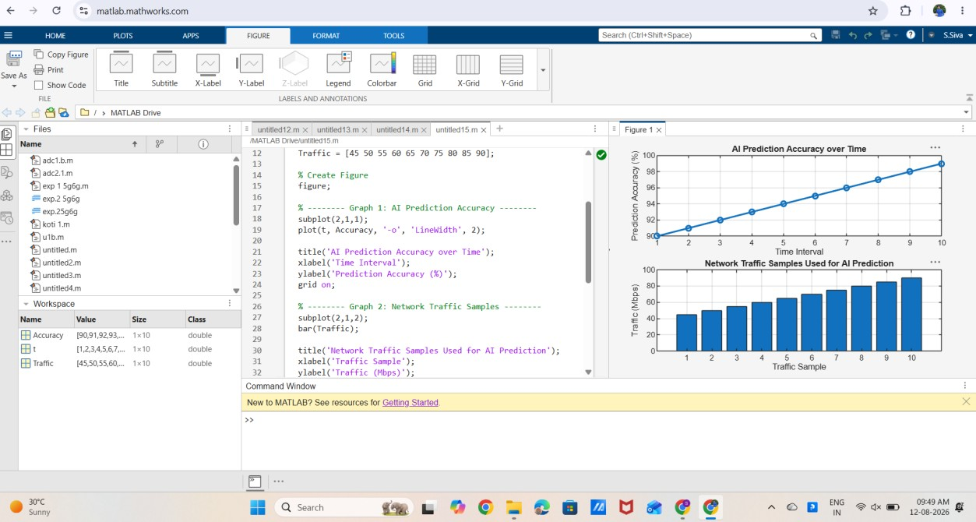

Result:

- The first graph shows that the AI model achieves progressively higher prediction accuracy over successive time intervals.

- The second graph represents the network traffic samples used by the AI model, illustrating varying traffic loads in the 5G network.

