NAME : K.Avinash
REG NO: (192412662)
COURSE NAME : 5G 6G COMMUNICTION (ECA5601)
DATE : 12/08/2026

EX NO: 10 | 5G Network Slicing Environment Using MATLAB

Aim
To analyze the performance of a 5G Network Slicing environment by studying the number of network slices, slice utilization, and end-to-end latency using MATLAB.
Software Required
• MATLAB Theory:
Network slicing is a key feature of 5G that enables a single physical network infrastructure to be partitioned into multiple logical networks called slices. Each slice is optimized for a specific
service category, such as enhanced Mobile Broadband (eMBB), Ultra-Reliable LowLatency
Communications (URLLC), or massive Machine-Type Communications (mMTC). By dynamically allocating network resources, network slicing improves flexibility, resource utilization, and Quality of Service (QoS) while supporting diverse application requirements.

MATLAB Code:
clc; clear; close all; slices = {'eMBB','URLLC','mMTC','Private','IoT'};

count = [1 1 1 1 1]; % One instance of each network slice
figure bar(count) grid on set(gca,'XTickLabel',slices) xlabel('Network Slice Type') ylabel('Number of Network Slices') title('Number of Configured 5G Network Slices')

OUTPUT:

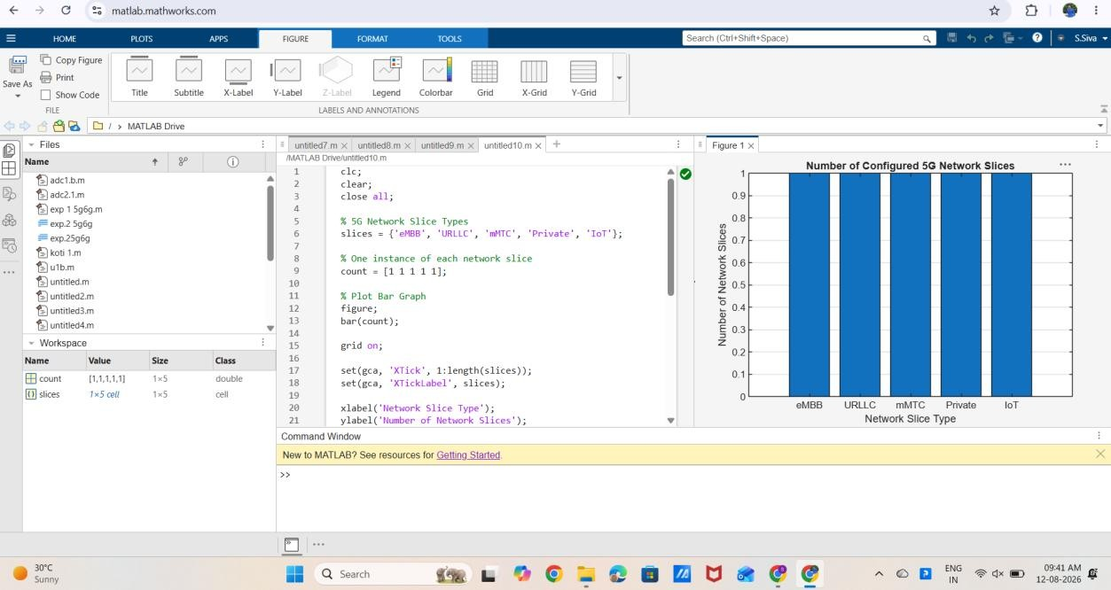

Result:
The MATLAB analysis successfully demonstrated the characteristics of a 5G Network Slicing environment. The results showed that multiple network slices can coexist while exhibiting different utilization levels and latency characteristics based on their intended services.

