NAME : K.Avinash
REG NO: (192412662)
COURSE NAME : 5G 6G COMMUNICTION (ECA5601)
DATE : 12/08/2026

EX NO: 11 | Implementation of IoT-based Smart Agriculture using MATLAB

AIM: To design and simulate an IoT-based smart agriculture system using MATLAB by monitoring soil moisture levels, controlling water pump status (ON/OFF), and evaluating irrigation efficiency for optimized water resource management.
Procedure:
- Define soil moisture range (0–100%) and set an irrigation threshold value (e.g., 40%).
- Generate or input soil moisture data to simulate field conditions.
- Compare soil moisture with the threshold value to determine pump status (ON if low moisture, OFF if sufficient moisture).
- Simulate water pumping action based on control logic.
- Calculate irrigation efficiency based on moisture improvement and water usage.
- Display soil moisture level, pump status, and efficiency results.
- Plot graphs to analyze soil moisture variation and irrigation performance.
- Evaluate system behavior for smart agriculture decision-making.
Objective 1 Matlab Code and Output: clc; clear; close all;
% Simulated soil moisture data (%) time = 1:10; soil_moisture = [30 35 28 25 20 18 22 30 40 45];
% Threshold for irrigation threshold = 40; figure
% -------- Graph 1: Soil Moisture Variation --------
subplot(2,1,1) plot(time, soil_moisture, '-o', 'LineWidth', 2) title('Soil Moisture Monitoring in IoT Smart Agriculture') xlabel('Time (Hours)') ylabel('Soil Moisture (%)')

grid on hold on yline(threshold,'r--','Threshold')
% -------- Graph 2: Moisture Status (Dry/Wet Level) -------- status = soil_moisture >= threshold; subplot(2,1,2) stem(time, status, 'filled', 'LineWidth', 2) title('Soil Condition Status (1=Wet, 0=Dry)') xlabel('Time (Hours)') ylabel('Status') grid on

OUTPUT:

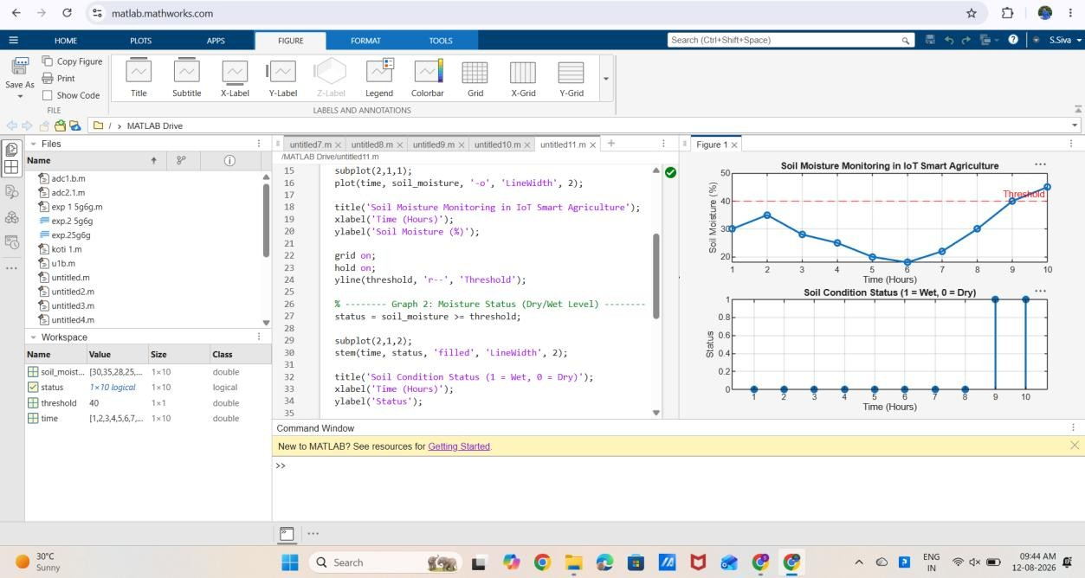

Result:
Soil moisture levels vary over time, showing fluctuations in field water content.
The threshold line helps identify dry and wet conditions for smart irrigation decisions.

