NAME : K.Avinash
REG NO: (192412662)
COURSE NAME : 5G 6G COMMUNICTION (ECA5601)
DATE : 12/08/2026

EX NO: 12 | NB-IoT vs LTE-M Throughput Simulation

AIM: To simulate and compare the performance of NB-IoT and LTE-M communication technologies in terms of Throughput (Mbps), Latency (ms), and Packet Delivery Ratio
(%) using MATLAB.
Procedure:
- Define system parameters for NB-IoT and LTE-M such as bandwidth, transmission power, and modulation efficiency.
- Generate network conditions by varying Signal-to-Noise Ratio (SNR) or channel quality values.
- Compute Throughput (Mbps) for both NB-IoT and LTE-M using their respective data rate models.
- Calculate Latency (ms) based on transmission time, scheduling delay, and network load.
- Determine Packet Delivery Ratio (PDR %) by comparing successfully received packets with transmitted packets.
- Simulate multiple iterations to observe performance under different channel conditions.

- Plot comparison graphs for Throughput, Latency, and PDR between NB-IoT and LTE- M.

- Analyze results to identify which technology performs better under different IoT scenarios.
Objective 1 Matlab Code and Output: clc; clear; close all;
% SNR values (dB)
SNR = 0:5:30;
% Simulated Throughput (Mbps)
NB_IoT = 0.05*(1-exp(-SNR/8));
LTE_M = 1.2*(1-exp(-SNR/8));

disp('SNR (dB) NB-IoT(Mbps) LTE-M(Mbps)') disp([SNR' NB_IoT' LTE_M']) figure
% -------- Graph 1 -------- subplot(2,1,1) plot(SNR,NB_IoT,'-o','LineWidth',2) title('NB-IoT Throughput vs SNR') xlabel('Signal-to-Noise Ratio (dB)') ylabel('Throughput (Mbps)') grid on
% -------- Graph 2 -------- subplot(2,1,2) plot(SNR,LTE_M,'-s','LineWidth',2) title('LTE-M Throughput vs SNR') xlabel('Signal-to-Noise Ratio (dB)') ylabel('Throughput (Mbps)') grid on

OUTPUT:

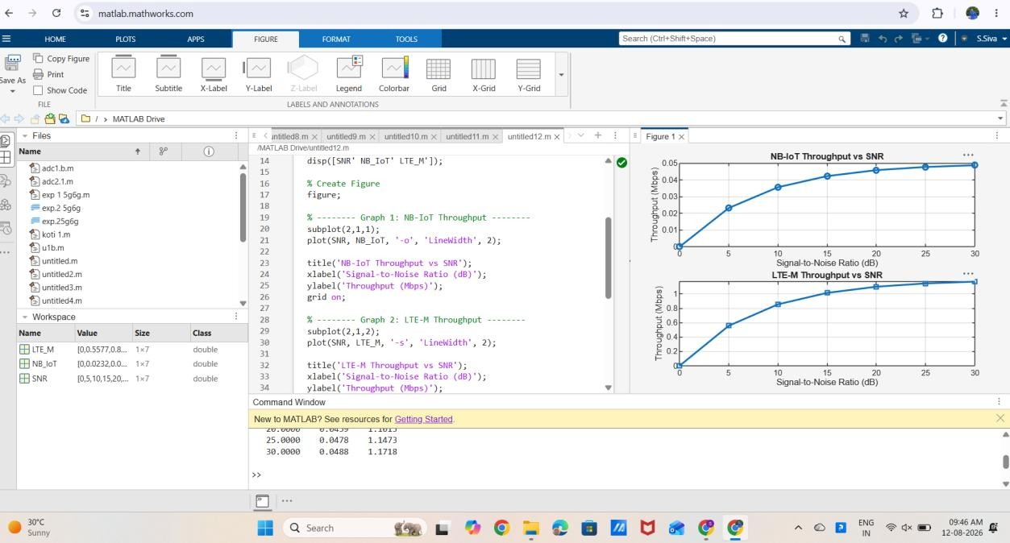

Result:
The throughput of both NB-IoT and LTE-M increases as the Signal-to-Noise Ratio (SNR) improves. LTE-M achieves significantly higher throughput than NB-IoT, making it more suitable for applications requiring higher data rates.

