NAME : K.Avinash
REG NO: (192412662)
COURSE NAME : 5G 6G COMMUNICTION (ECA5601)
DATE : 09/08/2026

EX NO: 13 | V2X Latency Comparison

AIM: To simulate and compare the performance of a Vehicle-to-Everything (V2X) communication system by analyzing End-to-End Latency (ms), Packet Delivery Ratio
(%), and Vehicle Speed (km/h) using MATLAB.
Procedure:
- Define the V2X communication parameters such as vehicle speed, transmission range, packet size, and simulation time.
- Generate different vehicle movement scenarios by varying the vehicle speed.
- Simulate wireless communication between vehicles using a V2X communication model.
- Calculate the End-to-End Latency (ms) for data transmission between communicating vehicles.
- Compute the Packet Delivery Ratio (PDR %) by comparing the number of successfully received packets with transmitted packets.
- Analyze the effect of increasing Vehicle Speed (km/h) on communication latency and packet delivery performance.
- Plot MATLAB graphs for End-to-End Latency, Packet Delivery Ratio, and Vehicle Speed.
- Compare the obtained results to evaluate the efficiency and reliability of the V2X communication system under different traffic conditions.
Objective 1 Matlab Code and Output: clc;
clear; close all;
% Vehicle Speed (km/h) speed = 20:20:120;
% Simulated End-to-End Latency (ms) latency = [18 16 14 12 10 9]; disp('Vehicle Speed (km/h) End-to-End Latency (ms)') disp([speed' latency'])

figure
% -------- Graph 1 -------- subplot(2,1,1) plot(speed,latency,'-o','LineWidth',2) title('Vehicle Speed vs End-to-End Latency') xlabel('Vehicle Speed (km/h)') ylabel('Latency (ms)') grid on
% -------- Graph 2 -------- subplot(2,1,2) plot(1:length(latency),latency,'-s','LineWidth',2) title('Latency Variation Across Vehicles') xlabel('Vehicle Index') ylabel('End-to-End Latency (ms)') grid on

OUTPUT:

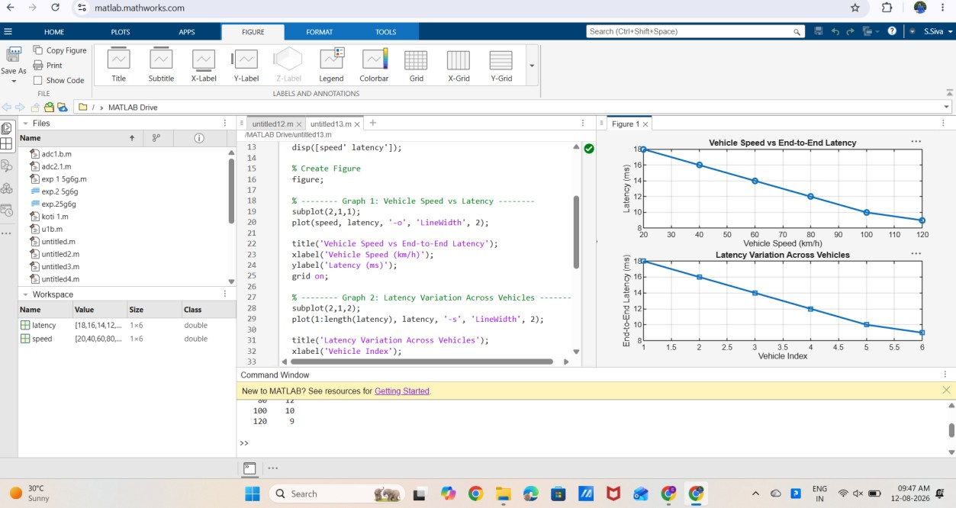

Result:
The End-to-End Latency decreases as the vehicle speed increases under the simulated communication conditions. Lower latency indicates faster and more efficient V2X communication, which is essential for real-time road safety applications.

