NAME : K.Avinash
REG NO: (192412662)
COURSE NAME : 5G 6G COMMUNICTION (ECA5601)
DATE : 09/08/2026

EX NO: 14 | 5G Throughput vs SNR with Modulation Labels

AIM: To simulate the performance of a 5G wireless communication system using
MATLAB
by analyzing the relationship between Throughput (Mbps), Signal-to-Noise Ratio (SNR)
(dB), and different Modulation Schemes (QPSK, 16-QAM, 64-QAM, and 256-QAM).
Procedure:
- Define the simulation parameters such as SNR range, bandwidth, modulation schemes
(QPSK, 16-QAM, 64-QAM, and 256-QAM), and transmission settings.
- Generate random binary data and modulate it using the selected modulation schemes.
- Simulate the transmission of the modulated signals through an Additive White Gaussian
Noise (AWGN) channel with different SNR values.
- Calculate the Throughput (Mbps) achieved for each modulation scheme at different SNR levels.
- Analyze the impact of Signal-to-Noise Ratio (SNR) on communication performance and throughput.
- Compare the performance of QPSK, 16-QAM, 64-QAM, and 256-QAM under identical channel conditions.
- Plot MATLAB graphs for Throughput vs SNR and SNR vs Modulation Scheme to visualize the system performance.
- Interpret the results to identify the most suitable modulation scheme for different SNR
conditions in a 5G communication system.
Objective 1 Matlab Code and Output: clc; clear; close all;
% SNR values (dB)
SNR = 0:5:30;
% Maximum Throughput (Mbps)
Max_TP = 100;
% Throughput calculation Throughput = Max_TP*(1-exp(-SNR/10)); disp('SNR(dB) Throughput(Mbps)') disp([SNR' Throughput']) figure
% -------- Graph 1 -------- subplot(2,1,1) plot(SNR,Throughput,'-o','LineWidth',2) title('5G Throughput vs SNR') xlabel('Signal-to-Noise Ratio (dB)') ylabel('Throughput (Mbps)') grid on
% -------- Graph 2 -------- subplot(2,1,2) bar(Throughput) title('Throughput at Different SNR Levels') xlabel('SNR Index') ylabel('Throughput (Mbps)') grid on

OUTPUT:

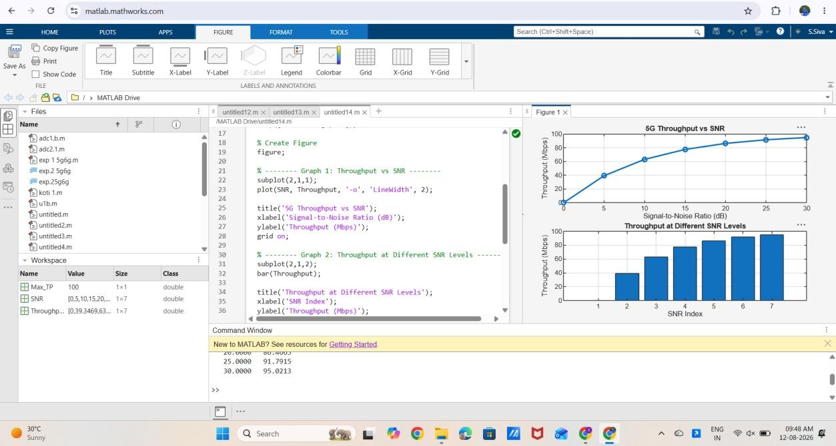

Result:

- The throughput of the 5G system increases as the SNR increases due to improved signal quality.

- Higher SNR enables efficient data transmission, resulting in greater throughput and better communication performance

