NAME : K.Avinash
REG NO: (192412662)
COURSE NAME : 5G 6G COMMUNICTION (ECA5601)
DATE : 12/08/2026

EX NO: 3 | Spectrum Analysis of Sub-1 GHz, Mid-band & mmWave by Plotting Propagation Loss.

AIM:

To analyze the propagation loss characteristics of different frequency bands (Sub-1 GHz, Mid-band, and mmWave) in wireless communication systems and compare their performance over varying distances using MATLAB.

Procedure:
- Define frequency bands: Sub-1 GHz (0.9 GHz), Mid-band (3.5 GHz), and mmWave (28 GHz).
- Set communication distance range (e.g., 0.1 km to 5 km).
- Use Free Space Path Loss (FSPL) formula to compute propagation loss:

PL(dB)=20log⁡10(d)+20log⁡10(f)+32.44

- Calculate propagation loss for each frequency band over varying distances.
- Plot distance vs propagation loss curves for comparison.
- Analyze how higher frequencies experience higher attenuation.
- Compare coverage efficiency of each spectrum band.
- Display results using MATLAB plots. Objective 1: Matlab Code and Output:
clc; clear; close all; d = 0.1:0.1:5; % Distance (km) f = [900 3500 28000]; % Frequency (MHz) PL1 = 32.44 + 20*log10(f(1)) + 20*log10(d);
PL2 = 32.44 + 20*log10(f(2)) + 20*log10(d); PL3 = 32.44 + 20*log10(f(3)) + 20*log10(d); figure
% -------- Graph 1 -------- subplot(2,1,1)

plot(d,PL1,'b','LineWidth',2); hold on plot(d,PL2,'r','LineWidth',2) plot(d,PL3,'k','LineWidth',2) title('Propagation Loss vs Distance') xlabel('Distance (km)') ylabel('Loss (dB)') grid on
% -------- Graph 2 (NO legend used to avoid error) -------- subplot(2,1,2)
Freq = [900 3500 28000]; Loss = [PL1(10) PL2(10) PL3(10)]; plot(Freq,Loss,'-o','LineWidth',2) title('Propagation Loss vs Frequency') xlabel('Frequency (MHz)') ylabel('Loss (dB)') grid on

OUTPUT:

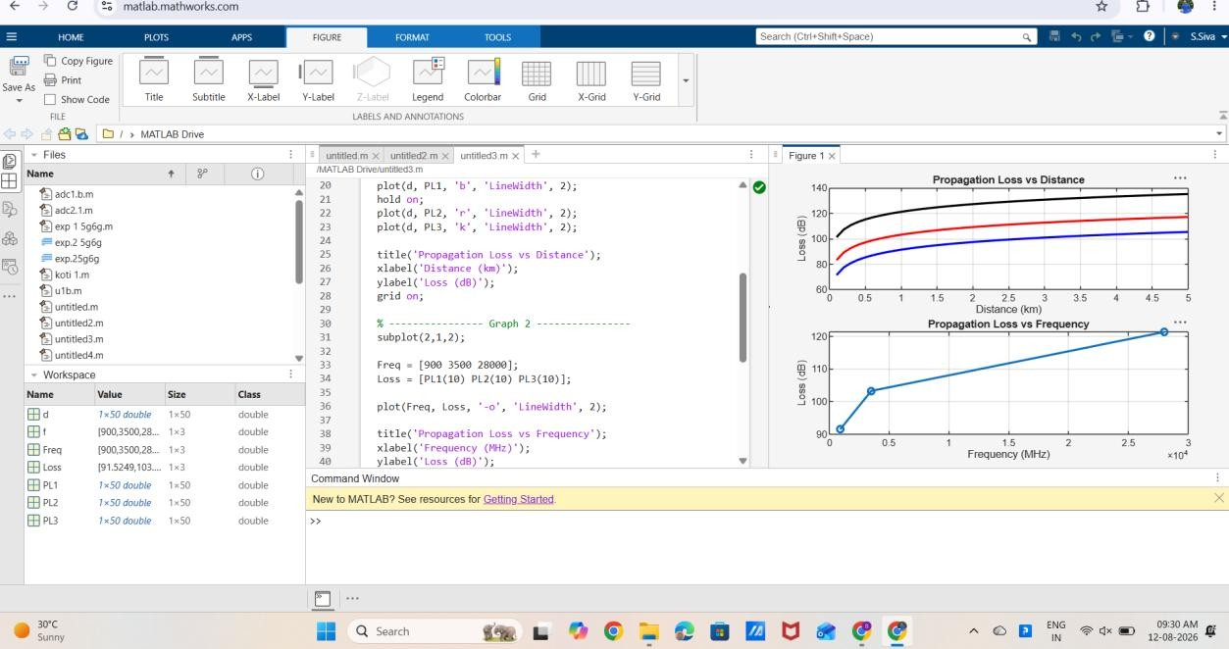

Result:
The graph shows that propagation loss increases with both communication distance and operating frequency in wireless systems.

