NAME : K.Avinash
REG NO: (192412662)
COURSE NAME : 5G 6G COMMUNICTION (ECA5601)
DATE : 12/08/2026

EX NO: 4 | OFDMA Resource Block Allocation

AIM: To simulate and analyze OFDMA (Orthogonal Frequency Division Multiple Access) resource block allocation and evaluate system performance in terms of resource utilization and user throughput using MATLAB.
Procedure:
- Define the system bandwidth and calculate the number of available resource blocks (RBs) based on RB size (e.g., 180 kHz per RB).
- Identify the number of active users in the OFDMA system for resource sharing.
- Allocate resource blocks to each user based on a predefined or equal distribution strategy.
- Compute Resource Block Utilization (%) using the ratio of allocated RBs to total RBs.
- Assign modulation efficiency values (e.g., QPSK, 16-QAM, 64-QAM) for each user.
- Calculate User Throughput (Mbps) using allocated RBs and modulation efficiency.
- Plot graphs for RB allocation and utilization/throughput analysis using MATLAB.
- Analyze results to evaluate spectrum efficiency and system performance.
Objective 1 Matlab Code and Output: clc; clear; close all; % System parameters bandwidth = 10e6; % 10 MHz rb_size = 180e3; % 180 kHz per RB % Total Resource Blocks total_RB = floor(bandwidth / rb_size);
% Users
users = 1:6;
% RB allocation (simple equal + remainder distribution) base = floor(total_RB / length(users));

alloc = base * ones(1,length(users)); alloc(1:mod(total_RB,length(users))) = alloc(1:mod(total_RB,length(users))) + 1; utilization = (alloc / total_RB) * 100; disp('Total Resource Blocks:') disp(total_RB) disp('RB Allocation per User:') disp(alloc) figure
% -------- Graph 1: RB Allocation per User -------- subplot(2,1,1) stem(users, alloc, 'filled', 'LineWidth', 2) title('OFDMA Resource Block Allocation per User') xlabel('User Index') ylabel('Number of Resource Blocks') grid on
% -------- Graph 2: RB Utilization -------- subplot(2,1,2) plot(users, utilization, '-o', 'LineWidth', 2) title('OFDMA Resource Block Utilization (%)') xlabel('User Index') ylabel('Utilization (%)') grid on

OUTPUT:

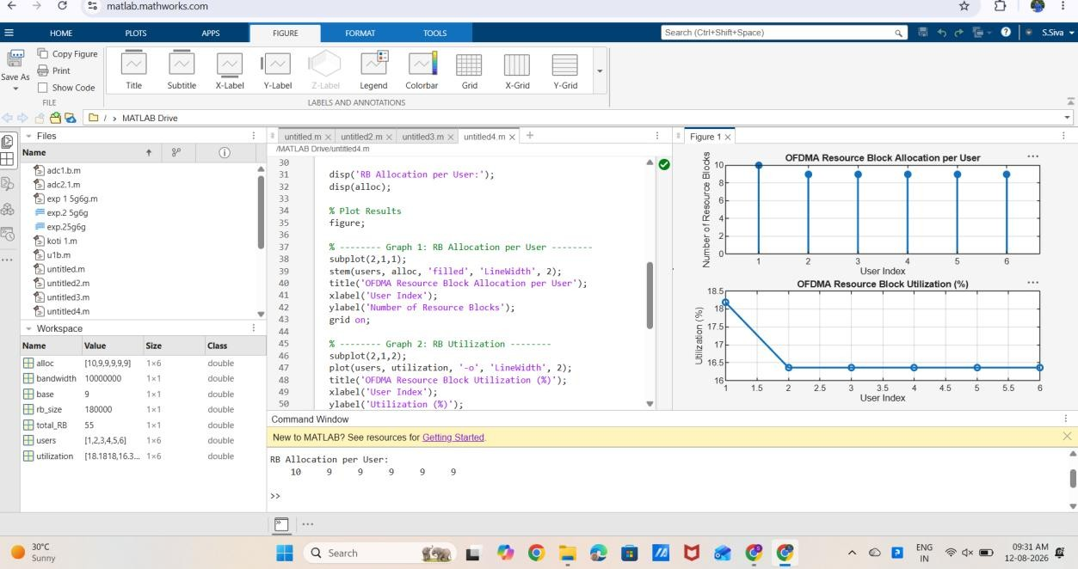

Result:
The first graph shows how available resource blocks are distributed among multiple users in the OFDMA system.

