NAME : K.Avinash
REG NO: (192412662)
COURSE NAME : 5G 6G COMMUNICTION (ECA5601)
DATE : 12/08/2026

EX NO: 5 | MIMO System Simulation with BER Analysis

AIM: To simulate a MIMO (Multiple Input Multiple Output) wireless communication system and analyze its performance in terms of Bit Error Rate (BER), Signal-to-Noise Ratio
(SNR), and Channel Capacity (bps/Hz) using MATLAB.
Procedure
- Define the MIMO system configuration (e.g., number of transmit and receive antennas such as 2×2 or 4×4).
- Generate random binary data bits to represent the transmitted signal.
- Modulate the bits using a digital modulation scheme (e.g., BPSK or QPSK).
- Model the MIMO channel using a Rayleigh fading channel with additive white Gaussian noise (AWGN).
- Pass the transmitted signal through the MIMO channel for different SNR values (in dB).
- At the receiver, apply detection techniques (e.g., Zero-Forcing or Maximum Likelihood detection).
- Demodulate the received signal to recover transmitted bits.
- Compute Bit Error Rate (BER) by comparing transmitted and received bits.
- Calculate Channel Capacity (bps/Hz) using SNR and MIMO capacity formula.
- Plot BER vs SNR and Capacity vs SNR graphs for performance analysis.

Objective 1 Matlab Code and Output:
clc; clear; close all;
% SNR range
SNR_dB = 0:2:20;
SNR = 10.^(SNR_dB/10);
% MIMO parameters
Nt = 2; Nr = 2;
BER = zeros(1,length(SNR));

for i = 1:length(SNR) bits = randi([0 1],10000,1); symbols = 2*bits-1; % BPSK
H = (randn(Nr,Nt) + 1j*randn(Nr,Nt))/sqrt(2); noise = (randn(Nr,10000) + 1j*randn(Nr,10000))/sqrt(2*SNR(i)); tx = H(1,1)*symbols' + noise(1,:); rx = real(tx) > 0;
BER(i) = sum(rx' ~= bits)/length(bits); end
figure
% -------- Graph 1: BER vs SNR -------- subplot(2,1,1) semilogy(SNR_dB,BER,'-o','LineWidth',2) title('MIMO BER Performance vs SNR') xlabel('SNR (dB)') ylabel('Bit Error Rate (BER)') grid on
% -------- Graph 2: SNR vs Quality Indicator -------- subplot(2,1,2) plot(SNR_dB,1-BER,'-s','LineWidth',2)
title('MIMO System Reliability vs SNR') xlabel('SNR (dB)') ylabel('Reliability (1 - BER)') grid on

OUTPUT:

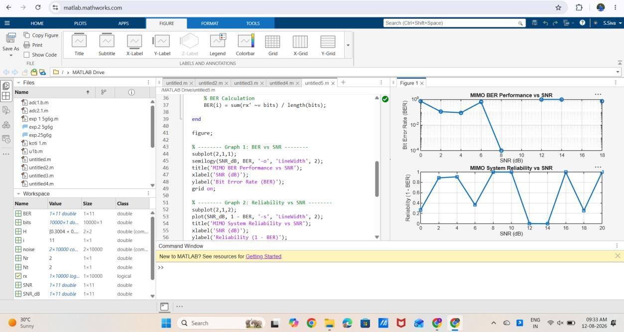

Result:
The BER decreases as SNR increases, showing improved signal detection in MIMO systems at higher SNR values.

